This case study revolves around evaluating “promotions (deals)” on a large-scale retail platform ($ 2M SKUs spread across 500 categories) represented in the following catalog model.

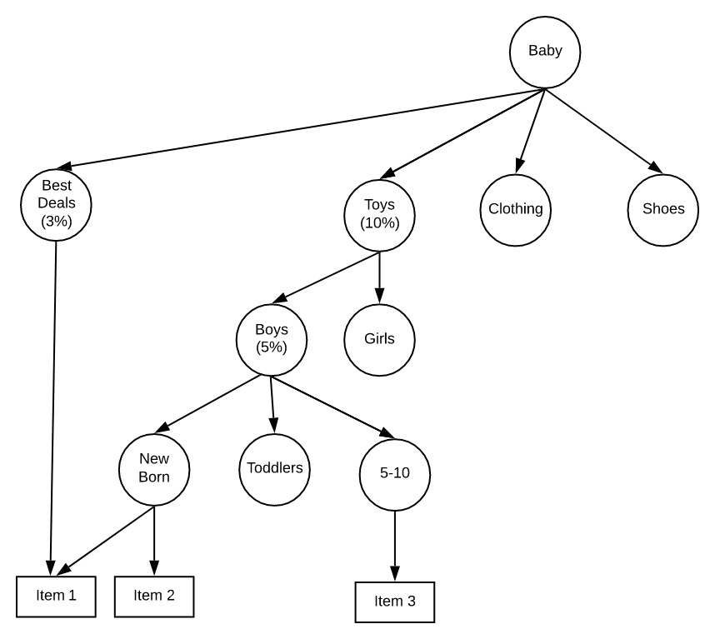

1. “Baby” is a super category that has multiple sub-categories (which could have subsequent children up-to a depth of 4)
2. “Item 1”, “Item 2” are SKUs that belong to one or more categories. One item can belong to multiple parents
3. Discounts (say 10% off) can be offered at multiple levels in the tree and they stack up additively. For example, if a customer buys “Item 1”, she gets a discount of 18 % (15% under the tree “Baby-> Toys -> Boys” and an additional three percent under “Baby -> Best Deals”.

Exercise:

1. Use a technology stack of your choice to create an abstraction model (POJOs, API Spec) that can best represent this use-case
2. Author a micro-service that can compute the total discount % for a given item.
3. Feel free to use any in-memory DB to hold the sample data

|  |  |  |
| --- | --- | --- |
| Item | Category | Price |
|  |  |  |

Kids -> Toys, Clothing,