1. **INSTALLATION**

* **Backend:** Install JDK and JRE 1.8 and Spring Tool Suite IDE 4-4.2.0.
* **Frontend:** Install Node.js, Visual studio code. In the visual studio code, open new terminal and run “npm i @angular/cli” command to get the angular installed.
* **Database:** PostgreSQL 11

1. **SETUP**
2. Clone the Github repository into your local. In this repository,

* ‘CourseRegistrationSystem’ folder has the complete backend code(Java springboot to be imported into Spring Tool Suite).
* ‘courseregistration-angular’ folder has the complete frontend angular code(Angular code to be imported into Visual Studio Code).

1. To get the backend code,

* Get the .project, .classpath and pom.xml files from Misc folder, place them in CourseRegistrationSystem folder and delete those files from Misc folder.
* Go to Spring Tool Suite and import project from Git – “Existing Local Repository”.

1. To get the frontend code,

* Go to Visual Studio code and open the folder ‘courseregistration-angular’ from there.

1. To get the database setup, go to pgAdmin and run all scripts (in ‘Database scripts’ folder) in Query Tool editor.
2. **EXECUTION**
3. To run the backend code, right click on project folder🡪Run As🡪Spring Boot App.

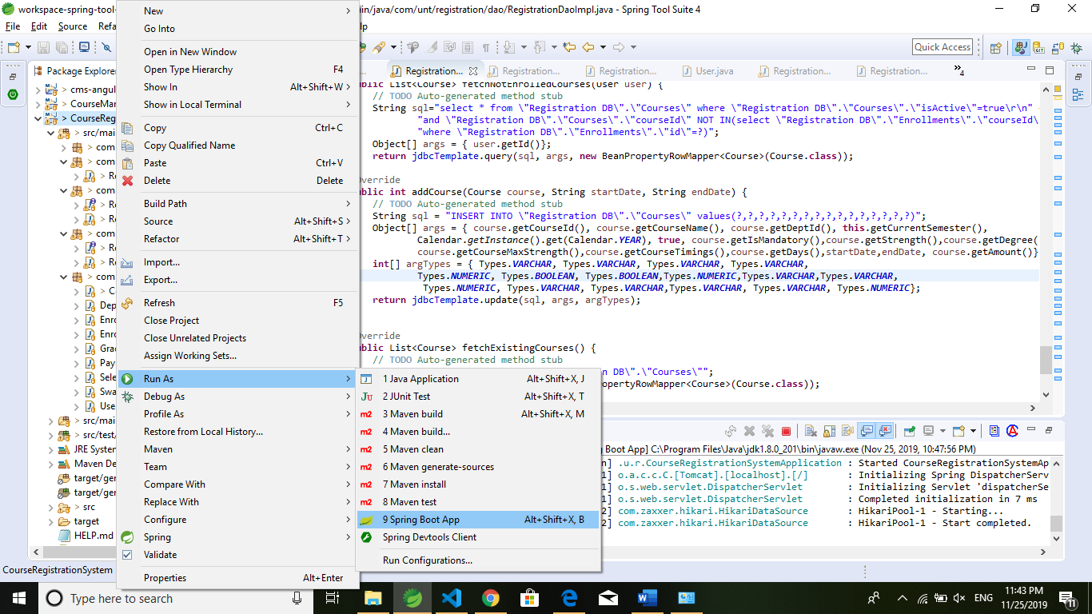

1. To run the frontend code, navigate to project folder(courseregistration-angular) in Visual Studio code terminal and run “ng serve --proxy-config proxy.conf.json” command.

1. Go to the browser and hit “ <http://localhost:4200/> “.
2. To login, the user must first signup. To sign up, go to create your account link. Here we have an assumption that the user ID you enter should be provided to you from the university (i.e., the user ID must be there in the ‘Universitydetails’ table before you signup). So, you must first create some IDs in ‘Universitydetails’ table and use one of those IDs to signup and then login. When you signup, all the details will be stored in ‘Userdetails’ table.

**Please email us if you find any issues.**