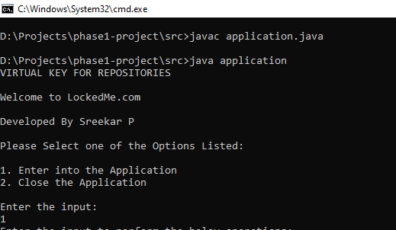

**1.1** **Welcome Screen**

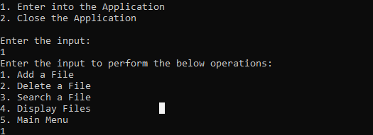

**1.2 Main Menu**

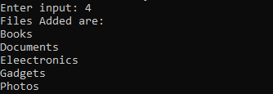

**1.3 Display Files**

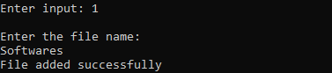

**1.4 Adding File**

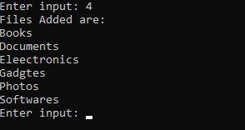

**1.5 Files After Adding**

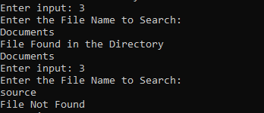

**1.6 Search a File**

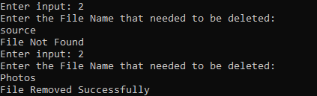

**1.7 Delete a File**

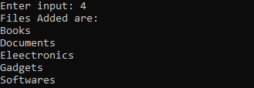

**1.8 Files After Delete**

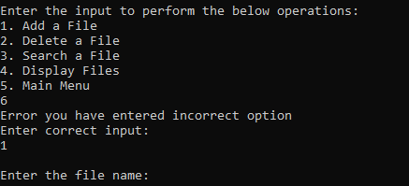

**1.9 Entering wrong input**

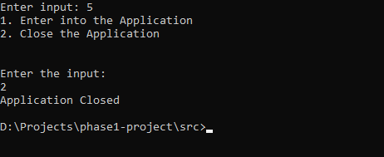

**1.10 Navigating Back and Closing Application**