1. **SCREENSHOTS**

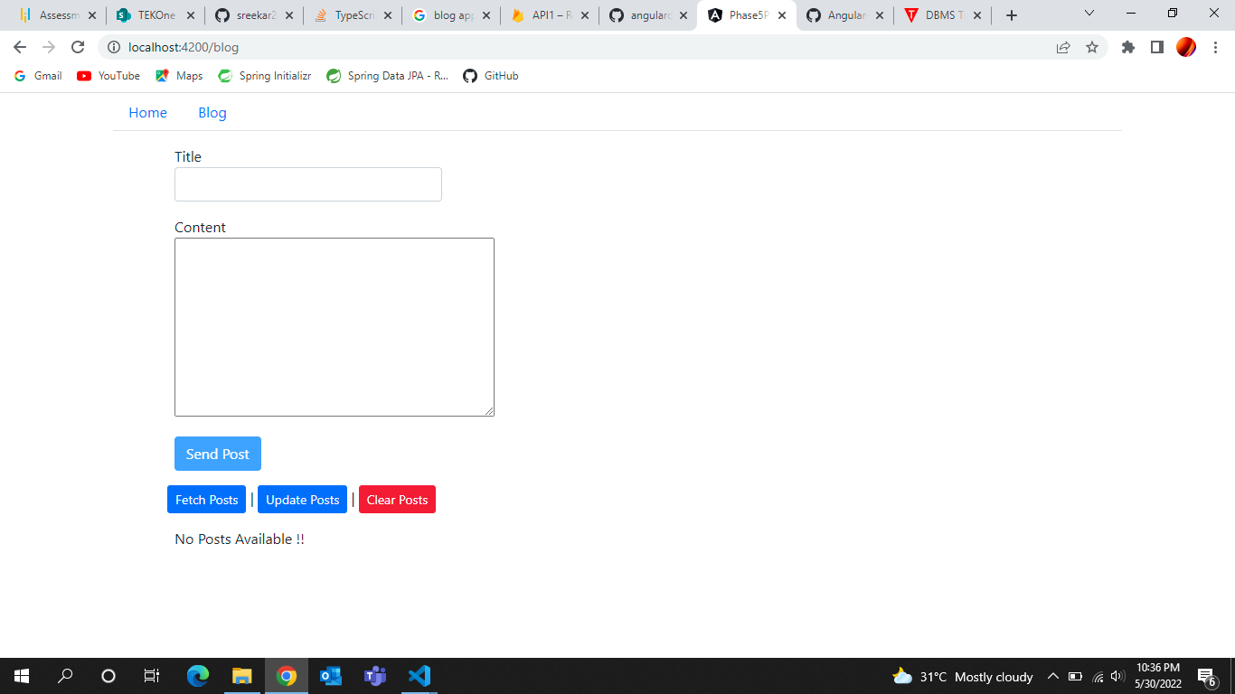

* 1. Home Page

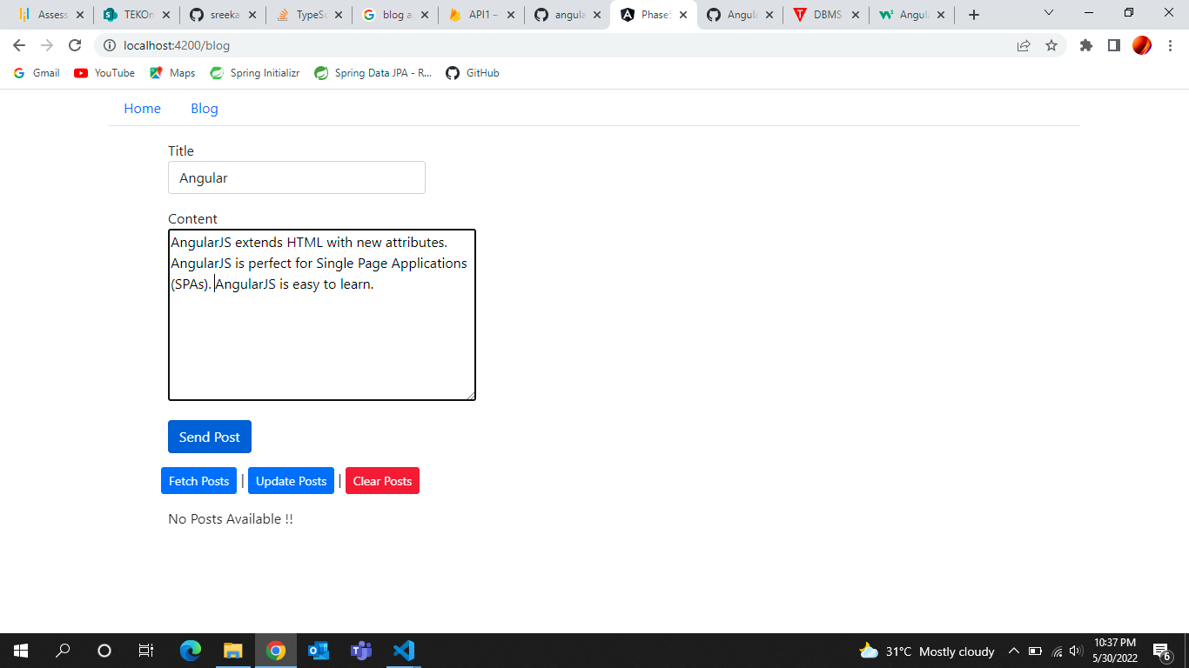

* 1. Adding Post

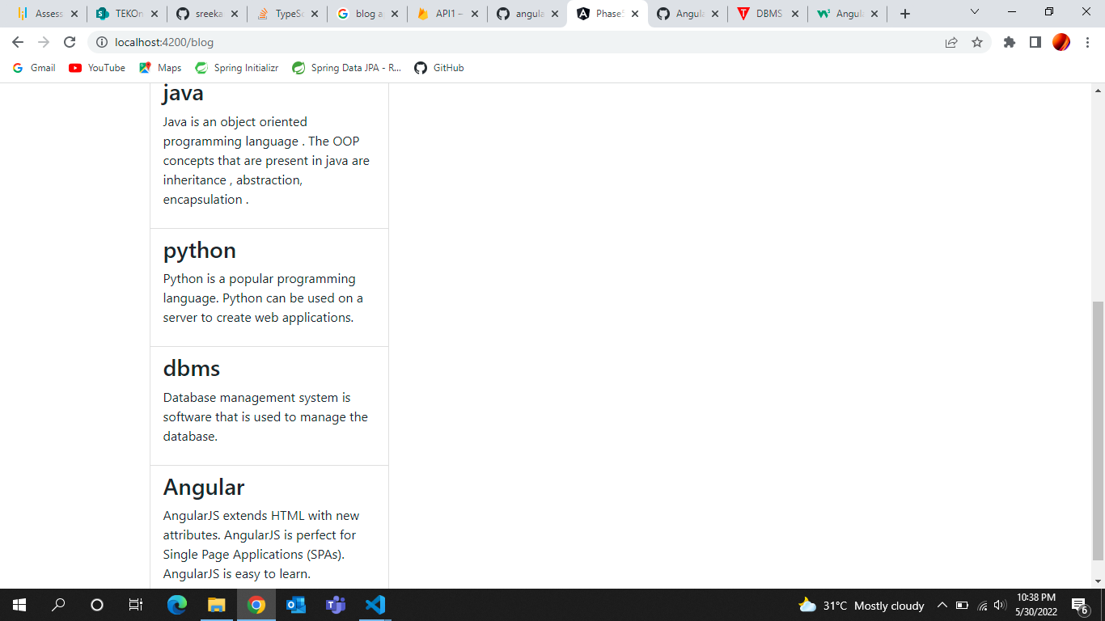

1.3 After Adding Post

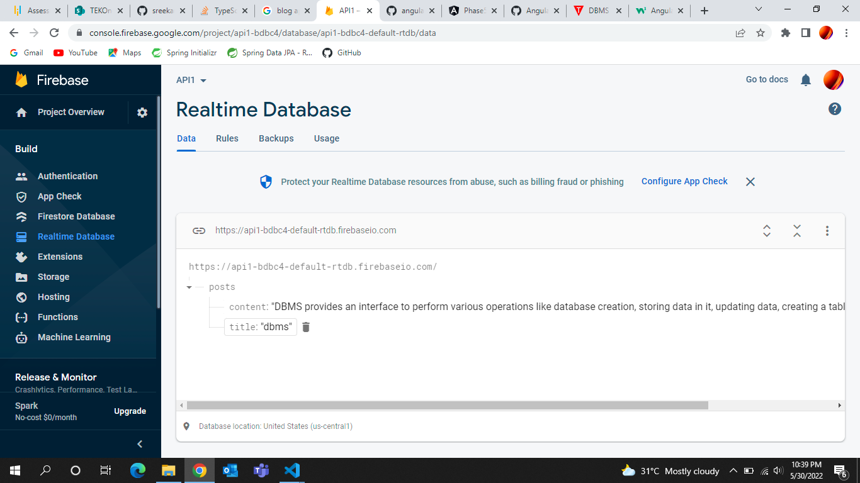

* 1. Updating Post



* 1. Fetching Posts

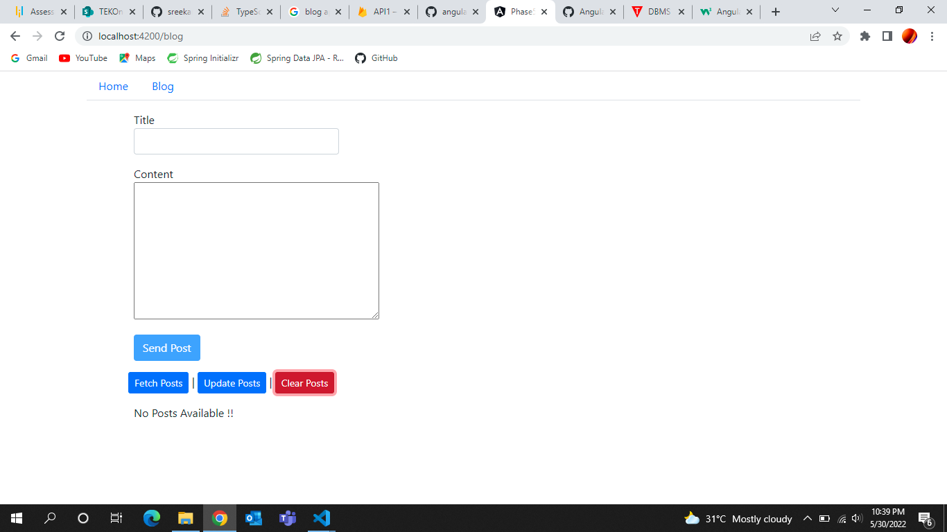

* 1. Clearing Posts

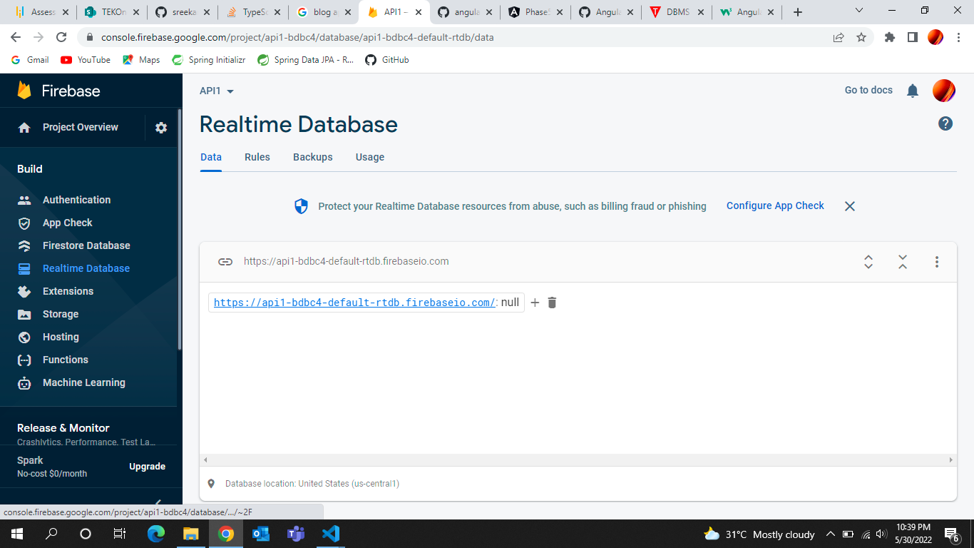

1.7 After Clearing Posts