TITLE
Sreekar¹ (Matriculation Number), Tanvi² (Matriculation Number),.

¹Study Program 1
²Study Program 2

Use this template to create your final report. It is supposed to elaborate a new research question on the data you used in one of the two projects. The report includes the sections given below and the abstract at this place. There is one example of a report given. The report must not exceed six pages including references. Do not use more than five figures/tables. Stick to the template.
KEYWORDS: 10 pt, up to 5 keywords separated by a comma.

INTRODUCTION: Here comes your introduction, no subheadings

METHODS: Here come the methods used

RESULTS: Fill in your results

DISCUSSION: Discuss your results, no subheadings

CONCLUSION: Short conclusion

REFERENCES
Figure 1 This is an example figure caption.

CNN Architecture 1
CNN Architecture 2
Sensor data comparison
Post-processing method
AI, ML comparison

INTRODUCTION:

The next generation of aircraft must comply with low carbon emission regulations. As structural weight is a key component in fuel consumption, it is natural to change from metallic to lighter composite structures. However, to fully utilize their strength to weight ratio, their conservative damage tolerance design needs to be revised. One way of ensuring the safety of the structure without overdesigning the components is to have continuous monitoring of its state to detect any alarming external impact events which could lead to vulnerability at the early stages of evolution (Tabian I, et al., 2019). With this motivation, a project regarding the prediction of impact location was undertaken. Previously, CNN along with other numerous models was implemented. Compared to other models, the main advantage of using an AI model is that it automatically detects the significant features without any human intervention, which made it the most used (Laith Alzubaidi, et al., 2021). It was found that the CNN model gave the closest predictions. One of the most common architectures namely AlexNet was implemented. AlexNet consequently improves the CNN learning ability by increasing its depth and implementing several hyper-parameter optimization strategies (Laith Alzubaidi, et al., 2021). Through its hyperparameters’ tuning, a mean square error of ~4.2 was obtained. Fig 1 shows the architecture of AlexNet the group implemented. Further for the improvement of the proposed models, certain prospects were noted. Firstly, it was decided to compare different CNN architectures and modify the model for the current use case. Secondly, running post-processing to improve the prediction. (Benefits of CNN can be added)
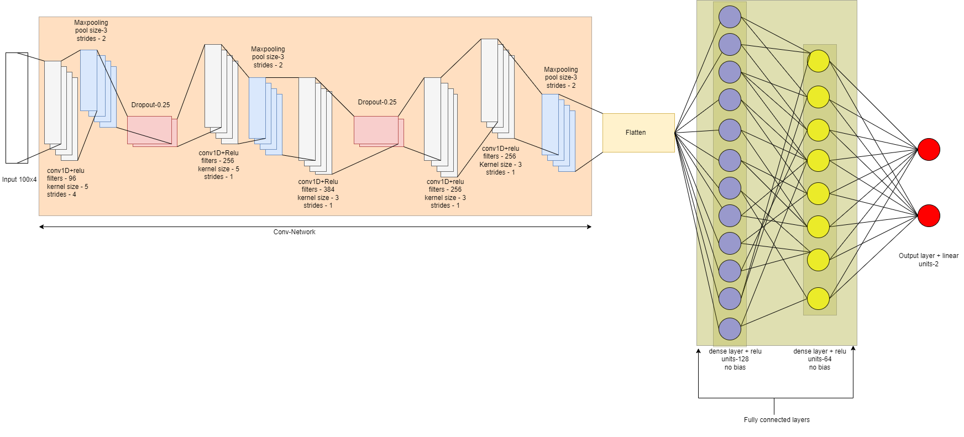Fig 1. The architecture of AlexNet and the tuned hyperparameters used.

(Explanations of hyperparameters can be done)

Methods

Based on this result we extended
- Compare different CNN architectures
(HP tuned). Motivation is to understand
what kind of traditional architecture
works best and how it could be modified
to yield better accuracy using hyper-
parameter tuning.
2. run post-processing to better the
prediction. we select a few surrounding
training data from the predicted location
and compare the MSE of sensor data
between training and experimental data,
choose the least MSE position to be the
impact location.

- Improved model performance with optimization.
- Better prediction with post-processing

