**Web Services:**

**Application Programming Interface (API):**

Defines everything we need to communicate with a Web Service.

**Elements of a Web Service API:**

**Message Format:**

* SOAP, XML, JSON (Java Script Object Notation), Other

**Request Syntax:**

* Named Methods: They use syntax similar to client side.
* Uniform Resource Identifier (URI): They sent us http request.
* Parameter names and data types.

**Requesting an action:**

* Named Methods
* HTTP Verbs (POST, GET, PUT, PATCH, DELETE).

**Authentication:**

* Username and Password
* Authentication tokens

**Receiving the data:**

* Formats: SOAP, XML, JSON
* Metadata: Describes data structure, including field/ property names and data types.

We have two kinds of Web services.

1. **SOAP** (Simple Object Access Protocol) which implements **JAX-WS**.
2. **REST** (Representational State Transfer) which implements **JAX-RS**.

The classes can access the method and if we want to provide any feature to user then we will have an MVC module that makes the web application to the users. MVC module will have a call to the method and then it can show the list of products to user in a nice HTML format. The following are some of the Key components of Web Service.

* **WSDL:**

It describes the web service in an XML format. So, those different technologies can understand.

* **UDDI:**

It is a directory where any publisher can publish their web services and consumer can query this directory and get access to all the different web services.

* **SOAP:**

It is a Protocol language in XML format, which used to encode and decode different messages. If we are making a call to Web Service, it ends up as a SOAP message that transmitted over the network.

* **SEI:**

Interface to a Web Service that provides a way for the client application irrespective of the technology to call the Web service.

**Steps to Generate Stubs from WSDL:**

* Open the Command prompt
* Create a new directory i.e. Mkdir sei
* Now change the directory to sei i.e. Cd sei
* Import all the files i.e. wsimport –keep –s src “url”

In the SEI folder, create a SRC folder after in which the execution of wsimport command it generates the Java class in SRC folder and class type in net folder.

After writing the code, project name: IPLocation Finder. For this, we need to pass input arguments like IP Address of Google. To get Google IP address type ping Google.com in command window. Copy that IP address and paste in Run Configurations-> Arguments->Run.

Fig shown below is the Output.

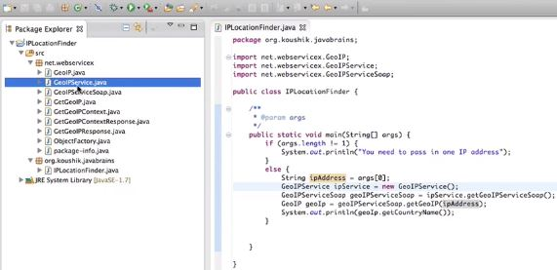

The important concepts in the SOAP based Web Service is:

* **JAX-B Annotations**

@xmlRootElement (), @xmlType (proporder= {}), @xmlElement (), @webmethod, @webResult ()

We need to have a noArg Constructor because we need a way for JAX-B to initialize our new instance of the class i.e. it will need to instantiate the object first and if we have only one constructor with some arguments. JAX-B does not know what arguments to pass the things. JAX-B does XML to Java Object Conversion tool.

* **Handling Faults**

In a method if something should not return the return type as mentioned, this can done when the method throws an exception.

* **SOAP UI**

-It is one of the tools to test the SOAP Web Services.

-It is widely used by lot of QA professionals.

-It is an Open Source.