Software Architecture and Design Specification
Project: ATM System
Version: 1.0.0.0
Authors: Kushal Kumar G, Kirthan G, K Sreekar, K sriharsha
Date: 06-10-2025
Status: Draft

Revision History
Version: 1.0.0.0
Date: 06-10-2025
Author: Kushal Kumar G, Kirthan G, K Sreekar, K Sriharsha
Change Summary: To Be Filled in Future

Approvals
Role: Faculty
Name: Ananda M S
Signature/Date:

1. Introduction
1.1 Purpose
This system is intended to provide a structured platform for company employees, who are not regular mart workers, to volunteer during weekends and festivals when customer footfall is high. It enables staff and managers to book slots in nearby marts, choose preferred sections, and earn Helping Hands Points (HHP) for their contributions.
1.2 Scope
The scope of the Helping Hands Software (HHS) is to provide a centralized, web-based platform that connects company employees with marts requiring additional support during weekends and festivals. The system allows staff and managers to search nearby marts, select preferred sections, and book time slots based on availability. It manages waitlists, cancellations, and booking priorities using a First-Come-First-Serve (FCFS) approach. Store admins can define store details, set manpower requirements, and monitor attendance, while the main admin oversees system-wide management, including user and store registration. The software also awards Helping Hands Points (HHP) to employees for completed slots, ensuring fairness, motivation, and performance tracking across all participants.
1.3 Audience
End Users (Staff, Branch Managers, and Company Employees), Store Admins, Main Admin
Secondary Stakeholders:
- Developers and Testers
- Management Team

- 1.4 Definitions
Helping Hands (HH): An initiative where company employees volunteer to assist marts during weekends and festivals.
- Helping Hands Software (HHS): The system that manages slot booking, store requirements, and performance tracking under the Helping Hands initiative.
- Helping Hands Points (HHP): Reward points awarded to users based on the number of hours worked in their booked slots, used to monitor employee contribution.
- Mart: A store location (mall, supermarket, electronics store, or other retail outlet) where volunteers can book slots.
- Slot: A specific time duration (date and hours) reserved by a user to work in a mart.
- Section: A defined area within a mart (e.g., billing, groceries, electronics, customer service) where volunteers can choose to work.
- Waitlist: A queue where users are placed if their preferred slot/section is already full.
- FCFS (First Come First Serve): The scheduling principle used to allocate slots and waitlist positions.
- End User: A company employee (staff, branch manager, or other employee) volunteering through the system.
- Store Admin: A role responsible for managing mart details, manpower requirements, attendance, and bookings.
- Main Admin: The central authority responsible for registering/removing users and marts, viewing performance, and ensuring smooth system operation.
2. Document Overview
2.1 How to use this document
Provides architectural deliverables including UML diagrams, ADRs, threat models, and API design.
2.2 Related Documents
SRS, STP, RTM.

3. Architecture
3.1 Goals & Constraints
Goals
- Provide a user-friendly platform for company employees to volunteer in marts during peak times.
- Enable easy booking, cancellation, and waitlist management of slots.
- Support role-based access for Users, Store Admins, and Main Admin.
- Track and reward employee contributions using Helping Hands Points (HHP).
- Ensure data privacy, security, and reliable notifications (SMS/Email).
- Maintain scalability and performance during weekends and festivals.

Constraints
- Users can cancel a maximum of two confirmed slots per day.
- Slot allocation follows First Come, First Serve (FCFS) priority.
- Location services are only for mart search and require user consent.
- System must remain available with ≥99.5% uptime on weekends/festivals.
- Database must support regular backups and recovery.
- Interfaces must be web-based and mobile responsive.

3.2 Stakeholders & Concerns
Customers: security, availability
Bank Ops: maintainability
Regulators: compliance
Developers: modularity.

3.3 Component (UML) Diagram
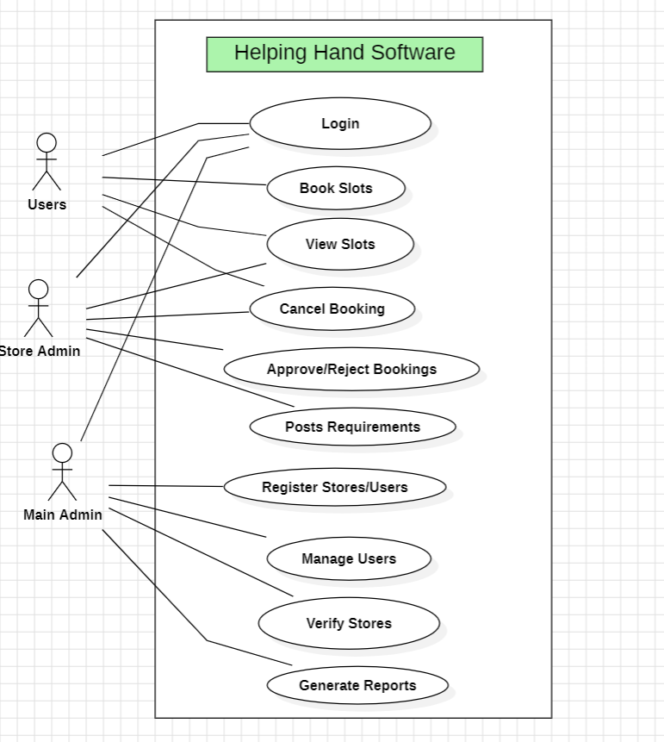

3.4 Component Descriptions

1. User Interface Component

Description: Provides the front-end interface for Users, Store Admins, and Main Admins.

2. Authentication & Authorization Component

Description: Ensures secure login and role-based access.

3. Booking Management Component

Description: Manages all slot booking operations.

4. Store Management Component

Description: Used by Store Admins to manage store-related details.

5. User & Store Administration Component

Description: Centralized control for the Main Admin.

6. Notification Component

Description: Handles user alerts and reminders.

7. HHP (Helping Hands Points) Component

Description: Calculates and updates HHP points based on attendance.

8. Database Component

Description: Central storage system for all data.

3.5 Chosen Architecture Pattern and Rationale

Architecture Pattern: Three-Tier Architecture (Presentation, Application, Data Layers)
The Helping Hands Software (HHS) will adopt a three-tier architecture pattern consisting of:
- Presentation Layer (Client UI):
  - Provides the web-based interface for Users, Store Admins, and Main Admins.
  - Implements responsive design for desktop and mobile devices.
- Application Layer (Backend Services):
  - Handles business logic such as slot booking, waitlist management, HHP calculation, user/store administration, and notifications.
  - Implements secure authentication and authorization using role-based access control.
- Data Layer (Database):
  - Stores persistent data such as user profiles, mart details, slots, attendance, and HHP points.
  - Ensures secure and reliable storage with backup and recovery mechanisms.
3.6 Technology Stack & Data Stores
Frontend: React.js, HTML5, CSS3, JavaScript
Backend: Node.js, Express.js, SMS/Email API, Geolocation API
Database: MongoDB
Tools & Environment: Git, GitHub

3.7 Risks & Mitigations
- Risk: Unauthorized access to sensitive data.
  - Mitigation: Implement RBAC, secure authentication (JWT), and encryption.
- Risk: Data loss due to system or hardware failure.
  - Mitigation: Regular database backups and disaster recovery plan.
- Risk: Server overload during peak times (weekends/festivals).
  - Mitigation: Scalable backend architecture and load balancing.
- Risk: Location privacy concerns.
  - Mitigation: Make location use opt-in, anonymize data, and store only necessary details.
- Risk: SMS/Email notification failure.
  - Mitigation: Use reliable third-party APIs with retry logic and fallback to email if SMS fails.

Risk: Malicious admin actions (misuse of privileges).

Mitigation: Maintain audit logs and restrict critical operations with dual authorization where needed.

Risk: Bugs or usability issues affecting adoption.

Mitigation: Conduct thorough testing (unit, integration, UAT) and gather user feedback.

3.8 Traceability to Requirements
Requirement ID | Requirement Description | System Feature | Acceptance Test(s)
FR-1 | Search nearby marts using GPS/manual location input | End User Interface, Location Search | AT-1
FR-2 | View mart details (type, size, sections) | End User Interface | AT-1
FR-3 | Select preferred section in a mart | End User Interface, Section Preference | AT-2, AT-3
FR-4 | Book available slots (date & time) | Slot Booking | AT-2
FR-5 | Waitlist for full slot/section | Waitlist Management | AT-3
FR-6 | Restrict slot cancellations to max two/day | Cancellation Policy | AT-4
FR-7 | View booking history and upcoming bookings | Booking History | AT-2
FR-8 | Display earned Helping Hands Points (HHP) | HHP Tracking | AT-6
FR-9 | Send SMS/email alerts before slot begins | Notifications | AT-5
FR-10 | Modify store details (name, type, size) | Store Setup & Management | -
FR-11 | Add/remove sections; define manpower requirements | Section Management | AT-2, AT-3
FR-12 | View and manage user bookings | Booking Oversight | AT-2, AT-3
FR-13 | Mark attendance of users | Attendance Management | AT-6
FR-14 | Enforce intake limits for slots/sections | Intake Limitation | AT-3
FR-15 | View user booking information for mart | User Booking Records | AT-2
FR-16 | Register new users and remove existing users | User Management | -
FR-17 | Register new marts and remove existing marts | Store Management | -
FR-18 | Access user details, booking records, and store data | Access to System Data | -
FR-19 | Monitor HHP points and performance reports | Performance Monitoring | AT-6
FR-20 | Oversee and monitor system-wide operations | System Oversight | -
NFR-1 | Handle at least 1000 concurrent users during peak usage | Performance & Efficiency | -
NFR-2 | 99.5% uptime on weekends/festivals | Reliability | -
NFR-3 | Responsive, user-friendly interface for mobile and desktop | Usability | AT-2
NFR-4 | Slot transaction within 2 seconds under normal load | Performance & Efficiency | AT-2
NFR-5 | Modular and maintainable for scalability | Maintainability & Scalability | -
SO-1 | Confidentiality and integrity of user data | Security | -
SO-2 | Authorized roles only access permitted functions | Security | -
SR-1 | Secure login/logout mechanism with password protection | Security | -
SR-2 | Role-based access control | Security | -
SR-3 | Encrypt sensitive data in storage and transmission | Security | -
SR-4 | Location data accessed only with consent and for mart search | Security | AT-1
SR-5 | Regular backups and recovery support | Security | -

3.9 Security Architecture

Client Layer (Browser/Mobile): Handles input validation before sending requests.

Application Layer (Backend): Implements RBAC, JWT authentication, and API security.

Data Layer (Database): Stores encrypted data, enforces restricted access, and ensures backup/recovery.

External Services: Integrated with secure APIs for notifications (SMS/Email) and location services.

4. Design

4.1 Design Overview

1. Presentation Layer

Provides role-based interfaces for End Users, Store Admins, and the Main Admin.

Built using React.js for a responsive and interactive user experience.

Supports desktop and mobile browsers.

2. Application Layer

Backend implemented in Node.js with Express.js.

Manages core business logic including:

Slot booking, waitlists, and cancellations.

Store and section management.

Attendance tracking and HHP point calculation.

Notification services (SMS/Email).

Implements authentication and authorization via JWT and RBAC.

3. Data Layer

MongoDB database to store users, stores, bookings, attendance, and HHP points.

Supports backups, recovery, and secure access.

Designed to scale with increasing data during peak events.

4. External Services

SMS/Email APIs (e.g., Twilio, SendGrid) for notifications.

Geolocation API (HTML5/Google Maps) for mart search functionality.

5. Key Design Principles

Modularity: Each feature (booking, store management, notifications) is a separate component.

Security: Data encryption, RBAC, secure APIs, and location privacy controls.

Scalability: Can handle 1000+ concurrent users during peak times.

Maintainability: Clear separation of concerns allows independent updates to UI, backend, or database.

4.2 UML Sequence Diagrams
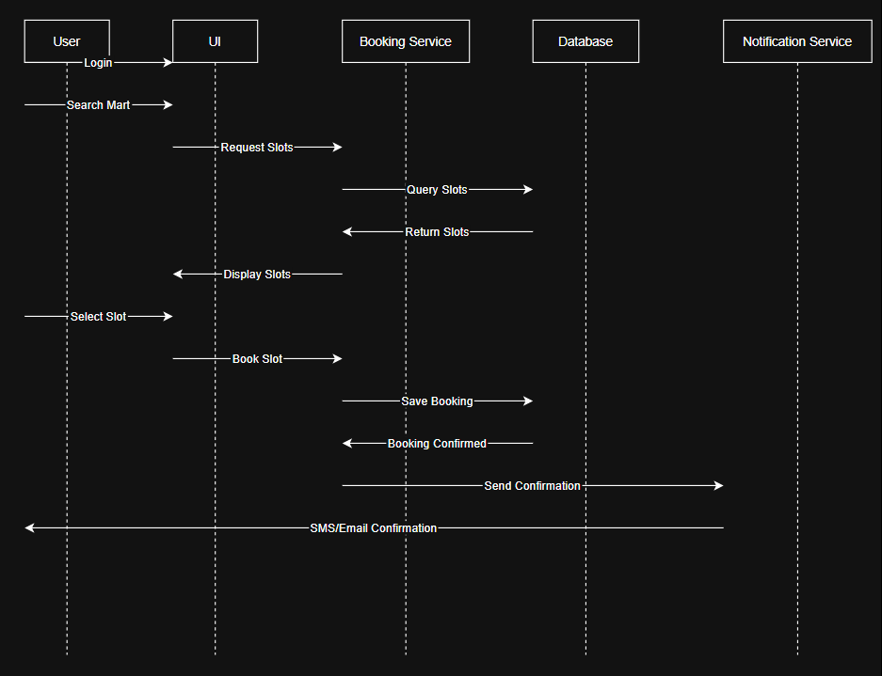

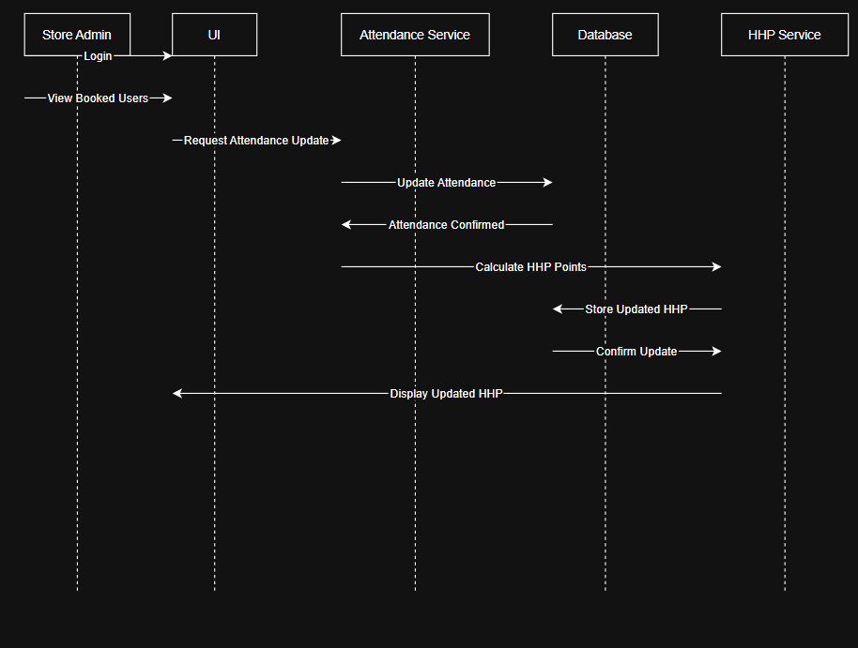

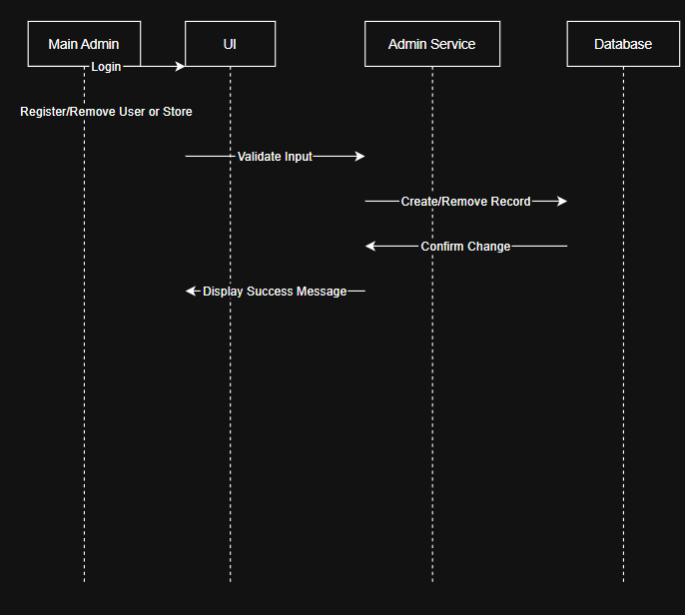

4.3 API Design

1.Booking Management API

Endpoint: /api/bookings
Method: POST
Request: { userId, martId, section, slot }
Response: { status, bookingId, message }
Errors: 401 Unauthorized, 409 Slot already booked, 400 Invalid data.

Endpoint: /api/bookings/cancel
Method: POST
Request: { userId, bookingId }
Response: { status, message, remainingCancellations }
Errors: 401 Unauthorized, 403 Cancellation limit exceeded, 404 Booking not found.

Endpoint: /api/bookings/search
Method: GET
Request: { location, section }
Response: { status, marts: [ {martId, martName, availableSlots} ] }
Errors: 404 No marts found, 400 Invalid location input.

2.Attendance & HHP Management API

Endpoint: /api/attendance/mark
Method: POST
Request: { bookingId, userId, status }
Response: { status, message }
Errors: 401 Unauthorized, 404 Booking not found, 400 Invalid attendance status.

Endpoint: /api/hhp/update
Method: POST
Request: { userId, hoursWorked }
Response: { status, newHHP, message }
Errors: 401 Unauthorized, 404 User not found, 500 Calculation error.

Endpoint: /api/hhp/view
Method: GET
Request: { userId }
Response: { status, totalHHP }
Errors: 404 User not found, 401 Unauthorized.

4.4 Error Handling, Logging & Monitoring

The system implements centralized error handling to capture and display user-friendly messages for invalid actions or failed operations. All critical events and errors are logged for audit and debugging, while real-time monitoring tools track API performance and system health.

4.5 UX Design
The UX design of the Helping Hands Software focuses on simplicity, clarity, and role-based accessibility. It provides intuitive navigation with separate dashboards for Users, Store Admins, and Main Admins. Users can easily search nearby marts, view available slots, and make bookings, while Store Admins and Main Admins have dedicated interfaces for management and monitoring. The design ensures responsive layouts, quick feedback for actions, and minimal steps for each task, enhancing the overall user experience.

4.6 Open Issues & Next Steps

Some features such as automated notification scheduling, advanced analytics for HHP tracking, and enhanced security auditing are pending implementation. Future steps include performance optimization, mobile app integration, and deployment of the system on a scalable cloud environment.

5. Appendices
5.1 Glossary: HHS, HHP, FCFS, UI, API
5.2 References: IEEE SRS Documentation Standard, Draw.io and StarUML for UML Diagram Design
5.3 Tools: React.js, HTML, CSS, JavaScript, Node.js, Express.js, MongoDB, StarUML, Draw.io, Git & GitHub

