I worked on web development projects from scratch, few among them are

Easy-Poll Application: This is a poll survey app where the questions can be framed by author along with the options(everything is flexible i.e. no restrictions on number of questions and options). Once a survey is created a link will be generated and can be shared to author's customers through email.

Few of the pages of the project are:

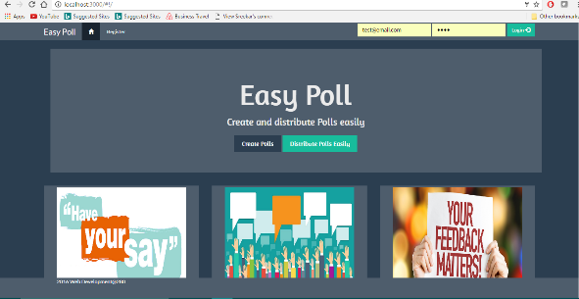

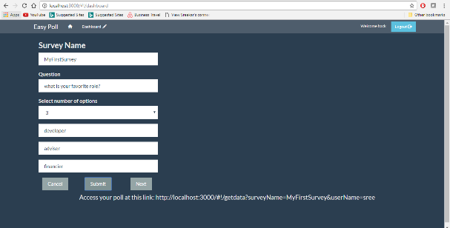

HostAProperty Application: This is similar to airbnb where tenants will be user, admin and host. Users can browse listings, book them where as hosts can add properties, can book a listings etc. We added log analytics dashboard i.e provided the features of real time user tracking, property wise revenue details to host of property.

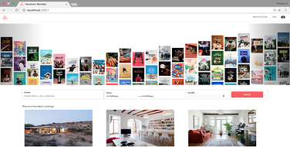

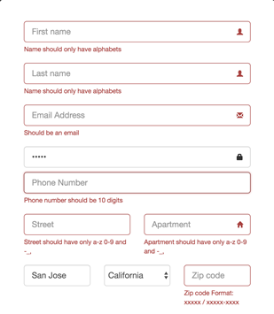

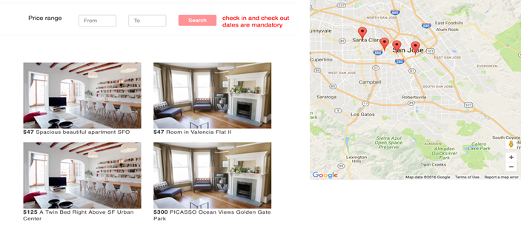

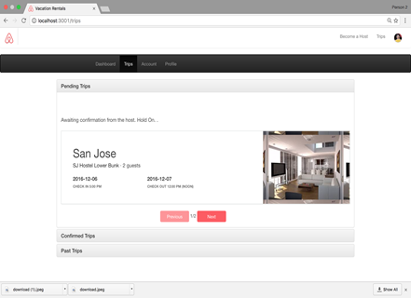

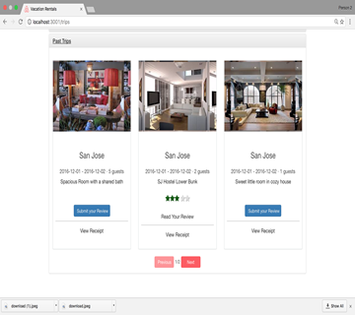

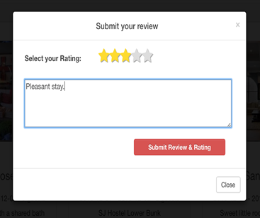

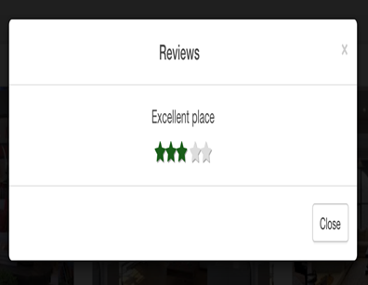

Visulaization:

I worked on visualization charts like Angular charts, Google charts and High Charts.

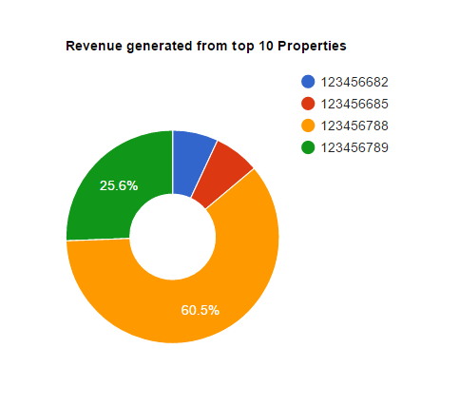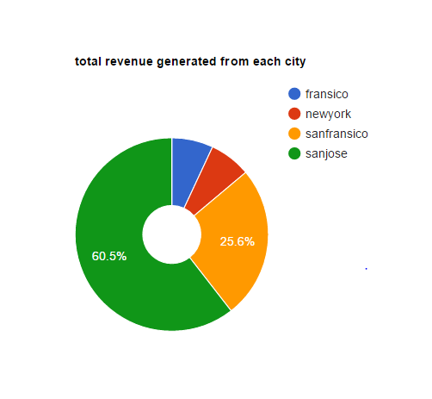

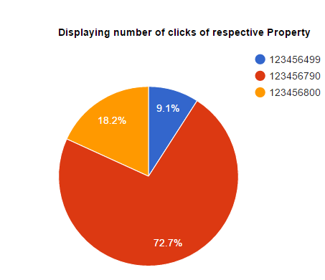 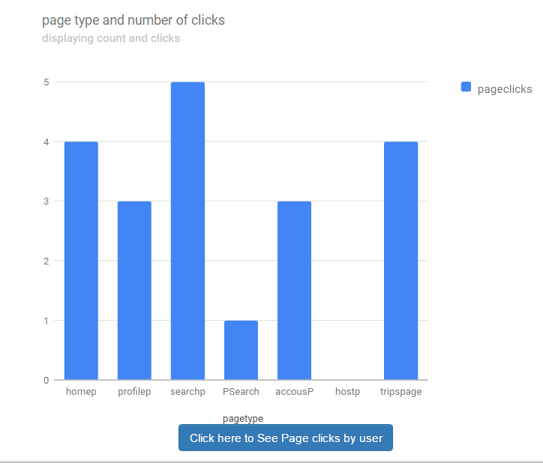

Air quality cloud:

I designed and implemented a virtual sensor cloud providing the features of multi-tenancy, scalability, load-balancing and virtualization.

