Comprehensive Evaluation of Pre-Trained Speaker Embeddings for Closed- and Open-Set Speaker Identification
Sree Kavin
Independent Research Project · Affiliation and email to be supplied for submission
Abstract—This study provides a unified evaluation of four frozen pre-trained speaker embedding models: ECAPA-TDNN, X-Vector, WavLM Base Plus SV, and UniSpeech-SAT Base Plus SV. Experiments include five-fold cross-validation, a leakage-controlled chapter-held-out sensitivity protocol, eight downstream classifiers, evaluation on LibriSpeech and a separate Kaggle-derived five-speaker corpus, short-duration and multi-noise stress tests, sample-rate and preprocessing ablations, open-set unknown-speaker rejection, PCA/t-SNE/UMAP visualization, nested hyperparameter tuning, resource profiling, and paired significance tests. Under the common five-fold linear-SVM evaluation, ECAPA-TDNN achieved 99.96% mean accuracy. Under the stricter chapter-held-out classifier benchmark, ECAPA-TDNN with cosine-centroid classification achieved 99.00%, while logistic regression was the most reliable classifier across models. ECAPA-TDNN also produced the clearest two-dimensional clusters and the strongest open-set rejection. X-Vector offered the best CPU speed/accuracy trade-off. The findings show that recognition accuracy alone is insufficient: data leakage control, classifier choice, robustness, unknown rejection, and computational cost materially affect deployment decisions.
Index Terms—speaker identification, speaker embeddings, ECAPA-TDNN, X-Vector, WavLM, UniSpeech-SAT, open-set recognition, robustness, cross-validation
I. INTRODUCTION
Speaker identification maps an utterance to an enrolled identity. Contemporary systems commonly use a frozen neural encoder to obtain a speaker embedding and a lightweight classifier to make the final decision. This modular design enables controlled comparison of representation quality, downstream classifier behavior, robustness, and efficiency.
A high score from one random train/test split is not sufficient evidence for a research claim. Audio segments from the same source chapter may share channel and recording cues, and closed-set classifiers may confidently mislabel previously unseen speakers. This work therefore combines broad five-fold evaluation with a stricter chapter-held-out sensitivity study and an explicit open-set rejection experiment.
The study answers five research questions:
- RQ1: Which pre-trained speaker embedding gives the highest recognition accuracy?
- RQ2: Which classifier is most effective for frozen speaker embeddings?
- RQ3: Which model is most robust to short speech and controlled noise?
- RQ4: Which model best balances recognition and computational efficiency?
- RQ5: Which front-end preprocessing choices materially affect accuracy?
The contribution is a single reproducible experiment suite covering all twelve requested research tasks, with persisted manifests, fold assignments, per-condition results, tables, publication figures, and machine-verifiable completion evidence.
II. MODELS AND SYSTEM ARCHITECTURE
Four publicly available checkpoints were evaluated as frozen feature extractors. No encoder weights were updated on either evaluation corpus; only the downstream classifiers were fit. Consequently, references to training in this paper mean classifier training rather than fine-tuning ECAPA-TDNN, X-Vector, WavLM, or UniSpeech-SAT.
TABLE I
PRE-TRAINED SPEAKER EMBEDDING MODELS
Model | Provider | Architecture | Dim. | Checkpoint
ECAPA-TDNN | SpeechBrain | Attentive TDNN | 192 | spkrec-ecapa-voxceleb
X-Vector | SpeechBrain | TDNN + statistics pooling | 512 | spkrec-xvect-voxceleb
WavLM | Microsoft | Transformer + X-Vector head | 512 | wavlm-base-plus-sv
UniSpeech-SAT | Microsoft | SSL + X-Vector head | 512 | unispeech-sat-base-plus-sv

The desktop application loads the selected encoder, extracts one normalized embedding, applies the matching scaler and classifier, displays a complete probability distribution, and returns ‘Unknown Speaker’ when the highest score is below the configured threshold.
III. EXPERIMENTAL METHODOLOGY
A. Corpora and Evaluation Splits
LibriSpeech dev-clean supplied 2,703 utterances from 40 speakers for the common five-fold experiment. Deterministic stratified utterance-level folds were reused by every model. This protocol provides stable broad estimates but may be optimistic because recordings from the same chapter can appear in training and test partitions.
A separate leakage-controlled sensitivity protocol retained 2,185 clips from 31 speakers and 88 chapters and assigned complete chapters to one of two outer test folds. The original Kaggle-derived five-speaker corpus was evaluated independently on each model's common valid clip intersection. Thus the study reports both a large public audiobook benchmark and an independent domain comparison.
TABLE II
EVALUATION PROTOCOLS
Protocol | Samples | Speakers | Purpose
LibriSpeech five-fold | 2,703 | 40 | Primary common model comparison
Chapter-held-out two-fold | 2,185 | 31 | Leakage-controlled sensitivity and classifiers
Kaggle-derived corpus | Model-specific common valid set | 5 | Independent-domain comparison
Balanced robustness subset | 186 | 31 | Identical clips across 16 stress conditions

B. Classifiers, Metrics, and Tuning
Eight classifiers were compared under the strict protocol: linear SVM, RBF SVM, logistic regression, k-nearest neighbors, random forest, decision tree, XGBoost, and cosine centroid. Scaling and classifier fitting used training data only. Nested SVM grid search selected C, gamma, and kernel without accessing the outer test chapters.
Accuracy = correct test predictions / all test predictions
Accuracy, macro precision, macro recall, and macro F1 were computed per fold. Training time measures downstream classifier fitting; prediction time excludes embedding extraction; cold and warm embedding latency are reported separately.
C. Robustness, Open Set, and Ablations
Clean-trained logistic-regression classifiers were evaluated on identical held-out clips at 0.5, 1, 2, 3, 5, and 10 s. Controlled additive conditions included white, traffic, office, cafe, rain, fan, and street noise at 10 dB SNR. Environmental categories are deterministic synthetic proxies, not real recordings. Sample-rate conditions were 8, 16, and 22.05 kHz.
SNR(dB) = 10 log10(Psignal / Pnoise)
Open-set thresholds were calibrated using four identities excluded from known-speaker training. Five different identities formed the final unknown test cohort. Reported measures include known correct-accept accuracy, unknown detection accuracy, false-accept rate (FAR), false-reject rate (FRR), balanced open-set accuracy, and known-versus-unknown ROC AUC.
The preprocessing ablation used the complete 2^3 factorial of silence trimming, stationary spectral denoising, and peak normalization. PCA, t-SNE, and UMAP used the same balanced 800-clip, 40-speaker subset for every embedding.
IV. RESULTS
A. Five-Fold Embedding Comparison
TABLE III
FIVE-FOLD LINEAR-SVM RESULTS
Model | Acc. (%) | SD (%) | Prec. (%) | Recall (%) | F1 (%) | Train (s) | Pred. (ms)
ECAPA-TDNN | 99.96 | 0.08 | 99.97 | 99.97 | 99.97 | 0.228 | 0.081
X-Vector | 99.82 | 0.23 | 99.84 | 99.80 | 99.81 | 0.519 | 0.160
WavLM | 98.41 | 0.97 | 98.58 | 98.38 | 98.42 | 0.454 | 0.147
UniSpeech-SAT | 98.08 | 0.49 | 98.12 | 98.07 | 98.01 | 0.474 | 0.145

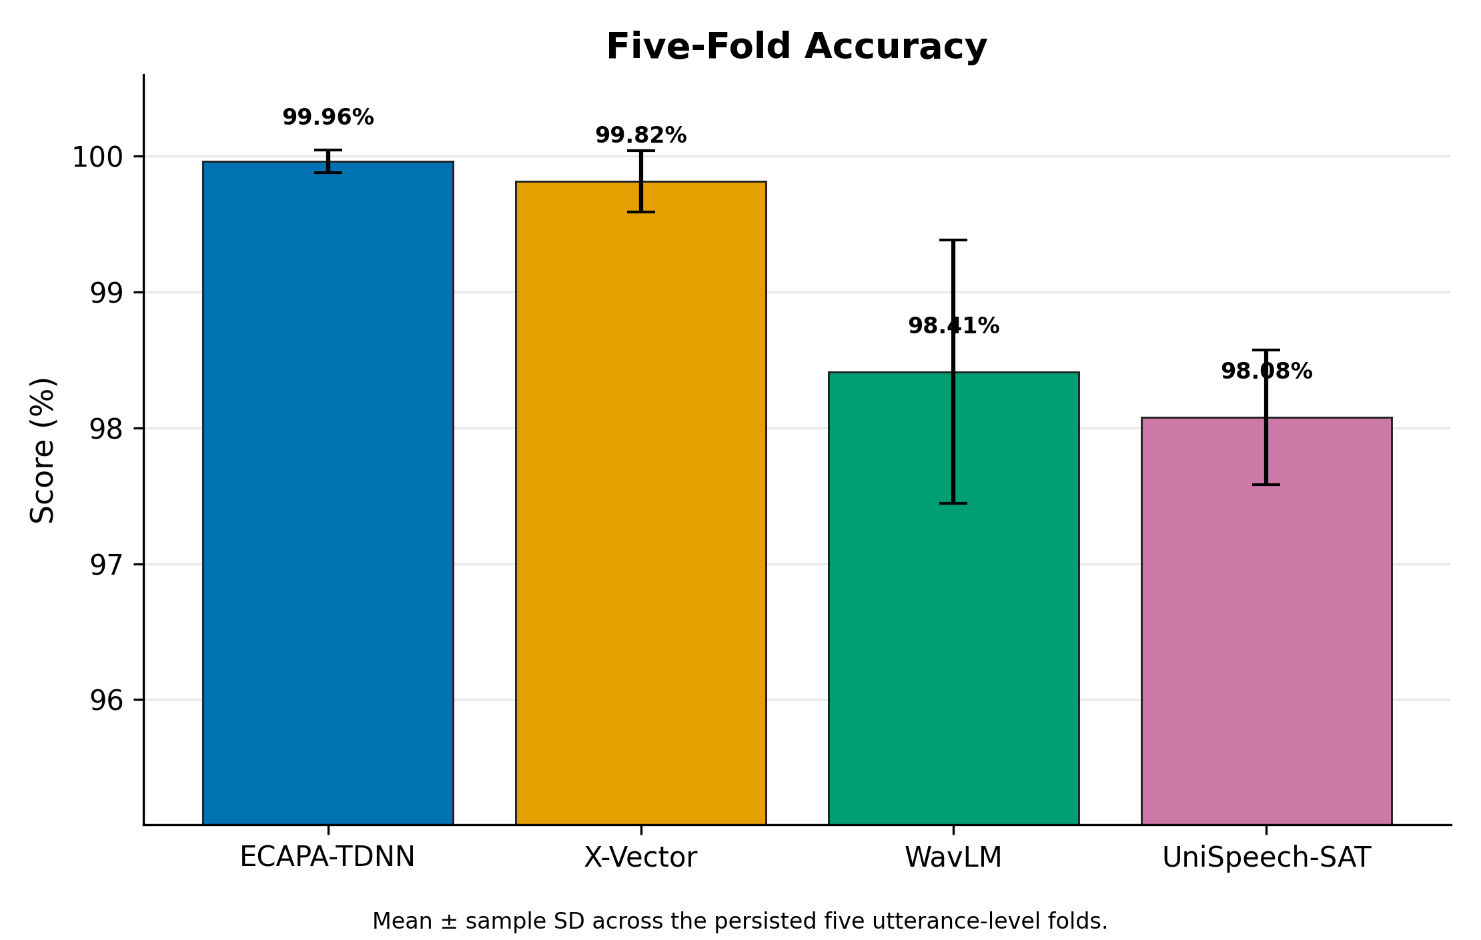
Fig. 1. Five-fold mean recognition accuracy with fold variability.
ECAPA-TDNN ranked first, followed closely by X-Vector. These near-ceiling utterance-level scores must be interpreted alongside the lower chapter-held-out results because the primary five-fold split does not isolate source chapters.
B. Classifier Comparison and Hyperparameter Tuning
TABLE IV
BEST STRICT-PROTOCOL CLASSIFIER PER EMBEDDING
Embedding | Best classifier | Accuracy (%) | Macro-F1 (%)
ECAPA-TDNN | Cosine Centroid | 99.00 | 98.98
X-Vector | Logistic Regression | 96.40 | 96.29
WavLM | Logistic Regression | 93.19 | 92.97
UniSpeech-SAT | Logistic Regression | 93.57 | 93.49

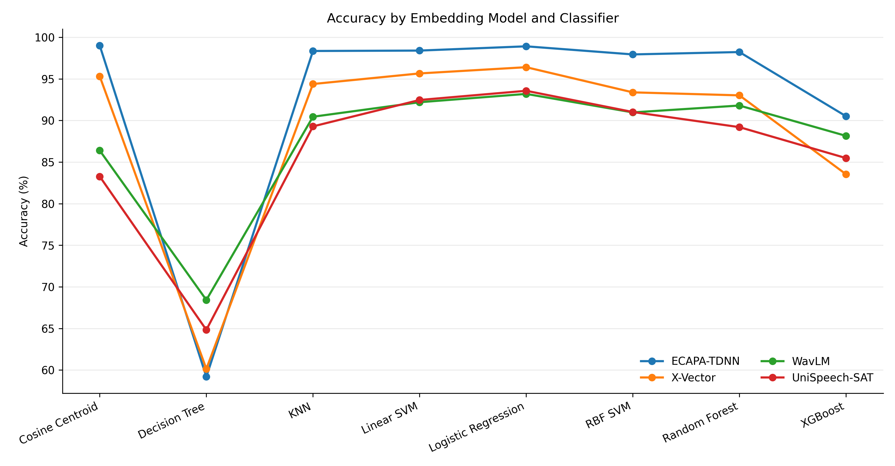
Fig. 2. Chapter-held-out accuracy for four embeddings and eight classifiers.
The highest cross-model mean belonged to Logistic Regression (95.52%). ECAPA-TDNN with cosine centroid produced the best single strict result. Nested SVM tuning did not consistently beat the fixed linear baseline; for WavLM it reduced outer-test accuracy, demonstrating that a larger search is not a guarantee of better generalization.
TABLE V
NESTED SVM TUNING
Model | Fixed linear (%) | Tuned (%) | Delta (pp)
ECAPA-TDNN | 98.40 | 98.40 | +0.00
X-Vector | 95.65 | 95.70 | +0.05
WavLM | 92.19 | 91.34 | -0.85
UniSpeech-SAT | 92.46 | 92.55 | +0.09

C. Cross-Dataset Evaluation
TABLE VI
ACCURACY ACROSS TWO DATA DOMAINS
Model | LibriSpeech (%) | Kaggle-derived (%) | Difference (pp)
ECAPA-TDNN | 99.96 | 86.42 | -13.54
X-Vector | 99.82 | 92.26 | -7.55
WavLM | 98.41 | 85.71 | -12.70
UniSpeech-SAT | 98.08 | 86.80 | -11.28

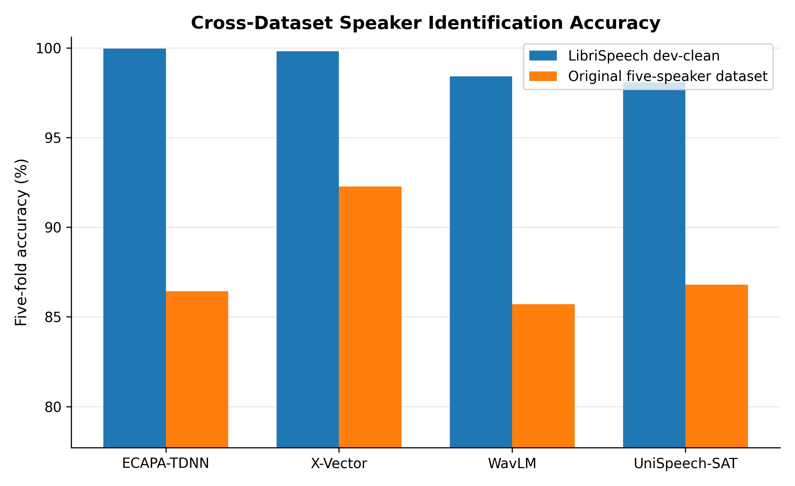
Fig. 3. Model accuracy across LibriSpeech dev-clean and the Kaggle-derived corpus.
Every model degraded on the five-speaker corpus, confirming a substantial domain effect. X-Vector achieved the best independent-corpus accuracy, whereas ECAPA-TDNN led on LibriSpeech. Therefore, no cross-domain conclusion should be based on one corpus alone.
D. Duration, Noise, and Sample-Rate Robustness
TABLE VII
SHORT-DURATION ACCURACY (%)
Length | ECAPA-TDNN | X-Vector | WavLM | UniSpeech-SAT
0.5 s | 80.65 | 44.09 | 20.97 | 13.98
1 s | 99.46 | 74.73 | 41.94 | 31.72
2 s | 98.39 | 88.71 | 75.81 | 65.05
3 s | 98.39 | 90.32 | 84.95 | 80.65
5 s | 97.85 | 80.11 | 89.78 | 86.02
10 s | 95.16 | 47.31 | 82.26 | 79.03

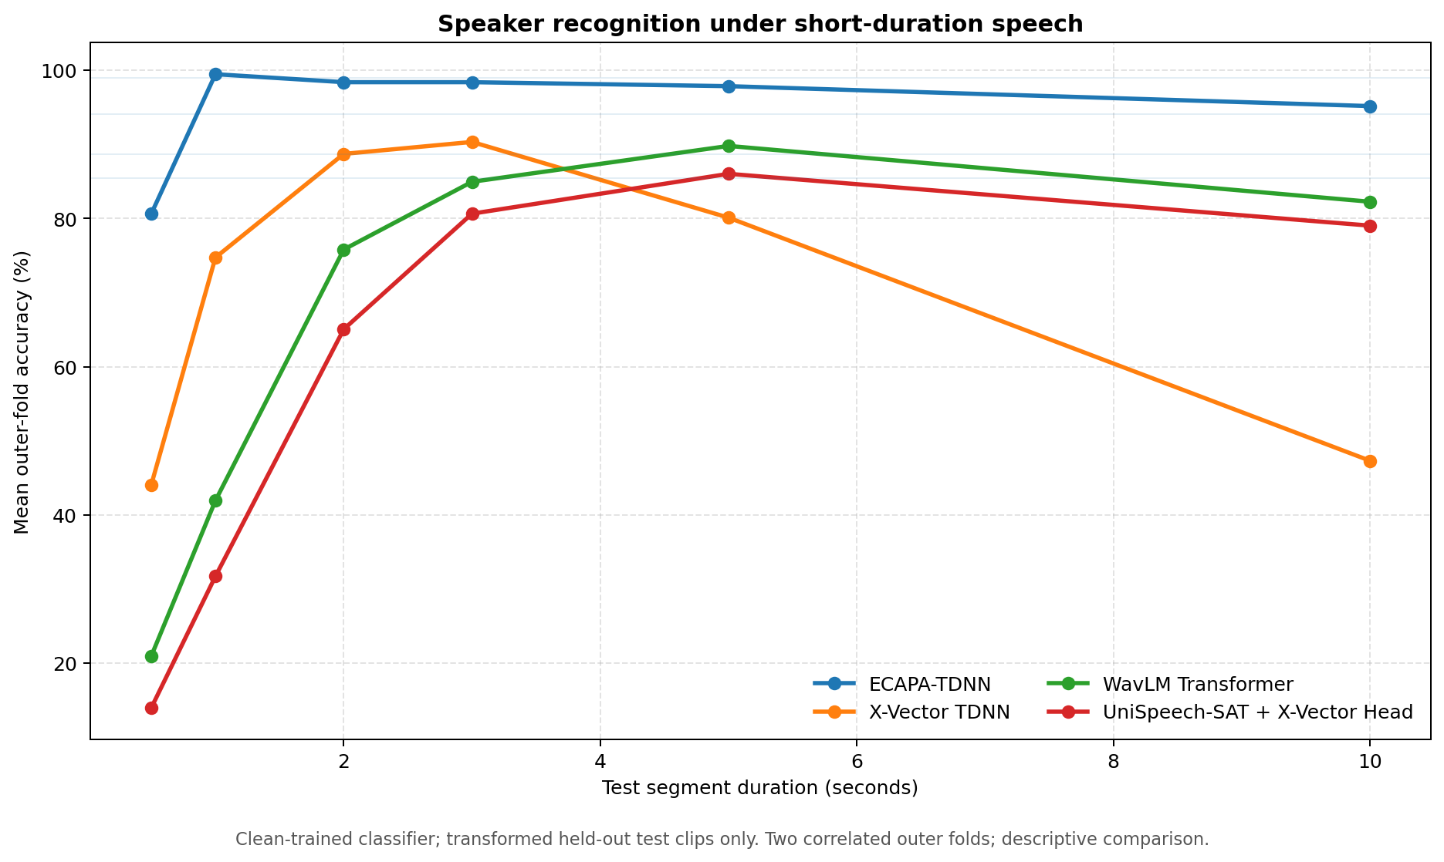
Fig. 4. Accuracy as a function of available speech duration.
TABLE VIII
CONTROLLED 10-DB NOISE ACCURACY (%)
Noise | ECAPA-TDNN | X-Vector | WavLM | UniSpeech-SAT
Original clean | 98.92 | 94.09 | 88.71 | 85.48
White | 98.39 | 30.65 | 56.45 | 52.15
Traffic | 98.39 | 87.10 | 70.43 | 69.35
Office | 97.31 | 45.16 | 63.98 | 53.76
Cafe | 97.31 | 30.65 | 62.37 | 52.15
Rain | 95.70 | 35.48 | 60.75 | 52.69
Fan | 98.92 | 75.27 | 72.04 | 65.59
Street | 98.39 | 70.43 | 67.74 | 65.05

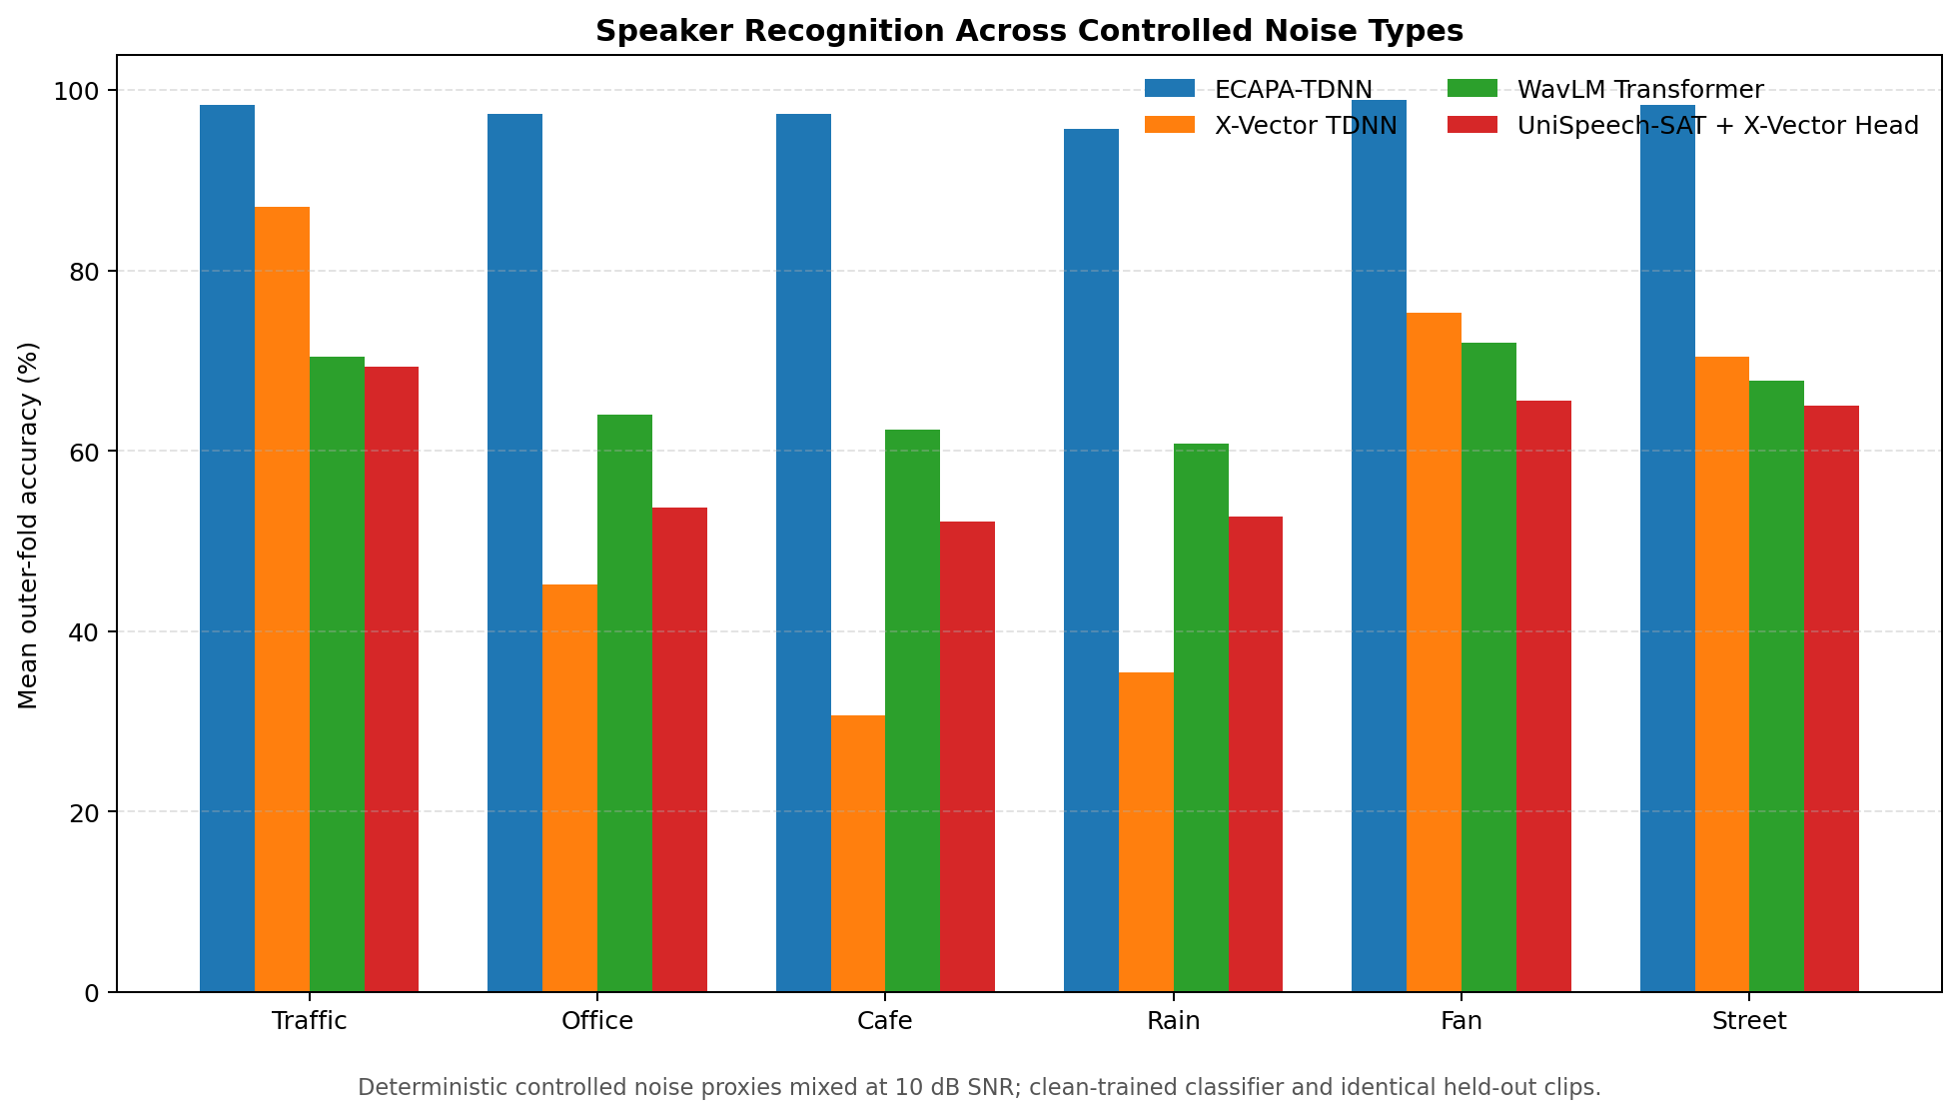
Fig. 5. Accuracy under deterministic environmental-noise proxies at 10 dB SNR.
TABLE IX
SAMPLE-RATE ABLATION ACCURACY (%)
Rate | ECAPA-TDNN | X-Vector | WavLM | UniSpeech-SAT
8 kHz | 97.31 | 57.53 | 78.49 | 73.66
16 kHz | 98.92 | 94.09 | 88.71 | 85.48
22.05 kHz | 98.92 | 94.62 | 88.17 | 85.48

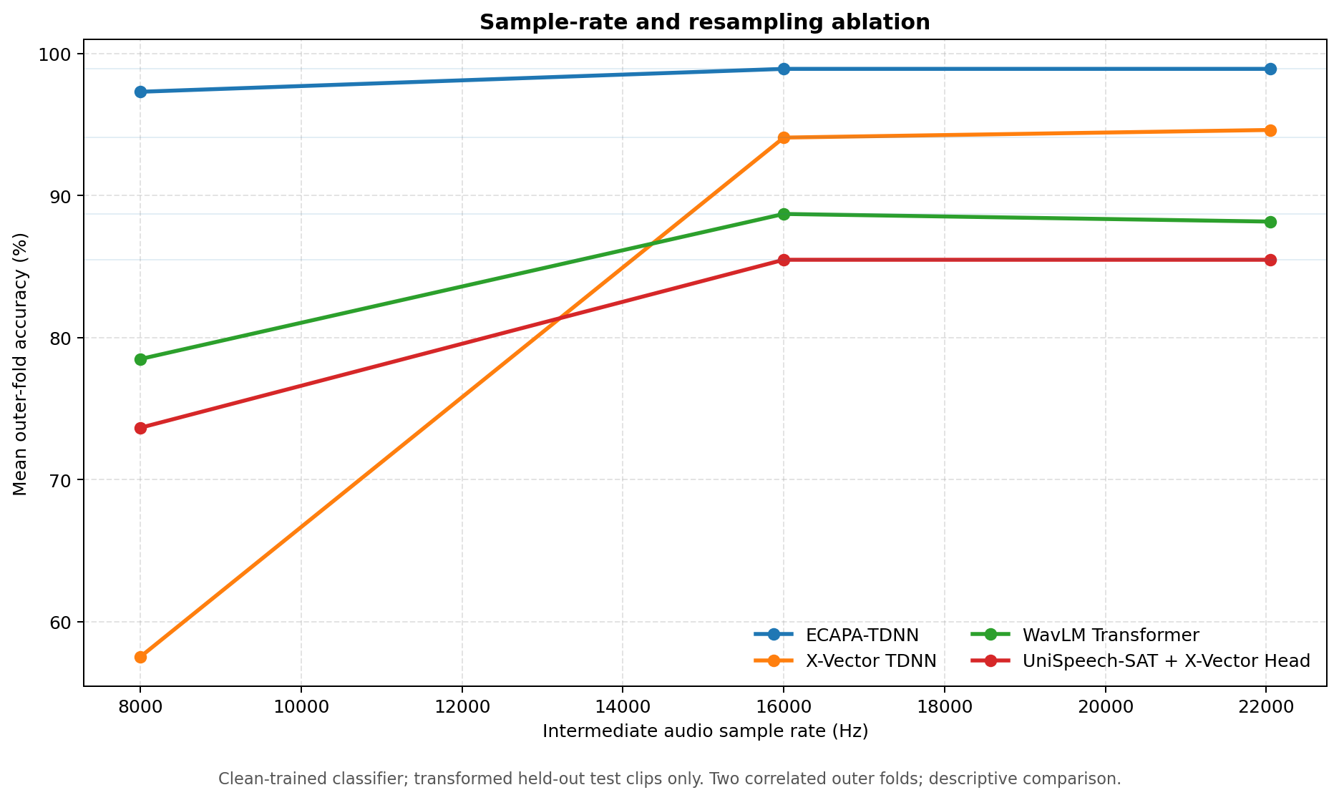
Fig. 6. Accuracy under 8, 16, and 22.05 kHz front-end conditions.
E. Open-Set Unknown-Speaker Recognition
TABLE X
OPEN-SET IDENTIFICATION RESULTS
Model | Threshold (%) | Known (%) | Unknown (%) | FAR (%) | FRR (%) | AUC
ECAPA-TDNN | 75.48 | 99.68 | 99.43 | 0.57 | 0.32 | 1.000
X-Vector | 91.53 | 98.45 | 99.72 | 0.28 | 1.55 | 0.999
WavLM | 94.52 | 93.78 | 76.09 | 23.91 | 6.08 | 0.920
UniSpeech-SAT | 91.98 | 92.77 | 75.59 | 24.41 | 7.09 | 0.907

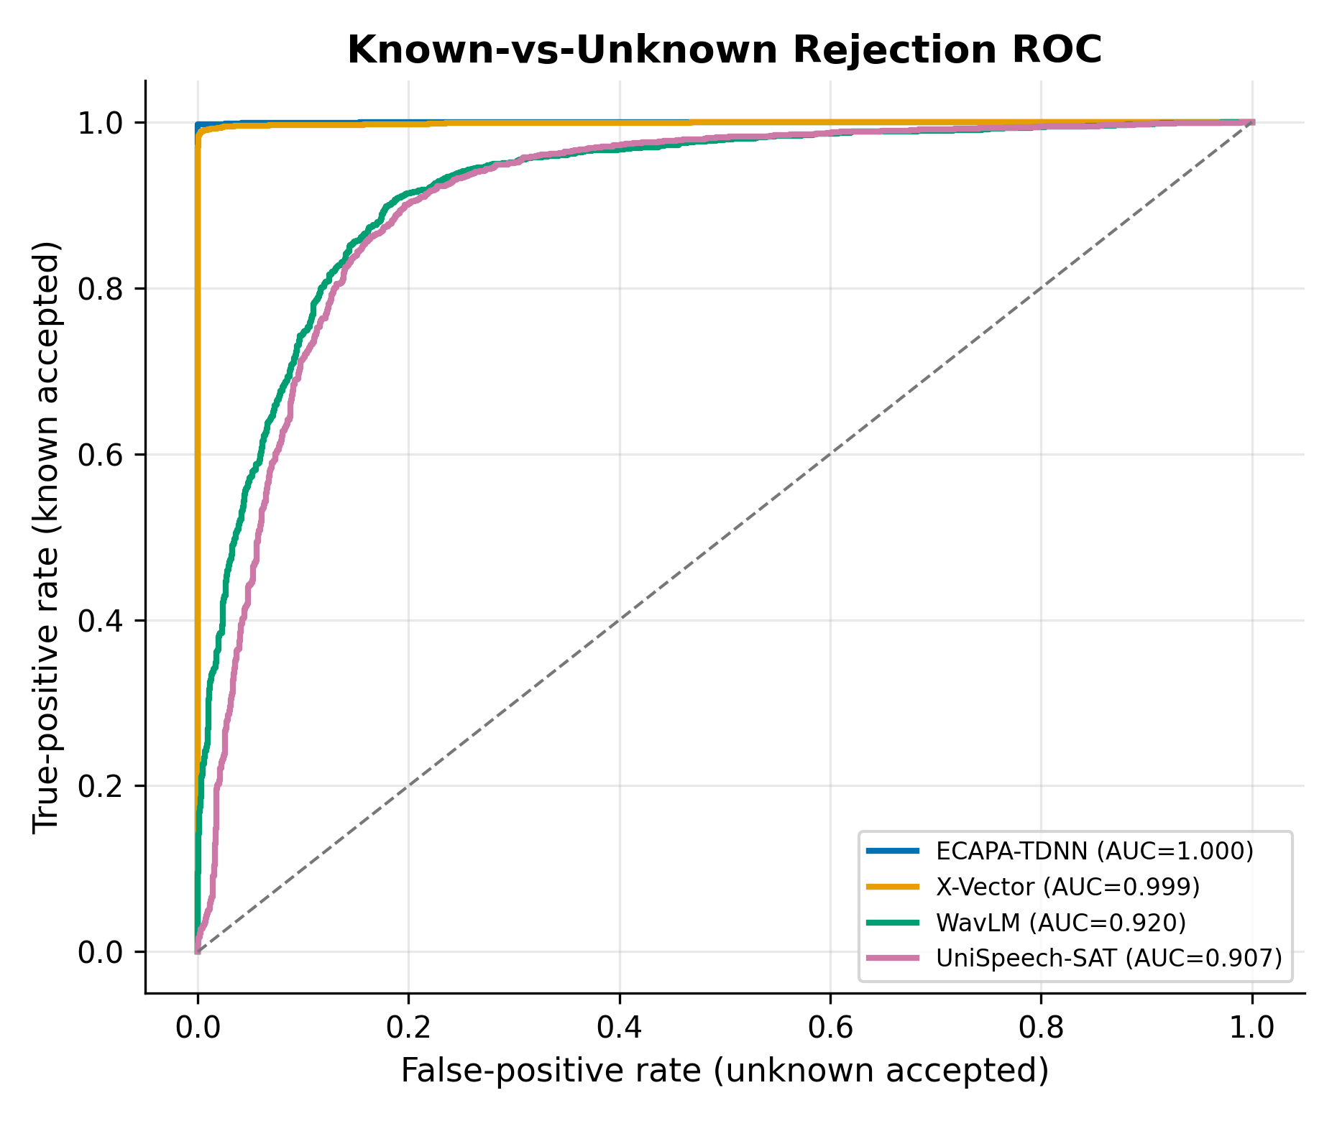
Fig. 7. Known-versus-unknown ROC curves for confidence-threshold rejection.
ECAPA-TDNN and X-Vector separated known and unknown speakers strongly. The self-supervised systems had substantially higher FAR under the same protocol, showing that closed-set class accuracy and open-set rejection quality are distinct properties.
F. Embedding Geometry
TABLE XI
TWO-DIMENSIONAL SILHOUETTE SCORES
Model | PCA | t-SNE | UMAP
ECAPA-TDNN | -0.013 | 0.840 | 0.949
X-Vector | -0.113 | 0.722 | 0.865
WavLM | -0.165 | 0.495 | 0.654
UniSpeech-SAT | -0.182 | 0.400 | 0.535

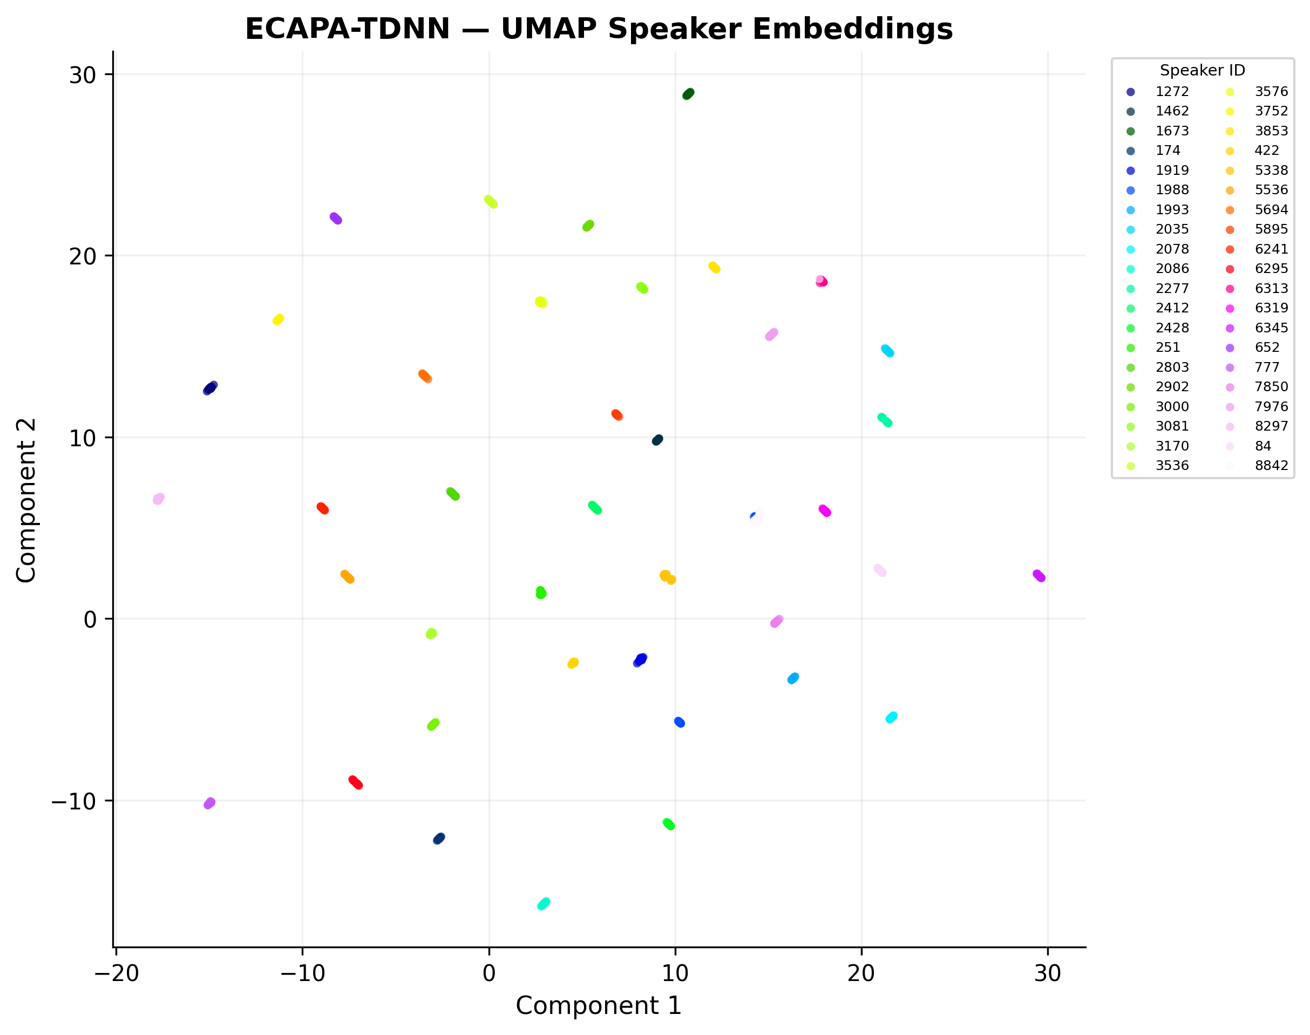
Fig. 8. UMAP projection of ECAPA-TDNN embeddings on the common 800-clip subset.
PCA compressed little of the discriminative geometry into two dimensions, producing negative silhouette values for all systems. Nonlinear t-SNE and UMAP revealed clear speaker clusters, with ECAPA-TDNN obtaining the highest scores. These plots are diagnostic visualizations, not substitutes for held-out recognition metrics.
G. Preprocessing Ablation
TABLE XII
BEST PREPROCESSING VARIANT PER MODEL
Model | Best variant | Raw (%) | Best (%) | Delta (pp)
ECAPA-TDNN | trim | 98.91 | 98.96 | +0.05
X-Vector | trim | 96.40 | 97.43 | +1.03
WavLM | denoise + normalize | 93.19 | 94.40 | +1.20
UniSpeech-SAT | raw | 93.57 | 93.57 | +0.00

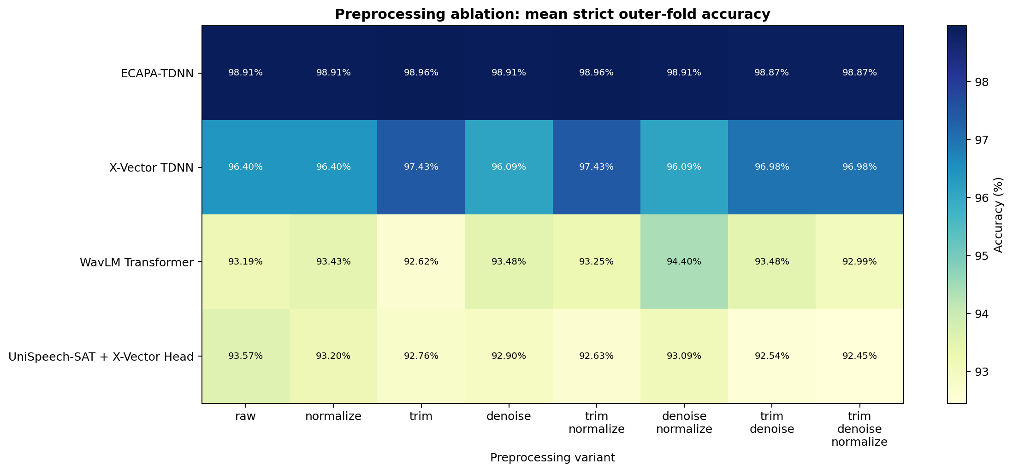
Fig. 9. Complete 2^3 trim/denoise/normalize preprocessing ablation.
No universal preprocessing recipe emerged. X-Vector benefited from trimming, WavLM from denoising plus normalization, UniSpeech-SAT from the raw pipeline, and ECAPA-TDNN changed only slightly. Front-end decisions should therefore be validated per architecture.
H. Computational Performance
TABLE XIII
COMPUTATIONAL PERFORMANCE ON THE WINDOWS CPU HOST
Model | Weights (MB) | Cold (ms) | Warm med. (ms) | Peak RAM (MB) | CPU equiv. (%) | Train (s) | Pred. (ms)
ECAPA-TDNN | 79.5 | 1887.7 | 117.5 | 489.3 | 218.5 | 0.228 | 0.081
X-Vector | 16.1 | 1361.2 | 25.7 | 316.7 | 164.3 | 0.519 | 0.160
WavLM | 385.7 | 13285.8 | 420.0 | 926.6 | 184.2 | 0.454 | 0.147
UniSpeech-SAT | 385.7 | 14264.2 | 387.2 | 940.8 | 164.7 | 0.474 | 0.145

GPU usage is reported as unavailable when the host exposes no CUDA device; zero GPU memory in this experiment therefore means CPU-only execution, not a measured GPU advantage. X-Vector provides the lowest warm latency and a strong accuracy/efficiency compromise.
I. Statistical Analysis
TABLE XIV
PAIRED FIVE-FOLD SIGNIFICANCE TESTS WITH HOLM CORRECTION
Comparison | Mean delta (pp) | t-test p | Wilcoxon p | Wilcoxon sig.
ECAPA-TDNN vs X-Vector | +0.15 | 0.484 | 1.000 | No
ECAPA-TDNN vs WavLM | +1.55 | 0.084 | 0.375 | No
ECAPA-TDNN vs UniSpeech-SAT | +1.89 | 0.006 | 0.375 | No
X-Vector vs WavLM | +1.40 | 0.077 | 0.375 | No
X-Vector vs UniSpeech-SAT | +1.74 | 0.003 | 0.375 | No
WavLM vs UniSpeech-SAT | +0.34 | 0.484 | 1.000 | No

The Wilcoxon signed-rank test is the conservative primary interpretation because only five paired folds are available. No pair remained significant after Holm correction. Some paired t-tests were significant, but distributional assumptions and low sample size make strong inferential claims inappropriate. Observed rankings are therefore reported as empirical results rather than universal model superiority.

V. DISCUSSION
RQ1: ECAPA-TDNN is the accuracy-first choice on LibriSpeech and under the strict protocol, while X-Vector leads on the independent Kaggle-derived domain. RQ2: Logistic regression is the most reliable shared classifier, although cosine centroid is exceptionally effective for ECAPA-TDNN. RQ3: ECAPA-TDNN is the strongest short-duration, controlled-noise, and open-set system in this experiment. RQ4: X-Vector offers the best CPU speed/accuracy balance. RQ5: preprocessing gains are model dependent; no single trim/denoise/normalize setting is optimal for all embeddings.
The contrast between near-perfect utterance-level five-fold scores and lower chapter-held-out scores is itself a central result. Evaluation design can change the apparent performance more than switching classifiers. Both estimates are retained transparently rather than selecting only the more favorable number.
VI. LIMITATIONS AND THREATS TO VALIDITY
The environmental noise signals are reproducible synthetic proxies and do not replace a real noise corpus containing reverberation, competing speech, varied microphones, and rooms. The Kaggle-derived corpus contains only five speakers and differs in size from LibriSpeech. The open-set experiment uses a confidence-threshold baseline; calibration unknown identities and final unknown identities are disjoint, but the final unknown cohort is reused across folds. Future verification work should include equal-error rate and detection cost on larger, fully independent enrollment, development, and test speaker cohorts.
Only five paired folds support the statistical comparison, giving low nonparametric power. Resource measurements depend on this Windows CPU host, software versions, caching, and one profiling utterance. The frozen-encoder design isolates embedding quality and deployment cost but does not measure potential gains from task-specific fine-tuning or multilingual adaptation.
VII. REPRODUCIBILITY AND COMPLETION EVIDENCE
All twelve requested research tasks were independently verified against non-empty artifacts. The completion matrix records the exact evidence path and scientific qualification for every task. Manifests, protocol identifiers, hashes, fold assignments, failure logs, embeddings, per-fold predictions, summary CSV files, and PNG/PDF figures are retained in the project.
TABLE XV
VERIFIED RESEARCH CHECKLIST
No. | Task | Status
1 | Comparative analysis of four embedding models | COMPLETE
2 | Five-fold cross-validation | COMPLETE
3 | Classifier comparison | COMPLETE
4 | Evaluation on an additional public dataset | COMPLETE
5 | Noise robustness | COMPLETE
6 | Short-duration evaluation | COMPLETE
7 | Open-set unknown-speaker recognition | COMPLETE
8 | PCA, t-SNE and UMAP embedding visualization | COMPLETE
9 | Hyperparameter tuning | COMPLETE
10 | Computational performance analysis | COMPLETE
11 | Statistical significance analysis | COMPLETE
12 | Preprocessing and sample-rate ablation | COMPLETE

VIII. CONCLUSION
This comprehensive study evaluated four frozen speaker encoders across classifiers, folds, datasets, short speech, seven controlled noise types, three sample rates, open-set rejection, embedding geometry, nested tuning, preprocessing, computation, and statistical tests. ECAPA-TDNN provides the strongest overall accuracy and robustness; X-Vector provides the best CPU-oriented balance; logistic regression is the most dependable shared classifier. The experiment also shows why leakage-controlled splits, unknown-speaker evaluation, and domain testing are essential before a speaker-identification system is considered practical.
REFERENCES
[1] D. Snyder et al., ‘X-vectors: Robust DNN embeddings for speaker recognition,’ in Proc. ICASSP, 2018, pp. 5329–5333.
[2] B. Desplanques, J. Thienpondt, and K. Demuynck, ‘ECAPA-TDNN: Emphasized channel attention, propagation and aggregation in TDNN based speaker verification,’ in Proc. Interspeech, 2020, pp. 3830–3834.
[3] M. Ravanelli et al., ‘SpeechBrain: A general-purpose speech toolkit,’ arXiv:2106.04624, 2021.
[4] S. Chen et al., ‘WavLM: Large-scale self-supervised pre-training for full stack speech processing,’ IEEE J. Sel. Topics Signal Process., vol. 16, no. 6, pp. 1505–1518, 2022.
[5] S. Chen et al., ‘UniSpeech-SAT: Universal speech representation learning with speaker aware pre-training,’ in Proc. ICASSP, 2022.
[6] V. Panayotov, G. Chen, D. Povey, and S. Khudanpur, ‘LibriSpeech: An ASR corpus based on public domain audio books,’ in Proc. ICASSP, 2015, pp. 5206–5210.
[7] C. Cortes and V. Vapnik, ‘Support-vector networks,’ Mach. Learn., vol. 20, pp. 273–297, 1995.
[8] F. Pedregosa et al., ‘Scikit-learn: Machine learning in Python,’ J. Mach. Learn. Res., vol. 12, pp. 2825–2830, 2011.
[9] L. McInnes, J. Healy, and J. Melville, ‘UMAP: Uniform manifold approximation and projection for dimension reduction,’ arXiv:1802.03426, 2018.
[10] L. van der Maaten and G. Hinton, ‘Visualizing data using t-SNE,’ J. Mach. Learn. Res., vol. 9, pp. 2579–2605, 2008.
[11] J. H. L. Hansen and T. Hasan, ‘Speaker recognition by machines and humans: A tutorial review,’ IEEE Signal Process. Mag., vol. 32, no. 6, pp. 74–99, 2015.

