Comparative Evaluation of Pre-Trained Speaker Embedding Models for Closed-Set and Open-Set Speaker Recognition
Sree Kavin
Department of [Department Name], [Institution Name], [City], India
Email: [author email]

Abstract
Speaker-identification studies can report impressive scores while still hiding practical weaknesses caused by source leakage, short utterances, background noise, unknown speakers, or excessive computational cost. This work addresses those concerns through a common evaluation of four frozen speaker encoders: ECAPA-TDNN, X-Vector, WavLM Base Plus SV, and UniSpeech-SAT Base Plus SV. The encoders were not fine-tuned; instead, their embeddings were paired with eight conventional classifiers. A chapter-held-out LibriSpeech protocol serves as the primary benchmark, while utterance-level cross-validation, an independent five-speaker corpus, duration and noise stress tests, sample-rate and preprocessing ablations, open-set rejection, visualization, resource profiling, nested tuning, and paired statistical tests provide complementary evidence. ECAPA-TDNN reached 98.40% chapter-held-out accuracy with a linear support-vector machine and 99.00% with cosine-centroid classification. Logistic regression was the strongest classifier on average across encoders. ECAPA-TDNN also retained the best accuracy under short-duration and noisy conditions and produced the most reliable unknown-speaker rejection. X-Vector offered the most attractive CPU speed-to-accuracy trade-off. The results demonstrate that a credible speaker-recognition comparison must consider split design, calibration, robustness, and efficiency alongside clean closed-set accuracy.
Index Terms: speaker identification, speaker embeddings, ECAPA-TDNN, X-Vector, self-supervised speech models, open-set recognition, robustness
I. Introduction
Speaker identification assigns a speech segment to an enrolled identity. A modern system first uses a neural encoder to convert variable-length audio into a fixed-dimensional embedding and then fits a lightweight classifier for the target speakers [1]-[5]. This modular design makes it possible to reuse a public pre-trained encoder without fine-tuning its neural weights.
A high score on a convenient closed-set split can conceal source leakage, weak unknown-speaker rejection, sensitivity to short or noisy speech, and excessive computational cost. In audiobook corpora, segments from the same chapter share speaker, channel, and recording conditions; distributing such segments across training and testing can make evaluation optimistic. A deployment-oriented study must therefore test generalization, robustness, calibration, and efficiency together.
This work compares ECAPA-TDNN, X-Vector, WavLM Base Plus SV, and UniSpeech-SAT Base Plus SV under a common frozen-embedding pipeline. It asks which encoder is most accurate, which classifier best matches each embedding, which model tolerates noise and short speech, which system balances accuracy and CPU cost, and which preprocessing choices matter. The primary result uses a chapter-held-out LibriSpeech protocol; secondary experiments cover eight classifiers, a separate five-speaker corpus, duration and noise stress, sampling rate, preprocessing, open-set rejection, visualization, resource profiling, nested tuning, and paired tests.
II. Related Work
X-Vector introduced a practical TDNN and statistics-pooling architecture for utterance-level speaker representations [1]. ECAPA-TDNN strengthened this family with Res2Net-style temporal blocks, channel attention, multi-layer aggregation, and attentive statistics pooling [2]. SpeechBrain distributes both encoders as reusable speaker-recognition checkpoints [3].
WavLM learns general speech representations from large-scale unlabeled audio with denoising objectives [4], while UniSpeech-SAT incorporates speaker-aware pre-training [5]. These Transformer models can capture rich acoustic information, but their parameter count and CPU latency make empirical profiling necessary. LibriSpeech [6] and VoxCeleb [7] supply standard data sources, yet their structures demand careful split design.
Open-set recognition requires rejection of identities absent from enrollment [12], and confidence scores should be calibrated before they are interpreted as probabilities [13]. Statistical comparisons across repeated folds additionally require control of multiple testing [14], [15]. These principles motivate the leakage-aware, threshold-calibrated, and paired protocols used here.
III. System and Experimental Design
A. Frozen embedding models
The four public checkpoints in Table I were used only for inference. Encoder weights were never updated on either evaluation corpus; training therefore means fitting the scaler and downstream classifier. Each extracted vector was checked for finite values and L2-normalized before classification.

TABLE I
PRE-TRAINED SPEAKER EMBEDDING MODELS
Model | Provider | Architecture | Dim. | Checkpoint
ECAPA-TDNN | SpeechBrain | Attentive TDNN | 192 | spkrec-ecapa-voxceleb
X-Vector | SpeechBrain | TDNN + statistics pooling | 512 | spkrec-xvect-voxceleb
WavLM | Microsoft | Transformer + X-Vector head | 512 | wavlm-base-plus-sv
UniSpeech-SAT | Microsoft | Speaker-aware SSL + X-Vector head | 512 | unispeech-sat-base-plus-sv

B. Data, splits, and classifiers
LibriSpeech dev-clean provided 2,703 utterances from 40 speakers for deterministic five-fold utterance-level analysis. Because chapters could cross folds, this analysis was treated as optimistic. The primary benchmark assigned complete chapters to two outer folds: 2,185 clips from 31 speakers and 88 chapters. A Kaggle-derived five-speaker corpus provided descriptive cross-domain evidence. The same balanced subset of 186 clips was reused for every robustness condition.

TABLE II
EVALUATION PROTOCOLS
Protocol | Samples | Speakers | Purpose
Chapter-held-out two-fold | 2,185 | 31 | Primary leakage-controlled comparison
LibriSpeech five-fold | 2,703 | 40 | Secondary utterance-level sensitivity
Kaggle-derived corpus | Model-specific common set | 5 | Independent-domain description
Balanced stress subset | 186 | 31 | Matched duration, noise, and rate tests

The strict protocol compared linear and RBF SVMs, logistic regression, k-nearest neighbors, random forest, decision tree, XGBoost, and cosine-centroid classification. Scaling, fitting, and nested SVM selection were confined to training partitions. Accuracy, macro precision, recall, macro F1, training time, and prediction latency were measured. Conventional estimators used scikit-learn [8].
Accuracy = N_correct / N_test (1)
C. Robustness, preprocessing, and open set
Clean-trained logistic-regression classifiers were evaluated from 0.5 to 10 s. Seven deterministic noise proxies were mixed at 10 dB SNR, and front-end ablations covered 8, 16, and 22.05 kHz plus all combinations of silence trimming, stationary denoising, and peak normalization. The proxy noises are reproducible stressors rather than substitutes for recordings made in real rooms.
SNR_dB = 10 log10(P_signal / P_noise) (2)
For open-set testing, four identities were excluded from known-speaker training and used only for threshold calibration; five different identities formed the final unknown cohort. A sample was accepted only when its calibrated best-known confidence exceeded the encoder-specific threshold. Known accuracy, unknown detection, false-accept rate (FAR), false-reject rate (FRR), and ROC AUC were reported. PCA, t-SNE, and UMAP [9], [10] were used only as two-dimensional diagnostics.
IV. Results
A. Leakage-controlled accuracy and classifiers

TABLE III
CHAPTER-HELD-OUT LINEAR-SVM PERFORMANCE
Model | Acc. (%) | SD (%) | Prec. (%) | Recall (%) | F1 (%) | Train (s) | Pred. (ms)
ECAPA-TDNN | 98.40 | 0.15 | 98.60 | 98.77 | 98.52 | 0.077 | 0.037
X-Vector | 95.65 | 2.85 | 96.30 | 96.09 | 95.49 | 0.162 | 0.078
WavLM | 92.19 | 1.79 | 93.12 | 93.17 | 92.05 | 0.145 | 0.079
UniSpeech-SAT | 92.46 | 2.17 | 93.49 | 93.52 | 92.30 | 0.140 | 0.067

ECAPA-TDNN led the primary linear-SVM protocol at 98.40%, followed by X-Vector at 95.65%. The utterance-level five-fold scores were 99.96%, 99.82%, 98.41%, and 98.08%, respectively, but were not used for the main ranking because chapter overlap made that split less demanding. Split construction therefore changed the apparent difficulty more than many downstream classifier choices.

TABLE IV
BEST STRICT-PROTOCOL CLASSIFIER FOR EACH EMBEDDING
Embedding | Best classifier | Accuracy (%) | Macro F1 (%)
ECAPA-TDNN | Cosine centroid | 99.00 | 98.98
X-Vector | Logistic regression | 96.40 | 96.29
WavLM | Logistic regression | 93.19 | 92.97
UniSpeech-SAT | Logistic regression | 93.57 | 93.49

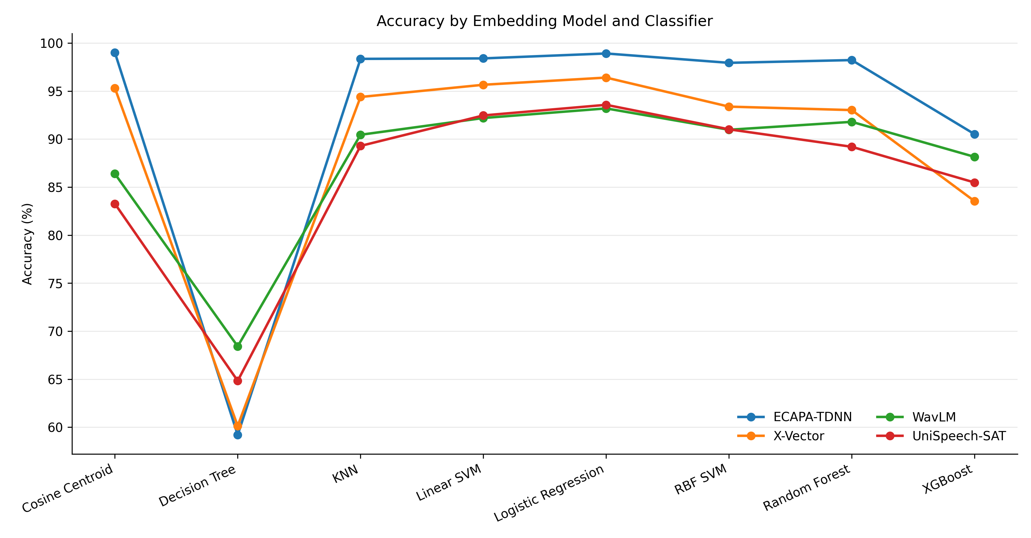
Fig. 1. Chapter-held-out accuracy across four embeddings and eight classifiers.

Logistic regression had the highest cross-encoder mean accuracy (95.52%) and was best for three representations. ECAPA-TDNN was the exception: cosine centroid reached 99.00%, consistent with compact angular speaker clusters. Nested SVM tuning changed results by only 0.00, +0.05, -0.85, and +0.09 percentage points for ECAPA-TDNN, X-Vector, WavLM, and UniSpeech-SAT, respectively.
B. Domain, duration, noise, and sampling rate
On the independent five-speaker corpus, X-Vector ranked first at 92.26%, followed by UniSpeech-SAT at 86.80%, ECAPA-TDNN at 86.42%, and WavLM at 85.71%. Since the corpora differ in speaker count, source, duration, and channel conditions, this is descriptive evidence rather than a controlled domain-shift estimate; nevertheless, it shows that model rankings can change with the recording domain.

TABLE V
DESCRIPTIVE ACCURACY ACROSS TWO DATA DOMAINS
Model | LibriSpeech raw (%) | Five-speaker raw (%) | Libri chance-normalized | Five-speaker chance-normalized
ECAPA-TDNN | 99.96 | 86.42 | 99.96 | 83.02
X-Vector | 99.82 | 92.26 | 99.81 | 90.33
WavLM | 98.41 | 85.71 | 98.37 | 82.14
UniSpeech-SAT | 98.08 | 86.80 | 98.03 | 83.50

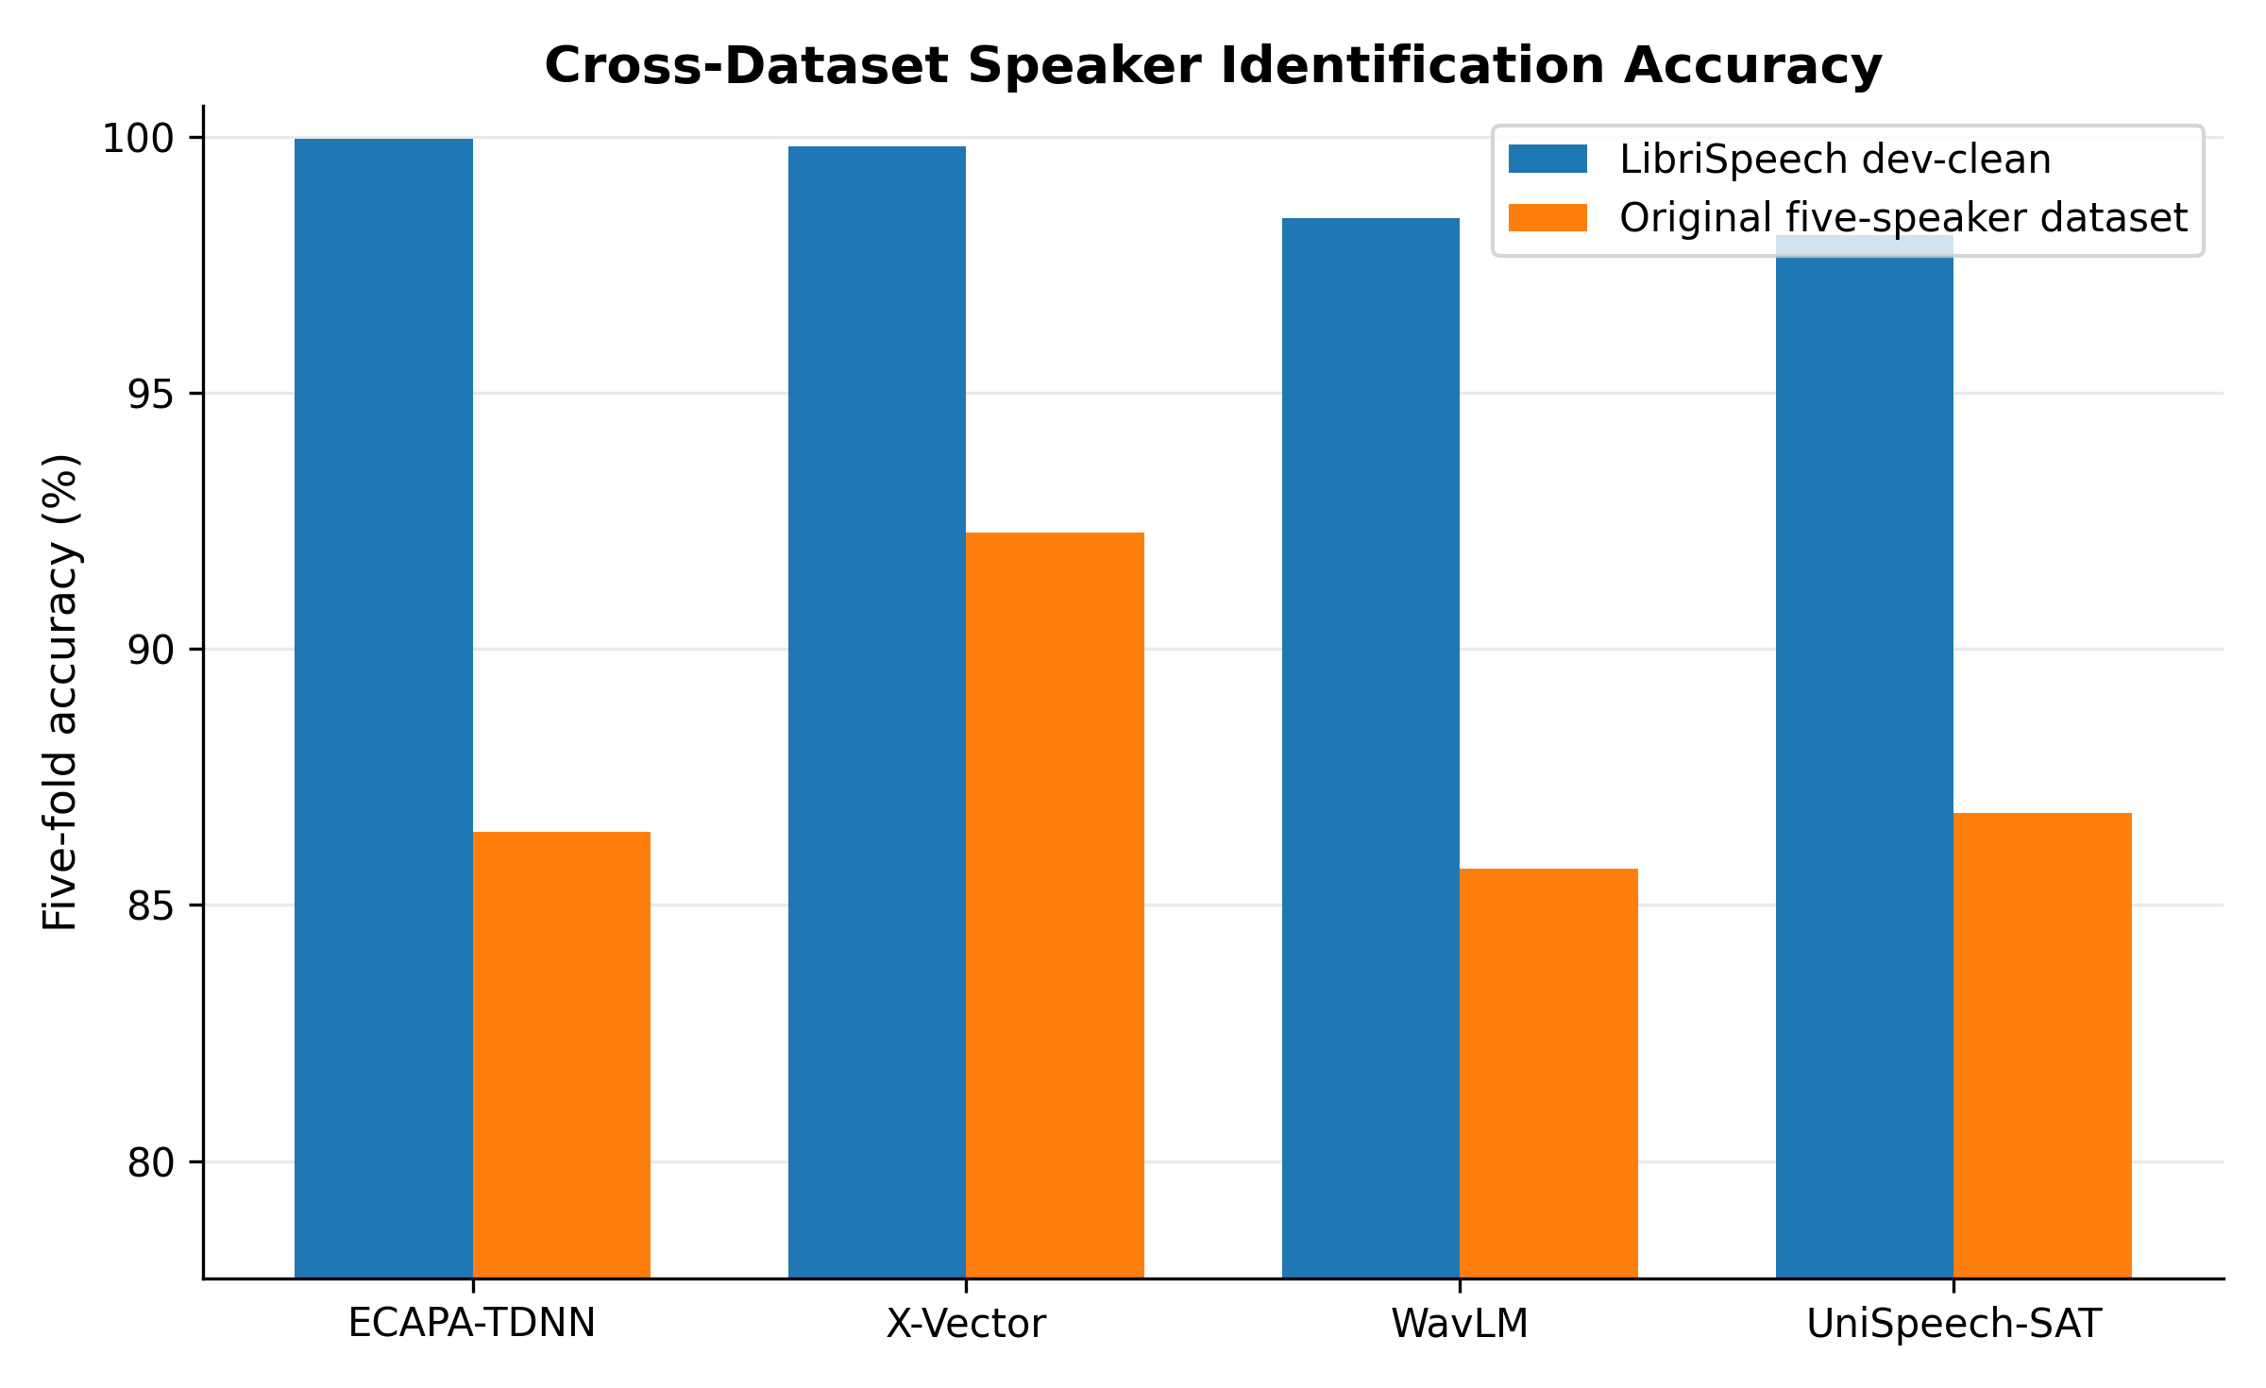
Fig. 2. Raw accuracy on corpora with different speaker counts and recording conditions.

TABLE VI
SHORT-DURATION ACCURACY (%)
Duration | ECAPA-TDNN | X-Vector | WavLM | UniSpeech-SAT
0.5 s | 80.65 | 44.09 | 20.97 | 13.98
1 s | 99.46 | 74.73 | 41.94 | 31.72
2 s | 98.39 | 88.71 | 75.81 | 65.05
3 s | 98.39 | 90.32 | 84.95 | 80.65
5 s | 97.85 | 80.11 | 89.78 | 86.02
10 s | 95.16 | 47.31 | 82.26 | 79.03

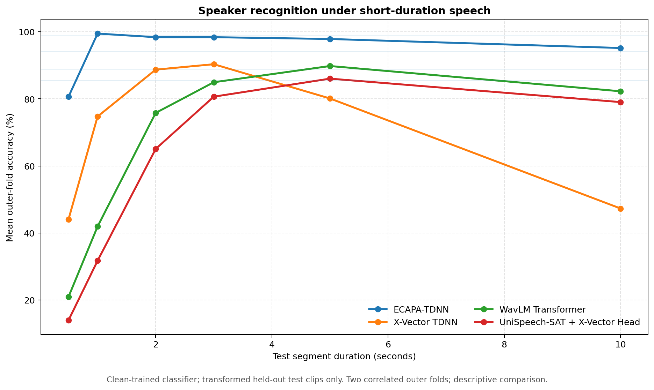
Fig. 3. Recognition accuracy as the available speech duration changes.

TABLE VII
MATCHED ROBUSTNESS SUMMARY: ACCURACY (%)
Model | Clean | 0.5 s | White noise, 10 dB | 8 kHz
ECAPA-TDNN | 98.92 | 80.65 | 98.39 | 97.31
X-Vector | 94.09 | 44.09 | 30.65 | 57.53
WavLM | 88.71 | 20.97 | 56.45 | 78.49
UniSpeech-SAT | 85.48 | 13.98 | 52.15 | 73.66

ECAPA-TDNN was the only system that remained strong in every displayed stress condition. At 0.5 s it retained 80.65%, compared with 44.09% or less for the other encoders. Its white-noise accuracy fell by only 0.53 percentage points from clean, and 8 kHz caused little loss. X-Vector was efficient on clean speech but particularly sensitive to short clips and several noises. Resampling above the native 16 kHz rate produced no meaningful gain.

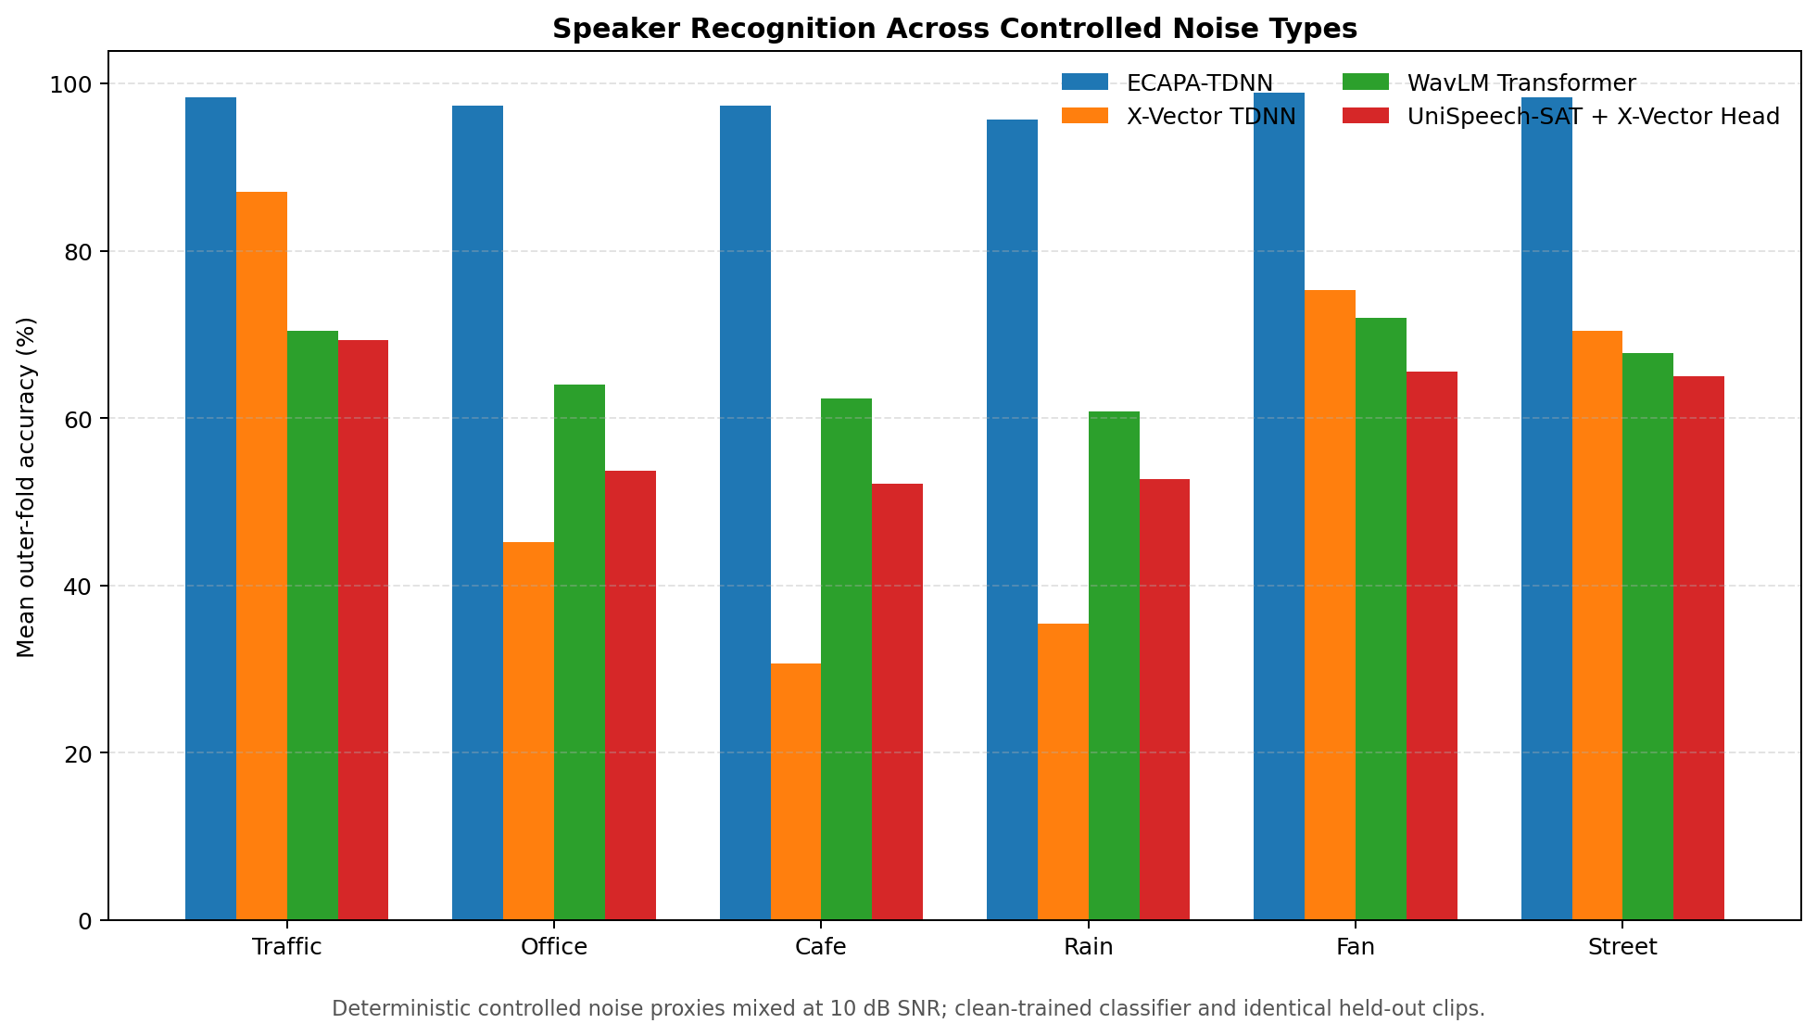
Fig. 4. Recognition accuracy under deterministic environmental-noise proxies at 10 dB SNR.

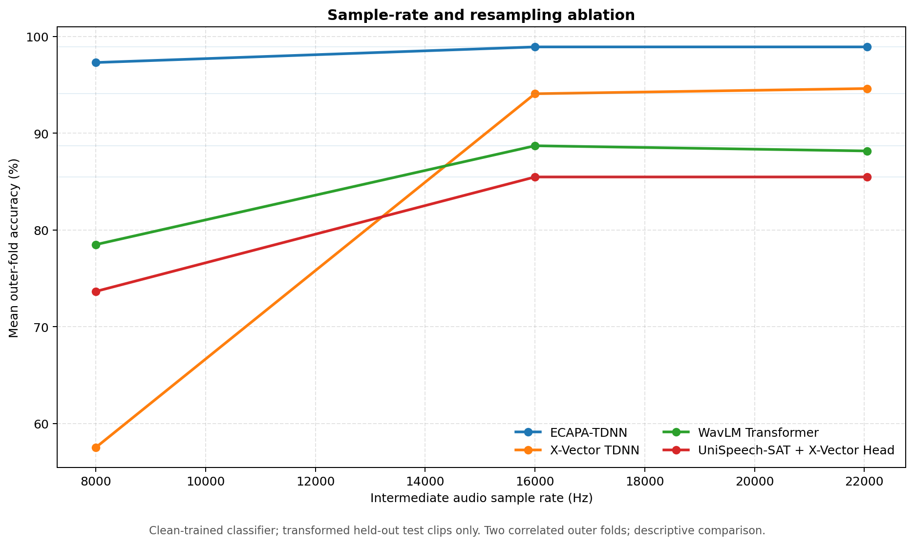
Fig. 5. Accuracy under 8, 16, and 22.05 kHz front-end conditions.

C. Open-set recognition

TABLE VIII
OPEN-SET IDENTIFICATION RESULTS
Model | Threshold (%) | Known (%) | Unknown (%) | FAR (%) | FRR (%) | AUC
ECAPA-TDNN | 75.48 | 99.68 | 99.43 | 0.57 | 0.32 | 1.000
X-Vector | 91.53 | 98.45 | 99.72 | 0.28 | 1.55 | 0.999
WavLM | 94.52 | 93.78 | 76.09 | 23.91 | 6.08 | 0.920
UniSpeech-SAT | 91.98 | 92.77 | 75.59 | 24.41 | 7.09 | 0.907

ECAPA-TDNN and X-Vector separated known from unknown voices with AUC values near one. WavLM and UniSpeech-SAT produced FAR values close to 24% despite reasonable closed-set accuracy. Open-set safety is therefore not implied by closed-set ranking, and every encoder requires a threshold calibrated on representative but identity-disjoint development speakers.

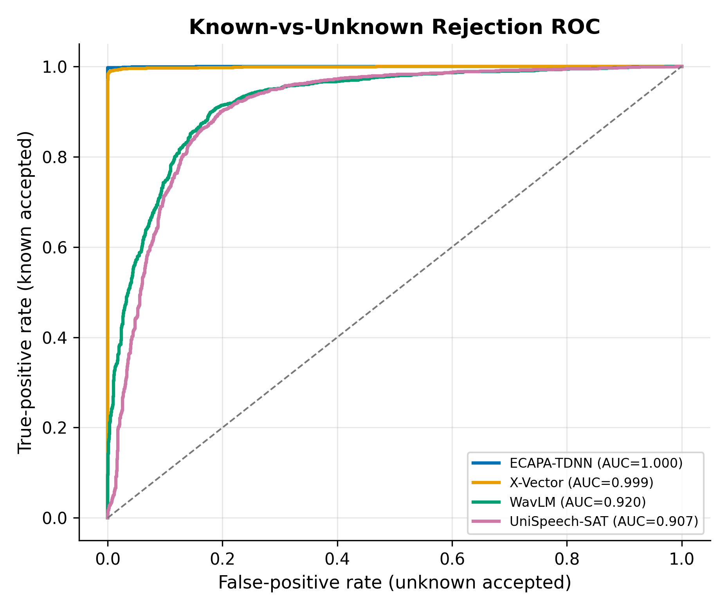
Fig. 6. Known-versus-unknown ROC curves for calibrated confidence-threshold rejection.

D. Preprocessing, embedding geometry, and efficiency

TABLE IX
PREPROCESSING AND CPU DEPLOYMENT SUMMARY
Model | Best preprocessing | Gain (pp) | Weights (MB) | Warm (ms) | Peak RAM (MB)
ECAPA-TDNN | Trim | +0.05 | 79.5 | 117.5 | 489.3
X-Vector | Trim | +1.03 | 16.1 | 25.7 | 316.7
WavLM | Denoise + normalize | +1.20 | 385.7 | 420.0 | 926.6
UniSpeech-SAT | Raw | +0.00 | 385.7 | 387.2 | 940.8

No front-end recipe was uniformly best. Trimming helped X-Vector, denoising plus normalization helped WavLM, UniSpeech-SAT preferred raw audio, and ECAPA-TDNN changed little. After two-dimensional projection, ECAPA-TDNN also had the clearest nonlinear separation (t-SNE 0.840; UMAP 0.949), but such plots remain diagnostic rather than substitutes for held-out accuracy. X-Vector required the fewest weights and had a 25.7 ms warm median extraction time, giving it the best CPU speed-to-accuracy balance. The two Transformer encoders required about 386 MB of weights and more than 380 ms per warm CPU call.

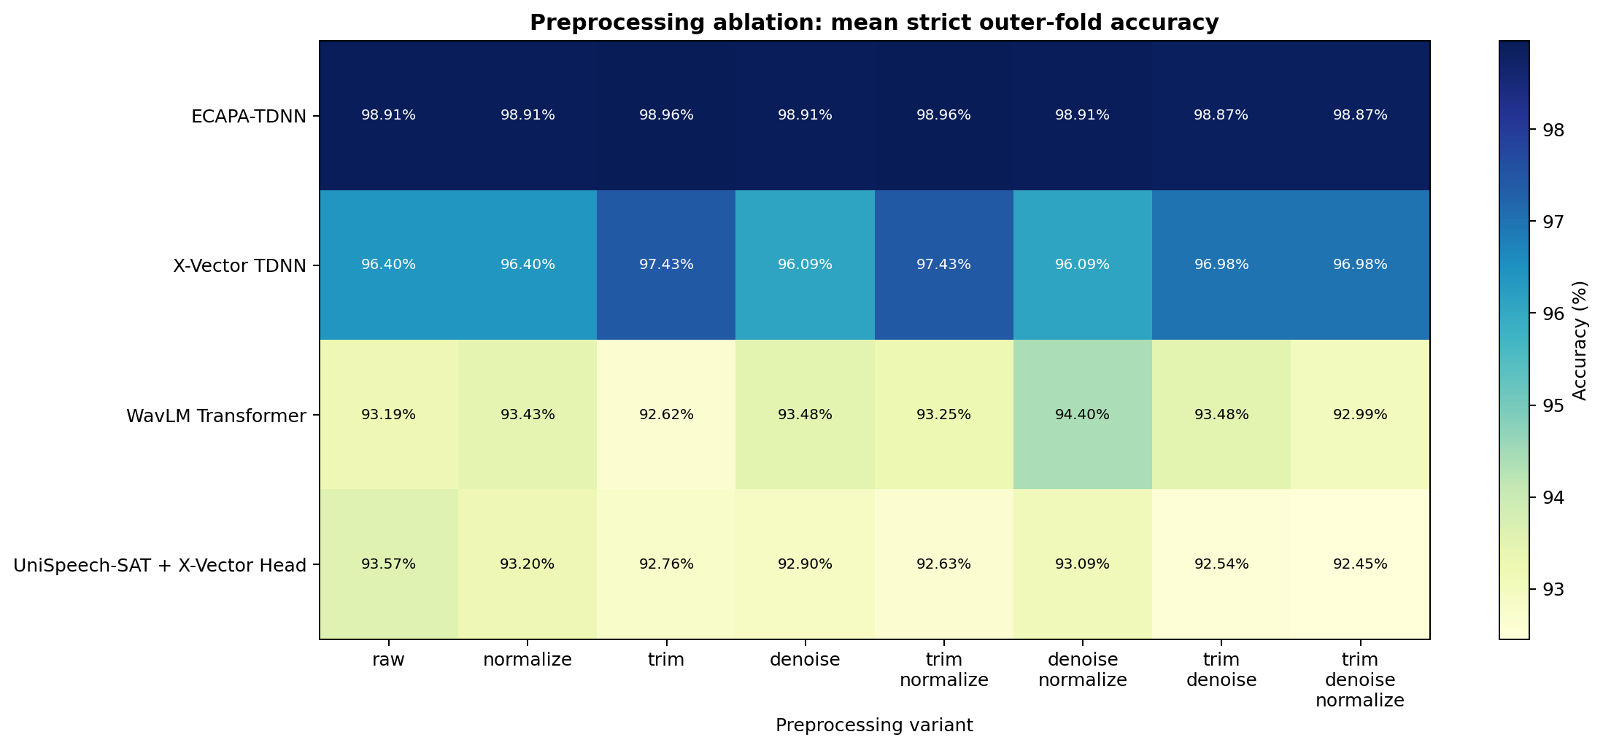
Fig. 7. Accuracy for all trimming, denoising, and normalization combinations.

E. Statistical interpretation
Paired five-fold differences were tested with both paired t-tests and Wilcoxon signed-rank tests [14]. Holm correction controlled the family-wise error across six model pairs [15]. No Wilcoxon comparison remained significant after correction (adjusted p >= 0.375). With only five paired folds, the nonparametric test has low power; the observed ordering should therefore be treated as evidence for these data and protocols, not proof of universal model superiority.
V. Discussion
The research questions have conditional rather than universal answers. ECAPA-TDNN is the strongest accuracy-first choice because it led the leakage-controlled benchmark, tolerated short and noisy speech, and supported reliable unknown rejection. Logistic regression is the safest classifier across encoders, while cosine centroid is preferable for ECAPA-TDNN in this setting. X-Vector is the best option when CPU responsiveness, memory, and competitive recognition matter more than maximum strict accuracy. Preprocessing must be selected per encoder; a universal front end is not justified by the ablation.
The gap between utterance-level and chapter-held-out testing is itself a central result. Near-ceiling scores from correlated segments can obscure weaknesses that become visible under source-disjoint splits. Likewise, the weaker open-set performance of the self-supervised encoders shows why a single clean closed-set number is insufficient for deployment decisions.
VI. Limitations and Threats to Validity
The deterministic noise signals do not reproduce reverberation, competing speech, microphone variation, or every real acoustic environment. The five-speaker corpus is too small to support large-enrollment claims. Public pre-training identities could not be exhaustively audited against every evaluation identity, and the unknown cohorts remain modest. Only five paired folds were available for significance testing. Resource measurements depend on one Windows CPU host, software versions, caching, and the profiling waveform. Freezing the encoders isolates representation quality but does not estimate the gains from fine-tuning, multilingual adaptation, or domain-specific augmentation.
VII. Reproducibility and Future Work
All experiments used fixed manifests, deterministic seeds, model-specific embedding directories, and saved scalers, classifiers, label encoders, and open-set thresholds. Failed or invalid waveform records were logged rather than silently included, and robustness comparisons reused identical clips and transform parameters. These controls separate errors in audio coverage from differences in the neural representations and make each table traceable to a reproducible artifact.
Future work should repeat the study with larger speaker-disjoint corpora, multilingual speech, genuine room noise, reverberation, competing speakers, and microphone mismatch. Open-set evaluation should add equal-error rate, detection-error trade-off curves, and application-specific detection cost. GPU and edge-device profiling, score-level model fusion, uncertainty estimation, and controlled encoder fine-tuning would show whether the present ranking persists beyond frozen CPU inference.
VIII. Conclusion
Four frozen speaker encoders were compared under leakage-controlled identification, eight classifiers, domain variation, duration and noise stress, sampling-rate and preprocessing changes, open-set rejection, visual diagnostics, CPU profiling, nested tuning, and paired statistics. ECAPA-TDNN offered the strongest overall recognition and robustness, X-Vector supplied the best CPU efficiency compromise, and logistic regression was the most reliable shared classifier. Credible speaker-recognition claims should therefore combine source-disjoint evaluation, unknown-speaker testing, robustness analysis, and deployment cost rather than relying on clean closed-set accuracy alone.

References
[1] D. Snyder, D. Garcia-Romero, G. Sell, D. Povey, and S. Khudanpur, "X-vectors: Robust DNN embeddings for speaker recognition," in Proc. IEEE ICASSP, 2018, pp. 5329-5333, doi: 10.1109/ICASSP.2018.8461375.
[2] B. Desplanques, J. Thienpondt, and K. Demuynck, "ECAPA-TDNN: Emphasized channel attention, propagation and aggregation in TDNN based speaker verification," in Proc. Interspeech, 2020, pp. 3830-3834, doi: 10.21437/Interspeech.2020-2650.
[3] M. Ravanelli et al., "SpeechBrain: A general-purpose speech toolkit," arXiv:2106.04624, 2021.
[4] S. Chen et al., "WavLM: Large-scale self-supervised pre-training for full stack speech processing," IEEE J. Sel. Topics Signal Process., vol. 16, no. 6, pp. 1505-1518, 2022, doi: 10.1109/JSTSP.2022.3188113.
[5] S. Chen et al., "UniSpeech-SAT: Universal speech representation learning with speaker-aware pre-training," in Proc. IEEE ICASSP, 2022, pp. 6152-6156.
[6] V. Panayotov, G. Chen, D. Povey, and S. Khudanpur, "LibriSpeech: An ASR corpus based on public domain audio books," in Proc. IEEE ICASSP, 2015, pp. 5206-5210, doi: 10.1109/ICASSP.2015.7178964.
[7] A. Nagrani, J. S. Chung, and A. Zisserman, "VoxCeleb: A large-scale speaker identification dataset," in Proc. Interspeech, 2017, pp. 2616-2620, doi: 10.21437/Interspeech.2017-950.
[8] F. Pedregosa et al., "Scikit-learn: Machine learning in Python," J. Mach. Learn. Res., vol. 12, pp. 2825-2830, 2011.
[9] L. McInnes, J. Healy, and J. Melville, "UMAP: Uniform manifold approximation and projection for dimension reduction," arXiv:1802.03426, 2018.
[10] L. van der Maaten and G. Hinton, "Visualizing data using t-SNE," J. Mach. Learn. Res., vol. 9, pp. 2579-2605, 2008.
[11] J. H. L. Hansen and T. Hasan, "Speaker recognition by machines and humans: A tutorial review," IEEE Signal Process. Mag., vol. 32, no. 6, pp. 74-99, 2015, doi: 10.1109/MSP.2015.2462851.
[12] W. J. Scheirer, A. de Rezende Rocha, A. Sapkota, and T. E. Boult, "Toward open set recognition," IEEE Trans. Pattern Anal. Mach. Intell., vol. 35, no. 7, pp. 1757-1772, 2013, doi: 10.1109/TPAMI.2012.256.
[13] C. Guo, G. Pleiss, Y. Sun, and K. Q. Weinberger, "On calibration of modern neural networks," in Proc. 34th Int. Conf. Mach. Learn., 2017, pp. 1321-1330.
[14] J. Demsar, "Statistical comparisons of classifiers over multiple data sets," J. Mach. Learn. Res., vol. 7, pp. 1-30, 2006.
[15] S. Holm, "A simple sequentially rejective multiple test procedure," Scand. J. Stat., vol. 6, no. 2, pp. 65-70, 1979.
[16] C. Cortes and V. Vapnik, "Support-vector networks," Mach. Learn., vol. 20, pp. 273-297, 1995, doi: 10.1007/BF00994018.
[17] A. Bendale and T. E. Boult, "Towards open set deep networks," in Proc. IEEE Conf. Comput. Vis. Pattern Recognit., 2016, pp. 1563-1572.

