something like a navigation bar that shows which page/screen you are on

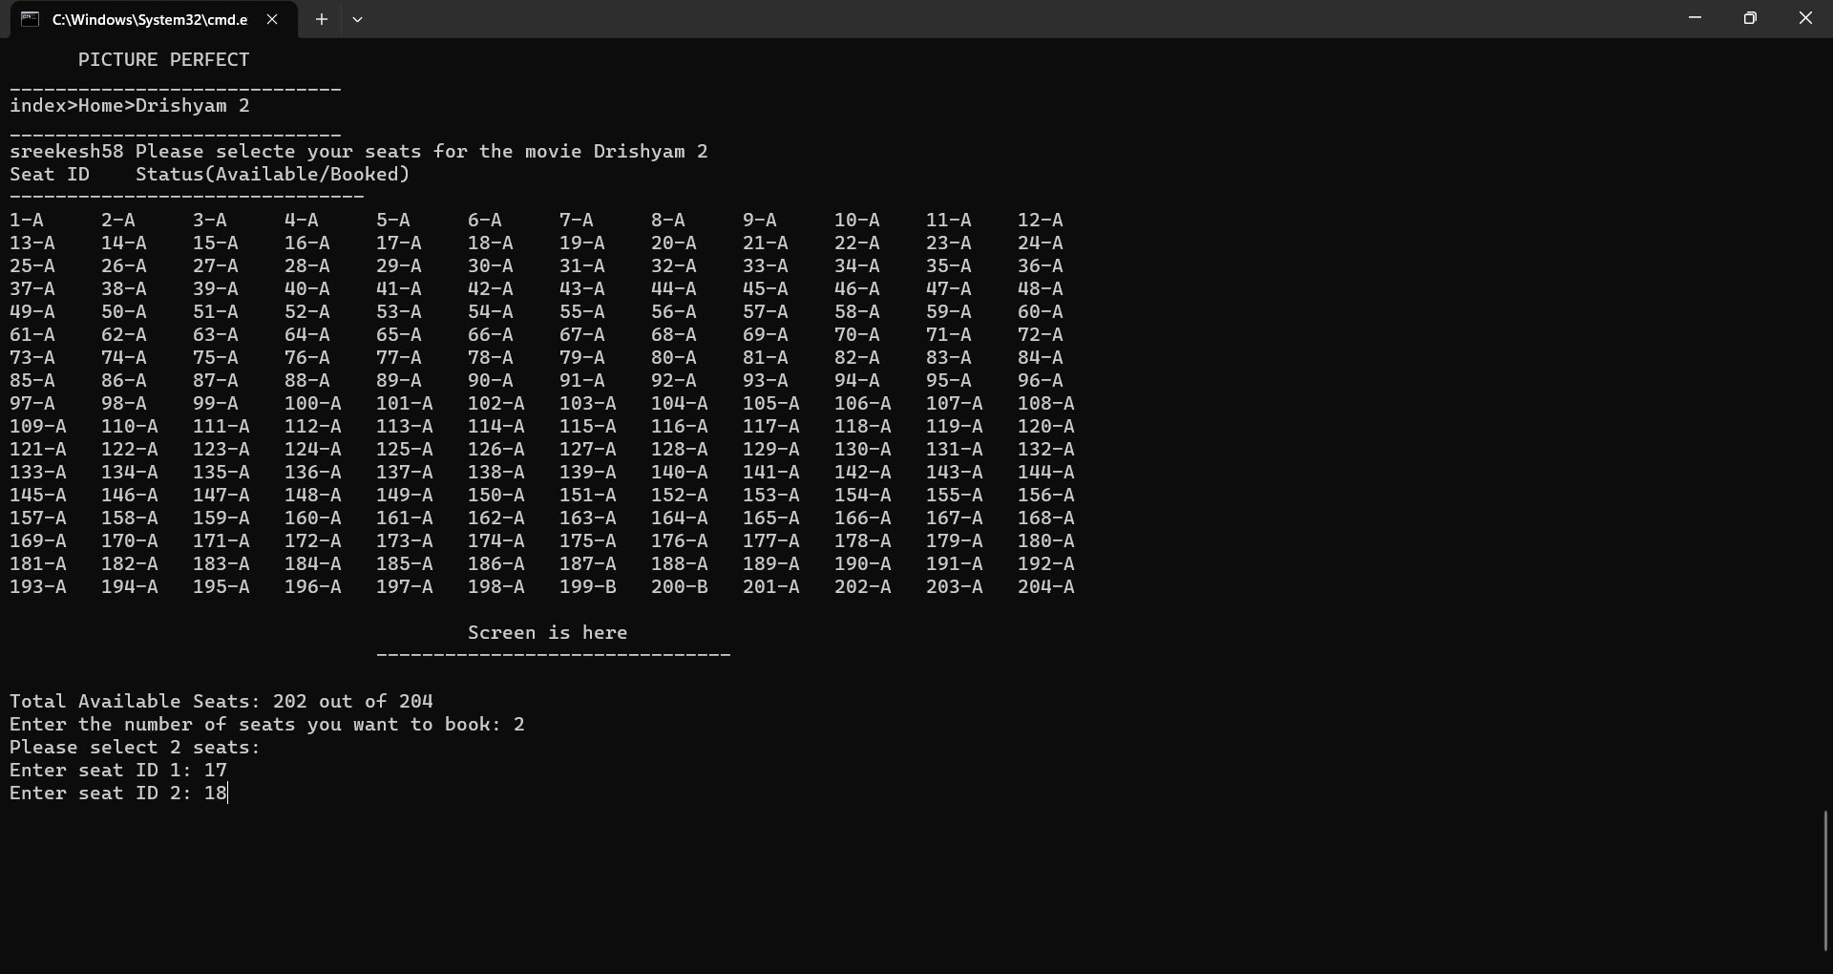

Users can select how many seats they want and selects their seats

Shows how the seats are arranged In the theater and where the screen. Also shows if the seat is available(A) or booked(B).

Users can choose their seats easily.

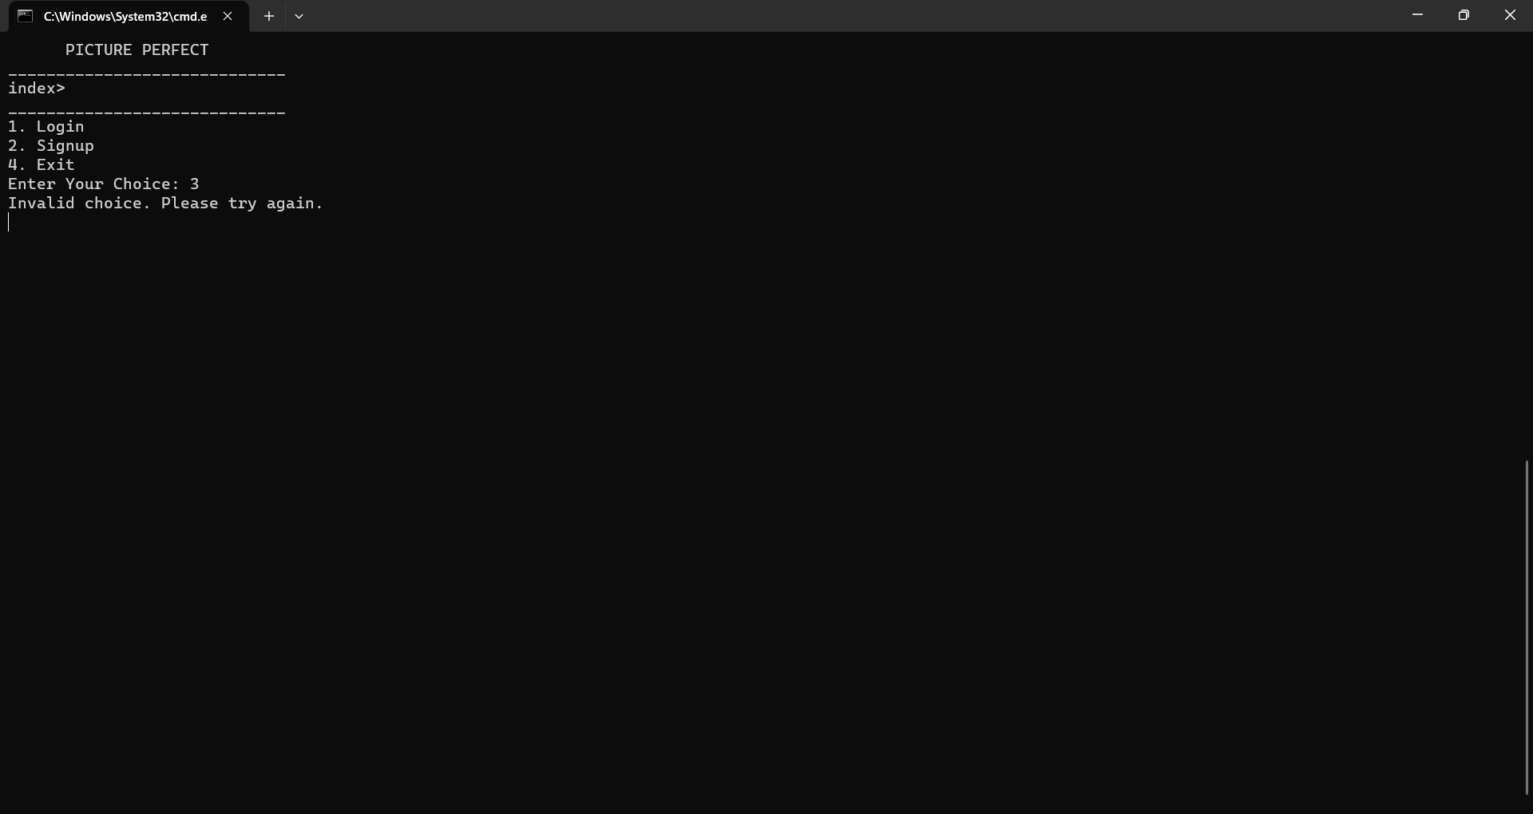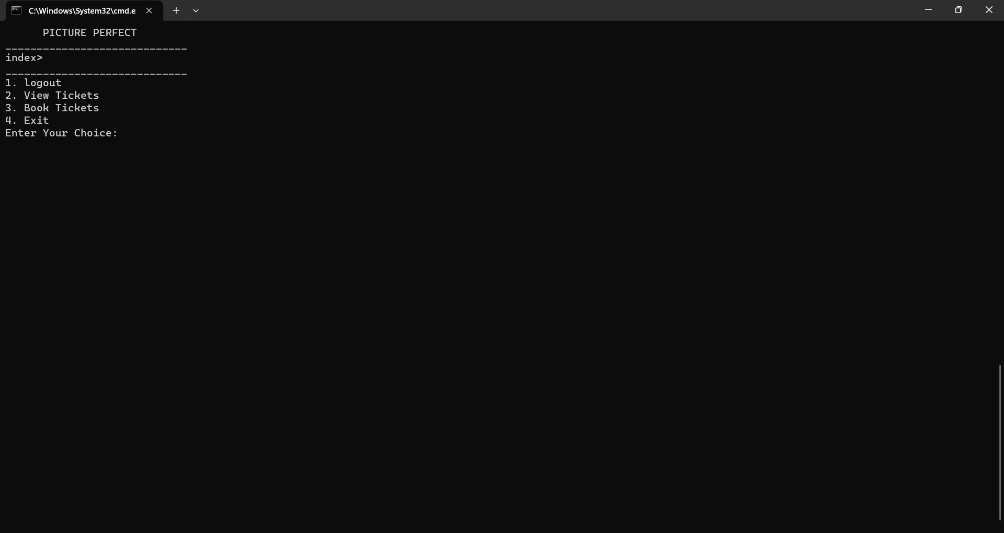

Same menu but before and after login.

Options change based on login

This Program also tries to handle most of the errors from user input and provide a continuity in the program until the user chooses to exit.

View their tickets after logging in.

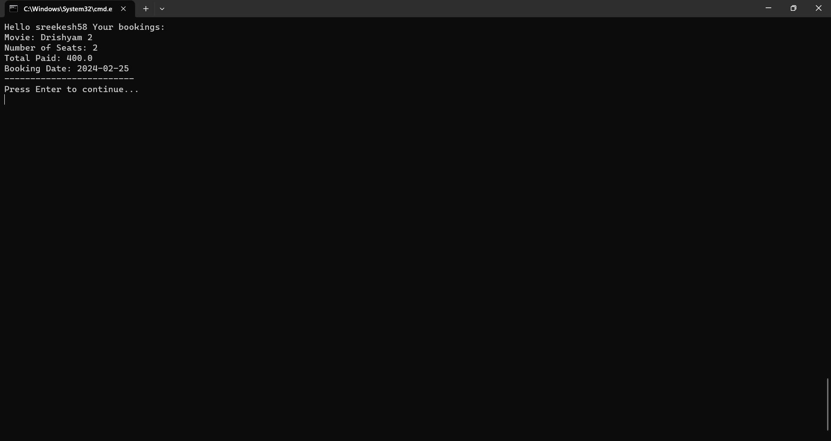

Program:

Tried to implement something like sessions in php

import java.util.List;

public class Session {

    private static boolean isLoggedIn = false;

    private static String username = null;

    private static int selectedMovieId = -1

private static List<Integer> selectedSeatIds = null;

    public static boolean isLoggedIn() {

        return isLoggedIn;

    }

    public static void setLoggedIn(boolean loggedIn) {

        isLoggedIn = loggedIn;

    }

    public static String getUserName() {

        return username;

    }

    public static void setUserName(String username) {

        Session.username = username;

    }

    public static int getSelectedMovieId() {

        return selectedMovieId;

    }

    public static void setSelectedMovieId(int selectedMovieId) {

        Session.selectedMovieId = selectedMovieId;

    }

    public static void setSelectedIds(List<Integer> selectedSeatIds) {

        Session.selectedSeatIds = selectedSeatIds;

    }

    public static List<Integer> getSelectedIds() {

        return selectedSeatIds;

    }

    public static void clearSession() {

        isLoggedIn = false;

        username = null;

        selectedMovieId = -1;

        selectedSeatIds = null;

    }

}

USED IN (ONE EXAMPLE):

        if (isAuthenticated) {

            System.out.println("Login successful!");

            Session.setLoggedIn(true);

            Session.setUserName(username);// Store usernmae in session

            System.out.println("Welcome Back " + username);

DIFFERENT CLASSES ARE MADE FOR SPECIFIC PURPOSES AND THUS TO GET MORE CLARITY AND UNDERTANDIBILITY FOR THE CODE READERS AND ALSO FOR ADDING NEW FUNCTIONS OR FEATURES.

