L1 SignalFabric — Test Document
Layer: L1 SignalFabric
Engineers: Sreekumar M K, Sruthy
Status: Prototype test plan (for async review, due Jun 12, 2026)
Companion: see DESIGN.md (architecture, schema) and PLAN.md (daily demos)
────────────────────────────────────────

1. Test Strategy
Testing maps directly to the four exit criteria. Every criterion has at least one
automated test plus a live demo path. Tests run from a cold docker-compose up so a fresh
checkout reproduces results.
Exit criterion | Test suite (§) | Verdict gate
All 5 sources streaming (not batch) | §4 Streaming-mode | each source emits ≥1 DELTA via push/CDC, 0 via batch
Sign-off email → L2 SignOffEvent < 5 min | §6 Sign-off trigger | node created, latency < 300 s
50 crew records, 0 data loss | §5 Ingestion (50-record) | sink count == source count, exactly
Changes propagate downstream < 5 min | §7 Latency per source | p95 latency < 300 s (target « 1 s push)
(resilience, supports the above) | §8 Failure/retry | 0 loss, ≤ documented duplicates, DLQ correct

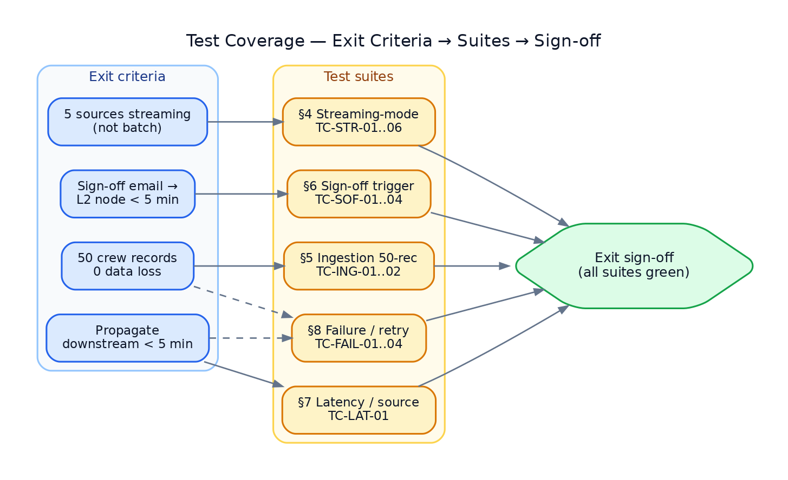
Figure 1 — Test coverage map: each exit criterion is gated by one or more test suites; all suites must pass for exit sign-off.

1.1 Levels & tooling
- Unit — pytest for normalizers, verifiers, classifiers, checkpoint math.
- Integration — connector → bus → sink with Redis + Postgres (compose), Pub/Sub emulator.
- E2E / demo — make demo-dayN; live sources where available, replay/emulator otherwise.
- Load — scripts/seed_erp.py + a driver that mutates N rows and reconciles counts.

1.2 Environments
Env | Sources | Use
local-mock | injected fixtures / replay | unit + CI, deterministic
local-live | test Slack workspace, test Workspace Gmail, local Postgres | integration + demo
emulator | Pub/Sub emulator, recorded payloads | Gmail path without GCP tenant

1.3 Fixtures
tests/fixtures/ holds recorded, event_id-stamped real payloads:
slack_message.json, slack_reaction.json, slack_join.json, gmail_push.json,
gmail_signoff.json, erp_outbox_batch.json. replay.py injects them on the real code path.
────────────────────────────────────────

2. Traceability Matrix
ID | Title | Criterion | Level | Day
TC-STR-01 | Slack message streams as DELTA | streaming | int | 2
TC-STR-02 | Slack reaction & channel-join stream | streaming | int | 2
TC-STR-03 | Gmail metadata streams (no body) | streaming | int | 3
TC-STR-04 | ERP crew change streams as DELTA | streaming | int | 4
TC-STR-05 | ERP contract + vessel/port stream | streaming | int | 4
TC-STR-06 | All 5 sources stream concurrently | streaming | e2e | 5
TC-ING-01 | 50 crew records, 0 loss (clean) | 50-rec/0-loss | load | 4
TC-ING-02 | 50 crew records, 0 loss (mid-run kill) | 50-rec/0-loss | load | 4
TC-SOF-01 | Sign-off email → SignOffEvent node | sign-off | e2e | 3
TC-SOF-02 | Sign-off latency < 5 min | sign-off | e2e | 3
TC-SOF-03 | Sign-off idempotent (redelivery) | sign-off | int | 3
TC-LAT-01 | Per-source p95 latency < 5 min | propagation | e2e | 4
TC-FAIL-01 | Connector crash → resume, 0 loss | resilience | int | 4
TC-FAIL-02 | Duplicate delivery → idempotent | resilience | int | 4
TC-FAIL-03 | Poison message → DLQ | resilience | int | 4
TC-FAIL-04 | Sink down → retry/backpressure, no drop | resilience | int | 4
TC-SEC-01 | Bad Slack signature rejected | security | unit | 2
TC-SEC-02 | Bad Pub/Sub JWT rejected | security | unit | 3
TC-SEC-03 | Gmail body never fetched/stored | privacy | unit | 3

────────────────────────────────────────

3. Common Verification Helpers
- Latency: metadata.custom.sinkAt − extractedAt per event; suite asserts p95 < 300 s.
- Loss/dup: compare source-side ids vs sink-side canonical key+sourceSequence sets;
missing = source − sink, dup = sink_count − distinct(sink).
- Streaming proof: assert operation == "DELTA" and arrival via push/poll (no manifest
file consumed) — distinguishes from Conduit's batch SNAPSHOT path.
────────────────────────────────────────

4. Streaming-Mode Tests (criterion: all 5 sources streaming)

TC-STR-01 — Slack message streams as DELTA
- Pre: service up; Slack connector live (or replay).
- Steps: post a message in the test channel (or inject slack_message.json).
- Expect: within seconds a SignalEvent{sourceSystem:SLACK, entity:message, operation:DELTA}
reaches the sink; appears on /stream; OrgMap gains author↔channel edge.
- Pass: event present, operation==DELTA, no batch/manifest involved.

TC-STR-02 — Slack reaction & channel-join
- Steps: add a reaction; join a channel.
- Expect: entity:reaction and entity:channel_join DELTAs; OrgMap edges created.

TC-STR-03 — Gmail metadata streams (no body)
- Steps: send a test email (or push gmail_push.json).
- Expect: sourceSystem:EMAIL, entity:email DELTA with from/to/cc/thread/sent_at; **no
body/body_text/body_html field present** (links to TC-SEC-03).

TC-STR-04 / TC-STR-05 — ERP streams
- Steps: UPDATE a crew row; insert a contract; update a vessel/port row.
- Expect: one DELTA per change via outbox poller; correct sourceSystem
(CREW_DB/CONTRACT_CLM/VESSEL_PORT_DB); watermark advances.

TC-STR-06 — All 5 concurrent (Day-5 gate)
- Steps: drive Slack + Gmail + 3 ERP sources together for 2 min.
- Expect: all five appear on one dashboard; every event DELTA; 0 errors.
────────────────────────────────────────

5. Ingestion Test — 50 Crew Records, 0 Data Loss (criterion)

TC-ING-01 — Clean 50-record load
- Setup: scripts/seed_erp.py --crew 50 seeds 50 distinct crew rows.
- Steps: trigger 50 updates (one per crew_id) → outbox → stream → sink.
- Assert:
- sink received exactly 50 crew DELTAs;
- distinct(crew_id) at sink == 50;
- missing == 0 and dup == 0;
- final checkpoint == last outbox id.
- Pass: source_count == sink_count == 50, 0 missing, 0 dup.

TC-ING-02 — 50-record with mid-run kill (overlaps §8)
- Steps: start the 50-update run; kill -9 the ERP connector at ~record 25; restart.
- Assert: after resume, sink distinct count == 50, missing == 0. Duplicates allowed only
if re-emitted before checkpoint commit and absorbed idempotently (net distinct == 50).
- Pass: 0 data loss; net distinct == 50.
────────────────────────────────────────

6. Sign-off Trigger Tests (criterion: email → L2 node < 5 min)

TC-SOF-01 — Sign-off email creates SignOffEvent node
- Steps: send an email matching the sign-off rule (label crew/sign-off or subject
pattern), or push gmail_signoff.json.
- Expect: Gmail connector classifies → metadata.custom.l2Intent == CREATE_SIGNOFF_EVENT;
L2 sink upserts a SignOffEvent node keyed on thread_id+crewRef.
- Pass: exactly one SignOffEvent node exists with correct crew/vessel refs.

TC-SOF-02 — Latency < 5 min
- Measure: sinkAt − sent_at (and sinkAt − extractedAt).
- Pass: < 300 s (expected sub-second to low-seconds via Pub/Sub push).

TC-SOF-03 — Idempotent on redelivery
- Steps: redeliver the same Pub/Sub message (same messageId/historyId) 3×.
- Pass: still exactly one SignOffEvent node (no duplicates).

TC-SOF-04 (negative) — non-sign-off email
- Steps: send an ordinary email.
- Pass: OrgMap edge created, no SignOffEvent node.
────────────────────────────────────────

7. Latency Tests — Per Source (criterion: propagate < 5 min)

TC-LAT-01
- Method: for each source, drive 30 events over 60 s; collect
sinkAt − extractedAt per event.
- Report: min / p50 / p95 / max per source.
Source | Target p95 | Expected
Slack | < 300 s | < 1 s
Gmail | < 300 s | 1–10 s (Pub/Sub + history.list)
ERP Crew DB | < 300 s | ≤ poll interval + ~1 s
ERP Contract CLM | < 300 s | ≤ poll interval + ~1 s
ERP Vessel/Port DB | < 300 s | ≤ poll interval + ~1 s

- Pass: every source p95 < 300 s.
────────────────────────────────────────

8. Failure / Retry Scenarios (resilience underpinning 0-loss & latency)

TC-FAIL-01 — Connector crash → resume, 0 loss
- Steps: mid-stream kill -9 a connector; restart.
- Expect: resumes from last committed position(); no gap, no silent drop.
- Pass: post-resume distinct count == expected; missing == 0.

TC-FAIL-02 — Duplicate delivery → idempotent
- Steps: replay the same payload (Slack retry / Pub/Sub redelivery / outbox re-read) ≥3×.
- Pass: sink distinct unchanged; OrgMap/SignOffEvent not duplicated.

TC-FAIL-03 — Poison message → DLQ
- Steps: inject a malformed payload that fails normalize/sink N times.
- Expect: after retry budget, message lands in signal.dlq with reason; stream is not
blocked for healthy messages; alert/metric increments.
- Pass: message in DLQ, healthy throughput continues, replay tool re-injects after fix.

TC-FAIL-04 — Sink/L2 down → retry & backpressure, no drop
- Steps: stop the L2 sink for 60 s while events flow; restart.
- Expect: events buffered in Redis Streams (pending), retried on recovery; 0 dropped;
latency rises but recovers; (if any event would exceed SLO, it is flagged in the report).
- Pass: missing == 0 after recovery.

TC-SEC-01/02/03 — Security & privacy
- SEC-01: tampered/expired X-Slack-Signature → 401, event not processed.
- SEC-02: invalid/expired Pub/Sub OIDC JWT → 401, event not processed.
- SEC-03: assert the Gmail fetch uses format=metadata; emitted SignalEvent.data has
no body* keys; recorded HTTP calls never request full format. *(Privacy gate.)*
────────────────────────────────────────

9. Daily Demo Acceptance (each must run green cold)
Day | make target | Acceptance
Jun 08 | demo-day1 | mock Slack + email events traverse ingress→bus→sink→/stream; /healthz green
Jun 09 | demo-day2 | real (or replayed) Slack message/reaction/join in OrgMap; forced sink error → retry shown; TC-SEC-01 passes
Jun 10 | demo-day3 | Gmail metadata edge + sign-off → SignOffEvent < 5 min; TC-SOF-01/02/03, TC-SEC-03 pass
Jun 11 | demo-day4 | ERP crew update streams; kill+resume 0-loss; 50-record reconciles; latency dashboard; TC-FAIL-01..04 pass
Jun 12 | demo-day5 | all 5 sources concurrent; full suite §4–§8 green

────────────────────────────────────────

10. Exit Criteria Sign-off (final)
- ☐ All 5 sources streaming (not batch) — TC-STR-01..06 pass.
- ☐ Sign-off email → L2 node < 5 min — TC-SOF-01/02/03 pass.
- ☐ 50 crew records, 0 data loss — TC-ING-01/02 pass.
- ☐ Changes propagate downstream < 5 min — TC-LAT-01 (all p95 < 300 s) + TC-FAIL-01..04 pass.
────────────────────────────────────────

11. Test Deliverables
- tests/ — unit + integration suites (pytest), runnable via make test.
- tests/fixtures/ — recorded real payloads for deterministic replay.
- scripts/seed_erp.py, scripts/replay.py, scripts/inject_mock.py.
- CI job — runs local-mock + emulator suites on every push; load/latency reports archived.
- Results report — per-run latency percentiles, loss/dup reconciliation, DLQ contents.
</content>

