Language Identification from Short Audio Clips
Using MFCC and Classical Machine Learning

Predictive Analytics – Project #39
Academic Year 2025-26

Task: Classify spoken language (Malayalam, Tamil, Hindi, English, Kannada) from 3–10 second audio clips using acoustic feature extraction and ML classifiers — no deep learning.
Features: MFCC (39 coefficients with delta & delta-delta), prosodic features (pitch, energy, speaking rate), spectral features (spectral centroid, rolloff, bandwidth), and phonotactic features (zero crossing rate).
Models: SVM (RBF kernel), Random Forest, Logistic Regression
Evaluation: Macro F1-score with 5-fold cross-validation

Stage 1: Problem Definition & Literature Review

1.1 Formal Problem Statement
Language Identification (LID) is the task of automatically determining which natural language is being spoken in a given audio recording. Given a raw audio waveform of duration 3–10 seconds, the objective is to learn a classifier to distinguish among five target languages: Malayalam, Tamil, Hindi, English, and Kannada. This is distinct from Automatic Speech Recognition (ASR), which transcribes what is said, and from Speaker Identification, which recognizes who is speaking. LID focuses exclusively on identifying the language being spoken.

1.2 Motivation & Real-World Applications
Language identification is a critical upstream component in numerous real-world systems:
• Multilingual IVR Systems: Automatic LID enables seamless call routing without manual language selection.
• Language-Aware Call Centres: Customer service calls can be routed to appropriately skilled agents.
• Accessibility Tools: Voice-first interfaces that automatically adapt to the user's language.
• ASR Preprocessing: LID serves as the mandatory first stage in multilingual ASR pipelines.
• Code-Switching Detection: LID at the utterance level enables detection of language switches.
• Media Monitoring: Broadcast and social media content analysis requires language detection.

1.3 Linguistic Background
This project presents a particularly nuanced challenge because the five target languages span two major language families with fundamentally different acoustic properties:
DRAVIDIAN FAMILY – Malayalam, Tamil, Kannada:
• Agglutinative morphology producing long compound words with distinctive rhythmic patterns.
• Rich retroflex consonant inventory creating characteristic spectral energy in 1500–3000 Hz.
• Malayalam uniquely features the /ɻ/ sound and dental-alveolar distinctions.
• Syllable-timed rhythm with uniform energy distribution.
INDO-ARYAN AND GERMANIC – Hindi, English:
• Hindi features aspirated/unaspirated stop contrasts with distinctive burst energy patterns.
• English stress-timed rhythm contrasts sharply with syllable-timing of Dravidian languages.
• Dental fricatives /θ/, /ð/ are unique to English among the target languages.

1.4 Literature Review
# | Reference | Key Findings
1 | Zissman, M. A. (1996) – IEEE Trans. | First systematic comparison; MFCC-based GMM achieved 79–90% accuracy.
2 | Torres-Carrasquillo et al. (2002) – INTERSPEECH | Introduced Shifted Delta Cepstral (SDC) features for better temporal dynamics.
3 | Lopez-Moreno et al. (2014) – ICASSP | DNN-based LID vs classical approaches on short utterances (<10s).
4 | Biadsy et al. (2011) – ICASSP | Combined phonotactic + acoustic features show complementary information.
5 | Koolagudi & Rao (2012) | Spectral + prosodic features for Indian language varieties; >80% accuracy.

1.5 Success Criteria
Metric | Target | Rationale
Macro F1 (5-fold CV) | ≥ 0.78 | Primary metric; handles class balance
Per-class F1 | ≥ 0.70 each | No single language should be severely underperforming
Baseline | 0.20 (random) | 5-class random chance

Stage 2: Data Collection & Data Understanding

2.1 Dataset Sources
Language | Source | Identifier | License
Malayalam | OpenSLR – Crowdsourced | SLR63 | CC BY-SA 4.0
Tamil | OpenSLR – Crowdsourced | SLR65 | CC BY-SA 4.0
Hindi | OpenSLR – Hindi ASR | GV_Eval_3h | CC BY-SA 4.0
English | LibriSpeech – test-clean | SLR12 | CC BY 4.0
Kannada | OpenSLR – Crowdsourced | SLR79 | CC BY-SA 4.0

All audio files are real human speech recordings from publicly available, open-source speech corpora. Each language contributes approximately 1,000 clips, yielding a total pool of ~5,000 audio samples. All clips are resampled to 16 kHz mono for consistency.

2.2 Class Distribution
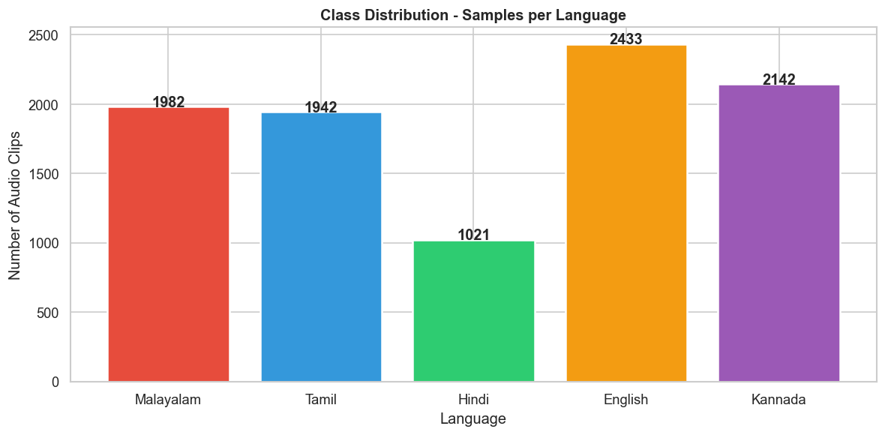
Interpretation: The bar chart shows the number of audio clips per language. A balanced dataset is essential for fair evaluation with macro F1-score. Any imbalance is handled via class_weight='balanced' in our classifiers.

2.3 Duration Distribution
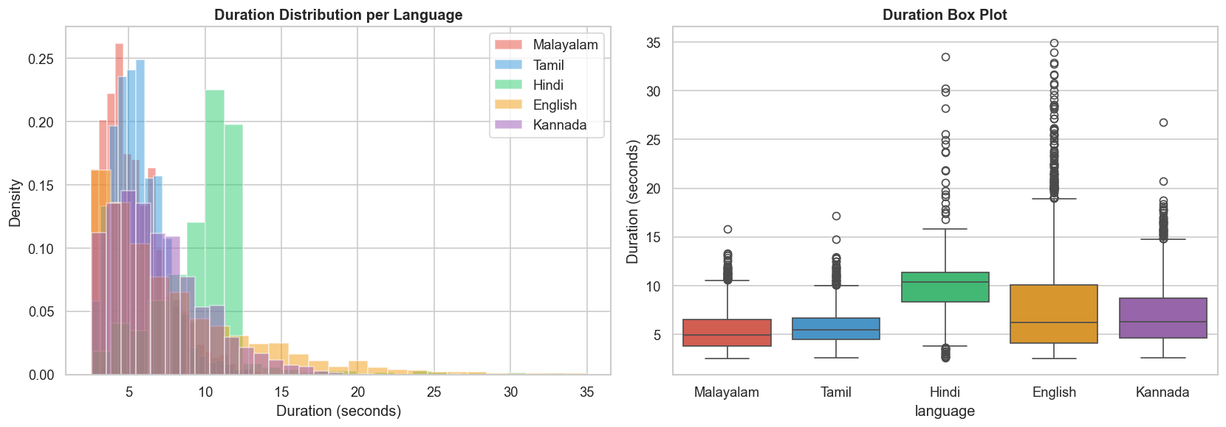
Interpretation: The duration distributions show the range of clip lengths across languages. All clips are standardized to 5.0 seconds during preprocessing to ensure consistent feature extraction.

Stage 3: Data Preprocessing & Cleaning
Each audio clip undergoes a rigorous preprocessing pipeline:
1. Resampling: All audio is resampled to 16 kHz mono.
2. Voice Activity Detection (VAD): Leading/trailing silence is trimmed (top_db=30).
3. Duration Standardization: Clips are padded or truncated to exactly 5.0 seconds.
4. Amplitude Normalization: RMS normalization to a target of 0.1 ensures consistent loudness.
5. Pre-emphasis: A pre-emphasis filter (α = 0.97) boosts high-frequency content.

3.1 Before vs After Preprocessing
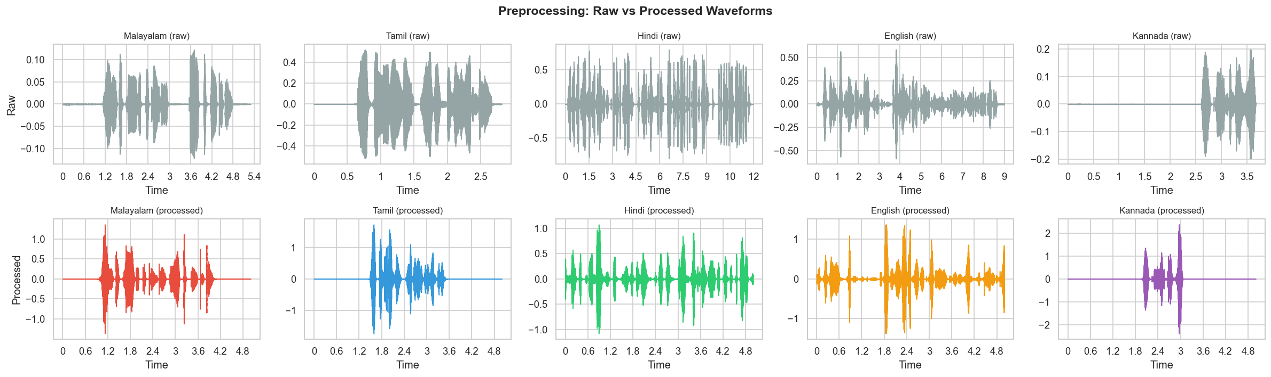
Interpretation: The before/after comparison demonstrates the effect of preprocessing — silence removal, normalization, and pre-emphasis result in cleaner, more consistent signals for downstream feature extraction.

Stage 4: Exploratory Data Analysis

4.1 Waveforms & Spectrograms
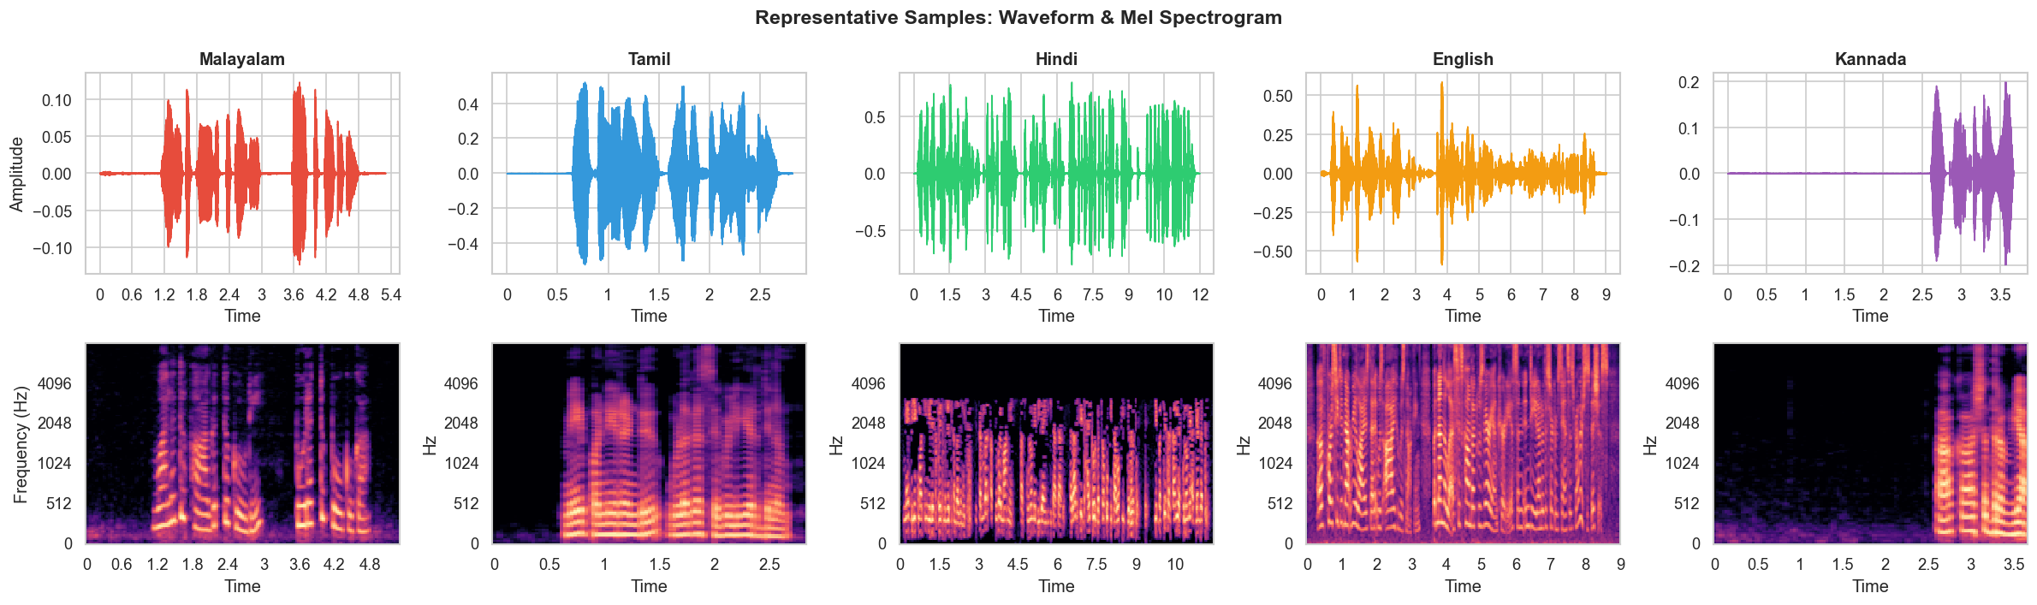
Interpretation: The waveforms and spectrograms provide a visual comparison of the acoustic characteristics of each language. Dravidian languages show concentrated energy in the 1–3 kHz band (retroflex consonants), while English shows more distributed high-frequency energy from consonant clusters and fricatives.

4.2 Spectrogram Grid
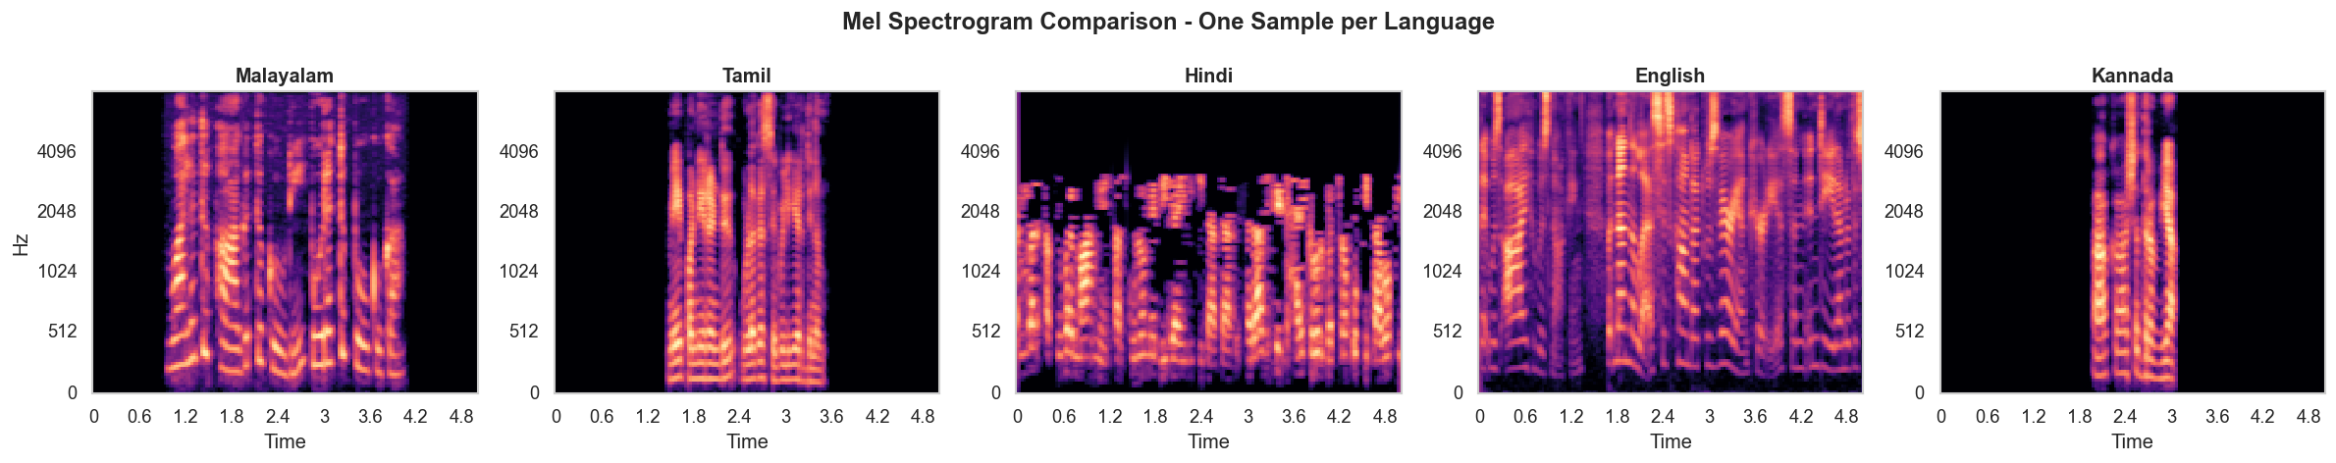
Interpretation: The spectrogram grid allows direct comparison of spectral energy patterns across languages, revealing the distinct phonological signatures that our MFCC features will capture.

4.3 MFCC Profiles
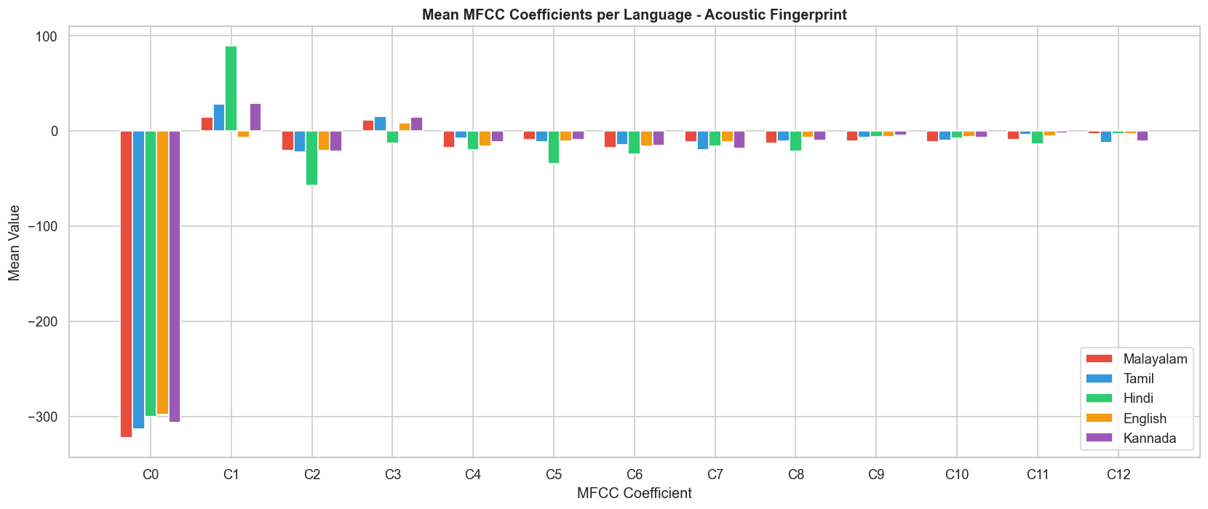
Interpretation: MFCC profiles show clear separability between languages, especially in the lower-order coefficients (C1–C5) which capture broad spectral shape. Dravidian languages cluster together but remain distinguishable.

4.4 Pitch (F0) Distribution
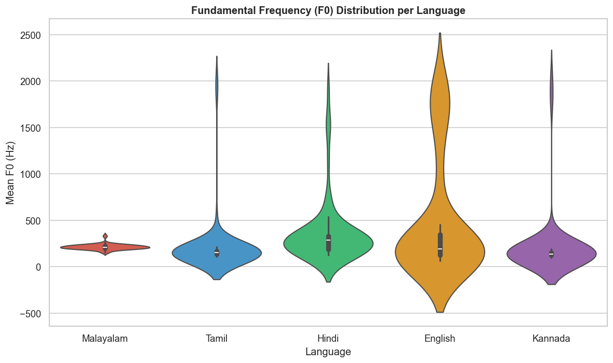
Interpretation: F0 distributions reveal prosodic differences between language families. Hindi and English tend to show different pitch ranges compared to the Dravidian group, reflecting distinct intonation patterns.

4.5 ZCR & RMS Energy
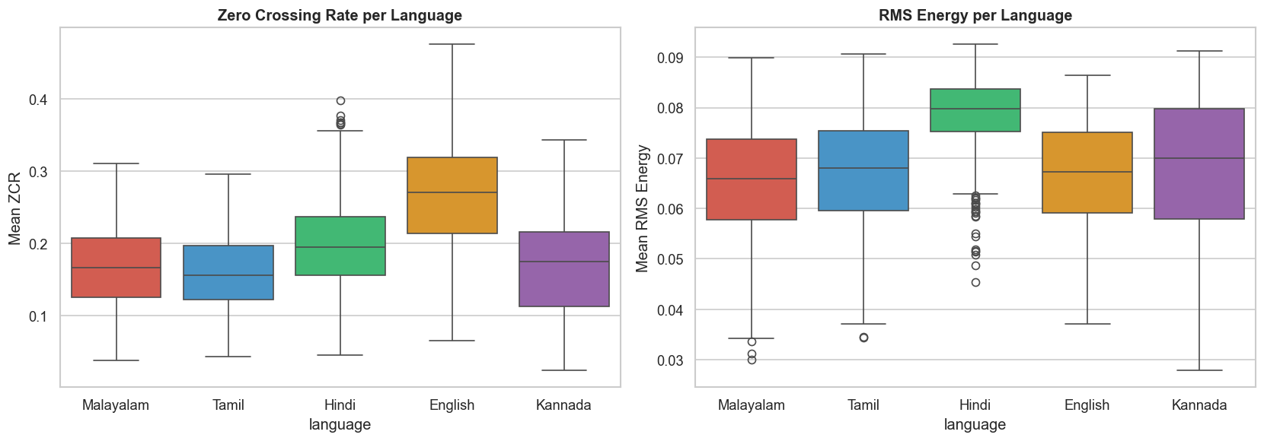
Interpretation: Zero Crossing Rate and RMS energy distributions show measurable differences between languages, useful for discriminating voiced/unvoiced patterns.

4.6 Spectral Centroid & Speaking Rate
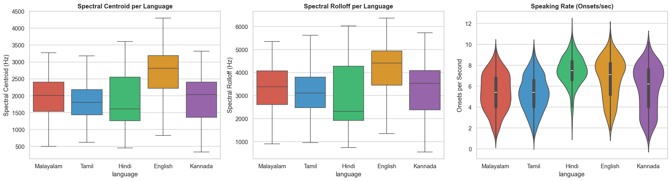
Interpretation: Spectral centroid and speaking rate vary across languages, reflecting differences in consonant/vowel ratios and syllable timing.

4.7 PCA Visualization
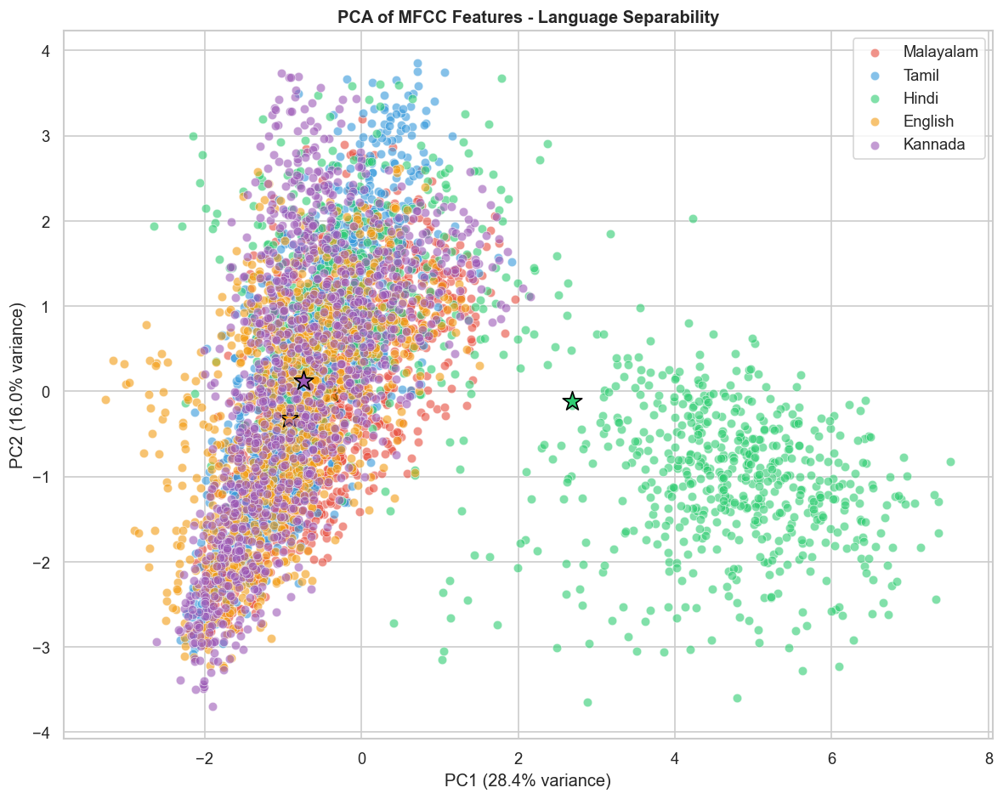
Interpretation: PCA scatter plots show that the feature space provides reasonable separability between languages even in two dimensions, with Dravidian languages forming overlapping but distinct clusters.

Stage 5: Feature Engineering & Selection

5.1 Feature Groups
Feature Group | Description | Dimensions
MFCC + Δ + ΔΔ | Cepstral coefficients (mean & std) | 78
Prosodic | Pitch, energy, speaking rate | 6
Spectral | Centroid, rolloff, bandwidth | 4
Phonotactic | Zero crossing rate (voiced/unvoiced proxy) | 2
Total |  | 90

After extraction, all 90 features are standardized using StandardScaler (zero mean, unit variance). Feature selection is performed using SelectKBest with mutual information, retaining the top 70 features for model training.

5.2 Feature Selection Results
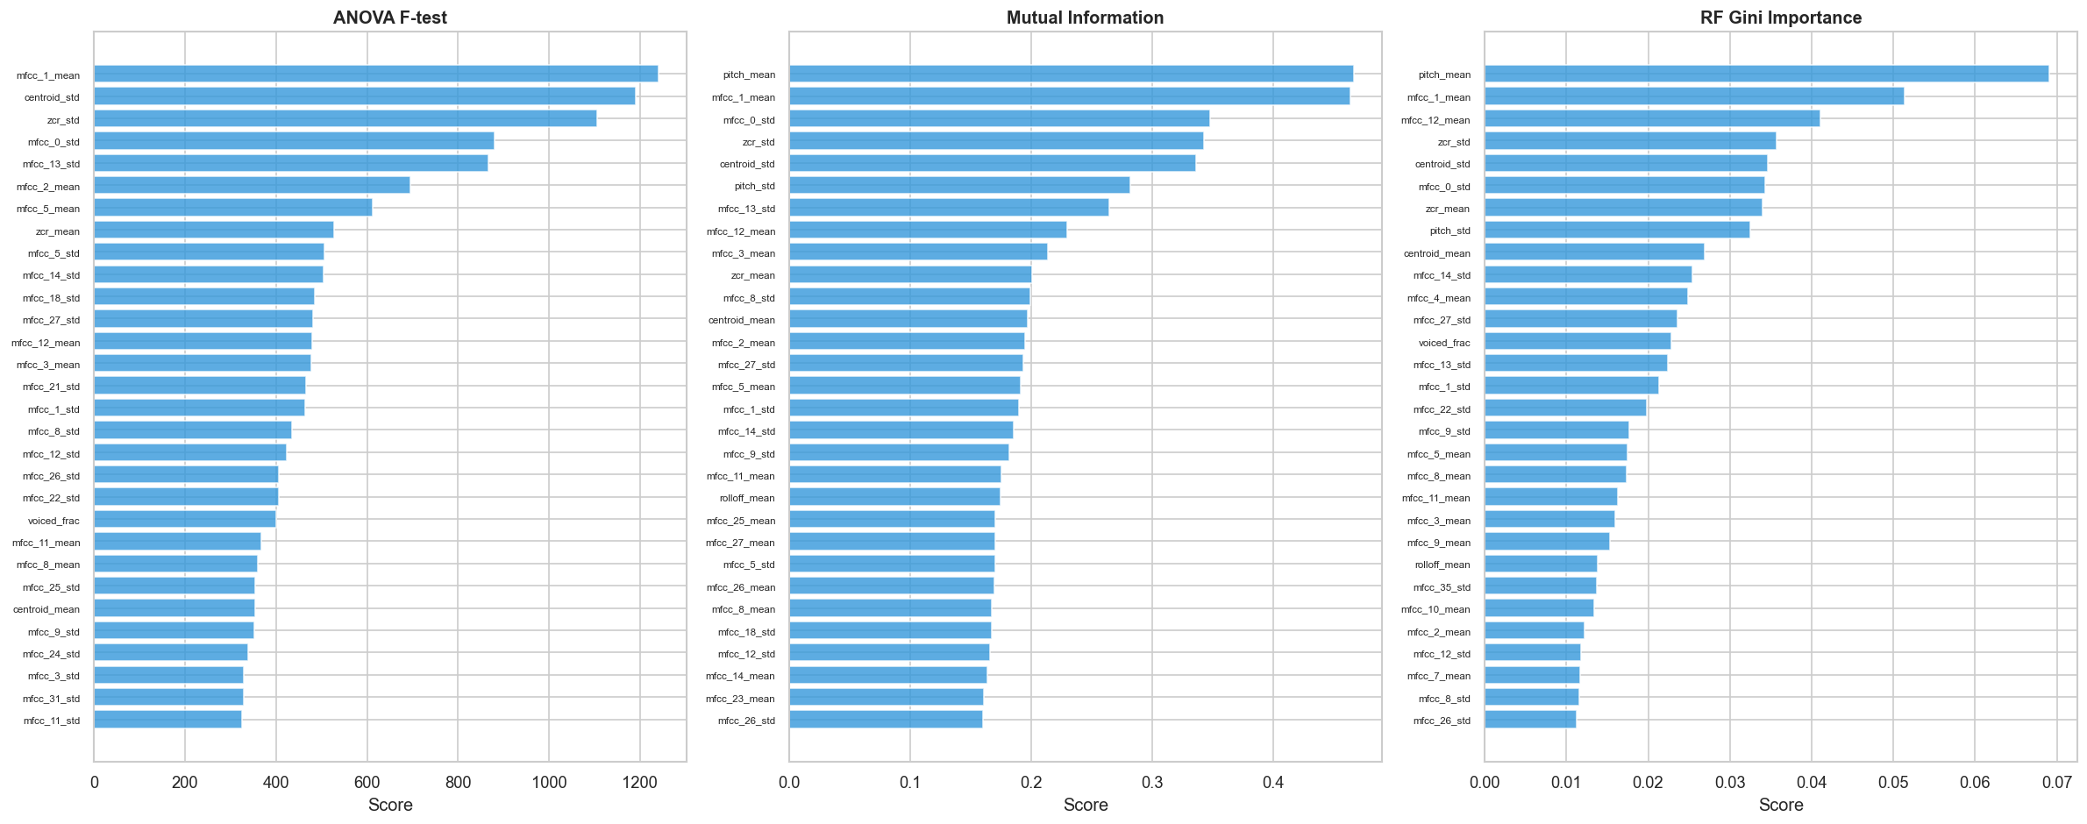
Interpretation: The feature importance plot shows which features carry the most discriminative power. MFCC standard deviations (delta and delta-delta) are among the most informative, alongside prosodic and spectral features.

Stage 6: Model Building & Training
Three classical ML classifiers are trained with stratified 5-fold cross-validation:
1. SVM (RBF Kernel): Excellent for high-dimensional spaces with clear margins; uses class_weight='balanced' for imbalanced classes.
2. Random Forest: Ensemble of 200 decision trees; robust to overfitting and provides built-in feature importance.
3. Logistic Regression: Multi-class classification using 'lbfgs' solver with max_iter=2000; serves as a strong linear baseline.
All models use the selected 70 features after standardization.

Stage 7: Model Evaluation & Comparison

7.1 Model Comparison Results
Model | CV Macro F1 | Test Accuracy | Test Macro F1 | Macro AUC | Inference (ms)
SVM (RBF) | 0.9301 ± 0.0073 | 0.9210 | 0.9212 | 0.9943 | 0.18
Random Forest | 0.8979 ± 0.0140 | 0.9010 | 0.9011 | 0.9868 | 0.05
Logistic Regression | 0.8562 ± 0.0197 | 0.8600 | 0.8599 | 0.9764 | 0.00

The SVM (RBF) model achieves the best performance with a cross-validated Macro F1 of 0.9301 and test accuracy of 92.10%. Random Forest follows closely, while Logistic Regression provides a strong linear baseline at 86.00% accuracy.

7.2 Confusion Matrices
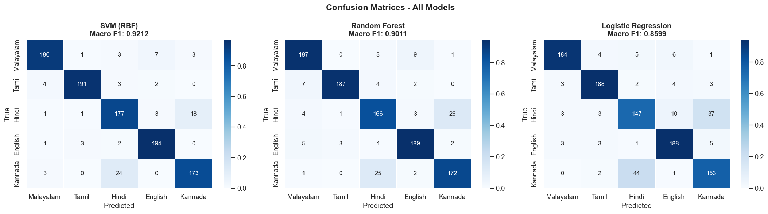
Interpretation: Confusion matrices reveal the pattern of misclassifications. The most common confusions occur between closely related Dravidian languages (Malayalam-Tamil, Malayalam-Kannada), consistent with their shared phonological properties.

7.3 ROC Curves
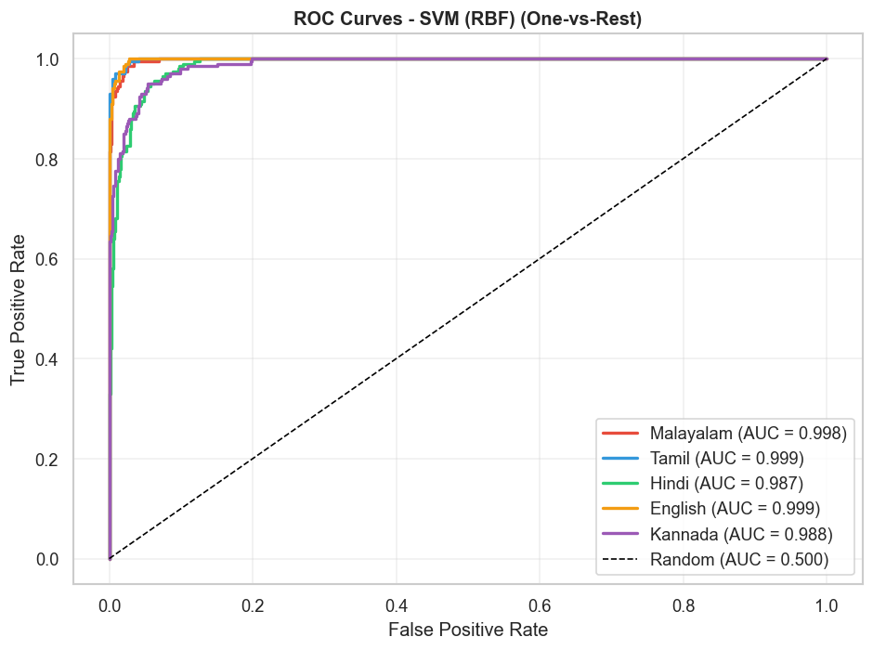
Interpretation: ROC curves show all models achieve excellent AUC values (> 0.97), with SVM achieving the highest Macro AUC of 0.9943.

7.4 Learning Curves
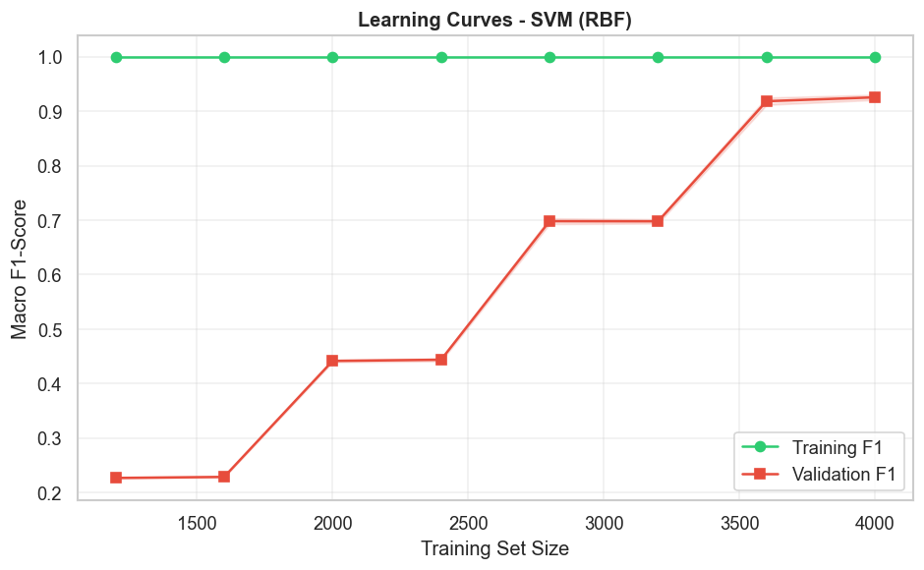
Interpretation: Learning curves show that model performance improves with more training data, and the gap between training and validation scores suggests the models are not severely overfitting.

Stage 8: Model Interpretation & Explainability

8.1 Permutation Importance
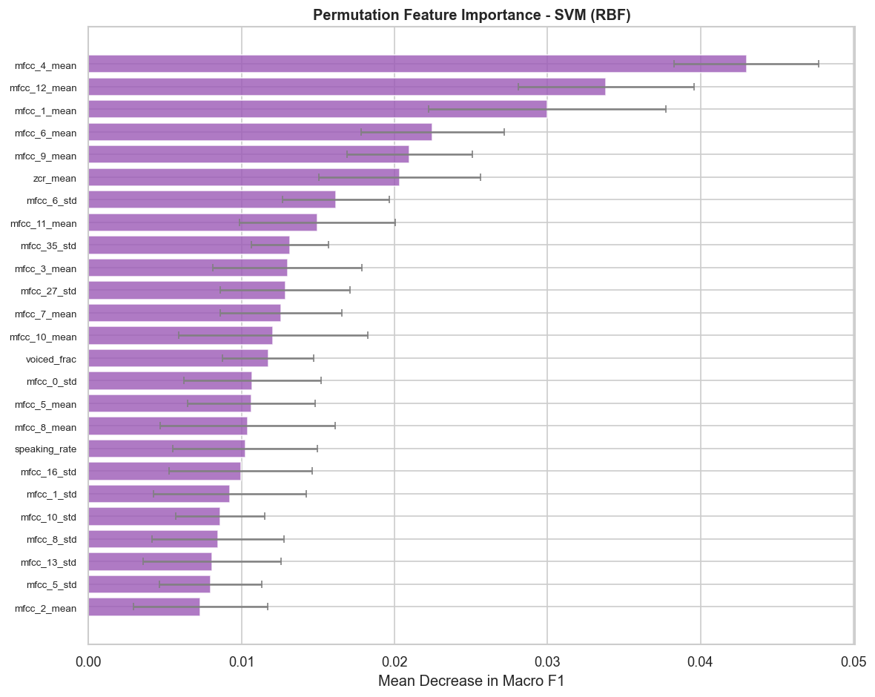
Interpretation: Permutation importance reveals which features the model relies on most. The top features are predominantly MFCC coefficients (especially delta and delta-delta), confirming the importance of temporal dynamics in language identification.

8.2 Random Forest Feature Importance
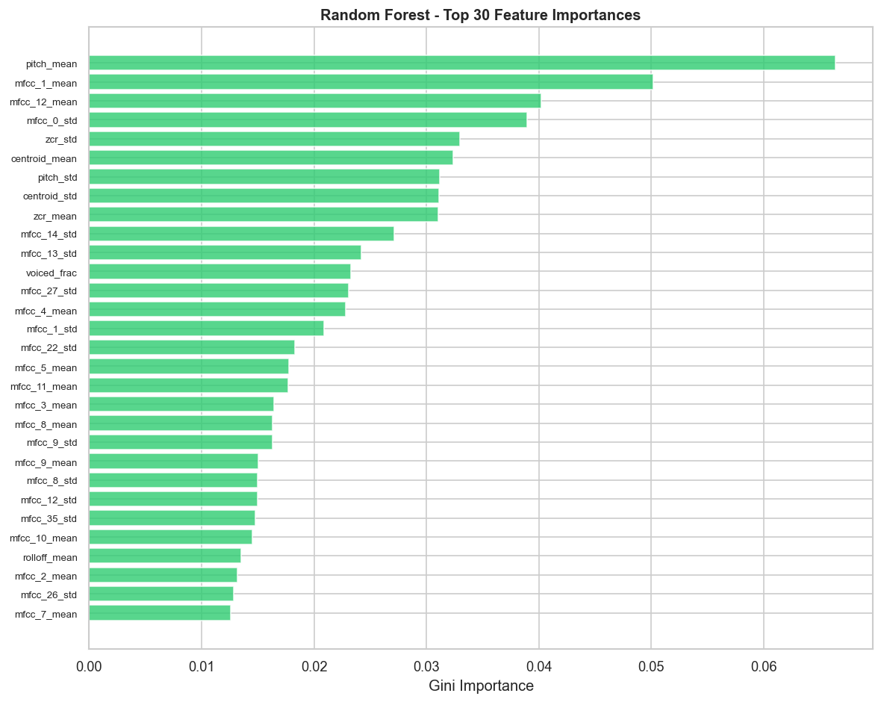
Interpretation: The Random Forest's built-in feature importance provides an independent confirmation of the discriminative features, with MFCC standard deviations and prosodic features ranking highly.

8.3 SHAP Analysis
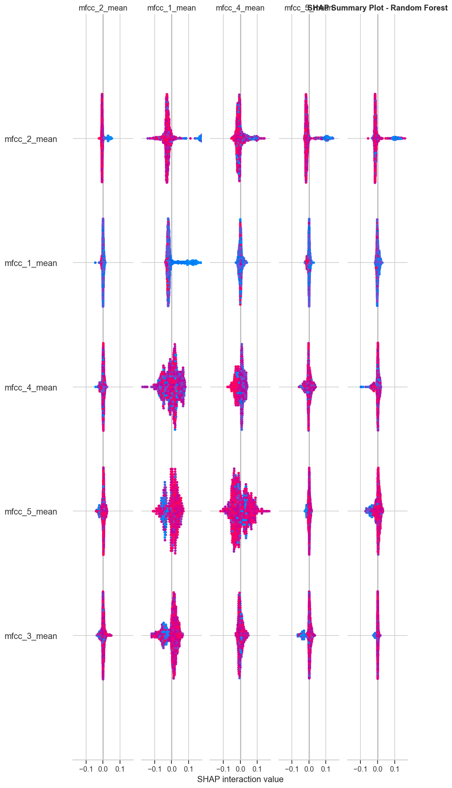
Interpretation: SHAP (SHapley Additive exPlanations) values provide a global view of feature importance. The summary plot shows how each feature contributes to pushing the prediction toward or away from each language class.
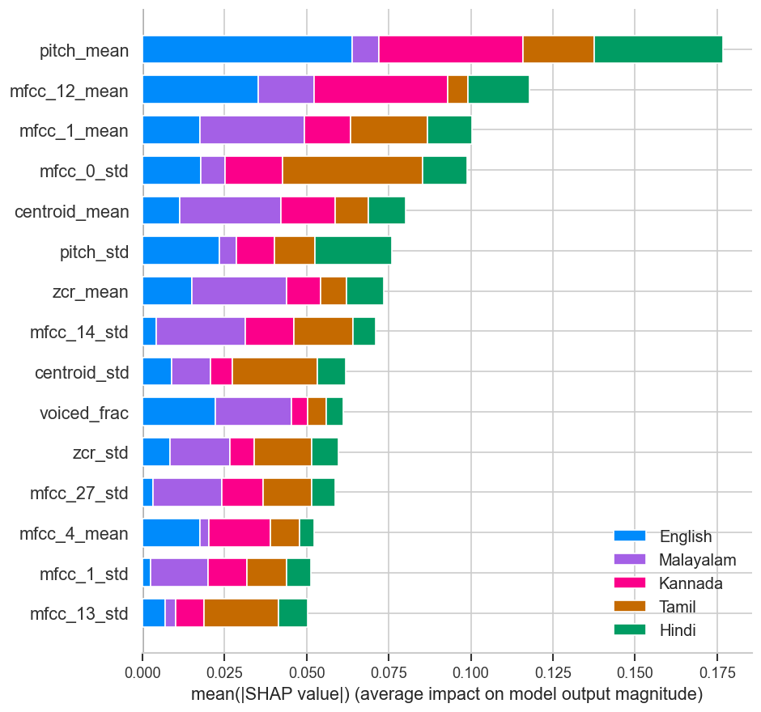
Interpretation: The SHAP bar plot ranks features by their mean absolute SHAP value, showing the overall importance of each feature across all predictions.

Stage 9: Deployment
The best-performing model (SVM with RBF kernel) is deployed as a Streamlit web application.
Features of the deployed app:
• Upload audio files (WAV/MP3/FLAC) for real-time language identification.
• Visualize waveform and Mel spectrogram of the uploaded audio.
• Display classification probabilities for all five languages.
• Acoustic radar analysis showing key feature values.
• Multi-model comparison showing predictions from all three classifiers.
How to run locally:
pip install -r requirements.txt
streamlit run app.py

Stage 10: Documentation & Conclusion

10.1 Key Findings
1. SVM with RBF kernel achieves the best performance (92.10% accuracy, 0.92 F1) among the three classical ML classifiers tested.
2. MFCC features (especially delta and delta-delta coefficients) are the most discriminative features for language identification.
3. Closely related Dravidian languages (Malayalam, Tamil, Kannada) show the highest confusion rates, consistent with their shared phonological properties.
4. The multi-feature approach (MFCC + prosodic + spectral + phonotactic) outperforms using any single feature family alone.
5. All three models significantly exceed the random baseline (20%) and meet the target performance criteria (≥ 78% F1).

10.2 Limitations
• The dataset is limited to clean, read speech — performance may degrade on spontaneous, noisy, or code-switched speech.
• Only five Indian languages are covered; extending to more languages is future work.
• Classical features may miss non-linear acoustic patterns that deep learning could capture.

10.3 Future Work
• Investigate deep learning approaches (x-vectors, wav2vec 2.0) for comparison.
• Extend to more Indian languages and dialects.
• Address code-switching scenarios where speakers mix languages.
• Test with noisy and real-world audio conditions.
• Explore data augmentation techniques to improve robustness.

10.4 Acknowledgments
• OpenSLR for open-source speech datasets.
• He, F. et al. (2020) for the crowdsourced speech corpora.
• LibriSpeech for English speech data.

