Paper Test Case 01 ILT Z Branch Valve Layout
Accepted concept record for S Lay ILS AI4D workflow testing
Purpose. This record captures the first accepted worked test case for the paper study. The case tests whether the governed workflow can convert a natural language ILT request into a traceable EDPR understanding, an EDAS-compatible layout, a deterministic plot, a screening strain statement, and future evidence needs.
Result. The concept was accepted by the human reviewer for component placement, connection label correctness, and high-strain marker location. The plot remains a concept review artifact because full GD-Con pipe-landing connector bodies are not explicitly modelled.

1 Test query and confirmed understanding
Item | Record
Initial user query | Provide an ILT layout for a 16 inch pipeline, 8 inch branch pipe leading to vertical connector, 8 inch valve on branch, no header valve, 90 m stinger radius and 150 MT tension. Provide possible maximum pipeline strain and expected location.
Confirmed branch topology | Branch ends with a vertical connector; Z-branch layout required.
Valve information | Use estimated dimensions for the 8 inch branch valve.
Top frame requirement | Top frame required.
Missing data handling | Use typical values for unspecified branch wall, valve body, connector body, and masses.
Plot requirement | Layout plot required.
Table 1. User request and confirmed EDPR inputs.

2 Proposed layout
Design element | Selected representation | Reason
Header pipeline | GD-HdPipe, 16 inch OD | Base pipeline for local ILT assembly.
Branch assembly | GD-B, Z variant | Vertical connector requires Z-branch rather than a simple vertical branch sketch.
Branch valve | Represented on GD-B branch run using estimated dimensions and GD-VLV visual grammar | Valve is on branch, not on header; branch valve must be visible for review.
Top frame | GD-ST around branch tee, valve, and branch end | Top frame is required and branch valve must remain inside the frame span.
Connection system | PS intent | Avoids unjustified F2/F2D stiffness unless evidence supports a fixed low-strain pocket.
Branch/top-frame tie | S connection from B.end to ST.top1 | Vertical branch connector anchored to top frame using sliding support intent.
Base structure | Not provided | No header valve or header component requiring roller-contact protection.
Table 2. Layout components and engineering basis.

3 Layout plot
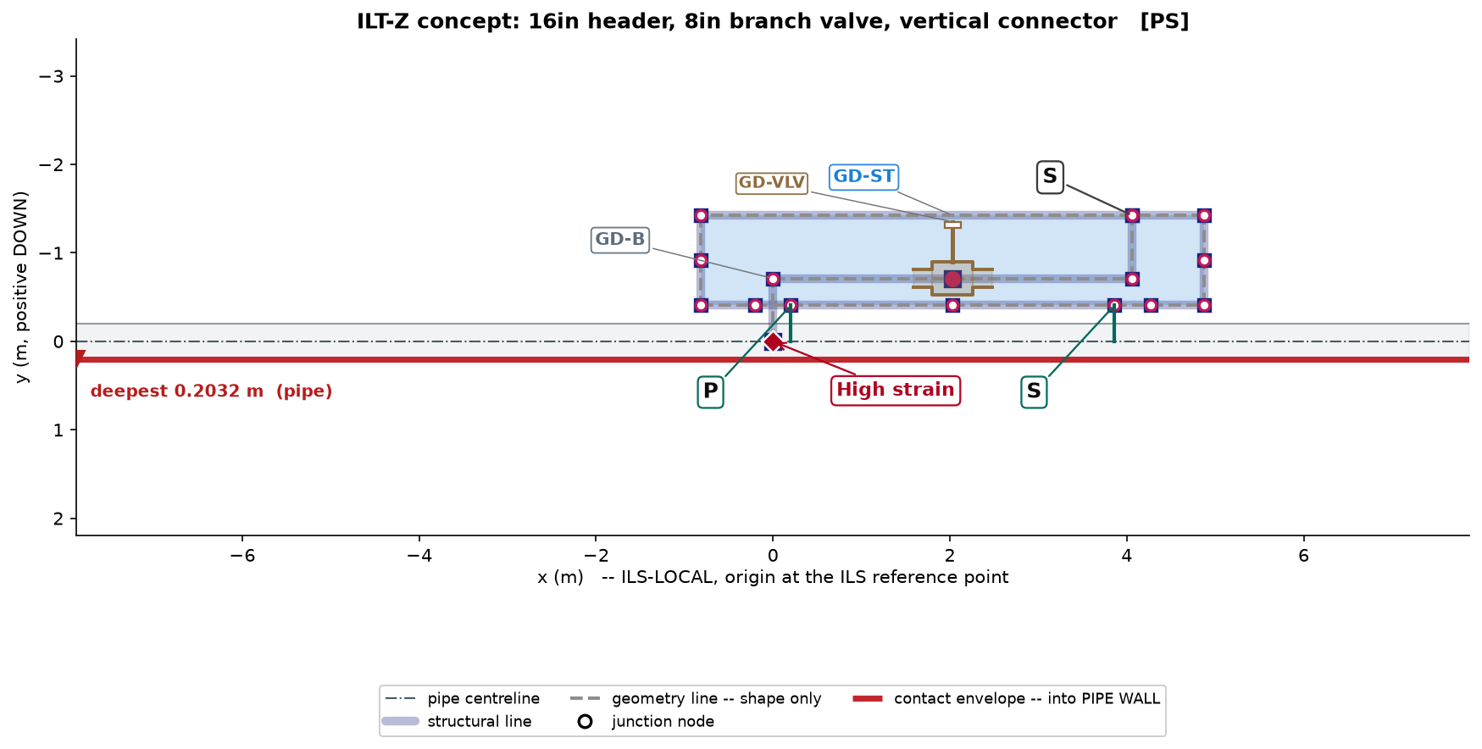
Figure 1. Deterministic ILS plot for the accepted ILT-Z branch valve concept. The high-strain marker is anchored to the branch tee feature.

4 Screening strain statement
Item | Screening statement
Possible maximum pipeline strain | Approximately 0.4% to 0.7%. This is a screening estimate only and is not an FEA value.
Expected primary location | Header near the branch tee / local stiffness entry region.
Secondary watch locations | Near the top-frame connector load-transfer points.
Main dependency | Support stiffness, branch valve weight, branch geometry, connector spacing, and connection type can shift the peak and strain magnitude.
Table 3. Screening strain estimate and location statement.

5 Plot and workflow status
Gate or check | Status | Comment
Plot status | warning | Concept plot generated without blocking errors.
Plot QA | passed_with_corrections | Automatic label corrections were applied and no remaining layout collisions were reported.
Plot annotation anchors | passed | High-strain marker resolved to a model feature.
Required connection labels | passed | Non-weld structure connection label requirement passed.
EA exposure gate | failed | Simplified connector representation; full GD-Con pipe-landing associations are not explicitly modelled.
Human review | accepted | Component placement, connection labels, and high-strain marker were accepted.
Table 4. Plotter and workflow status summary.

6 Future study candidate
Candidate field | Content
Candidate ID | future_study:branch_geometry_strain_covariance_ilt_z_01
Study need | Branch pipe geometry influence on header strain for ILT-Z branch valve layouts
Reason | During accepted paper test case 01, the concept used typical branch geometry. Expert review noted that geometrical parameters of the branch pipe could affect pipeline strains and should be studied further if sufficient data is unavailable.
Variables | GD-B.P_b1 branch horizontal length; GD-B.P_b2 vertical connector height; GD-B.P_b3 intermediate Z-branch rise; GD-B.P_bv branch valve station; GD-B.OD_branch and t_branch; GD-ST.L_top and H_top; ...
Responses | peak header strain; peak strain location; branch strain; connector reaction and moment transfer; strain redistribution outside GD-ST span
Before design claim | Do not claim optimized branch geometry or connector spacing for minimum strain unless supported by EDIKB dataset rows, FEA DOE, or validated ML/correlation evidence covering the selected geometry range.
Table 5. Future EDIKB study candidate recorded from the accepted test case.

7 Record package
Artifact | Path
Layout JSON | runs\paper_test_ilt_z_branch_valve\layout.json
Plot report | runs\paper_test_ilt_z_branch_valve\report.json
Parameter CSV | runs\paper_test_ilt_z_branch_valve\layout.parameters.csv
Future study candidate | knowledge\edikb\future_study_candidates\BRANCH_GEOMETRY_STRAIN_COVARIANCE_ILT_Z_01.json
Table 6. Files linked to this test case record.
Use limitation. This document records an accepted concept test for paper reporting. It should not be used as final engineering substantiation without connector-detail modelling and a validated strain analysis.

