**Second Semester MCA 2021 Batch -B**

**20MCA136 NSA Lab**

**Exercise II - Shell Programming**

1. Write a shell script to find the sum, the average and the product of the

four integers entered

**program**

echo "Enter four numbers:"

read n1

read n2

read n3

read n4

sum=`expr $n1 + $n2 + $n3 + $n4`

echo Sum=$sum

avg=`expr $sum / 4`

echo Average=$avg

pro=`expr $n1 \* $n2 \* $n3 \* $n4`

echo Product=$pro

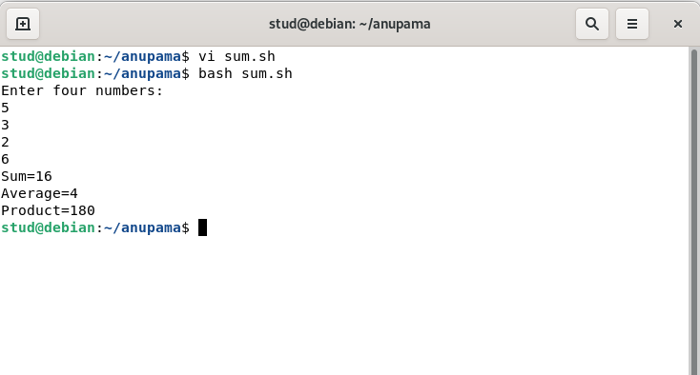

**2.a)Write a program to check whether a number entered is odd or even.**

echo "Enter a number"

read num

if [ `expr $num % 2` -eq 0 ]

then

echo "The number is even"

else

echo "The number is odd"

fi

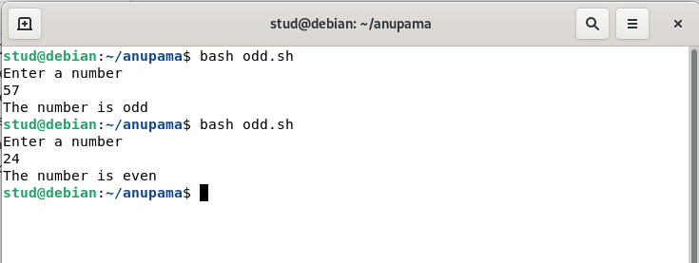

**b) Write a shell script to print given number in reverse order**

echo "Enter a number:"

read num

p=0

rev=0

while [ $num -gt 0 ]

do

p=`expr $num % 10`

rev=`expr $rev \* 10 + $p`

num=`expr $num / 10`

done

echo "Reverse number of entered digit is $rev"

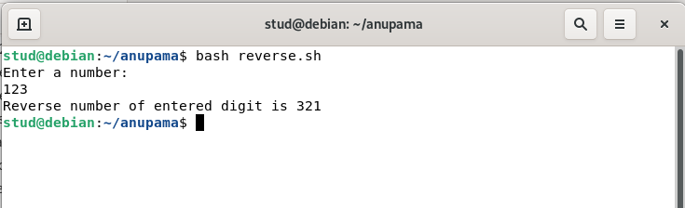

**c) Write a shell script to print sum of all digits of a given number**

**Program**

echo "Enter a number:"

read num

p=0

s=0

while [ $num -gt 0 ]

do

p=`expr $num % 10`

s=`expr $s + $p`

num=`expr $num / 10`

done

echo "Sum of all digits of a given number:$s"

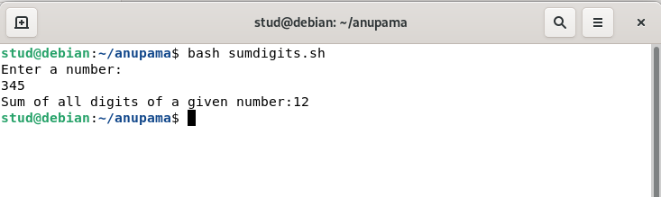 **3.Write a shell script that accepts any year from the keyboard and**

**determine whether the year is a leap year or not.**

echo "Enter a year:"

read y

if [ `expr $y % 4` -eq 0 -a `expr $y % 100` -ne 0 -o `expr $y % 400` -eq 0 ]

then

echo "$y is a leap year"

else

echo "$y is not a leap year"

fi

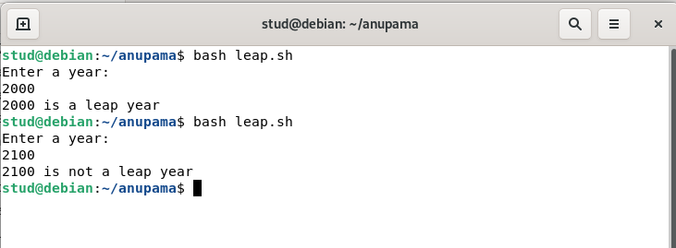

4. Write a shell script to find the factorial of a number

echo "Enter a number"

read num

f=1

i=1

while [ $i -le $num ]

do

f=`expr $f \* $i`

i=`expr $i + 1`

done

echo "Factorial of a number:$f"

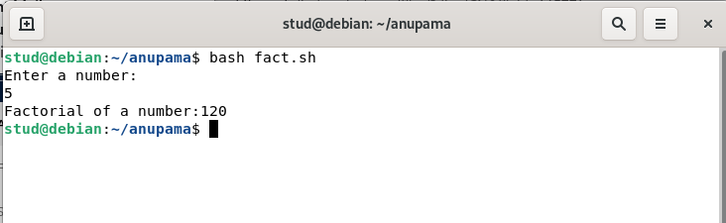

echo "Prime numbers"

echo 2

j=3

while test $j -le 100

do

i=2

x=`expr $j - 1`

while test $i -le $x

do

if [ `expr $j % $i` -ne 0 ]

then

i=`expr $i + 1`

else

break

fi

done

if [ $i -eq $j ]

then

echo $j

fi

j=`expr $j + 1`

done

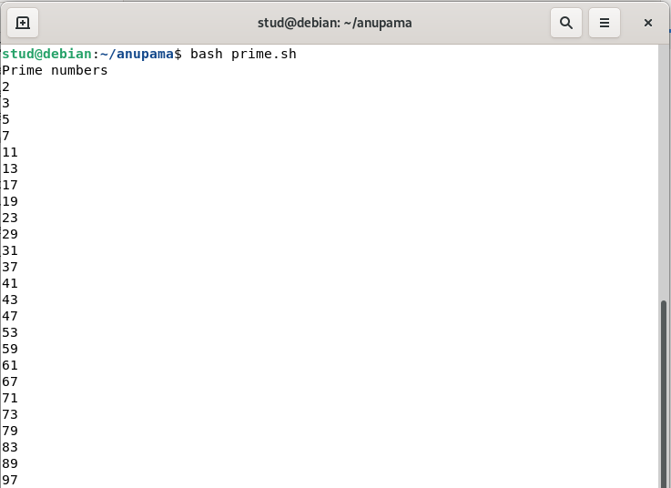

6. Write a script for Printing Numbers in ascending Order

echo "enter the limit:"

read l

for (( i=1; i <= l; i++ ))

do

echo "$i"

done

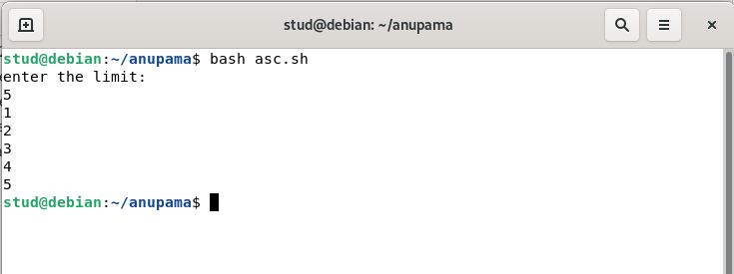

**7.Write a shell script which displays a list of files in the current directory to which we have read write and execute permissions.**

**8. Write a shell script to find the number of occurrence of particular digit in an inputted number**

**9. Write shell script to print alternate digits when a 7 digit number is passed as input**

**10.Write A shell script that takes a command –line argument and reports on whether it is directory ,a file,or something else**

**11.write a shell script that accepts a file name starting and ending line numbers as arguments and displays all the lines between the given line numbers**

**12. Write a shell script that deletes all lines containing a specified word**  **in one or more files supplied as arguments to it.**

**13.Write a shell script that computes the gross salary of a employee**

**according to the following:**

**1) if basic salary is <1500 then HRA 10% of the basic and DA =90% of the basic**

**2) if basic salary is >1500 then HRA 500 and DA =98% of the basic**

**The basic salary is entered interactively through the key board**

echo "Enter the basic salary:"

read bs

if [ $bs -lt 1500 ]

then

hra=`echo $bs \* 10 / 100 |bc`

da= `echo $bs \* 90 / 100 |bc`

else

hra=500

da=`echo $bs \* 98 / 100 |bc`

fi

gs=`echo $bs + $hra + $da |bc`

echo Gross salary =$gs rs

