## Experiment Number:18

**AIM:-** Program to find maximum of three numbers using AWT.

# Algorithm:-

DEPARTMENT OF COMPUTER APPLICATIONS

62

# Program Code:-

import java.awt.*; import java.net.*; import java.awt.event.*;

class maxawt extends Frame { TextField tf1;

TextField tf2; TextField tf3; TextField tf4;

Label l1,l2,l3,l4; Button b,b1; maxawt(){

setTitle("MAXIMUM"); tf1 = new TextField();

l1= new Label("ENTER 1st NO"); l1.setBounds(100,45,145,20); tf1.setBounds(100,75,145,20);

tf2 = new TextField();

l2= new Label("ENTER 2nd NO"); l2.setBounds(100,110,145,20); tf2.setBounds(100,145,145,20);

tf3 = new TextField();

l3= new Label("ENTER 3rd NO"); l3.setBounds(100,170, 145, 20);

tf3.setBounds(100, 200, 145, 20);

tf4 = new TextField(); l4 = new Label("");

l4.setBounds(100,240,145,20); tf4.setBounds(100,240,135,20);

b = new Button("FIND"); b.setBounds(105,278,70,40);

b1 = new Button("Exit"); b1.setBounds(195,278,70,40); add(b); add(b1);

add(l1);

add(tf1);

add(l2);

add(tf2);

add(l3);

add(tf3);

add(l4);

DEPARTMENT OF COMPUTER APPLICATIONS

add(tf4); setSize(400,400); setVisible(true);

b.addActionListener(new ActionListener(){ public void actionPerformed(ActionEvent e) { int a = Integer.parseInt(tf1.getText()); int b = Integer.parseInt(tf2.getText()); int c = Integer.parseInt(tf3.getText()); if(a>b && a>c)

{

l4.setText("MAXIMUM =" + String.valueOf(a)); }

else if(b>c)

{

l4.setText("MAXIMUM =" + String.valueOf(b)); }

else

{

l4.setText("MAXIMUM =" + String.valueOf(c)); }

}

});

b1.addActionListener(new ActionListener(){ public void actionPerformed(ActionEvent e) { System.exit(0);

}

});

}

public static void main(String []args) { new maxawt();

}

}

DEPARTMENT OF COMPUTER APPLICATIONS

# Output:-

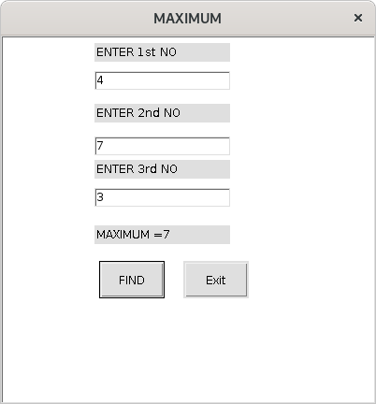

DEPARTMENT OF COMPUTER APPLICATIONS

## Experiment Number:19

**AIM:-** Implement a simple calculator using AWT components.

# Algorithm:-

DEPARTMENT OF COMPUTER APPLICATIONS

# Program Code:-

import java.awt.*; import java.net.*; import java.awt.event.*;

class Calc extends Frame { TextField tf1;

TextField tf2,tf3; Label l1,l2,l3;

Button b1,b2,b3,b4,b5,b6; Calc(){ setTitle("CALCULATOR"); tf1 = new TextField();

l1= new Label("ENTER 1st NO"); l1.setBounds(100,45,145,20); tf1.setBounds(100,75,145,20);

tf2 = new TextField();

l2= new Label("ENTER 2nd NO"); l2.setBounds(100,110,145,20); tf2.setBounds(100,145,145,20);

tf3 = new TextField(); l3= new Label("Result");

l3.setBounds(100,169,145,20); tf3.setBounds(100,185,145,20);

b1 = new Button("+"); b1.setBounds(65,200,80,40);

b2 = new Button("-"); b2.setBounds(155,200,80,40);

b3 = new Button("*"); b3.setBounds(245,200,80,40);

b4 = new Button("/"); b4.setBounds(95,250,80,40);

b5 = new Button("%"); b5.setBounds(195,250,80,40); b6 = new Button("EXIT"); b6.setBounds(140,310,70,40);

DEPARTMENT OF COMPUTER APPLICATIONS

add(b1);

add(b2);

add(b3);

add(b4);

add(b5);

add(b6);

add(l1);

add(tf1);

add(l2);

add(tf2);

add(l3);

add(tf3); setSize(400,400); setVisible(true);

b1.addActionListener(new ActionListener(){

public void actionPerformed(ActionEvent e) { int a = Integer.parseInt(tf1.getText());

int b = Integer.parseInt(tf2.getText()); int c = a+b;

l3.setText(

String.valueOf(a)+"+"+String.valueOf(b)+"="+ String.valueOf(c));

}

});

b2.addActionListener(new ActionListener(){

public void actionPerformed(ActionEvent e) { int a = Integer.parseInt(tf1.getText());

int b = Integer.parseInt(tf2.getText()); int c = a-b;

l3.setText(String.valueOf(a)+"-"+String.valueOf(b)+"="+ String.valueOf(c));

}

});

b3.addActionListener(new ActionListener()

{ public void actionPerformed(ActionEvent e) {

int a = Integer.parseInt(tf1.getText()); int b = Integer.parseInt(tf2.getText());

DEPARTMENT OF COMPUTER APPLICATIONS

int c = a*b; l3.setText(String.valueOf(a)+"*"+String.valueOf(b)+"="+ String.valueOf(c));

}

});

b4.addActionListener(new ActionListener(){

public void actionPerformed(ActionEvent e) { int a = Integer.parseInt(tf1.getText());

int b = Integer.parseInt(tf2.getText()); float c = a/b;

l3.setText(String.valueOf(a)+"/"+String.valueOf(b)+"="+ String.valueOf(c));

}

});

b5.addActionListener(new ActionListener(){

public void actionPerformed(ActionEvent e) { int a = Integer.parseInt(tf1.getText());

int b = Integer.parseInt(tf2.getText()); float c = a%b;

l3.setText(String.valueOf(a)+"%"+String.valueOf(b)+"="+ String.valueOf(c));

}

});

b6.addActionListener(new ActionListener(){

public void actionPerformed(ActionEvent e) { System.exit(0);

}

});

}

public static void main(String []args) { new Calc();

}

}

DEPARTMENT OF COMPUTER APPLICATIONS

# Output:-

ADDITION:-

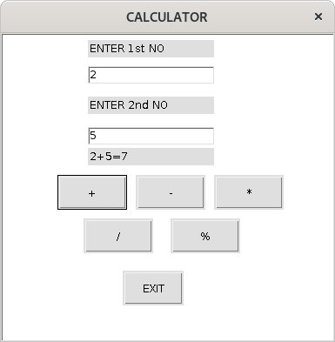

SUBTRACTION:-

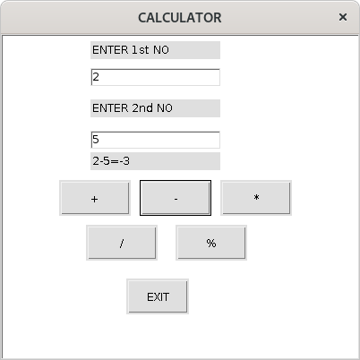

DEPARTMENT OF COMPUTER APPLICATIONS

MULTIPLICATION:-

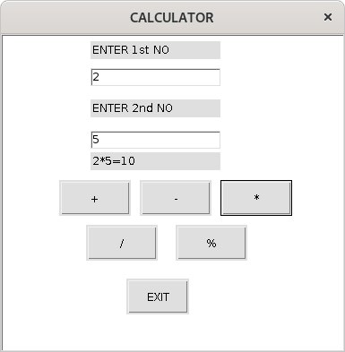

DIVISION:-

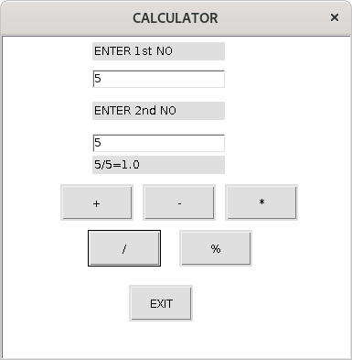

DEPARTMENT OF COMPUTER APPLICATIONS

71