**Authentication:** Implemented rest framework Token authentication

To get token pass the user credentials as below

For valid credentials

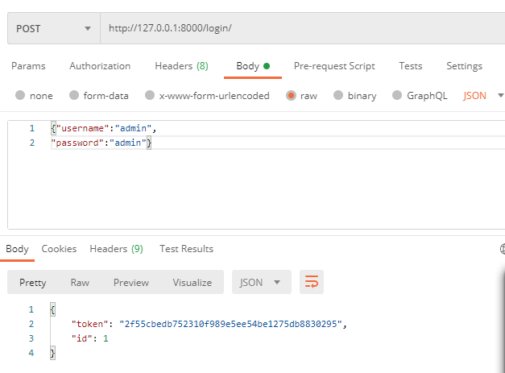

For invalid credentials

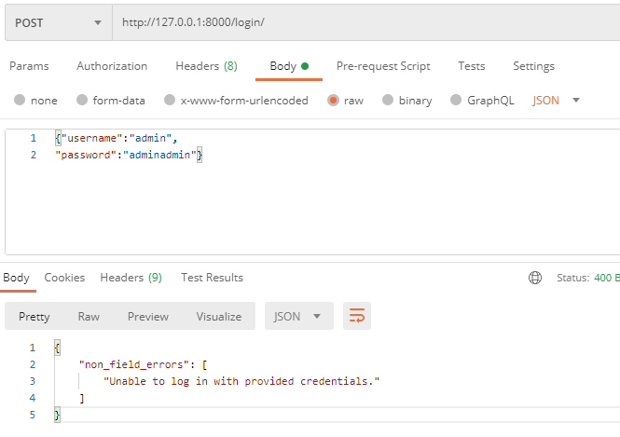

**Access API with Token Authorization:**

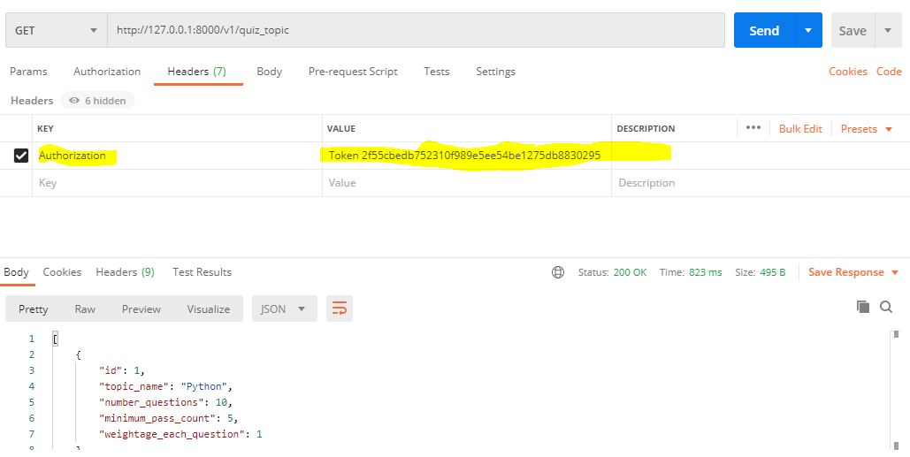

Logout:

