MODULE 3
CONSISTENY AND REPLICATION

In distributed systems, replication maintains multiple data copies for availability and performance, while consistency defines how these copies are updated and synchronized. Key consistency models include Strong Consistency, where all reads see the latest write; Weak Consistency, allowing out-of-order reads; and Eventual Consistency, where replicas converge over time.
It might be difficult to guarantee that all data copies in a distributed system stay consistent over several nodes. The guidelines for when and how data updates are displayed throughout the system are established by consistency models. Various approaches, including strict consistency or eventual consistency, help developers manage trade-offs between data reliability, availability, and performance.

What are Consistency models in distributed systems?

In distributed systems, consistency models establish criteria for data synchronization and specify how users and applications should interpret data changes across several nodes. In a distributed system, it specifically controls how data is accessed and changed across numerous nodes and how clients are informed of these updates. These models range from strict to relaxed approaches.
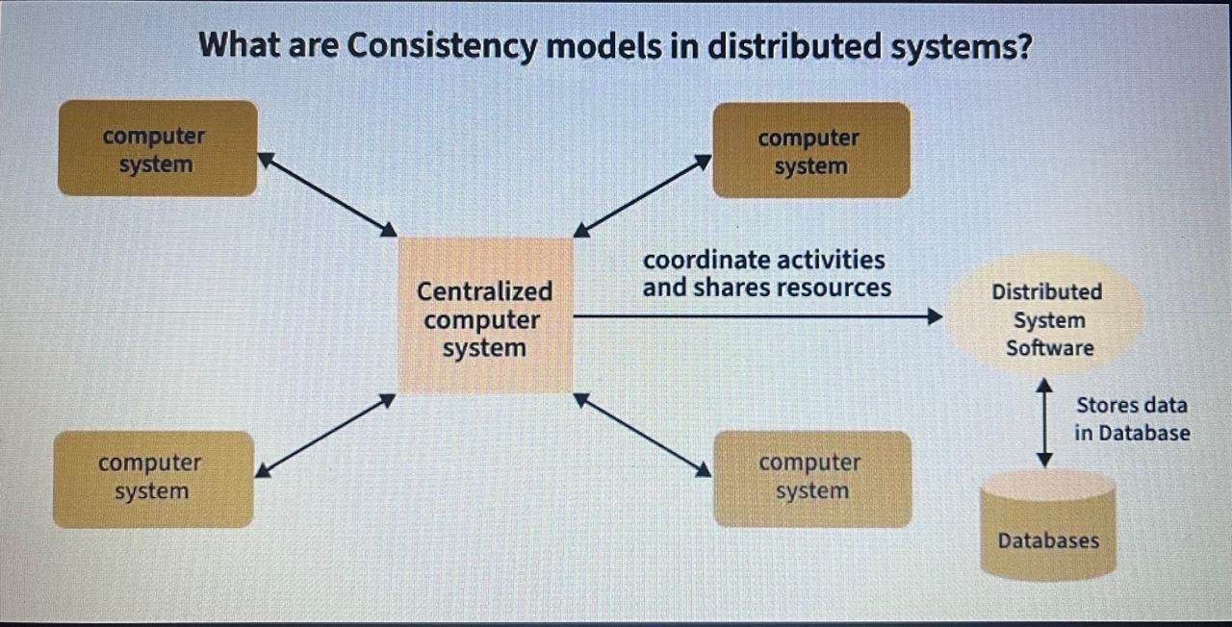

In distributed systems, consistency models come in a variety of forms. Every consistency model has advantages and disadvantages, and the system's particular requirements will determine which model is best.

Types of Consistency Models

1. Strong Consistency
In a strongly consistent system, all nodes in the system agree on the order in which operations occurred. Reads will always return the most recent version of the data, when an update occurs on one server, this model makes sure every other server in the system reflects this change immediately. This model provides the highest level of consistency, but it can be slower and require more resources in a distributed environment since all servers must stay perfectly in sync.

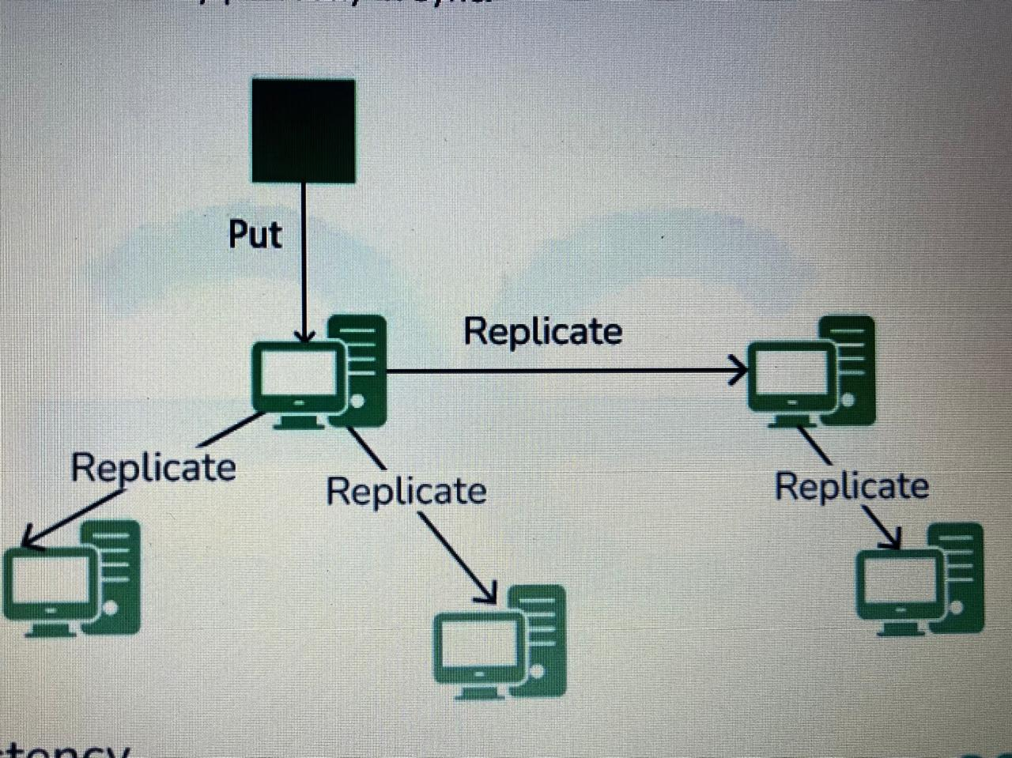
Strict Consistency Model in Distributed System

2. Sequential Consistency Model
It is a consistency model in distributed systems that ensures all operations across processes appear in a single, unified order. In this model, every read and write operation from any process appears to happen in sequence, regardless of where it occurs in the system. Importantly, all processes observe this same sequence of operations, maintaining a sense of consistency and order across the system.

3. Causal Consistency Model
The Causal Consistency Model is a type of consistency in distributed systems that ensures that related events happen in a logical order. In simpler terms, if two operations are causally related (like one action causing another), the system will make sure they are seen in that order by all users. However, if there’s no clear relationship between two operations, the system doesn’t enforce an order, meaning different users might see the operations in different sequences.
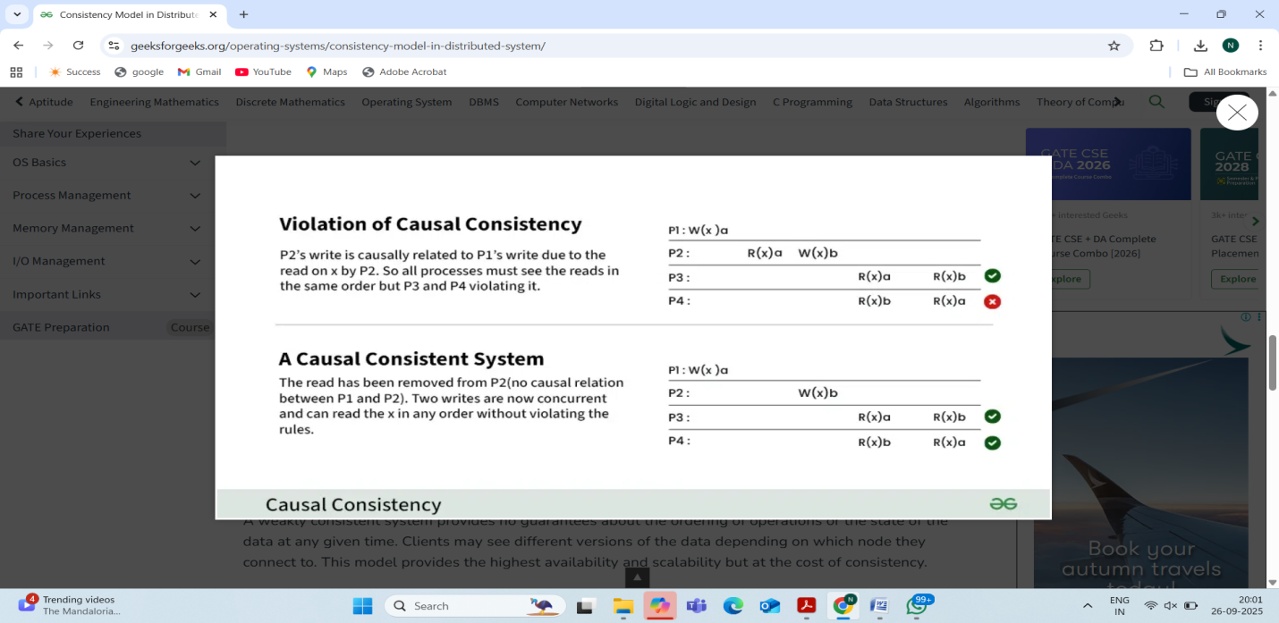
Causal Consistency in Distributed System

4. Weak Consistency Model
A weakly consistent system provides no guarantees about the ordering of operations or the state of the data at any given time. Clients may see different versions of the data depending on which node they connect to. This model provides the highest availability and scalability but at the cost of consistency.

5. Session Consistency
Session Consistency guarantees that all of the data and actions a user engages with within a single session remain consistent. Consider it similar to online shopping: session consistency ensures that an item will always be in your cart until you check out or log out, regardless of how you explore the page.
- In a distributed system, this means if you're interacting with different servers or services, you'll always get the same view of your data during your session.
- It might not reflect the most recent updates from other users, but for your own actions, it will remain consistent and reliable.

6. Monotonic Reads and Writes
Once a piece of data has been read or written, monotonic reads and writes guarantee that the data will always be viewed in a predictable and consistent order in subsequent reads or writes.
- Monotonic Reads: If you read a value from a system, the next time you read it, you will either get the same value or a more recent one. You won’t get an older value after seeing a newer one.
- Monotonic Writes: This ensures that once a write happens, all future writes will follow in the correct order. If you update a record or send a message, the system guarantees that it won’t reverse the order of your updates.

When to choose which Consistency Model?
- Strong Consistency:
  - Select strong consistency if you need to be absolutely certain that every node or data replica always reflects the most recent state.
  - When operations rely on the most recent data and consistency is crucial, like in banking systems or inventory management, it is important.
- Sequential Consistency Model:
  - Opt for sequential consistency when the order of operations matters but a perfect global order isn’t necessary.
  - It’s useful when you need to ensure that operations are executed in a predictable sequence, but don’t require every operation to be fully synchronized across all nodes.
- Causal Consistency Model:
  - Choose causal consistency when you want to ensure that related operations are seen by all nodes in the correct order, but don’t need a strict global order for all operations.
  - It’s good for systems where the relationship between actions matters (like user interactions or social media updates), but strict sequencing is not necessary.
- Weak Consistency Model:
  - Use weak consistency when availability and performance are more critical than absolute consistency, and it's acceptable for the data to be temporarily out of sync.
  - It’s ideal for systems where real-time consistency isn’t critical, but you still want to ensure that the data will eventually become consistent.
- Session Consistency:
  - Choose session consistency when a user's experience within a session needs to be consistent, but across different sessions, you may tolerate some inconsistency.
  - It’s useful for scenarios where users expect to interact with the same data during their session, but data may not need to be synchronized immediately between sessions.
- Monotonic Reads and Writes:
  - This model is best when you need to guarantee that a user’s view of the data will only move forward (not backward) in time.
  - Choose this when the sequence of user actions is important, and you want to avoid confusing the user with inconsistent or outdated information.

CONSISTENCY MODELS
1.Data-Centric Consistency Models
Data-centric consistency models define how data updates are propagated and observed across a distributed system, focusing on the state of the data itself. These models establish a contract between the distributed storage and the processes accessing it, specifying the results of read and write operations.
- Strong Consistency:
Guarantees that all nodes see the latest value of data at all times. Once a write operation is completed, any subsequent read operation, regardless of the node, will return the updated value. This requires high coordination and can impact performance and availability.
- All nodes always see the same latest value for a piece of data.
- After you update (write) a value, any read from any node will immediately return that updated value.
- There’s no temporary inconsistency—everyone sees the newest data right away.
- Requires coordination between all servers (nodes) to make sure the update is propagated before allowing reads.
- This can slow down the system or reduce availability, because if a server is down or slow, the system may wait to synchronize before confirming the write.

- Eventual Consistency:
A more relaxed model where updates eventually propagate throughout the system, but temporary inconsistencies are allowed. If no new updates are made to a data item, all replicas will eventually converge to the same value. This model prioritizes availability and performance over immediate consistency.
• In a distributed system (like databases spread across many servers), when you update some data, that update might not instantly appear on all the servers.
• Different servers might temporarily show different values for the same data (inconsistency).
• But if you stop making new updates and wait long enough, all the servers will synchronize and eventually show the same correct value.

- Causal Consistency:
Ensures that causally related operations are seen in the same order by all processes, while allowing unrelated operations to be seen in different orders. This provides a stronger guarantee than eventual consistency without the strictness of strong consistency.

- If one operation depends on another, everyone must see them in the same order.
- If operations are independent, they can be seen in different orders on different nodes.
- It’s stronger than eventual consistency because it respects cause-and-effect, but not as strict as strong consistency, so it’s faster and more available.
Example:
- Alice posts a message: “I’m going to the party.”
- Bob replies: “I’ll join you.”
- Causally related operations: Alice’s post → Bob’s reply.
  - Everyone must see Alice’s post before Bob’s reply.
- Unrelated operation: Charlie posts about lunch.
  - This can appear before or after Alice/Bob’s messages on different nodes.
- Causal order is preserved where it matters.
- Unrelated operations can be out of order, which keeps the system more efficient and available than strong consistency.

2. Client-Centric Consistency Models
Client-centric consistency models focus on providing a consistent view of data from the perspective of an individual client, even as that client interacts with different servers in a distributed system. These models are designed to enhance user experience by ensuring that a client's own actions and observations are consistently reflected.
- Read Your Writes (RYW):
Guarantees that if a client performs a write operation, any subsequent read operation by that same client will reflect the results of that write. The client will never read an older version of data it has just updated.
- Monotonic Reads:
Ensures that if a client reads a certain value, any subsequent read by that same client will never return an older value. The client will always see a monotonically increasing or stable version of the data.
- Once a client (like a user or application) reads a value from a database, any future reads by that same client will never show an older value.
- The data will either stay the same or move forward (get updated), but it will never go backward.
- It ensures the client sees a consistent progression of data, even if the system is distributed and updates are still propagating.
Example:
- You check your bank balance: $500.
- Someone deposits $100, but the update hasn’t reached all servers yet.
- Later, when you check again, monotonic reads guarantee you won’t see $500 again—you’ll see $600 (or later updates), but never an older value.

- Monotonic Writes:
Guarantees that write operations by a single client are performed in the order they were issued. If a client performs write A and then write B, all other processes will observe A before B.
- When a single client performs multiple writes (updates), they are applied in the exact order the client issued them.
- All other clients (or processes) will see the writes in that same order.
- Prevents situations where later updates appear before earlier updates, which could cause inconsistencies.
Example:
- You update your profile picture to Image A.
- Then you immediately change it to Image B.
- Monotonic writes ensure that everyone sees Image A before Image B, never the reverse.

- Writes Follow Reads:
Ensures that if a client reads a value and then performs a write operation based on that read, the write operation is guaranteed to occur after the read operation in the system's global order. This prevents overwriting based on stale data the client just read.
- If a client reads a value and then writes an update based on that value, the system guarantees that the write will happen after the read in the global order.
- This prevents a client from accidentally overwriting newer updates with stale data.
- Ensures causal relationship between reading and writing is preserved.
- Helps avoid inconsistencies when a write depends on a previous read.
Example:
- You read your bank balance: $500.
- You decide to withdraw $100 based on that read.
- Writes Follow Reads ensures your withdrawal updates the $500 balance correctly, not an older or outdated balance.

- Session Consistency:
Combines Read Your Writes and Monotonic Reads within a single client session. All operations within a session adhere to these guarantees, even if the client interacts with different servers during the session.
Example:
- You add an item to your shopping cart on Amazon.
- Later, you view your cart from a different device or server.
- Session consistency ensures you still see that item in your cart, and previous cart updates are never “lost” or overwritten unexpectedly.

Fault Tolerance in Distributed System
Fault tolerance in distributed systems is the capability to continue operating smoothly despite failures or errors in one or more of its components. This resilience is crucial for maintaining system reliability, availability, and consistency. By implementing strategies like redundancy, replication, and error detection, distributed systems can handle various types of failures, ensuring uninterrupted service and data integrity.
In distributed systems, three types of problems occur. All these three types of problems are related.
- Fault: Fault is defined as a weakness or shortcoming in the system or any hardware and software component. The presence of fault can lead to error and failure.
- Errors: Errors are incorrect results due to the presence of faults.
- Failure: Failure is the outcome where the assigned goal is not achieved.

What is Fault Tolerance?
Fault Tolerance is defined as the ability of the system to function properly even in the presence of any failure. Distributed systems consist of multiple components due to which there is a high risk of faults occurring. Due to the presence of faults, the overall performance may degrade.

Types of Faults
- Transient Faults: Transient Faults are the type of faults that occur once and then disappear. These types of faults do not harm the system to a great extent but are very difficult to find or locate. Processor fault is an example of transient fault.
- Intermittent Faults: Intermittent Faults are the type of faults that come again and again. Such as once the fault occurs it vanishes upon itself and then reappears again. An example of intermittent fault is when the working computer hangs up.
- Permanent Faults: Permanent Faults are the type of faults that remain in the system until the component is replaced by another. These types of faults can cause very severe damage to the system but are easy to identify. A burnt-out chip is an example of a permanent Fault.

Need for Fault Tolerance in Distributed Systems
Fault Tolerance is required in order to provide below four features.
- Availability: Availability is defined as the property where the system is readily available for its use at any time.
- Reliability: Reliability is defined as the property where the system can work continuously without any failure.
- Safety: Safety is defined as the property where the system can remain safe from unauthorized access even if any failure occurs.
- Maintainability: Maintainability is defined as the property states that how easily and fastly the failed node or system can be repaired.

Fault Tolerance in Distributed Systems
In order to implement the techniques for fault tolerance in distributed systems, the design, configuration and relevant applications need to be considered. Below are the phases carried out for fault tolerance in any distributed systems.

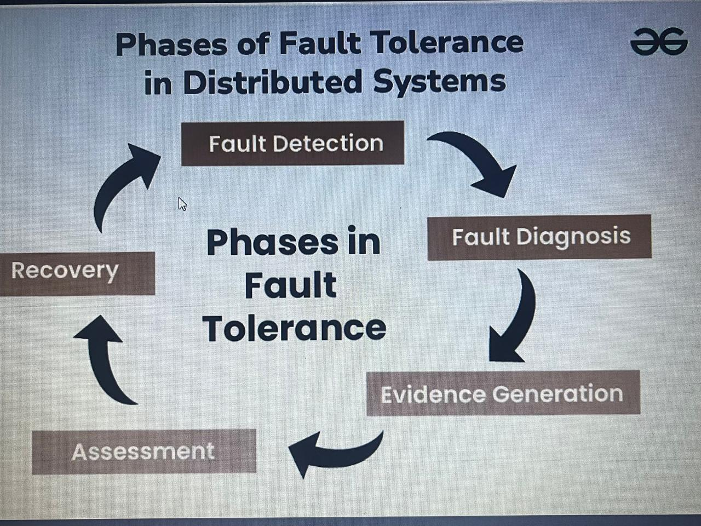

1. Fault Detection
Fault Detection is the first phase where the system is monitored continuously. The outcomes are being compared with the expected output. During monitoring if any faults are identified they are being notified. These faults can occur due to various reasons such as hardware failure, network failure, and software issues. The main aim of the first phase is to detect these faults as soon as they occur so that the work being assigned will not be delayed.

2. Fault Diagnosis
Fault diagnosis is the process where the fault that is identified in the first phase will be diagnosed properly in order to get the root cause and possible nature of the faults. Fault diagnosis can be done manually by the administrator or by using automated Techniques in order to solve the fault and perform the given task.

3. Evidence Generation
Evidence generation is defined as the process where the report of the fault is prepared based on the diagnosis done in an earlier phase. This report involves the details of the causes of the fault, the nature of faults, the solutions that can be used for fixing, and other alternatives and preventions that need to be considered.

4. Assessment
Assessment is the process where the damages caused by the faults are analyzed. It can be determined with the help of messages that are being passed from the component that has encountered the fault. Based on the assessment further decisions are made.

5. Recovery
Recovery is the process where the aim is to make the system fault free. It is the step to make the system fault free and restore it to state forward recovery and backup recovery. Some of the common recovery techniques such as reconfiguration and resynchronization can be used.

Process Resilience
Process resilience in fault tolerance involves designing processes and entire distributed systems to continue operating despite component failures by using techniques like replication, load balancing, caching, and graceful failure handling. Key to achieving this is error detection, where faults are identified, followed by recovery to restore normal service and data consistency, ensuring high availability and preventing single points of failure.

Core Concepts
- Fault:
A malfunction in a system component, such as a node crashing or a network failure.
- Fault Tolerance:
The ability of a system to continue operating correctly and consistently even when one or more components fail.
- Process Resilience:
A system's ability to maintain its functionality in the face of failures, often achieved by making individual processes redundant and ensuring the system can recover from errors.

Key Strategies for Achieving Process Resilience
- Replication:
Running identical copies of a process or service. If one fails, another can take over, providing continuous service.
- Redundancy:
Deploying backup or spare components that can replace failed ones to maintain system function.
- Load Balancing:
Distributing incoming workloads across multiple processes or servers to prevent any single resource from being overwhelmed and to provide failover capabilities.
- Caching:
Storing frequently accessed data in temporary high-performance memory stores (caches) to reduce dependence on the primary service and to serve requests even if the underlying service is temporarily unavailable.
- Graceful Failure Handling:
Designing the system to manage unexpected events or errors without crashing, either by effectively handling the problem or failing in a way that minimizes impact on the overall system.

The Fault Tolerance Lifecycle
To handle failures, a fault-tolerant system typically follows these phases:
- Error Detection: Identifying when a component is not functioning correctly.
- Damage Assessment: Determining the extent of the fault and its potential impact on the system.
- Error Recovery: Taking steps to restore the system to a normal operating state.
- Fault Treatment: Taking action to prevent future occurrences of the same fault and ensuring continued service delivery.

Importance of Resilience in Distributed Systems
Resilience in distributed systems is crucial for maintaining reliability and performance despite failures or disruptions. Here’s why:
- Fault Tolerance: Resilient systems can handle hardware or software failures without significant service interruption, ensuring continuous availability.
- Scalability: They adapt to increased loads by distributing tasks across multiple nodes, improving overall system performance.
- Error Recovery: Resilience mechanisms enable systems to recover quickly from errors, minimizing downtime and data loss.
- User Experience: By maintaining operational stability, resilient systems ensure a seamless experience for users, even during unexpected issues.
- Resource Efficiency: They optimize resource use by dynamically managing workloads and avoiding bottlenecks.

Resilience is essential for ensuring that distributed systems remain robust, efficient, and reliable in the face of challenges.

Design Principles for Resilience in Distributed Systems
Designing resilient distributed systems involves several key principles to ensure reliability and robustness. Here are some fundamental principles:
- Redundancy: Implement multiple instances of critical components to ensure that failure in one instance does not disrupt the entire system. This can be achieved through techniques like replication and failover.
- Fault Isolation: Design the system so that faults are contained within specific components or modules, preventing them from cascading and affecting other parts of the system.
- Graceful Degradation: Ensure that the system continues to operate, albeit at reduced functionality or performance, when parts of it fail. This helps maintain service availability even during partial outages.
- Load Balancing: Distribute workloads evenly across multiple servers or nodes to prevent any single point of overload and improve overall system performance and reliability.
- Consistent State Management: Use distributed consensus algorithms and state replication to maintain data consistency and ensure that all nodes have a coherent view of the system state.
- Monitoring and Alerting: Continuously monitor system performance and health, and set up alerts for anomalies or failures to enable quick responses and preventative maintenance.
- Scalability: Design the system to scale horizontally by adding more nodes rather than relying on scaling up a single node, which can improve resilience and accommodate varying loads.
By adhering to these principles, distributed systems can better withstand failures, adapt to changing conditions, and maintain high levels of service availability and performance.

Architectural Patterns for Resilient Distributed Systems
Architectural patterns play a crucial role in designing resilient distributed systems. Here are some key patterns that enhance resilience:
- Microservices Architecture:
  - Breaks down applications into small, loosely coupled services that can be developed, deployed, and scaled independently.
  - Isolates faults to individual services, reducing the impact on the overall system. Each service can be scaled or replaced independently.
- Replication:
  - Maintains multiple copies of data or services across different nodes or locations.
  - Ensures high availability and fault tolerance by allowing the system to continue operating even if some replicas fail.
- Sharding:
  - Divides a large dataset into smaller, manageable pieces (shards) that are distributed across multiple servers.
  - Reduces the load on any single server and improves performance and scalability, allowing the system to handle more traffic.
- Circuit Breaker:
  - Monitors interactions between services and prevents failures from cascading by halting requests to failing services.
  - Protects the system from complete failure by stopping requests to malfunctioning services, allowing them to recover.
- Load Balancing:
  - Distributes incoming requests or workloads evenly across multiple servers or instances.
  - Prevents overloading of individual servers and improves system reliability and responsiveness.
- Failover and Backup:
  - Automatically switches to a standby system or backup in case of a failure in the primary system.
  - Minimizes downtime and maintains service availability by quickly transitioning to a secondary system.
- Service Mesh:
  - Provides a dedicated infrastructure layer for managing microservices communications, including load balancing, service discovery, and fault tolerance.
  - Enhances observability and control over service interactions, improving fault isolation and recovery.

Failure Models and Analysis for Resilient Distributed Systems
Below are some failure models and failure analysis techniques for resilient distributed systems:

1. Failure Models
- Crash Failures:
  - Nodes or processes stop functioning suddenly and do not recover. They may cease communication and fail to process requests.
  - The system must handle sudden losses of nodes and ensure data consistency and availability through redundancy or failover strategies.
- Omission Failures:
  - Nodes fail to send or receive messages, leading to incomplete or missing communication.
  - Requires mechanisms like timeouts and retries to detect and manage missing messages.
- Timing Failures:
  - Nodes fail to meet timing constraints, such as responding within a certain time frame, causing delays or missed deadlines.
  - Systems must be designed with tolerance for variability and implement monitoring to handle delays gracefully.
- Byzantine Failures:
  - Nodes exhibit arbitrary or malicious behavior, including sending conflicting or incorrect information.
  - Requires sophisticated consensus algorithms and fault-tolerant mechanisms to ensure correct system operation despite faulty or malicious nodes.
- Network Partitions:
  - The network is split into disjoint segments, causing nodes in different segments to be unable to communicate.
  - The system needs to handle partitioned states and ensure data consistency and coordination across partitions.
- Data Corruption:
  - Data becomes incorrect or corrupted, either due to hardware failures, software bugs, or malicious attacks.
  - Data integrity checks and redundancy mechanisms are essential to detect and correct corrupted data.

2. Failure Analysis Techniques
- Failure Modes and Effects Analysis (FMEA):
  - Systematically identifies potential failure modes, their causes, and their effects on the system.
  - Helps in prioritizing risk mitigation strategies based on the impact and likelihood of failure modes.

- Failure Tree Analysis (FTA):
  - Uses a top-down approach to identify and analyze potential causes of system failures, represented in a tree structure.
  - Provides a detailed understanding of failure dependencies and helps in designing appropriate redundancy and fault tolerance.
- Failure Injection Testing:
  - Intentionally introduces failures or faults into the system to test its resilience and response mechanisms.
  - Validates the effectiveness of fault tolerance strategies and uncovers weaknesses in the system.
- Chaos Engineering:
  - Proactively introduces controlled disruptions into the system to observe and improve its resilience.
  - Enhances the system's ability to withstand and recover from real-world failures.
- Performance Monitoring and Logging:
  - Continuously monitors system performance and logs events to detect and analyze failures.
  - Provides insights into system behavior under failure conditions and aids in diagnosing and addressing issues.
RPC semantics in the presence of failures
RPC semantics in the presence of failures refers to how Remote Procedure Call (RPC) systems define the effects and guarantees of executing a remote procedure when failures occur, such as network errors, crashes, or timeouts.
Because RPC involves communication over networks and potentially interacting with remote systems that may fail or behave unpredictably, understanding what the client can expect when something goes wrong is critical.

Types of RPC Semantics in the Presence of Failures
There are three main types of failure semantics for RPC systems:

1. At-most-once Semantics
- Guarantee: The procedure is executed no more than once.
- Prevents duplicate side effects.
- Often used in critical systems where duplicated operations are dangerous (e.g., money transfers).
- Usually implemented using unique request IDs and duplicate request suppression.
Safe but possibly incomplete: the operation might not happen if a failure occurs before execution.

2. At-least-once Semantics
- Guarantee: The procedure is executed at least once.
- Ensures the operation will happen eventually, even if retries are needed.
- Duplicates may occur if the client retries after timeouts and the server already completed the operation.
🔁 Reliable but risky: not ideal for non-idempotent operations (operations that must not be repeated).

3. Exactly-once Semantics
- Guarantee: The procedure is executed exactly one time, even in the face of retries or failures.
- Most desirable but hardest to implement.
- Requires coordination, state tracking, and idempotency checks on both client and server.
- Achievable in some cases with transactions, message queues, or idempotent designs.

Reliable Client-Server Communication in a Distributed System

Reliable client-server communication in a distributed system refers to the dependable exchange of data between clients and servers across a network. Ensuring this reliability is critical for maintaining system integrity, consistency, and performance.
- Challenges like network latency, packet loss, and data corruption can hinder effective communication. Addressing these issues involves using robust protocols and error-handling techniques.
- In this article, we will explore the importance of reliable communication, common challenges, and the best practices for achieving it in distributed systems

What Is Reliable Communication?
In distributed systems, reliable communication ensures that messages (e.g., RPC calls, requests/responses) between a client and server are:
- Delivered (eventually reach the destination)
- Delivered once (no duplicates unless allowed)
- Delivered in order (when required)
- Handled correctly, even in the face of failures
The communication system should mask failures (as much as possible) and provide guarantees to the application layer.

Why It's Hard in Distributed Systems
Distributed systems face many failure modes:
Failure Type | Description
Network failures | Packet loss, delay, duplication, reordering
Process failures | Crashes, hangs, or slow responses
Message corruption | Bit errors or malformed packets
Partial failures | Some components fail, others don't
Asynchronous systems | No global clock, unpredictable delays

Communication Models

A. Synchronous (Blocking) Communication
- Client waits for the server response (e.g., RPC)
- Easier for logic, but can block indefinitely if the server or network is down

B. Asynchronous (Non-blocking) Communication
- Client sends message and continues
- Often used with callbacks, promises, or message queues
- More complex, but increases responsiveness and resilience

Techniques to Achieve Reliability

1. Timeouts and Retransmissions
- If no response is received within a timeout, retry
- Can lead to duplicate messages if the original was actually delivered

2. Sequence Numbers
- Add a unique ID to each message (request ID)
- Receiver can detect duplicates or reordered messages

3. Acknowledgments (ACKs)
- Server sends ACK to confirm receipt
- Client resends if no ACK received

4. Idempotent Operations
- Ensure that re-executing a request does not change the result
- Crucial for safely retrying requests (e.g., PUT instead of POST)

5. Persistent Storage (Durability)
- Server logs received requests and results
- Helps in recovery after crashes (e.g., replay logs)

6. Two-Phase Commit (2PC)
- Used in transactional systems to ensure atomic commitment across systems
- Coordinates actions so that either all or none of the nodes commit

7. Reliable Transport Protocols
- Use TCP instead of UDP:
  - TCP provides in-order, reliable delivery with retransmissions and congestion control
  - But even TCP doesn’t guarantee exactly-once semantics!

Importance of Reliable Communication
Reliable communication is vital for ensuring the smooth operation of distributed systems. It guarantees that data transmitted between clients and servers remains accurate and consistent. Here are several key reasons why reliable communication is essential:

- Data Integrity: Ensuring data integrity means that the information sent is received without errors. This is crucial for applications like financial transactions where accuracy is paramount.
- Consistency: Consistent communication prevents data mismatches across different parts of the system. This helps maintain a unified state across distributed nodes.
- System Performance: Maintaining reliable communication helps in optimizing system performance. It reduces the need for repeated data transmissions and reprocessing.
- Security: Reliable protocols often include security features that protect data from interception and tampering. This ensures that sensitive information remains confidential and intact.
- Scalability: As systems grow, maintaining reliable communication becomes more challenging. Reliable communication strategies support scalable solutions that can handle increased load without compromising performance.

Common Challenges in Client-Server Communication
Maintaining reliable client-server communication in distributed systems can be complex due to various inherent challenges. These challenges can impact the system's performance, data integrity, and overall user experience. Here are some common issues faced in client-server communication:

- Network Latency: Delays in data transmission can slow down system responses. High latency can degrade user experience and hinder real-time processing.
- Packet Loss: Data packets may get lost during transmission due to network issues. Packet loss can lead to incomplete or corrupted messages, affecting data integrity.
- Data Corruption: Errors during transmission can corrupt data, rendering it unusable. Ensuring data integrity requires robust error detection and correction mechanisms.
- Concurrency Issues: Simultaneous data requests can cause conflicts and inconsistencies. Managing concurrent requests effectively is crucial for maintaining data consistency.
- Scalability: As the system grows, ensuring reliable communication becomes more challenging. Increased traffic can strain network resources and lead to performance bottlenecks.
- Security Threats: Data transmitted over the network can be intercepted or tampered with. Implementing strong encryption and security measures is essential to protect sensitive information.

Protocols and Techniques for Reliable Communication

Ensuring reliable communication in a distributed system requires a combination of robust protocols and effective techniques. Here are several key methods and protocols that help achieve dependable client-server communication:

- Transmission Control Protocol (TCP): TCP ensures reliable, ordered, and error-checked delivery of data between applications. It manages packet loss by retransmitting lost packets and ensures data integrity through checksums.
- HTTP/2 and HTTP/3: These protocols improve performance and reliability with features like multiplexing, which allows multiple requests and responses simultaneously over a single connection. They also include header compression to reduce overhead.
- Message Queues: Systems like RabbitMQ and Apache Kafka help manage message delivery. They queue messages and retry sending them if they fail, ensuring no message is lost even if the server is temporarily unavailable.
- Acknowledgment Mechanisms: Implementing acknowledgment protocols ensures that a message is received and processed. If an acknowledgment is not received, the message can be resent.
- Automatic Repeat reQuest (ARQ): ARQ is a protocol for error control that automatically retransmits lost or corrupted packets. This technique ensures that all data reaches its destination intact.
- Forward Error Correction (FEC): FEC adds redundant data to the original message. This allows the receiver to detect and correct errors without needing a retransmission.

Error Detection and Correction Mechanisms
Error detection and correction mechanisms are essential for maintaining data integrity in client-server communication. They ensure that any data corrupted during transmission is identified and corrected.
Below are several key mechanisms used in distributed systems:
- Checksums: Checksums generate a small value from a block of data. The sender includes this value with the data, and the receiver recalculates it to verify integrity.
- Cyclic Redundancy Check (CRC): CRC is a more advanced form of checksum. It uses polynomial division to detect errors in transmitted messages.
- Parity Bits: Parity bits add an extra bit to data to make the number of set bits either even or odd. This helps detect single-bit errors.
- Hamming Code: Hamming code adds redundant bits to data. It detects and corrects single-bit errors and detects two-bit errors.
- Automatic Repeat reQuest (ARQ): ARQ protocols, like Stop-and-Wait and Go-Back-N, request retransmission of corrupted or lost packets. This ensures reliable delivery.
- Forward Error Correction (FEC): FEC adds redundant data to enable the receiver to detect and correct errors without needing retransmission.

Examples of Reliable Client-Server Communication
Reliable client-server communication is crucial for various real-world applications where data integrity and performance are paramount. Below are some examples demonstrating its importance:
- Financial Systems: In banking and stock trading platforms, reliable communication ensures transaction accuracy and data consistency. A single error can lead to significant financial loss and undermine trust.
- E-commerce Platforms: Online shopping sites rely on dependable communication for inventory management and payment processing. This ensures users have a smooth and secure shopping experience.
- Healthcare Systems: Electronic health records and telemedicine services require accurate and timely data exchange. Reliable communication ensures patient information is correct and up-to-date.
- Cloud Services: Cloud platforms like AWS and Google Cloud maintain data consistency and availability across distributed servers. This enables seamless access and high availability for users.
- Gaming Applications: Multiplayer online games need real-time data synchronization to ensure a fair and enjoyable experience. Reliable communication minimizes lag and prevents data discrepancies.
- IoT Devices: Smart home systems and industrial IoT applications rely on consistent data transmission. This ensures devices function correctly and respond promptly to commands.

Best Practices for Reliable Client-Server Communication in a Distributed System
Ensuring reliable client-server communication in a distributed system requires a combination of strategies. Here are several best practices that can help achieve robust and efficient communication:

- Implement Redundancy: Use multiple communication channels to provide backup in case one fails. This ensures that if one channel goes down, the system can continue to function without interruption.
- Monitor Network Performance: Regularly monitor the network to identify and address issues like latency and packet loss. This helps in maintaining optimal performance and preemptively resolving potential problems.
- Apply Security Measures: Encrypt data to protect it from interception and tampering during transmission. Secure communication channels prevent unauthorized access and ensure data integrity.
- Use Message Queues: Implement message queues like RabbitMQ or Kafka to manage and retry failed messages. These systems ensure that messages are delivered even if the initial attempt fails.
- Acknowledge and Retry Mechanisms: Ensure that the server acknowledges received messages and clients retry sending if no acknowledgment is received. This confirms that messages are not lost during transmission.
- Test Thoroughly: Conduct extensive testing under various conditions to identify and fix potential communication issues. Regular testing helps ensure the system can handle real-world scenarios effectively.
- Implement Load Balancing: Distribute network traffic evenly across multiple servers to prevent overload. This improves system performance and reliability, especially under high load.

Reliable client-server communication is essential for the success of distributed systems. By addressing common challenges and implementing robust protocols, we can ensure data integrity and system efficiency. Effective error detection and correction mechanisms are crucial in maintaining seamless interactions. Adopting best practices further enhances reliability and performance. Understanding these principles helps in designing resilient systems that meet user expectations. Mastering these strategies is key to achieving dependable communication in any distributed environment.

Reliable Group Communication in Distributed Systems

Group communication in distributed systems refers to the process where multiple nodes or entities communicate with each other as a group.
- Instead of sending messages to individual recipients, group communication allows a sender to transmit information to all members of a group simultaneously.
- This method is essential for coordinating actions, sharing data, and ensuring that all participants in the system are informed and synchronized. It's particularly useful in scenarios like collaborative applications and real-time updates.

+-----------+ +-----------+ +-----------+
| Process A | -----> | Process B | -----> | Process C |
+-----------+ +-----------+ +-----------+
| | |
| Send Message | Deliver Message | Deliver Message
|------------------->|------------------->|------------------->

Reliable multicast + ordering + retransmission + agreement

Importance of Group Communication in Distributed Systems

Group communication is critically important in distributed systems due to several key reasons:
- Multiple nodes must collaborate and synchronize their actions. Group communication helps them exchange information and stay updated.
- Different nodes can create data that needs to be shared. Group communication helps quickly send this information to everyone involved, reducing delays and keeping data consistent.
- Group communication protocols enhance reliability by allowing messages to be replicated or acknowledged across multiple nodes. This ensures robust communication, even during failures or network issues.
- As distributed systems expand, effective scaling is crucial. Group communication mechanisms can manage more nodes and messages without sacrificing performance, keeping the system efficient and responsive.

Types of Group Communication in a Distributed System

Below are the three types of group communication in distributed systems:

1. Unicast Communication
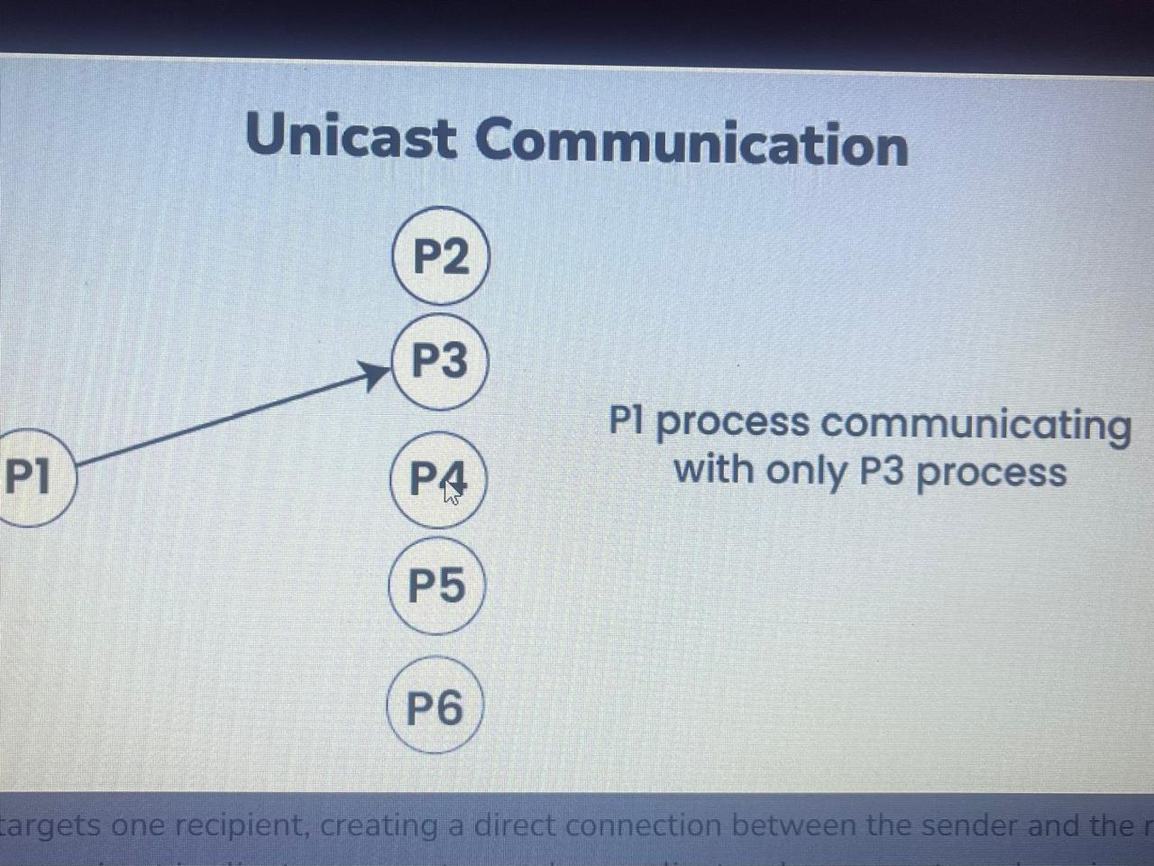

Unicast communication is the point-to-point transmission of data between two nodes in a network. In the context of distributed systems:

- Unicast is when a sender sends a message to a specific recipient, using their unique network address.
- Each message targets one recipient, creating a direct connection between the sender and the receiver.
- You commonly see unicast in client-server setups, where a client makes requests and receives responses, as well as in direct connections between peers.
- This method makes good use of network resources, is easy to implement, and keeps latency low because messages go straight to the right person.
- Unicast isn’t efficient for sending messages to many recipients at once, as it requires separate messages for each one, leading to more work.

2.Multicast Communication

Multicast communication involves sending a single message from one sender to multiple receivers simultaneously within a network. It is particularly useful in distributed systems where broadcasting information to a group of nodes is necessary:
- Multicast lets a sender share a message with a specific group of people who want it.
- This way, the sender can reach many people at once, which is more efficient than sending separate messages.
- This approach is often used to send updates to subscribers or in collaborative applications where real-time sharing of changes is needed.
- By sending data just once to a group, multicast saves bandwidth, simplifies communication, and can easily handle a larger number of recipients.
- Managing group membership is necessary to ensure reliable message delivery, and multicast can run into issues if there are network problems that affect everyone in the group.

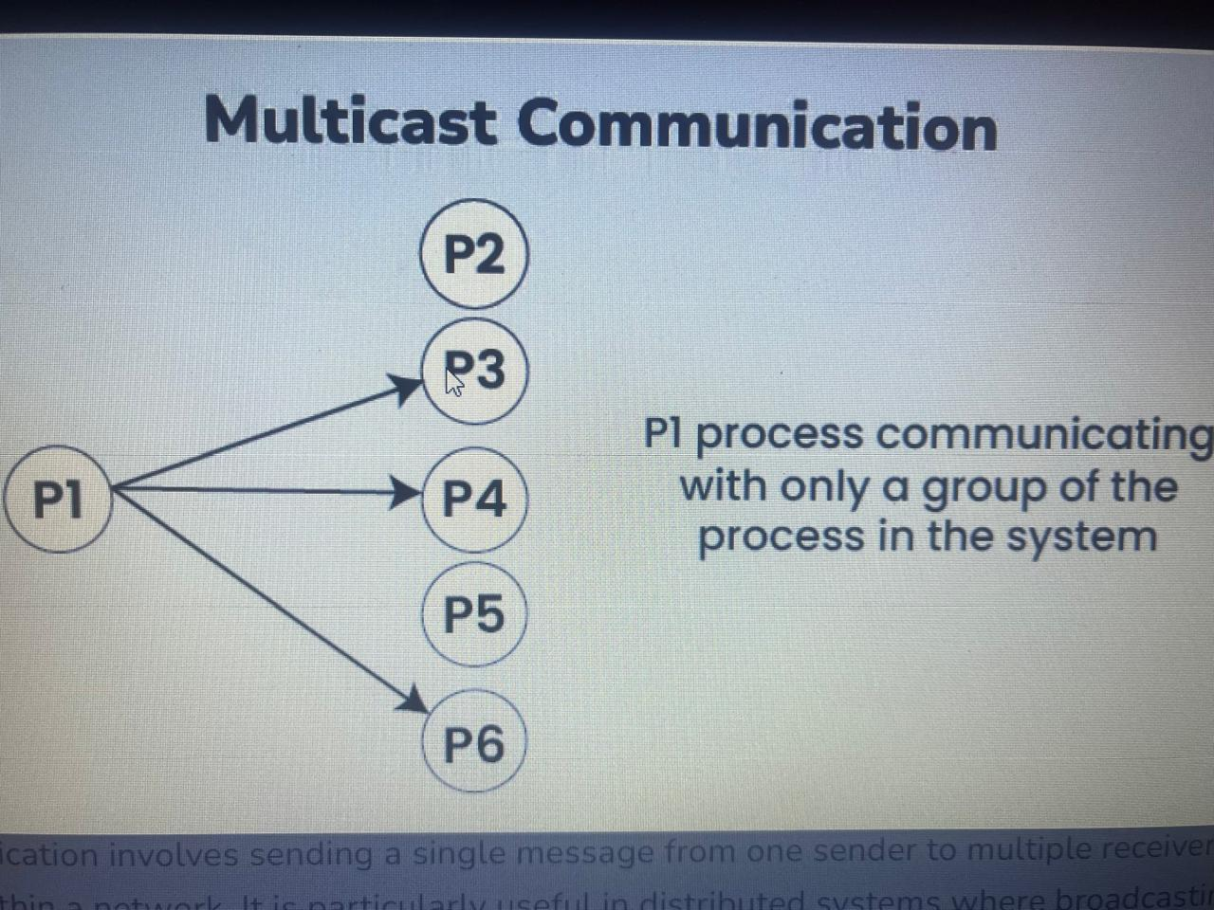

Broadcast Communication
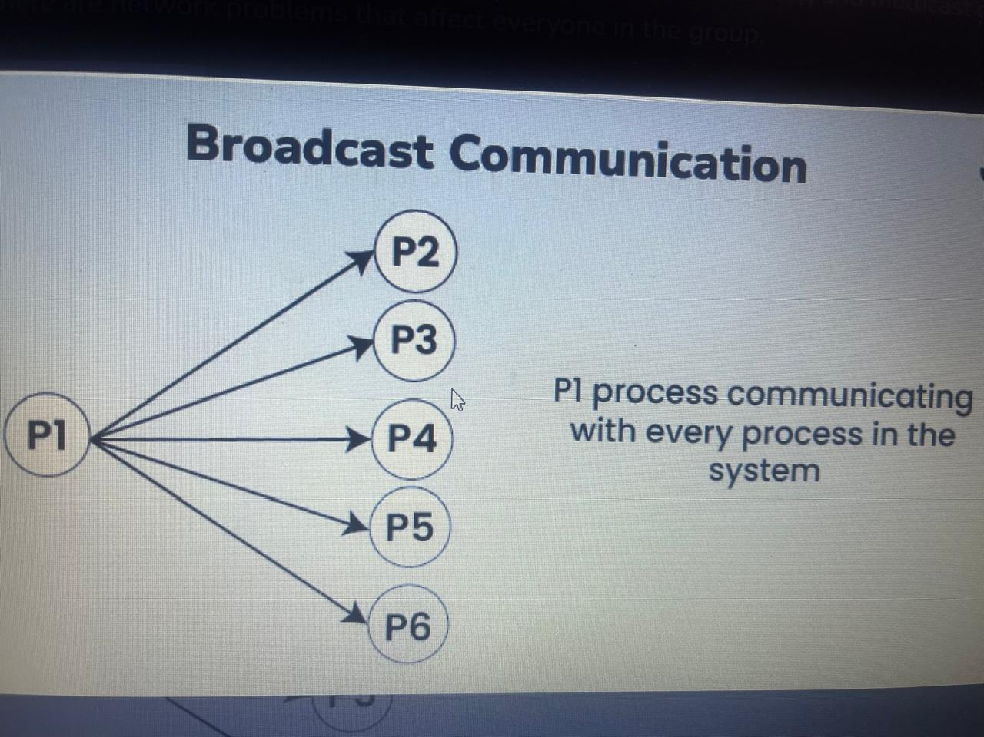
- Broadcast is when a sender sends a message to every node in the network without targeting specific recipients.
- Messages are delivered to all nodes at once using a special address designed for this purpose.
- It’s often used for network management tasks, like sending status updates, or for emergency alerts that need to reach everyone quickly.
- Broadcast ensures that every node receives the message without needing to specify who the recipients are, making it efficient for sharing information widely.
- It can cause network congestion in larger networks and raises security concerns since anyone on the network can access the broadcast message, which might lead to unauthorized access.

Reliable Multicast Protocols for Group Communication
Messages sent from a sender to multiple recipients should be delivered reliably, consistently, and in a specified order. Types of Reliable Multicast Protocols include:

- FIFO Ordering:
  - Ensures that messages are delivered to all group members in the order they were sent by the sender.
  - Achieved by sequencing messages and delivering them sequentially to maintain the correct order.
- Causal Ordering:
  - Preserves the causal relationships between messages based on their dependencies.
  - Ensures that messages are delivered in an order that respects the causal dependencies observed by the sender.
- Total Order and Atomicity:
  - Guarantees that all group members receive messages in the same global order.
  - Ensures that operations based on the multicast messages (like updates to shared data) appear atomic or indivisible to all recipients.

Scalability for Group Communication
Scalability and performance are vital for effective group communication in distributed systems. It’s essential for the system to handle more nodes, messages, and participants while still operating efficiently. Here’s a closer look at these important aspects:

1. Scalability
Scalability refers to the system's ability to grow without losing efficiency. This includes:
- Managing an increasing number of nodes or participants while keeping communication smooth.
- Handling more messages exchanged among group members, ensuring timely and responsive communication.
- Supporting connections across distant nodes or networks, which can introduce latency and bandwidth issues.

2. Challenges in Scalability
As the group size grows, several challenges arise:
- The management of group membership and message routing becomes more complex, adding overhead.
- The network must have enough bandwidth to support the higher traffic from a larger group to avoid congestion.
- Keeping distributed nodes consistent and synchronized gets more complicated as the system scales.

3. Strategies for Scalability
To tackle these challenges, various strategies can be employed:
- Partitioning and Sharding: Breaking the system into smaller parts can make communication and management more manageable.
- Load Balancing: Evenly distributing the workload across nodes helps prevent bottlenecks and optimizes resource use.
- Replication and Caching: Duplicating data or messages across nodes can lower access times and enhance fault tolerance, aiding scalability.

Performance for Group Communication
Performance in group communication is crucial for optimizing message speed, resource utilization, and addressing challenges like message ordering and concurrent access, ensuring efficient collaboration in distributed systems.

1. Performance
In group communication, performance focuses on a few key areas:
- It’s crucial to minimize the time it takes for messages to reach their intended recipients.
- We want to enhance the rate at which messages are handled and sent out.
- Efficient use of bandwidth, CPU, and memory helps keep communication fast and effective.

2. Challenges in Performance
There are challenges that come with achieving high performance:
- Making sure messages arrive in the right order can be tough, especially with strict protocols.
- Handling multiple users trying to access shared resources at the same time can lead to slowdowns.
- Communication needs to adjust based on changing conditions, like slow bandwidth or lost packets.

3. Strategies for Improvement
To boost performance, consider these strategies:
- Smart Routing: Using efficient routing methods can reduce delays by cutting down on the number of hops messages take.
- Asynchronous Communication: This allows senders and receivers to work independently, improving responsiveness.
- Pre-storing Data: Keeping frequently accessed messages or data ready can help lower delays and speed up responses.

Challenges of Group Communication in Distributed Systems
Group communication in distributed systems comes with several challenges due to the need to coordinate multiple nodes that may be spread out or connected through unreliable networks. Key challenges include:
- Reliability: Messages must reach all intended recipients, even during network failures or node crashes, which can be complicated when nodes frequently join or leave.
- Scalability: As the number of participants grows, managing communication effectively becomes harder, leading to issues with bandwidth usage and processing delays.
- Concurrency and Consistency: Keeping shared data consistent while allowing simultaneous updates is tricky, requiring strong synchronization to avoid conflicts.
- Fault Tolerance: The system must handle node failures and communication issues without losing reliability. This means having mechanisms to detect failures and manage changes in group membership.

Basic Reliable-Multicasting Schemes
To reliably deliver messages to a known set of receivers, handling failures like message loss.
- Mechanisms:
  - Sequence Numbers: Senders assign sequence numbers to messages to help receivers detect missing packets.
  - Acknowledgments: Receivers send acknowledgments to confirm message receipt.
  - History Buffer: Senders keep sent messages in a history buffer until all receivers acknowledge them.
  - Negative Acknowledgments: If a receiver misses a packet, it can send a negative acknowledgment to request a retransmission from the sender.
- Limitations:
These schemes typically do not handle dynamic group membership changes or the complex failure scenarios that arise with a large number of processes.

Three Basic Reliable Multicast Techniques

ACK-based (Positive Acknowledgment) Scheme
- Each receiver sends an ACK back to the sender after receiving the message.
- Sender retransmits if ACK is not received.
- Works well for small groups.
- Drawback: ACK explosion problem for large groups (too many ACKs overwhelm sender).

NAK-based (Negative Acknowledgment) Scheme
- Receiver sends a NAK only when it detects a missing message.
- Sender retransmits the missing message upon receiving NAK.
- More efficient in large groups.
- Problem: NAK implosion if many receivers miss the same message.

Reliable Multicast with Designated Retransmitters
- Use designated nodes (e.g., a tree or hierarchy) to handle retransmissions.
- Distributes load and reduces ACK/NAK overhead.
- Used in protocols like Scalable Reliable Multicast (SRM).

Atomic Multicast
- Purpose:
To ensure that a message is either delivered to all correct members of the group or to no members at all.
- Guarantee:
A message is delivered atomically if it is delivered to every non-faulty process in the group, or if it is never delivered to any process. This provides strong consistency for the operations derived from these messages.
Virtual Synchrony
- Purpose:
To provide a powerful guarantee where all members of a group experience group membership changes and messages in the same globally consistent order.
- Mechanisms:
  - Group Membership: The system manages group membership changes, which are separated into "epochs".
  - Hold-back Queue: A hold-back queue stores incoming multicast messages at each server node.
  - Coordination: Messages are delivered from the queues after coordination between servers, ensuring a consistent, totally-ordered sequence.
- Characteristics:
Virtual synchrony combines the reliability and ordering guarantees of atomic multicast with the ability to handle dynamic group membership, making it a more robust model for distributed systems.
Summary of Guarantees (from most basic to advanced)
1. Reliable Multicast:
All correct processes receive all messages sent to the group, potentially in any order.
2. Causal-Ordered Multicast:
All messages are delivered in an order that respects causal dependencies, ensuring that if A causally precedes B, then A is delivered before B.
3. FIFO-Ordered Multicast:
Messages from a single sender are delivered in the order they were sent.
4. Total-Ordered Multicast:
All processes deliver all messages in the exact same global order, regardless of the sender.
5. Atomic Total-Ordered Multicast (Virtual Synchrony):
All correct processes receive all messages in the same total order, even in the presence of failures, and also experience group membership changes in this same consistent order.

