Storage Accounts:

* High availability and Durability - Replicated across different regions
* Security – By default all the data is encrypted by storage service, encryption to access data storage account provides different authorization methods such storage keys, shared access signatures, Azure active directory which is Microsoft Entra ID.
* Scalability
* Accessibility – http, https can be used to access the data that is stored in azure storage.

Azure offers 2 performance tiers for storage accounts

* Standard Tier [ workloads that doesn’t require a high throughput, low latency]
* Premium Tier [workloads that requires High performance, Low latency, high Throughput such as databases and high performance computing]

Azure storage provides variety of services to meet different storage needs those are containers, tables, files and ques.

We have a container and we have a multiple blobs inside that for Documents, videos, audios, images etc.

Azure Files offers a fully managed file share in the cloud accessed via SMB protocol.

Azure Table provides a solution for storing No SQL data.

Queue Storage is a service for storing large number of messages that can be accessed from anywhere in the world over authenticated http, https call.

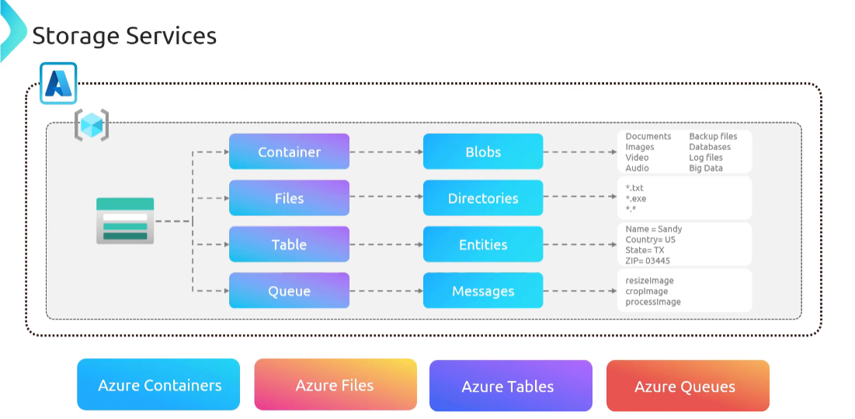

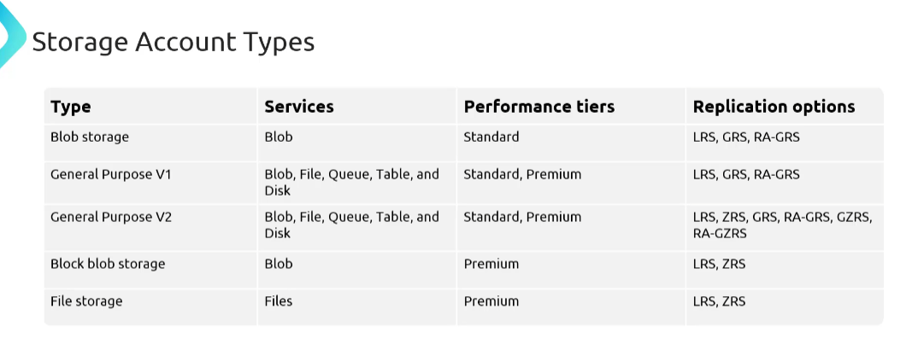

**Storage Replication – Locally Redundant Storage (LRS):**

Data stored in LRS protected from Hardware failure as data is stored in different fault domain.

If the entire data centre is down then the data will not be available.

Durability 99.99999999999(11 9’s)

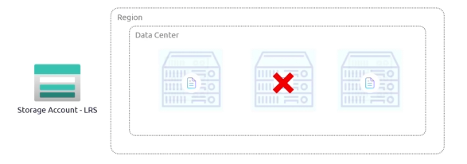

**Storage Replication – Zone Redundant Storage (ZRS):**

Availability zone – collection of data centres which are located 300 miles away

Data replicated with in region across 3 different availability zones

Data protected from datacentre failure, and durability is up to 99.999999999999(12 9’s)

If entire region goes down then the data will not be available

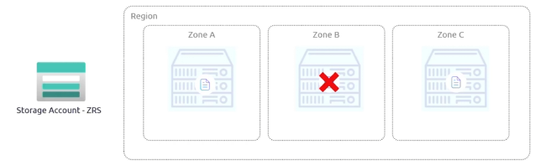

**Storage Replication – Geo Redundant Storage:**

LRS + LRS

Secondary region will be available for read operations only and it will only available when there is a failover.

Failover can be customer initiative or Microsoft

Durability - 99. (60 9’s)

Primary region available all the operation and secondary region is available only after the secondary region failure.

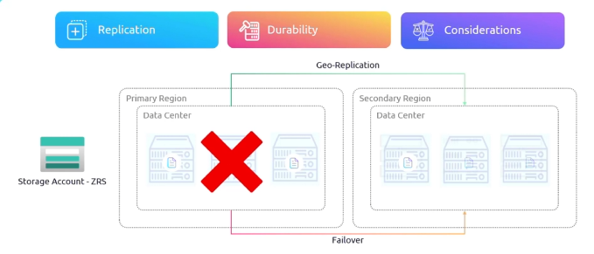

**Storage Replication – Read Access Geo Redundant Storage:**

ZRS + ZRS

Without fail over we can access data from secondary region that’s it is called as RA-GRS

Works same as GRS

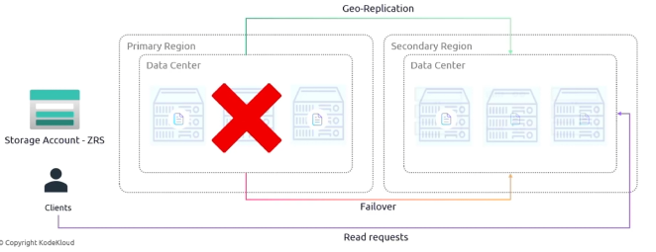

**Storage Replication - Geo Zone Redundant Storage:**

GRS + LRS

Secondary region available only when primary region fail overs.

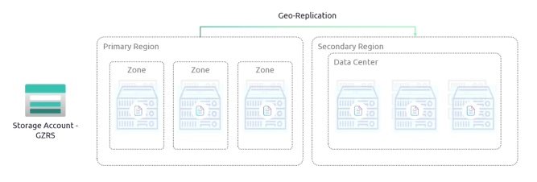

**Storage Replication – Read Access Geo Zone Redundant Storage:**

Same like GZRS but, without fail over we will be able to access the secondary region.

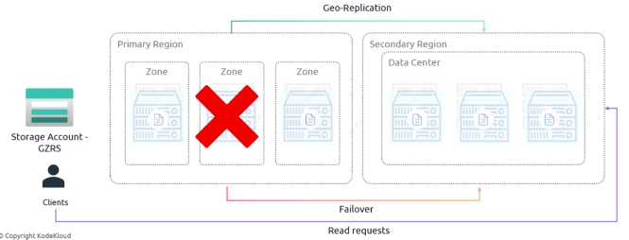

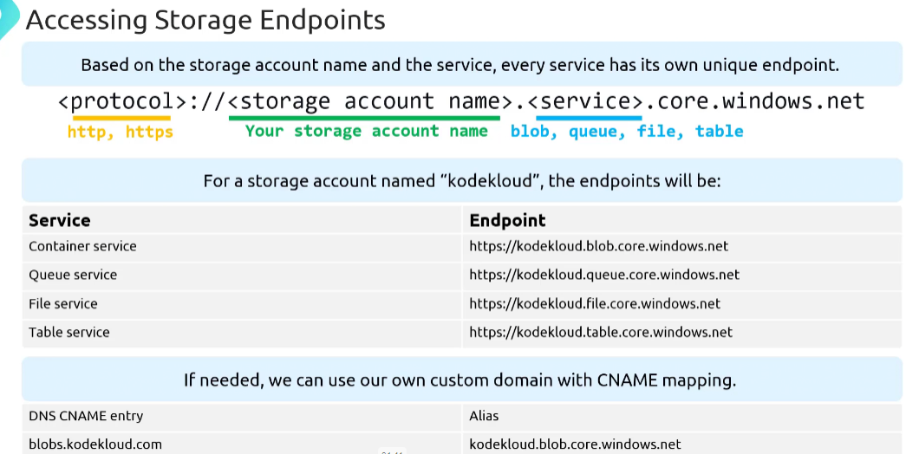

**Storage Tiers:**

Hot – ideal for data that is accessed frequently and needs to be highly available

Cool – only accessible for occasional access.

Archive - rarely accessed and retrieval times of several hours. – Most economical but comes up with highest accessible cost. – Mostly suitable for blob storage.

