Storage Account = unique azure name space

* Every object in azure has its own web address.

BLOB (binary large object)

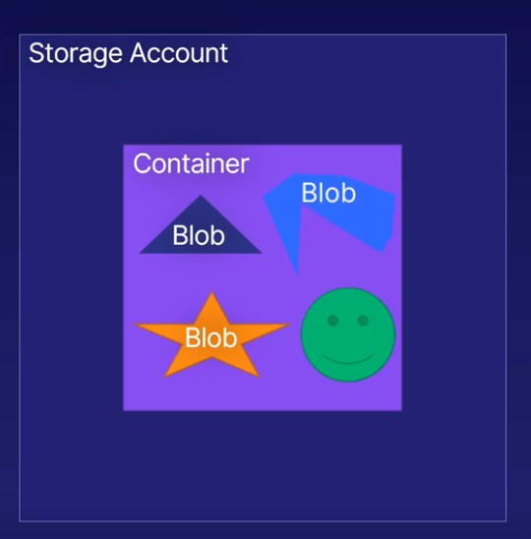 Scenarios:

* Images – stores various sizes and formats as a single image storage.
* All types – store any kind of files and have distributed access through the azure cloud storage.
* Streaming – stream audio and video directly from your blob storage.
* Log files - write log files regardless of size and frequency.
* Data store – store any kind of data at scale, such as for archiving, backup, restore and disaster recovery.

Types of blob storages:

1. Block Blob: stores text and binary data up to 4.7TB. Made up of individually managed blocks of data.

2. Append: Block blob that are optimized for append operations. Works well of logging where data is constantly appended.

3. Page: stores files up to 8TB. Any part of the file could be accessed anytime, for example virtual hard drive.

Pricing Tiers

1.Hot: Frequently accessed files. Lower accessed times and higher accessed costs.

2.Cool: Lower accessed cost and higher accessed time. Data remains here for at least 30 days.

3.Archive: Lowest cost and highest access time.

Disk storage

It’s a disk that you can store data on

Managed disk is nothing but what you attached your VM

Azure manages – you don’t have worry about the backup and uptime.

Size and Performance – Microsoft and azure guarantees size and performance as per your agreement with them

Upgrade – you can upgrade your disk size and type

Disk Types:

1.HHD – Spinning hard drive. Low cost and suitable for backups.

2.Standard SSD – Solid state drive. Standard for production environment. Higher reliability, scalability and Lower latency over HHD.

3.Premium SSD – super fast and high performance. Very low latency. Use for critical workloads. Premium SSD are recommended for database installation particular as the latency is very low.

4.Ultra Disks: for the most demanding, data-intensive workloads. Disks up to 64TB. And extremely scalable with sub-millisecond latency. Microsoft recommend this tier for transaction heavy workloads, complex analytical models, gaming, rendering

# critical workloads – highly sensitive to performance, reliability, availability.

# data-intensive workloads – Large volumes of data

File Storage

Issues: all these issues can be resolved by file storage system

1.constraints – you only have limited amount of storage

2.Backups – time and resources spent on maintaining backups

3.Security – it is hard to keep all the data secure at all the times. Specialist assistance often needed.

4.File sharing – sharing files will be difficult through teams and organizations.

Benefits:

1.Sharing – you can share access to the azure file storage across machines and provide access to your on-premises infrastructure.

2.Fully managed – you don’t have worry about hardware and operating system.

3.Resilient – network and power outages won’t affect your storage.

Scenarios:

Hybrid: supplement or replace your existing on-premises file storage solution

Lift and shift - Move you existing file storage and related services to azure.

ARCHIVE

Requirements: policies and legislation, recovery can be requirements for archiving data. these can be very large amount of data.

Lowest price

Features: Durable and encrypted, stable. Perfectly suitable for the data that is accessed infrequently.

Free up premium storage: with cheap archive storage you can free up your more premium on-premises data.

Secure: fully secure to allow any personal data such as financial records and medical records.

Blob: archive storage is blob storage, so that the same tool will work for both.

Importance of Data redundancy

Data redundancy protects from unplanned failures such as hardware failure, zone/regional outage.

Multiple replicated copies of data

Azure storage will create multiple copies of your data

-automatic

-minimum 3 copies –being replicated in multiple locations or regions

-invisible to end users

* High availability = high cost

Redundancy options at glance:

Single Region

Zone Redundant Storage(ZRS)

Local redundant Storage(LRS)

Multi-Region

Geo-Zone Redundant Storage

Geo-Redundant Storage (GRS)

All options include:

Three copies in primary region

Three copies in secondary region (Multi region options)

Local Redundancy Storage (LRS):

Three copies in same location (datacentre/zone)

1.Lowest cost option

2.Protect against single disk failure

3.Does not protect against zone or regional outage why because all three copies are stored in same zone.

Zone Redundant Storage (ZRS):

Three copies across three availability zones

1.one copy in each zone

2.protects against zone outage but not regional outage

Geo- Redundant Storage (GRS):

Three copies in two different regions

1.three copies in primary regional physical location (LRS)

2.three copies in secondary(paired) regional physical location (LRS)

3.protects against primary regional failure but no primary zone redundancy

4.can configure read access from secondary region for high availability

Geo-Zone-Redundant Storage (GZRS):

Maximum redundancy

1.copy across three availability zones in primary region (ZRS)

2.copy across three availability zones in secondary region physical location/zone (LRS)

3.protects against primary region failure and primary region zone failure.

4.can also configure read access from secondary region for high availability.

Moving Data

Moving data into and out of azure storage

Solutions depends on:

Transfer frequency(occasional/continuous)

Data size

Network bandwidth

Transfer solution:

1.AzCopy – command line utility for occasional data transfer.

* Transfer blobs and Azure files
* Downloaded application
* Useful for scripting data transfer which is integrated with the bash and power shell

Example: AzCopy command in command line

2.Storage Explorer: it is a graphical interface or a GUI interaction method instead

Simply drag and drop different data types into and out of azure storage

* Downloaded application
* User-friendly graphical interface – drag and drop interaction
* Move all storage account formats.

3.Azure File Sync: this works specifically with Azure file storage format in which it will

Automatically synchronize the azure file service with on-premises file server.

Local file server performance + cloud availability

Use cases:

Backup local file server-In case of disaster recovery scenarios

Synchronize files between multiple on-premises locations

Remote users access files

Transition to only azure files for file server

Additional Migration Options

For larger scale data transfer scenarios

1.Azure Data Box: If you have too much to transfer over the internet, azure data box simply provides an offline data transfer method either into or out of azure storage.

It is simply physical box

Copy data to physical storage device (Data Box)

* Encrypted
* Rugged – hard drive

You simply transfer your data on to your azure data box appliance ship it to azure.

Ship data box to/from azure

* To azure: data box data transferred to azure storage account
* From azure: data box delivered to on-premises location for on-site transfer. (in which you take a large amount of data already in storage account, arranged to have it copied to data box, and then have it shipped to on-premises location for an on-site transfer)

Uses:

* Initial bulk data migration
* Disaster recovery –Restore azure backup to on-premises location
* Security requirements – sensitive data that can’t be transferred over the internet

2.Azure Migrate:

Migrate non-Azure resources in Azure [servers, databases, applications]

Example: migrate databases managed database service (Azure SQL)

Discover dependent resources to migrate (migrate VM)

Migrate on-premises applications and dependencies

Migrate bulk data with data box

Premium Performance Operations