COSMOS DB

Synchronization

Easy with cosmos – traditional database that weren’t cloud enabled could be very difficult to set up across multiple regions. Azure takes care of all of it with cosmos.

One-click to add regions – it is very easy to expand to more regions with cosmos DB and have the data in sync.

Continuous synchronization – cosmos DB stays on top of all reads and writes to your data and makes sure the data is moved between regions to stay in sync.

# latency is the time it takes for data to travel.

Scalability:

Automated- cosmos DB automatically scales to meet resource demand

Infinite resources – any number of users of your application can be supported.

Lowest price – even though scaling is automatic, you only pay for the resources you use.

Connectivity:

Developer- choose from various development kits (SDKs) and application programming interface(APIs).

Languages – all different types of languages

Platforms – different platforms to integrate with including SQL, mongo DB, Cassandra.

* Higher total cost of ownership

Azure SQL

Database as a service

One of the main use cases that azure Microsoft highlights for Azure SQL is that you can migrate your on-premises SQL server instances directly to azure to get all the benefits of managed instances.

* Frictionless process
* Cost saving
* Lower total cost of ownership

Cloud Benefits

1.scalability and high availability

2.space- manage space up to 100TB

3.security – benefit from the built-in-security features of the azure cloud platform

Azure SQL Database Azure SQL managed instances

Most like traditional SQL server aimed at managed from on premises

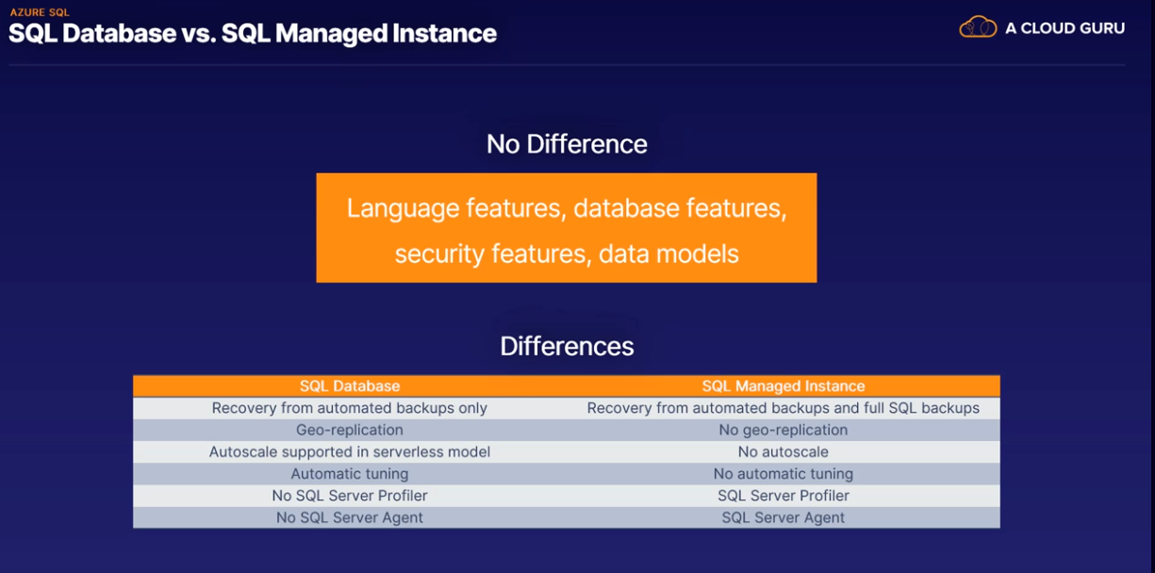

Azure database of MySQL

MySQL is a Microsoft product

Open source

Relational database- data in the database is connected through relations in the data itself

Mature and Stable- millions of applications and websites use MySQL .it is both a mature product and stable.

Azure advantages

* Platform –as-a-service: the service infrastructure is managed by Microsoft azure
* Development focus: focus on developing business strengths
* Choice of language: use the language and framework of your choice, such as php and word press.
* High availability
* Azure security features- you will get all high azure security features
* Cloud capabilities: all the cloudy PaaS features such as database patching, automatic backups and monitoring are included in the price.

MySQL use cases

* Web applications
* E-commerce
* Mobile applications
* Digital marketing
* Finance management
* Gaming

Azure database for PostgreSQL

Use cases

* Financial applications
* Government

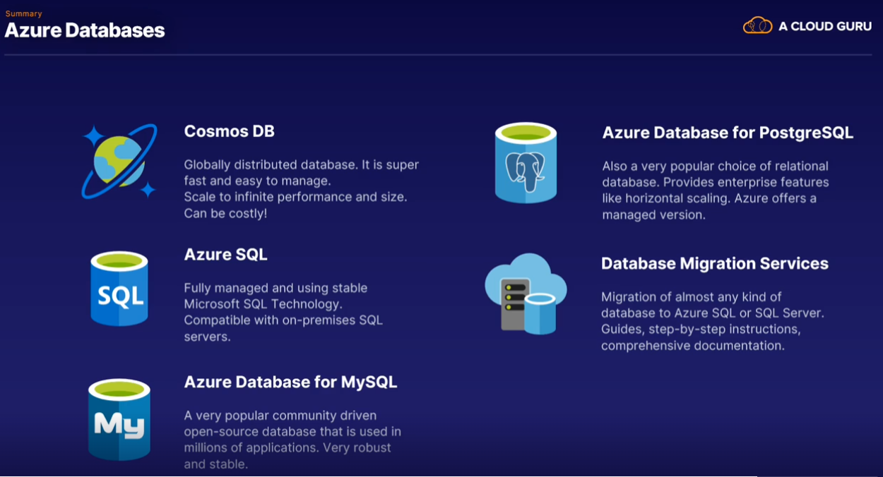

What are the valid online (continuous sync) source databases for the Azure Database Migration Service when migrating to Azure DB for PostgreSQL?

* PostgreSQL
* Oracle
* MySQL
* RDS PostgreSQL

What are the advantages of using a database for storing data?

* They offer the ability to sort and index data.
* You can manage access to data in a database more granularly than for any other type of storage.
* It is a much cheaper option than using regular Azure storage.
* You can store more data in less space due to the compression algorithms used by databases.
* Databases are more secure for storing data than regular Azure storage.
* It is a very powerful way of getting the data out in exactly the format you want.

What are the advantages of Cosmos DB?

* Improved Azure portal experience for managing the various Cosmos DB locations in your application
* A large range of tools to work with Cosmos DB, such as SDKs, APIs and more
* Near-infinite scaling to handle any demand
* Great backup facilities for other Azure services, such as App Services and Azure Functions
* Very low latency
* Very cheap data storage

Which of the following is a true statement regarding Microsoft SQL Server or Azure SQL?

* Microsoft SQL Server is faster than Azure SQL.
* Azure SQL is a managed service, meaning Azure takes care of all the infrastructure maintenance.
* Azure SQL is faster than Microsoft SQL Server.
* Microsoft SQL Server is a managed service, meaning Azure takes care of all the infrastructure maintenance.

Azure SQL is a managed service, which means Microsoft takes care of all the hardware and maintenance tasks for running the database. You only have to worry about using the database for storing and retrieving data. There is no noticeable performance advantage with using either SQL service.

What is a recommended use case for Azure SQL?

* Update on-premises SQL Server to gain better performance and lower cost.
* Migrate your on-premises SQL Server instances directly to Azure and get all the benefits of managed instances.
* Migrate Cosmos DB data if only a single geographical location is used.
* Migrate all instances of Microsoft SQL Server to Azure SQL to improve security and reduce cost.