**Networking**

**Switching:** the switch can enable communication with in a network.

*To reach system1 to system2, we connect them to one switch and the switch creates a network containing two systems.

*To connect the systems to the switch we need a network interface on each host.

**ip link** 🡪 to see the interfaces for the host [list and modify]

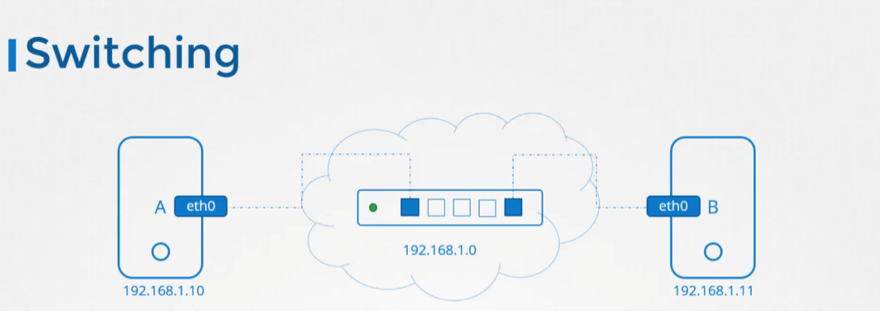

**Router:** helps you to connect two networks together, it is intelligent device. So think of it as another service with many network ports.

**route** 🡪 to see existing routing configuration

*To configure the gateway on the system B to reach the system network 2.0 , run the

**ip route add <network 2.0 ip> via <gate way address>**

*any requests to any network outside of your existing network goes to the particular router

**ip route add default via <gateway>**

**sudo ip r del default 🡪** To delete default route

**ip addr** 🡪 to see ip addresses assigned to those interfaces

**ip addr add <ip addr> dev <interface name>** 🡪 to set ip addresses to the interfaces.

**ip route 🡪** to view the routing table

*a system is able to use host name to ip mapping from the etc hosts file locally as well as from a remote DNS server

*Every host has a DNS resolution configuration file at etc/reslov.conf

*The order is defined by the entry In the file etc/nsswitch.conf

DNS: DNS, or Domain Name System, is a crucial part of the internet infrastructure that translates human-readable domain names (like [www.example.com](http://www.example.com/)) into IP addresses (like 192.168.1.1) that computers use to identify each other on a network.

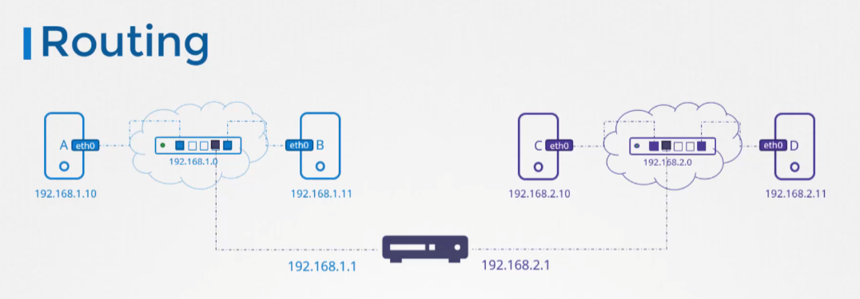

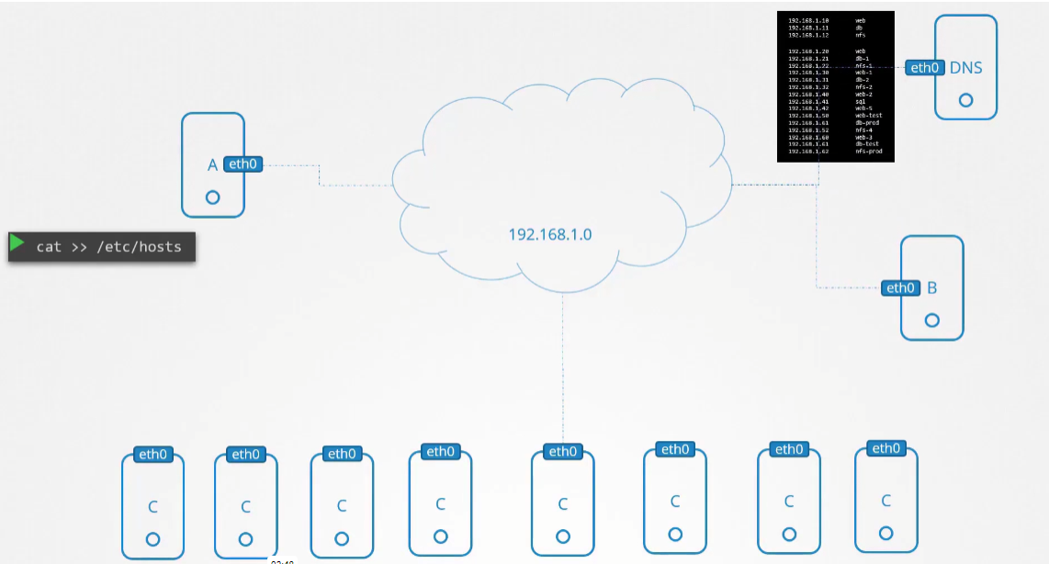

Network

Server2

Server1