My sql

It is a relational database, which stores data in the form of rows and columns.

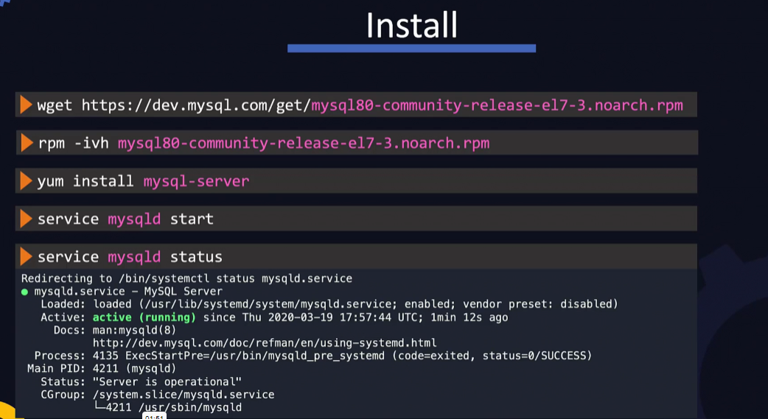

Database logs are stored at path /var/log/mysqld.log

The default port that mysql listens on is 3306

Mysql –u root –pXXXXXX 🡪 to connect to the database and we can use mysql client utility.

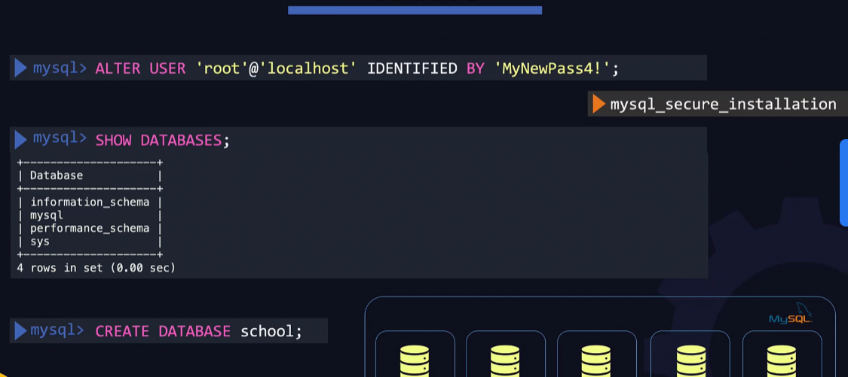

To select a databse -🡪 use <database name> ;

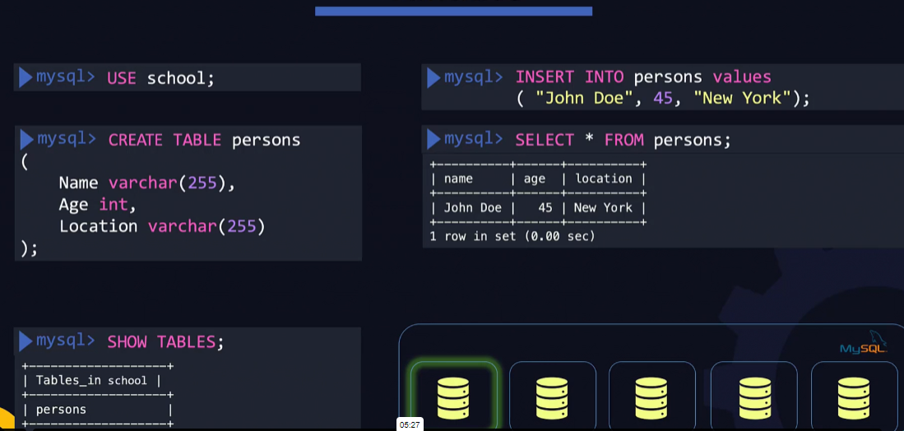

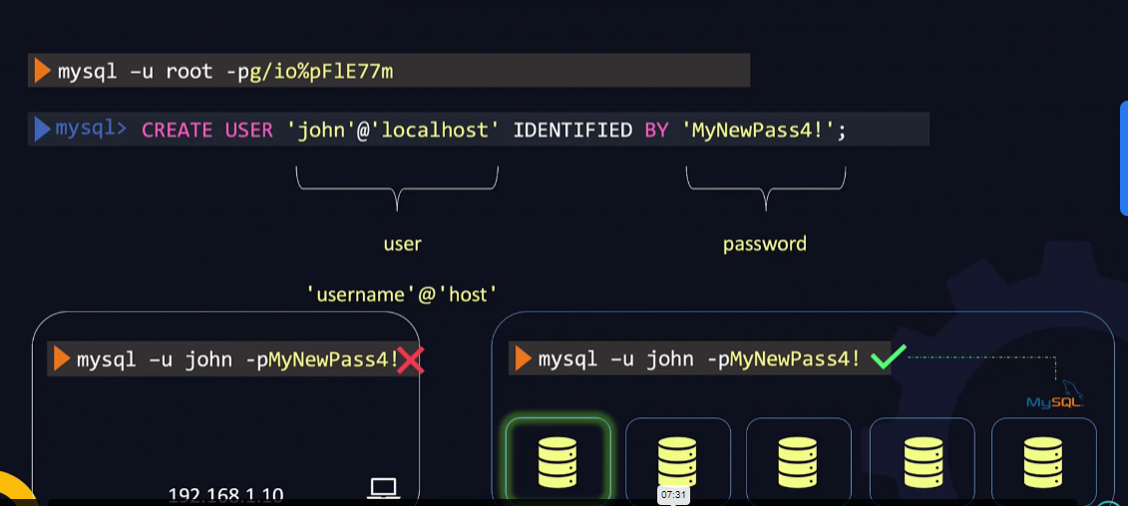

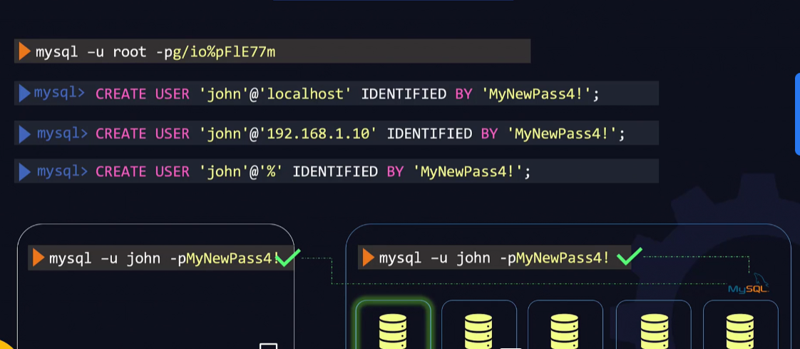

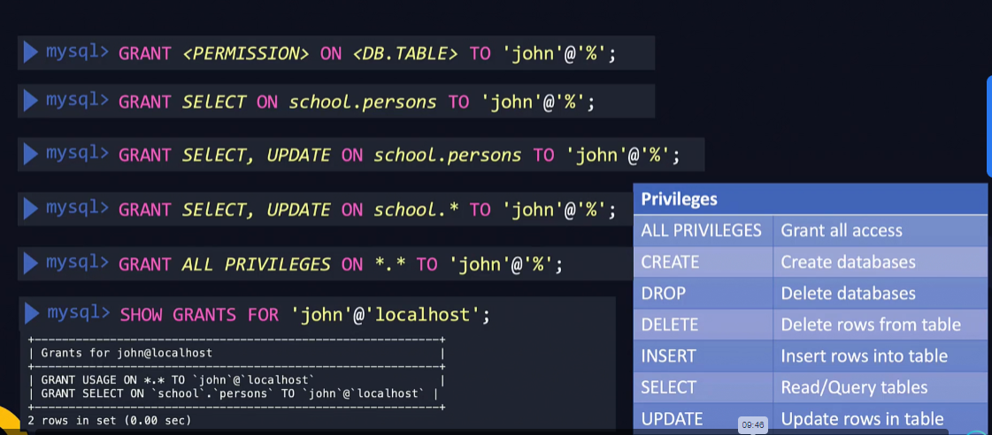

Mongo DB

Mondo db is an open source, no sql database or also known as document database as it stores data in json like document format.

It is a high performance scalable database

Multiple documents together form a collection

Multiple collection together form a database

Multiple databases together form a mongo db



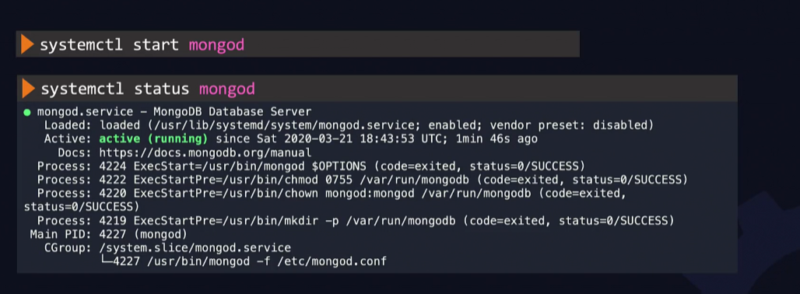

The logs are stored at path /var/log/mongodb/mongod.log

Default port -27017

Mondo db configuration file /etc/mongod.conf

To display list of databases > show dbs

To create new database or switch to an existing database

> use <database name>

To know which database you switched to > db

To create a collection > db.createcollection(“name of the collection”)

To list collections > show collections

To insert data into colletions

* Db.collection name. insert ({

})

To retrieve data from the database > db.collection name.