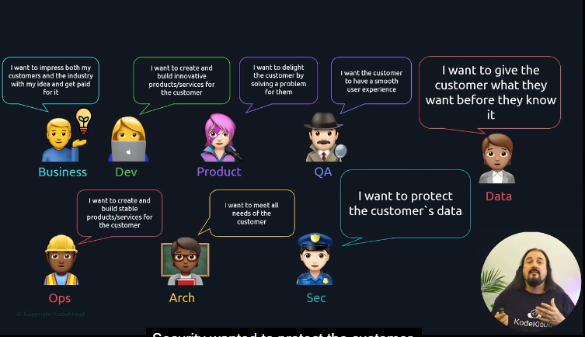

* Devops overcomes the barriers by embracing three perspectives

1. the way of flow

2. the way of feedback

3. the way of continual improvement

Visit <https://web.devopstopologies.com>

Devops started as a conversation about the challenges that developers and operational roles had in delivering software. 🡪 culture

Developers wants to release often, fast, and predominantly value innovation and change.

Operations roles want to keep things up, running, and they tend to value stability and control

These conflicting standards creates when it comes release.

One wants to go and one wants to stop

**Devops culture principles**

* **Why:** start with why? [What is reason/strategy behind?]

Ex: is it a business reason or a technical reason

What drives your team? What are you trying to accomplish with your customers, products, your services etc.

* **Continual improvement:** Fundamental idea that any person, process, and technology must evolve, or will not be relevant in today’s task ever changing and growing IT world.

Ex: can this be better?

* **Creating trust-managing expectations**: making sure that transparency is primary so that teams have visibility and accessible metrics about what matters to clients both internal and external. These can be in the form of documents Dashboards, working APIs, metric boards that allow people to self-service around the data they needed
* **Communication and collaboration:** simply sharing.

It is all about creating a sense of teamwork and collaboration and empathy, not just with your teams but any group that relevant to your organization even the world in some cases.

* **Experimentation and innovation:** this aspect embraces the testing and exploration of new ideas, new ways of thinking, new technologies and patterns that are business relevant.