CSA0711-COMPUTER NETWORKS
1)TYPE CASTING
i)Integer to Float

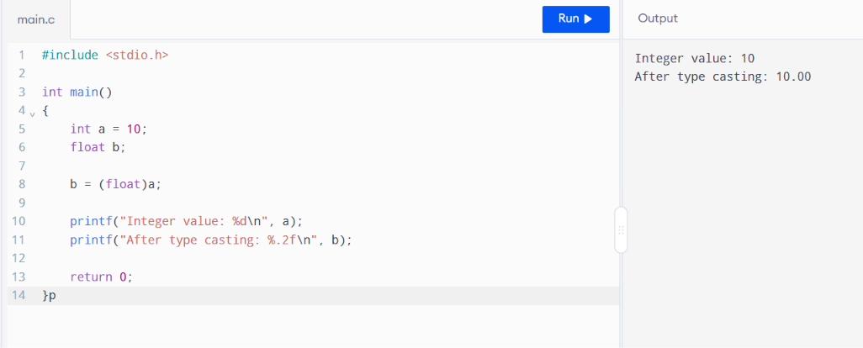

ii) Float → Integer

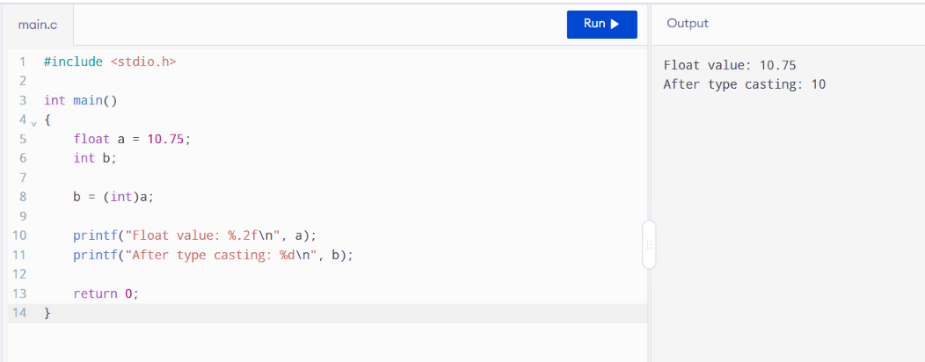

2)Dead Code Removal

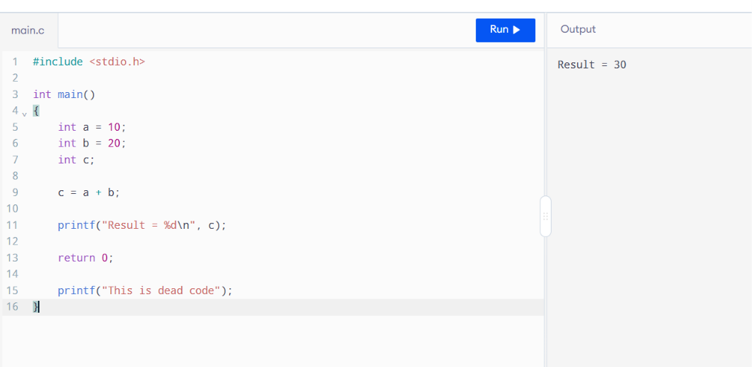

3)Lexical Analysis with Tokens

