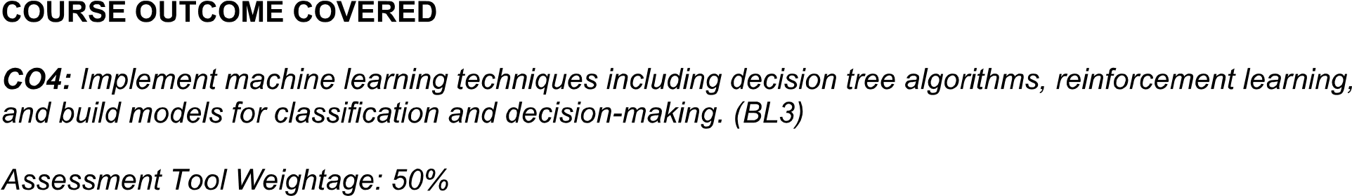

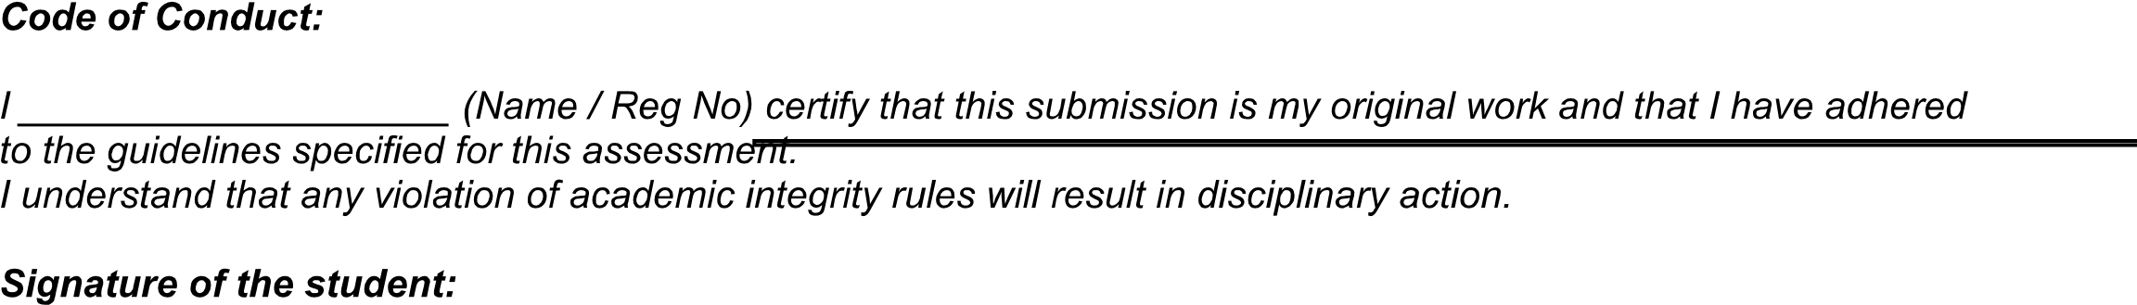

Select any ONE peer-reviewed research article (published after 2019) from IEEE Xplore, Springer, Elsevier, ACM Digital Library, or another reputed research database related to any of the following topics:
- Machine Learning
- Deep Learning
- Artificial Intelligence
- Decision Trees
- Statistical Learning Methods
- Reinforcement Learning
- Natural Language Processing
- Computer Vision
- Generative AI
- AI Applications
Submit:
(i) Article citation details
(ii) PDF or valid DOI link
(iii) Written review as per the tasks below

Task 1: Article Summary
(a) Provide the full citation of the selected article, including Author(s), Title, Journal/Conference, Year, Publisher, and DOI. Mention the domain/application area and clearly state the ML/AI problem addressed.
(b) Summarize the key objective of the article in your own words (150–200 words). Clearly explain the research gap, motivation, and how the authors attempted to address the identified problem.

Task 2: Methodology Analysis
(a) Explain the ML/AI technique(s) used in the article. Describe the dataset, including its source, size, features/attributes, preprocessing techniques, training and testing procedure, and evaluation methodology.
(b) Map the methodology to relevant course concepts such as Inductive Learning, Decision Trees, Statistical Learning, Reinforcement Learning, Deep Learning, or AI techniques.
Identify one methodological strength and one limitation of the authors' approach.

Task 3: Results & Critical Evaluation
(a) Report the major results obtained by the authors using appropriate metrics such as Accuracy, Precision, Recall, F1-Score, AUC-ROC, RMSE, MAE, reward, or convergence rate.
Prepare a comparative table if multiple algorithms/models are evaluated.
(b) Critically evaluate the reported results. Discuss whether the evaluation metrics are appropriate and whether the dataset and experimental setup are sufficient to support the authors' conclusions.
Identify any possible biases, limitations, or threats to validity.
(c) Discuss the real-world applicability of the proposed approach. Explain where the technique can be deployed and identify challenges related to data availability, computational requirements, scalability, privacy, security, cost, or ethical issues.

Task 4: Reflection & Learning Outcome
(a) State three key insights gained from reading the article. Connect each insight to a specific concept from the course syllabus.
(b) Explain how the article improved your understanding of the selected AI/ML technique and its practical applications.
(c) If you were to extend this research, propose one novel experiment, improvement, or new application domain. Your proposal may involve:
- A different dataset
- An improved algorithm
- Hybrid ML techniques
- Feature engineering
- Hyperparameter optimization
- Explainable AI
- Real-time implementation
- A new application domain
Justify the feasibility, expected improvement, and potential impact of your proposed enhancement.

Expected Learning Outcomes
After completing this assignment, the student should be able to:
- Identify and understand recent AI/ML research articles.
- Analyze different machine learning methodologies and algorithms.
- Evaluate experimental results using appropriate performance metrics.
- Critically assess the strengths and limitations of research work.
- Connect theoretical AI/ML concepts with real-world applications.
- Propose meaningful research improvements or extensions.

