REACT
1. ReactJS-HOL
Installation Commands
node -v
npm -v
npm install -g create-react-app
npx create-react-app myfirstreact
cd myfirstreact
code .
npm start
App.js
import React from 'react';
import './App.css';

function App() {
return (
<div className="App">
<h1>welcome to the first session of React</h1>
</div>
);
}

export default App;
Command Prompt Output:
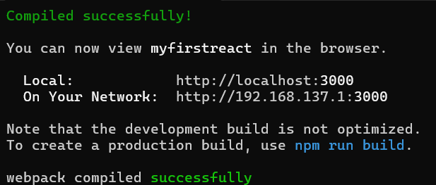Browser Output
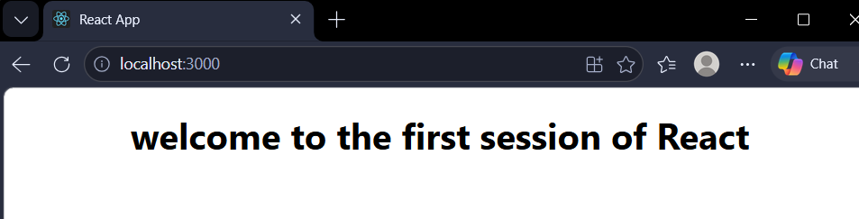

2. ReactJS-HOL
Home.js
import React from 'react';

function Home() {
return (
<div>
<h1>Welcome to the Home page of Student Management Portal</h1>
</div>
);
}

export default Home;

About.js
import React from 'react';

function About() {
return (
<div>
<h1>Welcome to the About page of the Student Management Portal</h1>
</div>
);
}

export default About;

Contact.js
import React from 'react';

function Contact() {
return (
<div>
<h1>Welcome to the Contact page of the Student Management Portal</h1>
</div>
);
}

export default Contact;

App.js
import React from 'react';
import './App.css';
import Home from './Components/Home';
import About from './Components/About';
import Contact from './Components/Contact';

function App() {
return (
<div className="App">
<Home />
<About />
<Contact />
</div>
);
}

export default App;
Command Prompt Output:
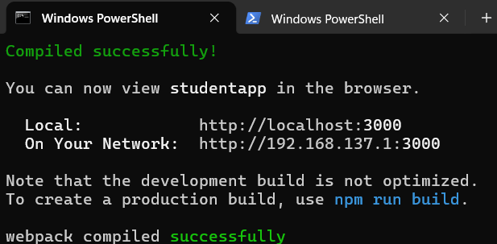Browser Output
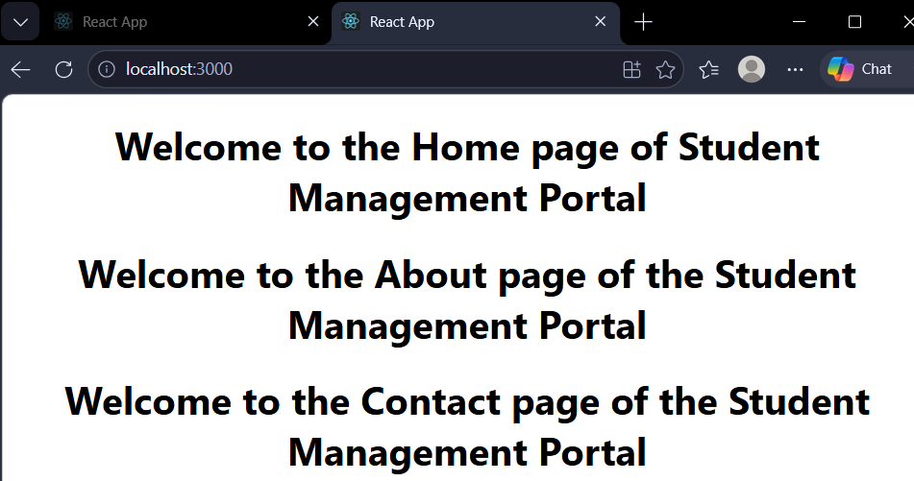

3. ReactJS-HOL
CalculateScore.js
import React from 'react';
import '../Stylesheets/mystyle.css';

function CalculateScore(props) {
const average = props.total / props.goal;

return (
<div className="score-card">
<h2>Student Score Details</h2>
<p><strong>Name:</strong> {props.name}</p>
<p><strong>School:</strong> {props.school}</p>
<p><strong>Total Score:</strong> {props.total}</p>
<p><strong>Goal:</strong> {props.goal}</p>
<p><strong>Average Score:</strong> {average}</p>
<h3>Result: {average >= 50 ? "Pass" : "Fail"}</h3>
</div>
);
}

export default CalculateScore;

mystyle.css
.score-card {
background-color: #f0f8ff;
border: 2px solid #4CAF50;
border-radius: 10px;
padding: 20px;
margin: 20px auto;
max-width: 400px;
font-family: Arial, sans-serif;
box-shadow: 0 4px 8px rgba(0, 0, 0, 0.1);
}

.score-card h2 {
color: #2c3e50;
text-align: center;
border-bottom: 2px solid #4CAF50;
padding-bottom: 10px;
}

.score-card p {
font-size: 16px;
margin: 8px 0;
color: #34495e;
}

.score-card h3 {
text-align: center;
padding: 10px;
background-color: #4CAF50;
color: white;
border-radius: 5px;
margin-top: 15px;
}

App.js
import React from 'react';
import './App.css';
import CalculateScore from './Components/CalculateScore';

function App() {
return (
<div className="App">
<CalculateScore
name="John Doe"
school="Springfield High School"
total={450}
goal={500}
/>
<CalculateScore
name="Jane Smith"
school="Riverside Academy"
total={320}
goal={500}
/>
<CalculateScore
name="Mike Johnson"
school="Greenwood School"
total={480}
goal={500}
/>
</div>
);
}

export default App;
Command Prompt Output:
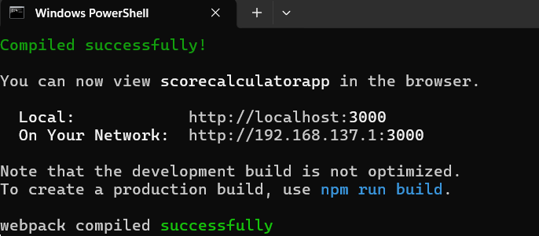Browser Output
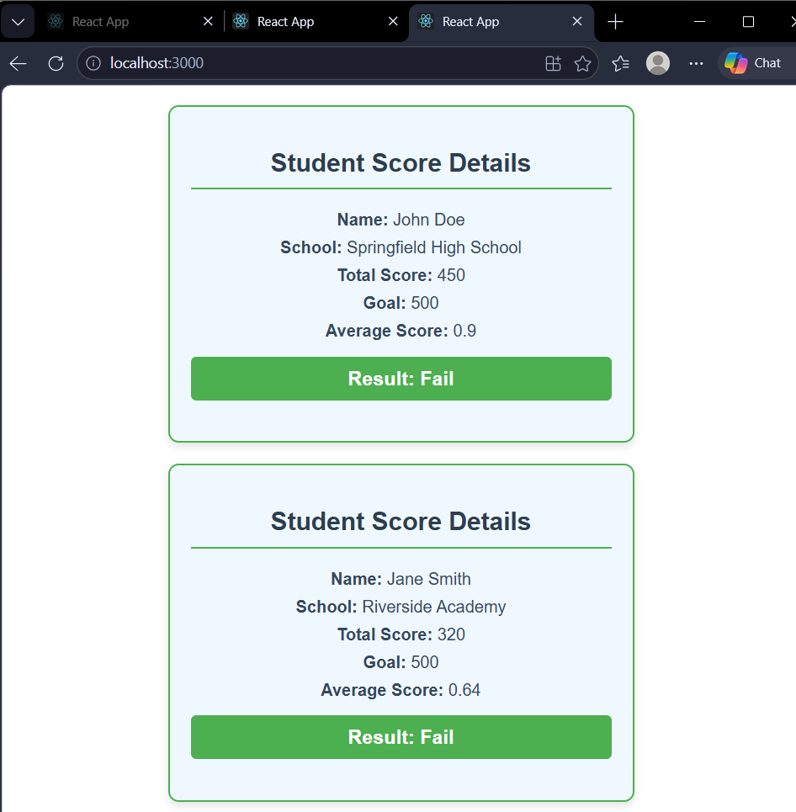

4. ReactJS-HOL

Post.js
class Post {
constructor(id, title, body) {
this.id = id;
this.title = title;
this.body = body;
}
}

export default Post;

Posts.js
import React, { Component } from 'react';
import Post from './Post';

class Posts extends Component {
constructor(props) {
super(props);
this.state = {
posts: []
};
}

loadPosts() {
fetch('https://jsonplaceholder.typicode.com/posts')
.then(response => response.json())
.then(data => {
const posts = data.map(item =>
new Post(item.id, item.title, item.body)
);
this.setState({ posts: posts });
})
.catch(error => {
throw new Error('Failed to load posts: ' + error.message);
});
}

componentDidMount() {
this.loadPosts();
}

componentDidCatch(error, info) {
alert('Error occurred: ' + error.message);
console.error('Error:', error);
console.error('Info:', info);
}

render() {
return (
<div style={{ padding: '20px', fontFamily: 'Arial' }}>
<h1 style={{ textAlign: 'center', color: '#2c3e50' }}>Blog Posts</h1>
{this.state.posts.map(post => (
<div key={post.id} style={{
border: '1px solid #ddd',
borderRadius: '8px',
padding: '15px',
margin: '15px 0',
backgroundColor: '#f9f9f9'
}}>
<h2 style={{ color: '#2980b9' }}>{post.title}</h2>
<p style={{ color: '#34495e' }}>{post.body}</p>
<small style={{ color: '#7f8c8d' }}>Post ID: {post.id}</small>
</div>
))}
</div>
);
}
}

export default Posts;
App.js
import React from 'react';
import './App.css';
import Posts from './Posts';

function App() {
return (
<div className="App">
<Posts />
</div>
);
}

export default App;
Command Prompt Output:
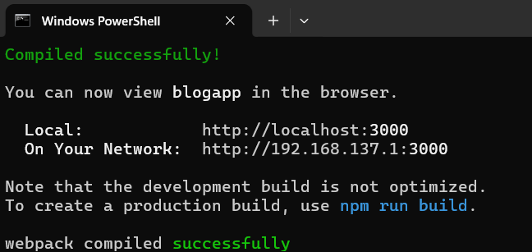Browser Output
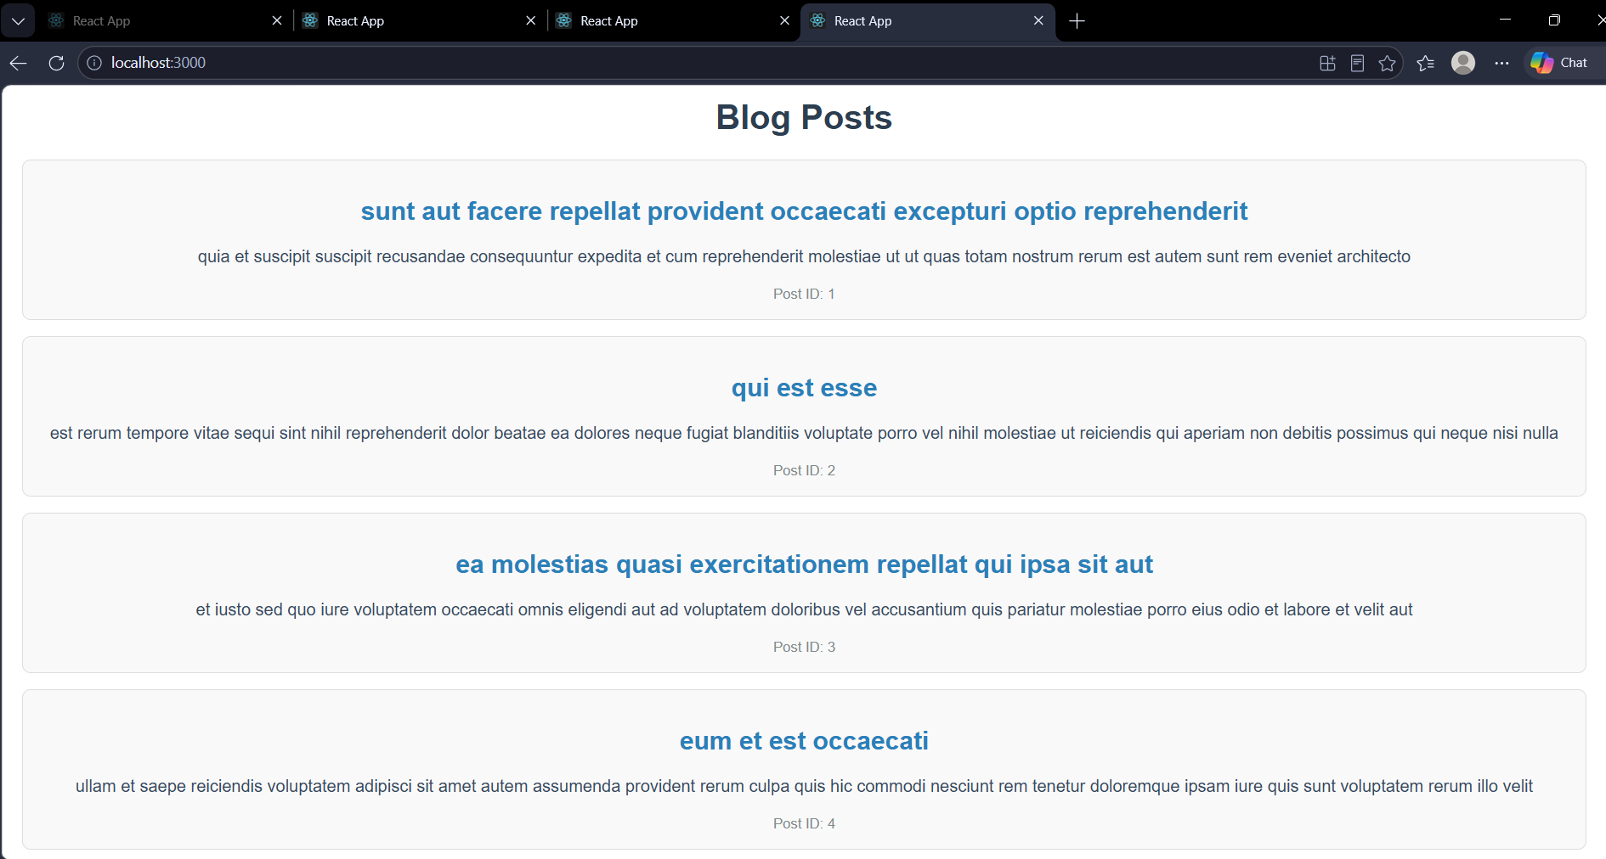

5. ReactJS-HOL

CohortDetails.js
class Post {
constructor(id, title, body) {
this.id = id;
this.title = title;
this.body = body;
}
}

export default Post;

CohortDetails.module.css
import React, { Component } from 'react';
import Post from './Post';

class Posts extends Component {
constructor(props) {
super(props);
this.state = {
posts: []
};
}

loadPosts() {
fetch('https://jsonplaceholder.typicode.com/posts')
.then(response => response.json())
.then(data => {
const posts = data.map(item =>
new Post(item.id, item.title, item.body)
);
this.setState({ posts: posts });
})
.catch(error => {
throw new Error('Failed to load posts: ' + error.message);
});
}

componentDidMount() {
this.loadPosts();
}

componentDidCatch(error, info) {
alert('Error occurred: ' + error.message);
console.error('Error:', error);
console.error('Info:', info);
}

render() {
return (
<div style={{ padding: '20px', fontFamily: 'Arial' }}>
<h1 style={{ textAlign: 'center', color: '#2c3e50' }}>Blog Posts</h1>
{this.state.posts.map(post => (
<div key={post.id} style={{
border: '1px solid #ddd',
borderRadius: '8px',
padding: '15px',
margin: '15px 0',
backgroundColor: '#f9f9f9'
}}>
<h2 style={{ color: '#2980b9' }}>{post.title}</h2>
<p style={{ color: '#34495e' }}>{post.body}</p>
<small style={{ color: '#7f8c8d' }}>Post ID: {post.id}</small>
</div>
))}
</div>
);
}
}

export default Posts;
App.js
import React from 'react';
import './App.css';
import CohortDetails from './Components/CohortDetails';

function App() {
return (
<div className="App">
<CohortDetails />
</div>
);
}

export default App;
Command Prompt Output:
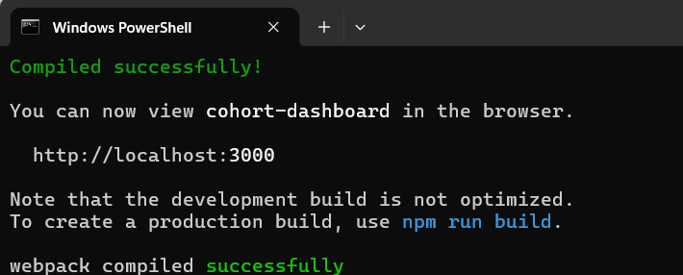Browser Output
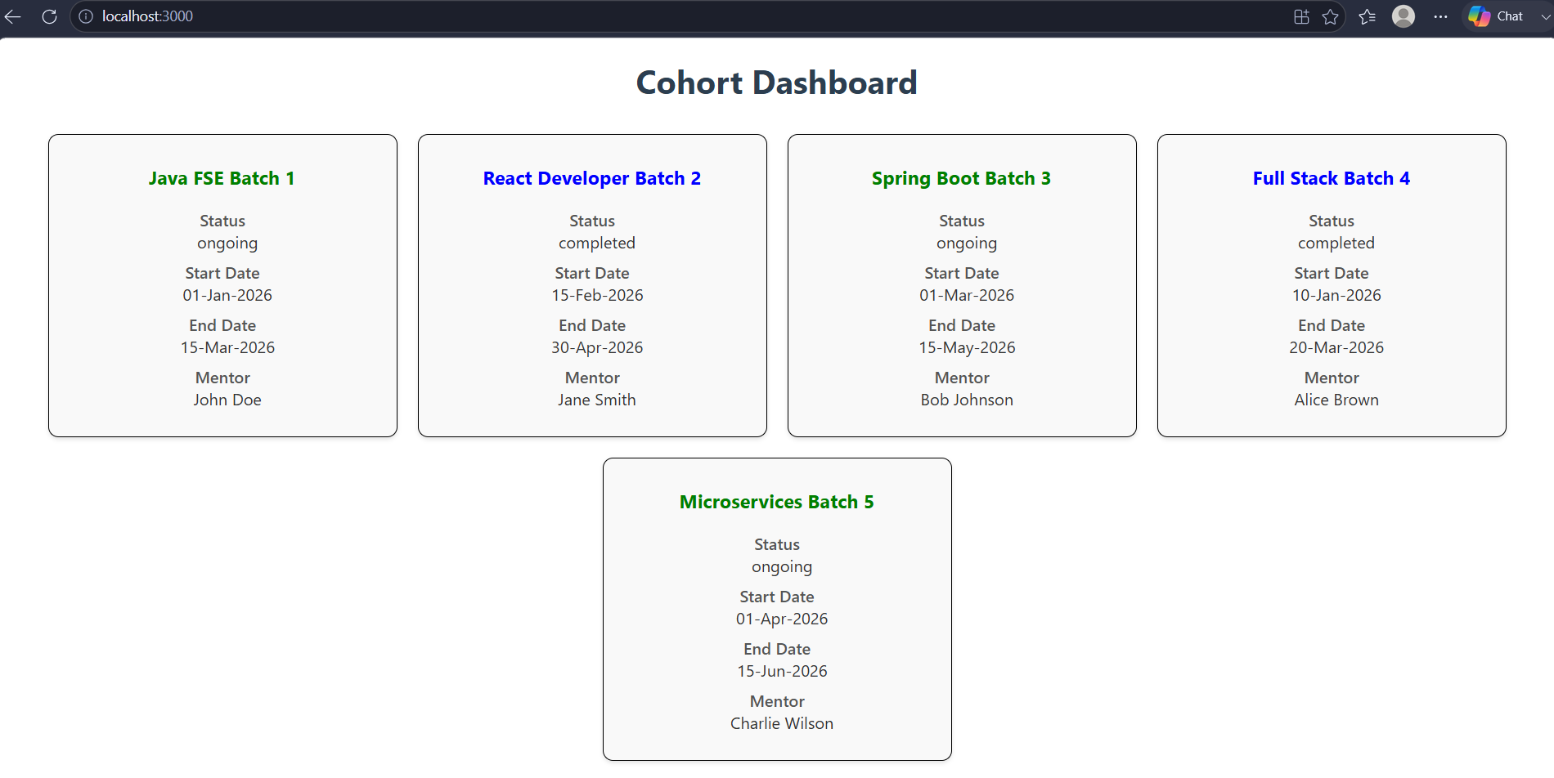

9. ReactJS-HOL

IndianPlayers.js
import React from 'react';

function IndianPlayers() {
const T20players = ['Virat Kohli', 'Rohit Sharma', 'KL Rahul', 'Suryakumar Yadav', 'Hardik Pandya'];
const RanjiTrophyPlayers = ['Ravindra Jadeja', 'Rishabh Pant', 'Shubman Gill', 'Axar Patel', 'Jasprit Bumrah'];

const mergedPlayers = [...T20players, ...RanjiTrophyPlayers];
const [oddTeam, evenTeam] = [[], []];

T20players.forEach((player, index) => {
if (index % 2 === 0) {
evenTeam.push(player);
} else {
oddTeam.push(player);
}
});

return (
<div style={{ padding: '20px', fontFamily: 'Arial' }}>
<h2 style={{ color: '#2c3e50' }}>Indian Players</h2>
<h3 style={{ color: '#2980b9' }}>Odd Team Players</h3>
<ul>
{oddTeam.map((player, index) => (
<li key={index}>{player}</li>
))}
</ul>
<h3 style={{ color: '#27ae60' }}>Even Team Players</h3>
<ul>
{evenTeam.map((player, index) => (
<li key={index}>{player}</li>
))}
</ul>
<h3 style={{ color: '#8e44ad' }}>Merged Players (T20 + Ranji Trophy)</h3>
<ul>
{mergedPlayers.map((player, index) => (
<li key={index}>{player}</li>
))}
</ul>
</div>
);
}

export default IndianPlayers;

ListofPlayers.js
import React from 'react';

function ListofPlayers() {
const players = [
{ name: 'Virat Kohli', score: 85 },
{ name: 'Rohit Sharma', score: 92 },
{ name: 'KL Rahul', score: 65 },
{ name: 'Suryakumar Yadav', score: 78 },
{ name: 'Hardik Pandya', score: 45 },
{ name: 'Ravindra Jadeja', score: 55 },
{ name: 'Jasprit Bumrah', score: 20 },
{ name: 'Mohammed Shami', score: 30 },
{ name: 'Rishabh Pant', score: 70 },
{ name: 'Shubman Gill', score: 88 },
{ name: 'Axar Patel', score: 40 }
];

const below70 = players.filter(player => player.score < 70);

return (
<div style={{ padding: '20px', fontFamily: 'Arial' }}>
<h2 style={{ color: '#2c3e50' }}>All Players</h2>
<ul>
{players.map((player, index) => (
<li key={index}>
{player.name}: {player.score}
</li>
))}
</ul>
<h2 style={{ color: '#e74c3c' }}>Players with Score Below 70</h2>
<ul>
{below70.map((player, index) => (
<li key={index}>
{player.name}: {player.score}
</li>
))}
</ul>
</div>
);
}
export default ListofPlayers;
App.js
import React, { useState } from 'react';
import './App.css';
import ListofPlayers from './Components/ListofPlayers';
import IndianPlayers from './Components/IndianPlayers';

function App() {
const [flag, setFlag] = useState(true);

return (
<div className="App">
<button onClick={() => setFlag(!flag)} style={{ padding: '10px 20px', margin: '20px', fontSize: '16px' }}>
{flag ? 'Show Indian Players' : 'Show List of Players'}
</button>
{flag ? <ListofPlayers /> : <IndianPlayers />}
</div>
);
}

export default App;

Command Prompt Output:
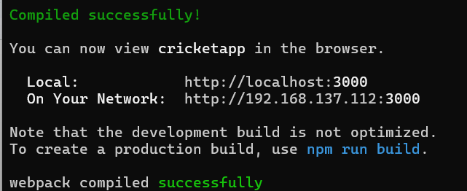
Browser Output
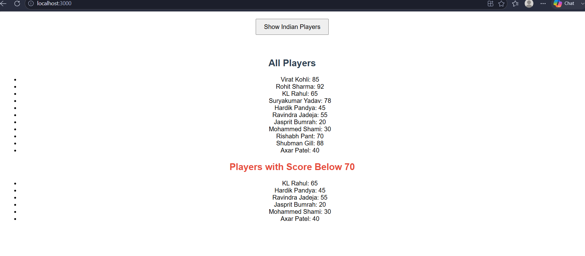
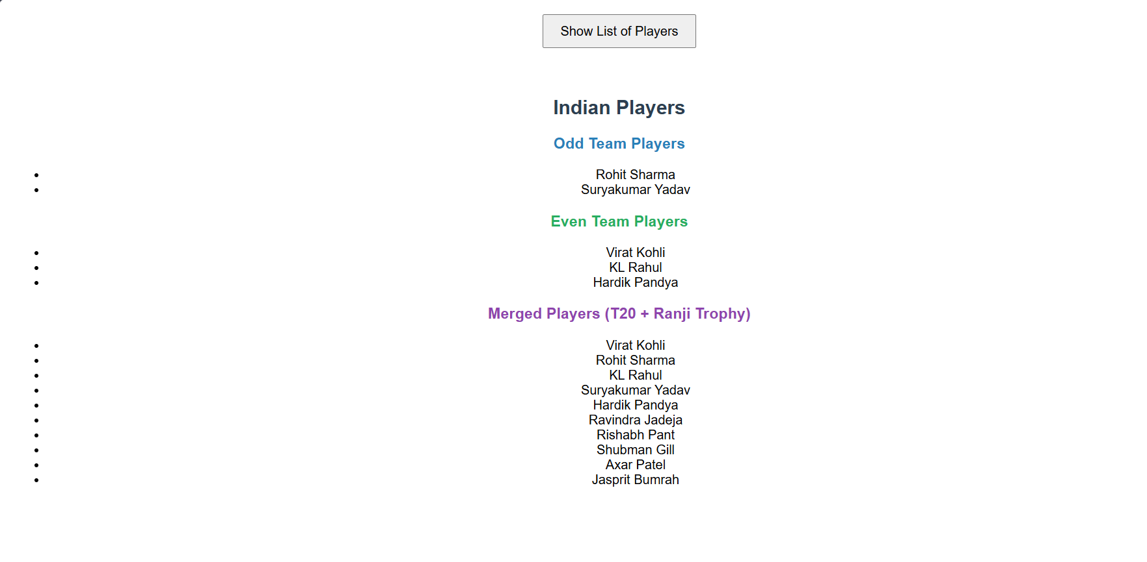
10. ReactJS-HOL

OfficeSpace.js
import React from 'react';
function OfficeSpace() {
const offices = [
{ id: 1, name: 'Downtown Office', rent: 55000, address: '123 Main Street, New York' },
{ id: 2, name: 'Business Park', rent: 75000, address: '456 Corporate Drive, Chicago' },
{ id: 3, name: 'Tech Hub', rent: 48000, address: '789 Innovation Way, Austin' },
{ id: 4, name: 'Executive Tower', rent: 85000, address: '321 Luxury Lane, Los Angeles' },
{ id: 5, name: 'Startup Space', rent: 35000, address: '654 Co-working Road, San Francisco' },
{ id: 6, name: 'City Center', rent: 62000, address: '987 Plaza Avenue, Boston' }
];

const officeImage = "https://images.unsplash.com/photo-1497366216548-37526070297c?w=400&h=200&fit=crop";

return (
<div style={{ padding: '20px', fontFamily: 'Arial, sans-serif' }}>
<h1 style={{ textAlign: 'center', color: '#2c3e50', borderBottom: '3px solid #3498db', paddingBottom: '10px' }}>
Office Space Rental
</h1>

<div style={{ textAlign: 'center', margin: '20px 0' }}>
<img
src={officeImage}
alt="Office Space"
style={{ width: '80%', maxWidth: '600px', borderRadius: '10px', boxShadow: '0 4px 8px rgba(0,0,0,0.2)' }}
/>
</div>

<div style={{ display: 'flex', flexWrap: 'wrap', justifyContent: 'center', gap: '20px' }}>
{offices.map(office => (
<div key={office.id} style={{
border: '1px solid #ddd',
borderRadius: '10px',
padding: '15px',
width: '250px',
backgroundColor: '#f9f9f9',
boxShadow: '0 2px 4px rgba(0,0,0,0.1)'
}}>
<h2 style={{ color: '#2980b9', fontSize: '18px', margin: '0 0 10px 0' }}>
{office.name}
</h2>
<p style={{ margin: '5px 0', color: '#555' }}>
<strong>Address:</strong> {office.address}
</p>
<p style={{ margin: '5px 0' }}>
<strong>Rent:</strong>
<span style={{
color: office.rent < 60000 ? 'red' : 'green',
fontWeight: 'bold',
marginLeft: '5px'
}}>
${office.rent}
</span>
</p>
</div>
))}
</div>
</div>
);
}
export default OfficeSpace;
App.js
import React from 'react';
import './App.css';
import OfficeSpace from './Components/OfficeSpace';
function App() {
return (
<div className="App">
<OfficeSpace />
</div>
);
}
export default App;
Command Prompt Output:
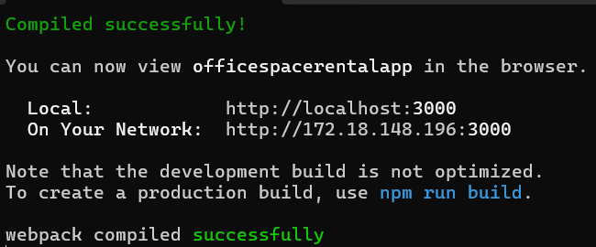Browser Output
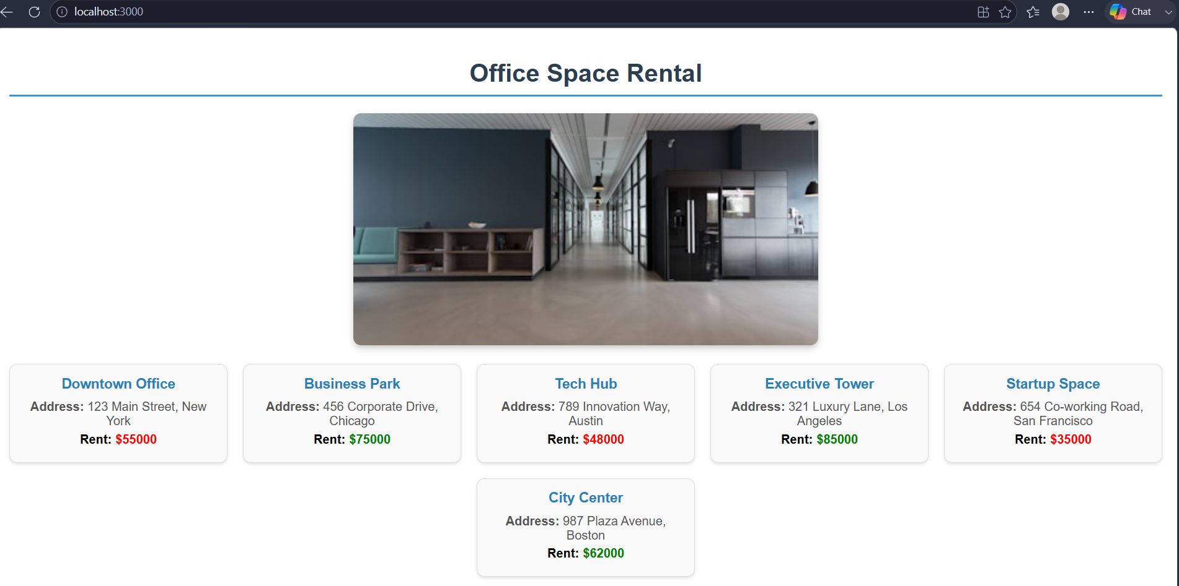

11. ReactJS-HOL

EventExamples.js
import React, { useState } from 'react';
function EventExamples() {
const [counter, setCounter] = useState(0);

const increment = () => {
setCounter(counter + 1);
};

const decrement = () => {
setCounter(counter - 1);
};

const sayHello = () => {
alert('Hello! Welcome to Event Examples App');
};

const multipleMethods = () => {
increment();
sayHello();
};

const sayWelcome = (message) => {
alert(message);
};

const handleOnPress = () => {
alert('I was clicked');
};

return (
<div style={{ padding: '20px', fontFamily: 'Arial, sans-serif' }}>
<h1 style={{ textAlign: 'center', color: '#2c3e50' }}>Event Examples</h1>

<div style={{ margin: '20px 0', padding: '20px', border: '1px solid #ddd', borderRadius: '8px' }}>
<h2>Counter: {counter}</h2>
<button onClick={multipleMethods} style={buttonStyle}>Increment + Say Hello</button>
<button onClick={decrement} style={buttonStyle}>Decrement</button>
</div>

<div style={{ margin: '20px 0', padding: '20px', border: '1px solid #ddd', borderRadius: '8px' }}>
<h2>Say Welcome</h2>
<button onClick={() => sayWelcome('Welcome to React Events!')} style={buttonStyle}>
Say Welcome
</button>
</div>

<div style={{ margin: '20px 0', padding: '20px', border: '1px solid #ddd', borderRadius: '8px' }}>
<h2>Synthetic Event</h2>
<button onClick={handleOnPress} style={buttonStyle}>
Click Me
</button>
</div>
</div>
);
}
const buttonStyle = {
padding: '10px 20px',
margin: '5px',
fontSize: '16px',
backgroundColor: '#3498db',
color: 'white',
border: 'none',
borderRadius: '5px',
cursor: 'pointer'
};
export default EventExamples;

CurrencyConvertor.js
import React, { useState } from 'react';
function CurrencyConvertor() {
const [rupees, setRupees] = useState('');
const [euro, setEuro] = useState('');

const handleSubmit = () => {
const conversionRate = 0.011;
const euroValue = (parseFloat(rupees) * conversionRate).toFixed(2);
setEuro(euroValue);
};
return (
<div style={{ padding: '20px', fontFamily: 'Arial, sans-serif', maxWidth: '400px', margin: '0 auto' }}>
<h2 style={{ textAlign: 'center', color: '#2c3e50' }}>Currency Converter</h2>
<div style={{ border: '1px solid #ddd', padding: '20px', borderRadius: '8px', backgroundColor: '#f9f9f9' }}>
<div style={{ marginBottom: '15px' }}>
<label style={{ display: 'block', marginBottom: '5px', fontWeight: 'bold' }}>
Indian Rupees (INR):
</label>
<input
type="number"
value={rupees}
onChange={(e) => setRupees(e.target.value)}
placeholder="Enter amount in INR"
style={{ width: '100%', padding: '8px', fontSize: '16px', border: '1px solid #ccc', borderRadius: '4px' }}
/>
</div>
<button
onClick={handleSubmit}
style={{ width: '100%', padding: '10px', fontSize: '16px', backgroundColor: '#27ae60', color: 'white', border: 'none', borderRadius: '4px', cursor: 'pointer' }}
>
Convert to Euro
</button>
{euro && (
<div style={{ marginTop: '15px', padding: '10px', backgroundColor: '#e8f8f5', borderRadius: '4px', border: '1px solid #27ae60' }}>
<h3 style={{ color: '#27ae60' }}>Amount in Euro (EUR):</h3>
<p style={{ fontSize: '20px', fontWeight: 'bold' }}>€ {euro}</p>
</div>
)}
</div>
</div>
);
}
export default CurrencyConvertor;
App.js
import React from 'react';
import './App.css';
import EventExamples from './Components/EventExamples';
import CurrencyConvertor from './Components/CurrencyConvertor';

function App() {
return (
<div className="App">
<EventExamples />
<hr style={{ margin: '40px 0' }} />
<CurrencyConvertor />
</div>
);
}
export default App;
Command Prompt Output:
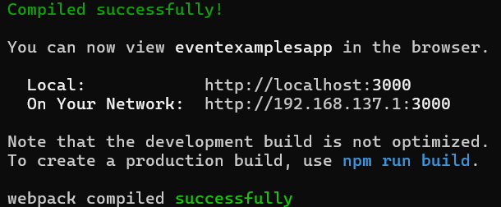
Browser Output
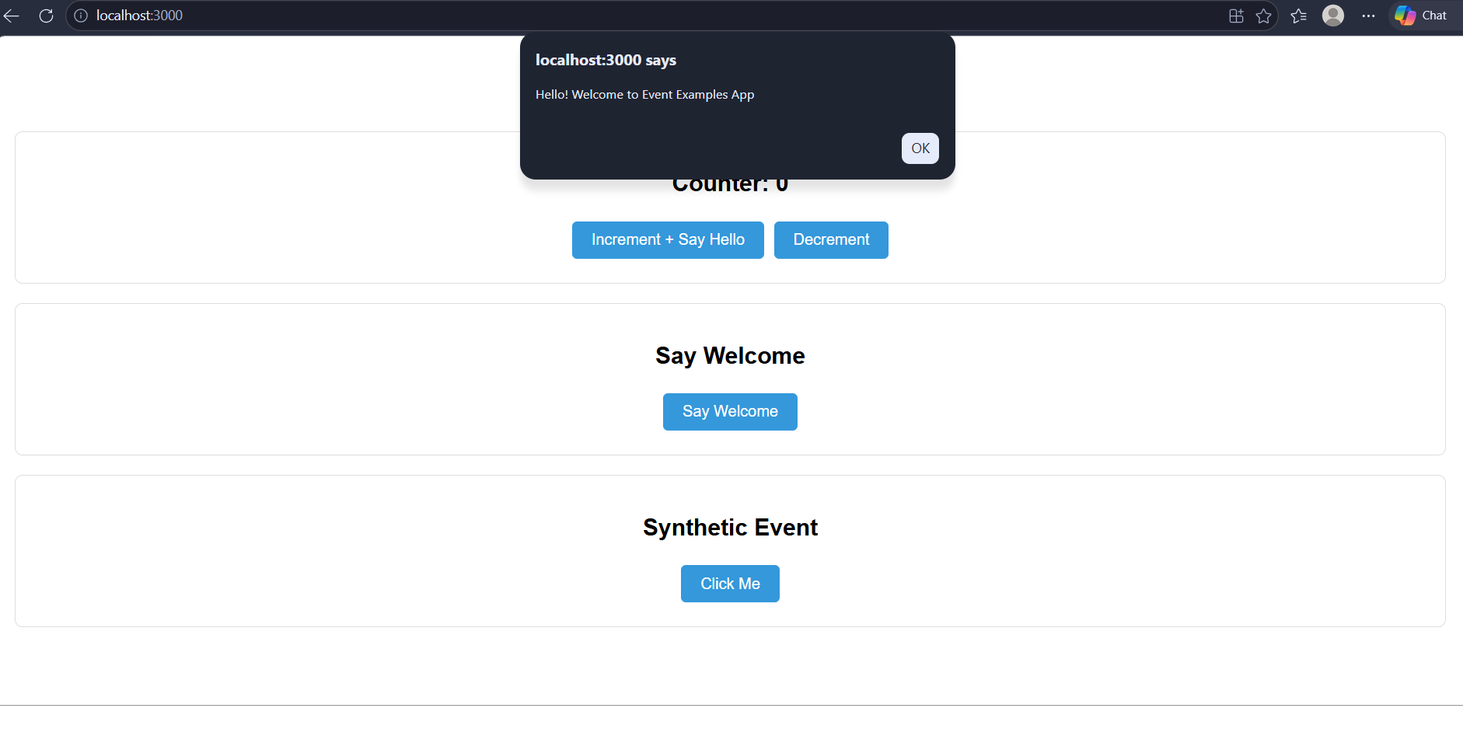
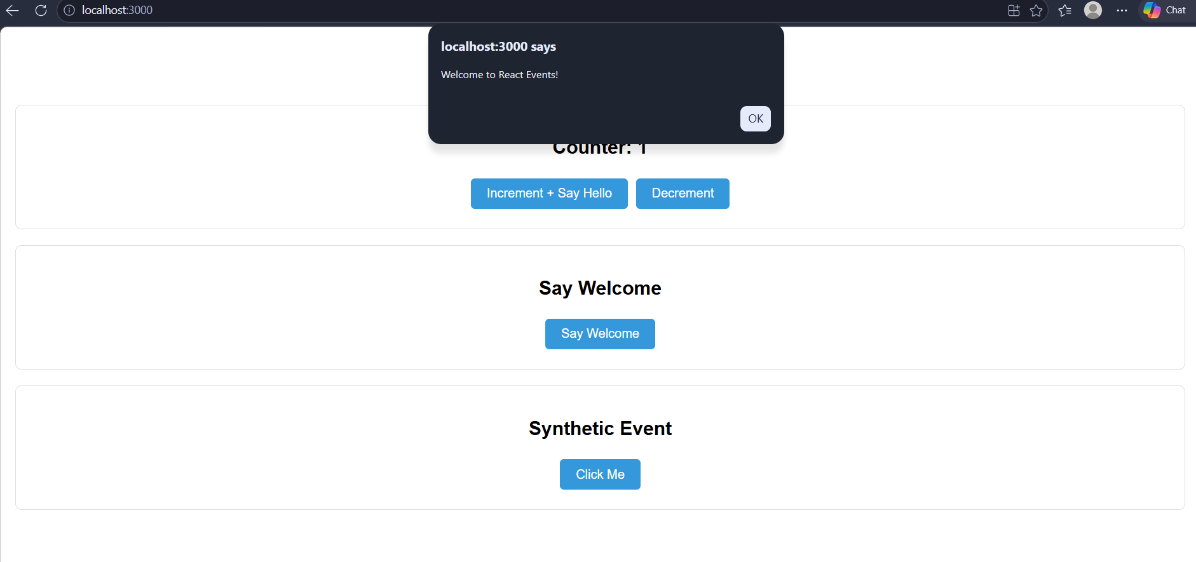
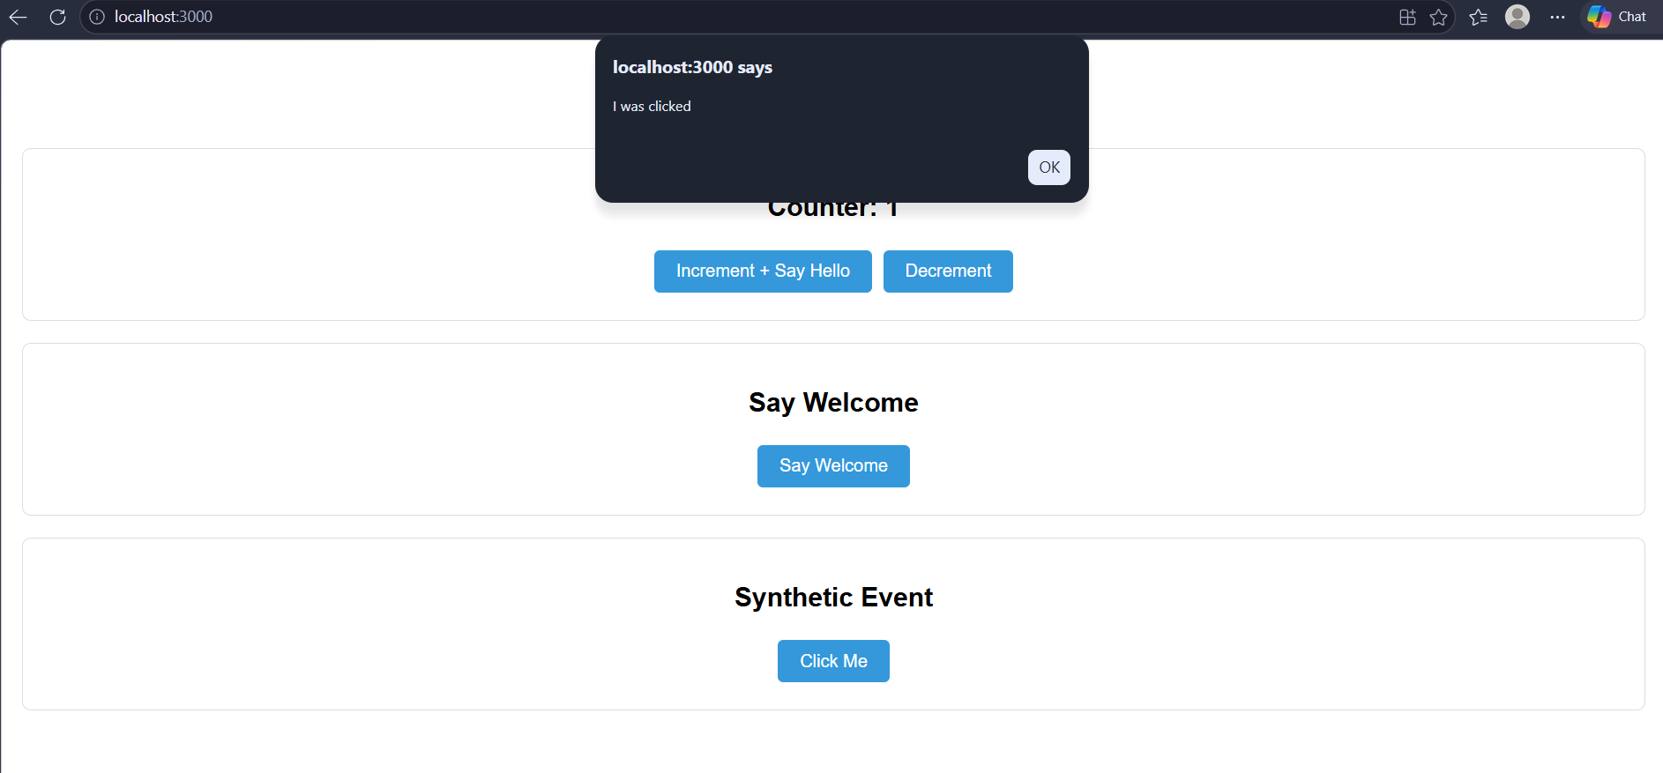
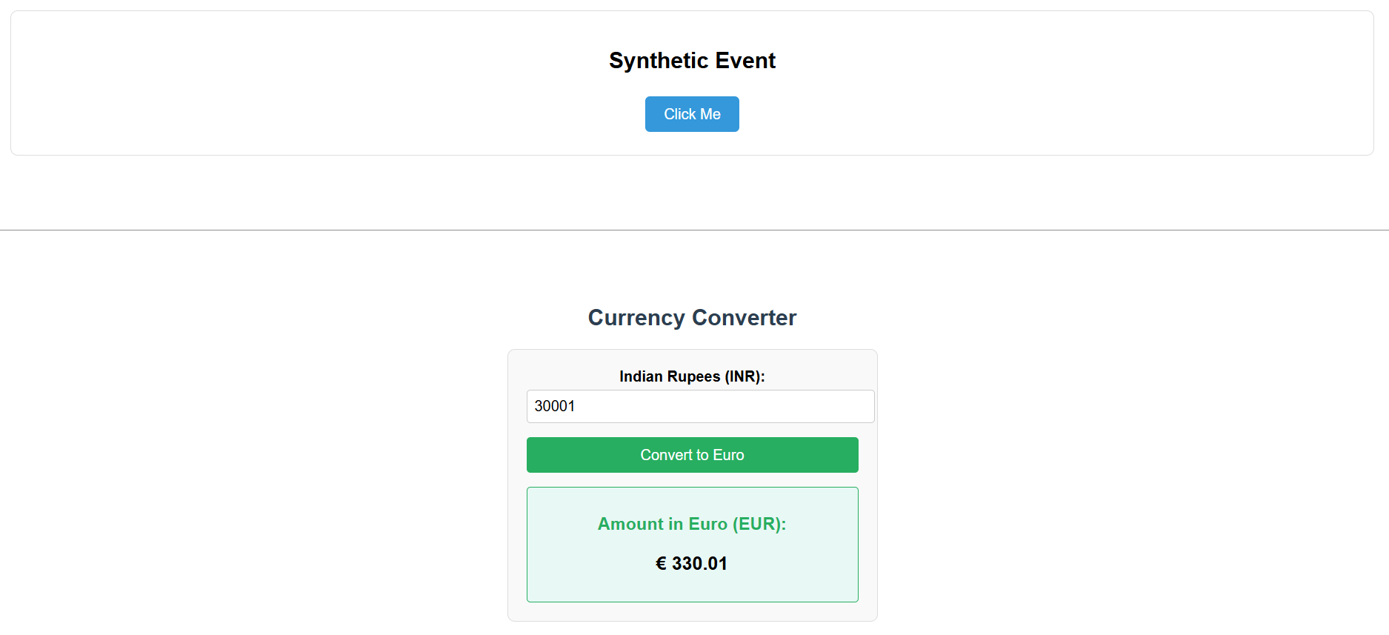
12. ReactJS-HOL

FlightDetails.js
import React from 'react';

function FlightDetails() {
const flights = [
{ id: 1, from: 'New York', to: 'London', departure: '10:00 AM', arrival: '10:00 PM', price: '$500' },
{ id: 2, from: 'Chicago', to: 'Paris', departure: '2:00 PM', arrival: '8:00 AM', price: '$650' },
{ id: 3, from: 'Los Angeles', to: 'Tokyo', departure: '11:30 PM', arrival: '5:00 AM', price: '$800' },
{ id: 4, from: 'Miami', to: 'Dubai', departure: '8:00 AM', arrival: '7:00 PM', price: '$700' }
];

return (
<div>
<h2 style={{ color: '#2c3e50' }}>Available Flights</h2>
<div style={{ display: 'flex', flexWrap: 'wrap', gap: '15px' }}>
{flights.map(flight => (
<div key={flight.id} style={{
border: '1px solid #ddd',
borderRadius: '8px',
padding: '15px',
width: '200px',
backgroundColor: '#f9f9f9',
boxShadow: '0 2px 4px rgba(0,0,0,0.1)'
}}>
<h3 style={{ margin: '0 0 10px 0', color: '#2980b9' }}>
{flight.from} → {flight.to}
</h3>
<p style={{ margin: '5px 0' }}><strong>Departure:</strong> {flight.departure}</p>
<p style={{ margin: '5px 0' }}><strong>Arrival:</strong> {flight.arrival}</p>
<p style={{ margin: '5px 0', color: '#27ae60', fontWeight: 'bold' }}>
{flight.price}
</p>
</div>
))}
</div>
</div>
);
}

export default FlightDetails;

UserPage.js
import React from 'react';
import FlightDetails from './FlightDetails';

function UserPage() {
return (
<div style={{ padding: '20px', fontFamily: 'Arial, sans-serif' }}>
<h1 style={{ color: '#27ae60' }}>Welcome, User!</h1>
<p style={{ fontSize: '18px' }}>You are logged in. You can now book tickets.</p>
<FlightDetails />
<button style={{
padding: '10px 20px',
marginTop: '20px',
fontSize: '16px',
backgroundColor: '#27ae60',
color: 'white',
border: 'none',
borderRadius: '5px',
cursor: 'pointer'
}}>
Book Ticket
</button>
</div>
);
}

export default UserPage;
GuestPage.js
import React from 'react';
import FlightDetails from './FlightDetails';

function GuestPage() {
return (
<div style={{ padding: '20px', fontFamily: 'Arial, sans-serif' }}>
<h1 style={{ color: '#e74c3c' }}>Welcome, Guest!</h1>
<p style={{ fontSize: '18px' }}>Please login to book tickets.</p>
<FlightDetails />
</div>
);
}

export default GuestPage;

App.js
import React, { useState } from 'react';
import './App.css';
import UserPage from './Components/UserPage';
import GuestPage from './Components/GuestPage';

function App() {
const [isLoggedIn, setIsLoggedIn] = useState(false);

const handleLogin = () => {
setIsLoggedIn(true);
};

const handleLogout = () => {
setIsLoggedIn(false);
};

return (
<div className="App" style={{ padding: '20px', fontFamily: 'Arial, sans-serif' }}>
<div style={{ textAlign: 'center', marginBottom: '20px' }}>
<h1 style={{ color: '#2c3e50' }}>Flight Ticket Booking</h1>
<div>
{!isLoggedIn ? (
<button onClick={handleLogin} style={buttonStyle}>
Login
</button>
) : (
<button onClick={handleLogout} style={{ ...buttonStyle, backgroundColor: '#e74c3c' }}>
Logout
</button>
)}
<span style={{ marginLeft: '15px', fontWeight: 'bold', color: isLoggedIn ? '#27ae60' : '#e74c3c' }}>
Status: {isLoggedIn ? 'Logged In' : 'Guest'}
</span>
</div>
</div>

{isLoggedIn ? <UserPage /> : <GuestPage />}
</div>
);
}

const buttonStyle = {
padding: '10px 20px',
fontSize: '16px',
backgroundColor: '#3498db',
color: 'white',
border: 'none',
borderRadius: '5px',
cursor: 'pointer'
};

export default App;

Command Prompt Output:
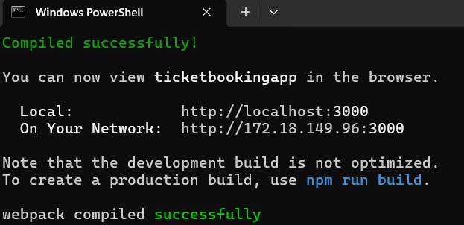
Browser Output
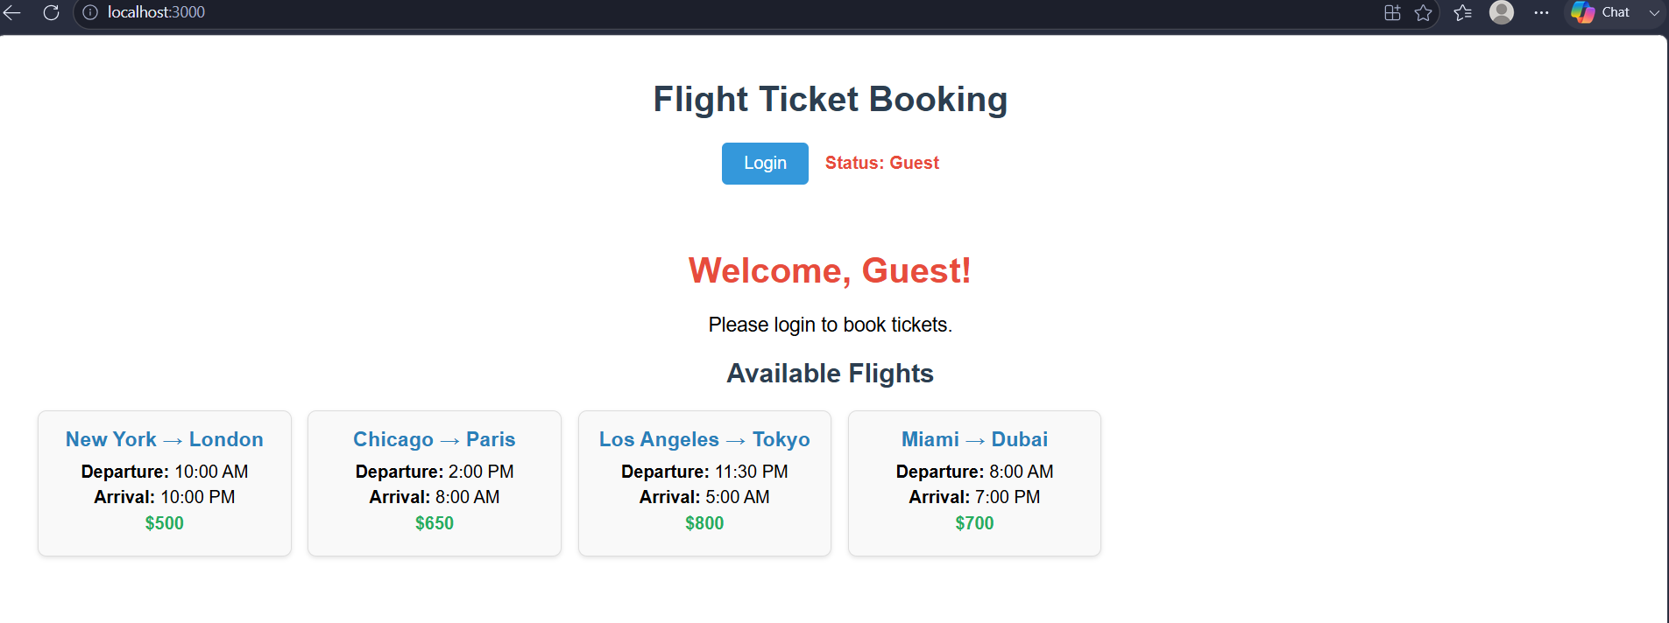
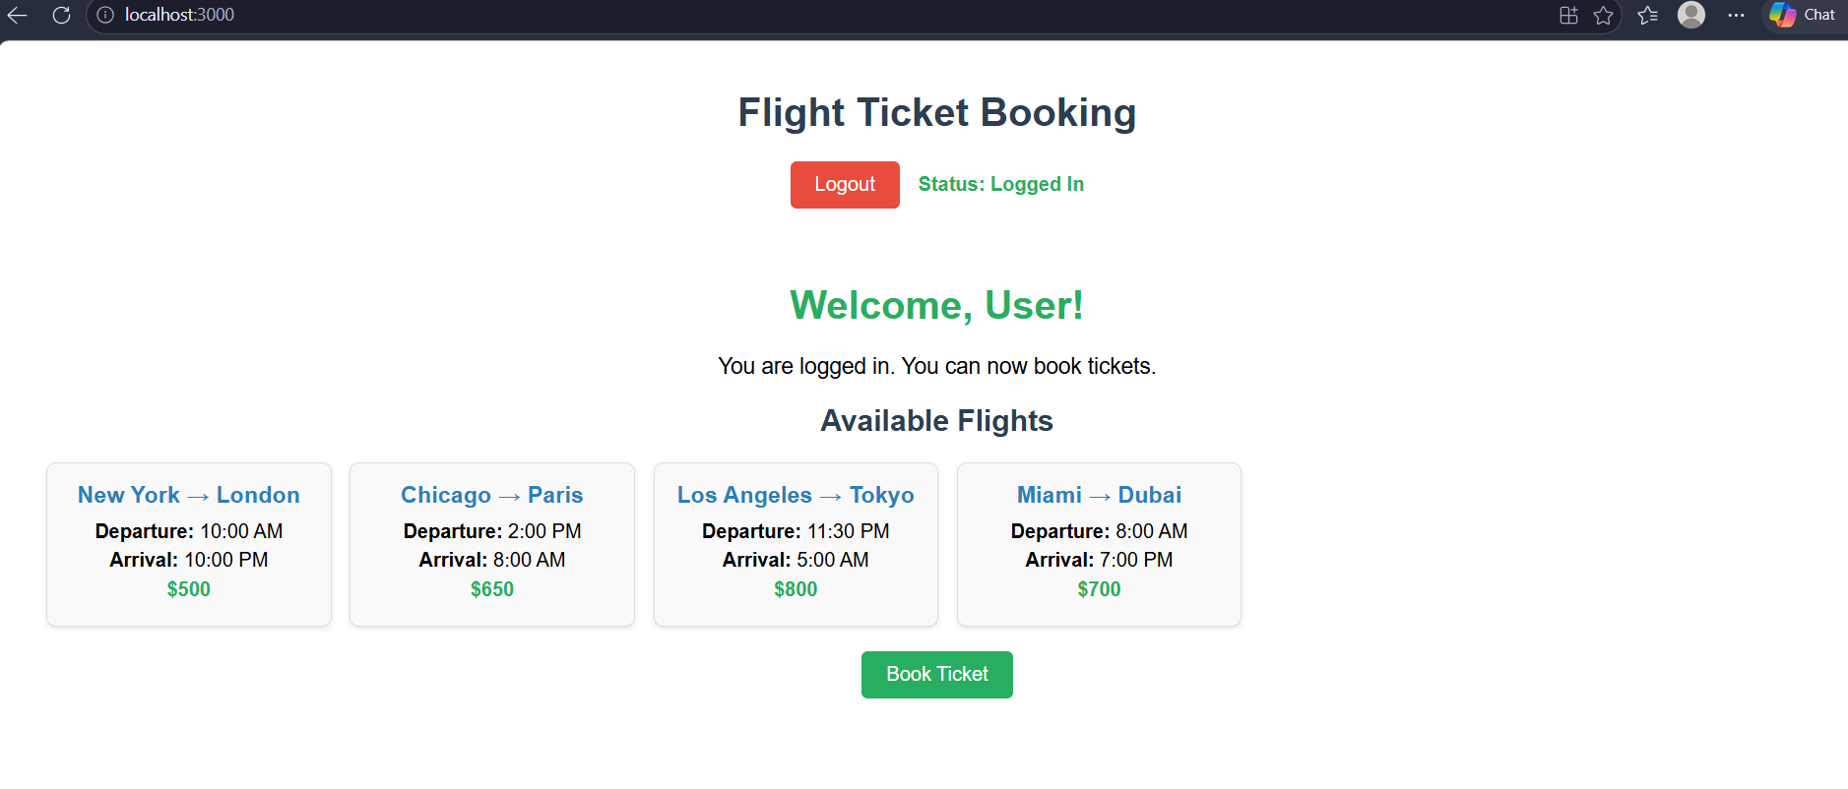

13. ReactJS-HOL

BookDetails.js
import React from 'react';

function BookDetails() {
const books = [
{ id: 1, title: 'The Great Gatsby', author: 'F. Scott Fitzgerald', year: 1925 },
{ id: 2, title: 'To Kill a Mockingbird', author: 'Harper Lee', year: 1960 },
{ id: 3, title: '1984', author: 'George Orwell', year: 1949 },
{ id: 4, title: 'Pride and Prejudice', author: 'Jane Austen', year: 1813 }
];

return (
<div style={{ padding: '15px', border: '1px solid #3498db', borderRadius: '8px', backgroundColor: '#ebf5fb' }}>
<h2 style={{ color: '#2980b9' }}>Book Details</h2>
{books.map(book => (
<div key={book.id} style={{
border: '1px solid #ddd',
borderRadius: '5px',
padding: '10px',
margin: '10px 0',
backgroundColor: 'white'
}}>
<h3>{book.title}</h3>
<p><strong>Author:</strong> {book.author}</p>
<p><strong>Year:</strong> {book.year}</p>
</div>
))}
</div>
);
}

export default BookDetails;

BlogDetails.js
import React from 'react';

function BlogDetails() {
const blogs = [
{ id: 1, title: 'React Hooks Explained', author: 'John Doe', category: 'React' },
{ id: 2, title: 'Spring Boot Microservices', author: 'Jane Smith', category: 'Java' },
{ id: 3, title: 'CSS Flexbox Guide', author: 'Bob Johnson', category: 'CSS' },
{ id: 4, title: 'Python for Data Science', author: 'Alice Brown', category: 'Python' }
];

return (
<div style={{ padding: '15px', border: '1px solid #e67e22', borderRadius: '8px', backgroundColor: '#fef5e7' }}>
<h2 style={{ color: '#e67e22' }}>Blog Details</h2>
{blogs.map(blog => (
<div key={blog.id} style={{
border: '1px solid #ddd',
borderRadius: '5px',
padding: '10px',
margin: '10px 0',
backgroundColor: 'white'
}}>
<h3>{blog.title}</h3>
<p><strong>Author:</strong> {blog.author}</p>
<p><strong>Category:</strong> <span style={{ backgroundColor: '#f1c40f', padding: '2px 8px', borderRadius: '12px' }}>{blog.category}</span></p>
</div>
))}
</div>
);
}

export default BlogDetails;

CourseDetails.js
import React from 'react';

function CourseDetails() {
const courses = [
{ id: 1, name: 'Full Stack Development', duration: '6 months', level: 'Advanced' },
{ id: 2, name: 'Data Science Bootcamp', duration: '4 months', level: 'Intermediate' },
{ id: 3, name: 'Cloud Computing', duration: '3 months', level: 'Beginner' },
{ id: 4, name: 'DevOps Engineering', duration: '5 months', level: 'Advanced' }
];

return (
<div style={{ padding: '15px', border: '1px solid #27ae60', borderRadius: '8px', backgroundColor: '#eafaf1' }}>
<h2 style={{ color: '#27ae60' }}>Course Details</h2>
{courses.map(course => (
<div key={course.id} style={{
border: '1px solid #ddd',
borderRadius: '5px',
padding: '10px',
margin: '10px 0',
backgroundColor: 'white'
}}>
<h3>{course.name}</h3>
<p><strong>Duration:</strong> {course.duration}</p>
<p><strong>Level:</strong> <span style={{
backgroundColor: course.level === 'Advanced' ? '#e74c3c' :
course.level === 'Intermediate' ? '#f39c12' : '#2ecc71',
color: 'white',
padding: '2px 8px',
borderRadius: '12px'
}}>{course.level}</span></p>
</div>
))}
</div>
);
}
export default CourseDetails;
App.js
import React, { useState } from 'react';
import './App.css';
import BookDetails from './Components/BookDetails';
import BlogDetails from './Components/BlogDetails';
import CourseDetails from './Components/CourseDetails';

function App() {
const [selectedComponent, setSelectedComponent] = useState('books');

let displayComponent;

if (selectedComponent === 'books') {
displayComponent = <BookDetails />;
} else if (selectedComponent === 'blogs') {
displayComponent = <BlogDetails />;
} else if (selectedComponent === 'courses') {
displayComponent = <CourseDetails />;
} else {
displayComponent = <p>Please select a category</p>;
}

const getButtonStyle = (component) => ({
padding: '10px 20px',
margin: '5px',
fontSize: '16px',
backgroundColor: selectedComponent === component ? '#2c3e50' : '#3498db',
color: 'white',
border: 'none',
borderRadius: '5px',
cursor: 'pointer'
});

const showWelcome = selectedComponent === 'books';

return (
<div className="App" style={{ padding: '20px', fontFamily: 'Arial, sans-serif' }}>
<h1 style={{ textAlign: 'center', color: '#2c3e50' }}>Blogger App</h1>
<div style={{ textAlign: 'center', marginBottom: '20px' }}>
<button onClick={() => setSelectedComponent('books')} style={getButtonStyle('books')}>
{selectedComponent === 'books' ? '📚 Books' : 'Books'}
</button>
<button onClick={() => setSelectedComponent('blogs')} style={getButtonStyle('blogs')}>
{selectedComponent === 'blogs' ? '📝 Blogs' : 'Blogs'}
</button>
<button onClick={() => setSelectedComponent('courses')} style={getButtonStyle('courses')}>
{selectedComponent === 'courses' ? '🎓 Courses' : 'Courses'}
</button>
</div>

{showWelcome && (
<div style={{
textAlign: 'center',
backgroundColor: '#f0f8ff',
padding: '10px',
borderRadius: '5px',
marginBottom: '15px'
}}>
<p style={{ margin: 0, color: '#2980b9' }}>Welcome to the Books section!</p>
</div>
)}

{/* 6. Conditional rendering with element variables */}
<div style={{ marginTop: '20px' }}>
{displayComponent}
</div>

{/* 7. Conditional rendering with switch statement */}
{(() => {
switch(selectedComponent) {
case 'books':
return <p style={{ textAlign: 'center', color: '#7f8c8d' }}>Showing {selectedComponent} details above</p>;
case 'blogs':
return <p style={{ textAlign: 'center', color: '#7f8c8d' }}>Showing {selectedComponent} details above</p>;
case 'courses':
return <p style={{ textAlign: 'center', color: '#7f8c8d' }}>Showing {selectedComponent} details above</p>;
default:
return null;
}
})()}
</div>
);
}

export default App;

Command Prompt Output:
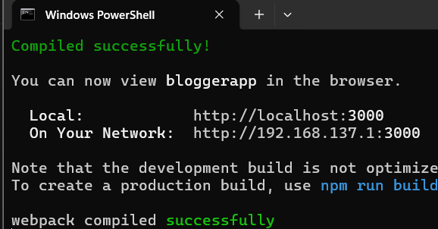
Browser Output
