NAAN MUDHALVAN PROJECT
ST. TERESA ARTS AND SCIENCE COLLEGE FOR WOMEN ,MANGALAKUNTU-629178
(AFFILIATED TO ΜΑΝΟΝΜΑΝΙAM SUNDARANAR UNIVERSITY TIRUNELVELI)
KANYAKUMARI DISTRICT, TAMILNADU

This report is submitted to the Manonmaniam Sundaranar university, Tirunelveil. In partial fulfillment of the requirement for the degree of
BACHELOR OF SCIENCE IN COMPUTER SCIENCE
Topic: JSON REFINER ADVANCED EDITION
Submitted by,
S. SHALINI
V.SREE LAKSHMI
V.KANISHKA
ASMILA
Under the Guidance of
MRS.T.D. JAIN SUBHA
(Asso.prof., Dept. of Computer Science)

DEPARTMENT OF COMPUTER SCIENCE

Project Title: JSON Refinery – Advanced Edition

1. Project Description

JSON Refinery – Advanced Edition is a data processing and transformation tool designed to clean, transform, validate, and normalize JSON data.
The system handles multiple real-world scenarios such as data migration, API response formatting, configuration management, data flattening for analytics, and schema-based validation.
The main objective of this project is to build a flexible and scalable solution that refines raw data into structured, consistent, and usable JSON format.

2. Scenario Explanation

Scenario 1: Data Migration from CSV to JSON
Many legacy systems store data in CSV format.
This module:
Reads CSV files
Converts records into structured JSON objects
Handles missing or inconsistent values
Saves output in properly formatted JSON
Use Case: Migrating customer or employee data into modern web applications.

Scenario 3: Configuration File Management

Applications use JSON for configuration files.
This module:
Validates configuration structure
Updates configuration dynamically
Merges multiple configuration files
Ensures correct data types
Use Case: Managing environment-based settings (Dev, Test, Production).

Scenario 4: Data Flattening for Analytics

Analytics tools often require flat data.
This module:
Converts nested JSON into flat key-value pairs
Prepares structured datasets for reporting
Improves compatibility with BI tools
Use Case: Preparing data for dashboards and reports.

Scenario 5: Schema-Based Data Validation

Ensures JSON data follows a predefined schema.
This module:
Validates required fields
Checks data types
Enforces constraints
Generates validation reports
Use Case: Ensuring reliable data before storing in database.

3. Architecture Overview

The system follows a modular architecture:
1. Input Layer
Accepts CSV/JSON files or API responses
2. Processing Layer
Transformation Engine
Validation Engine
Normalization Module
Flattening Module
3. Output Layer
Clean JSON Output
Validation Report
Logs
This layered design ensures scalability and maintainability.
5. Pre-Requisites

Software Requirements

Operating System: Windows / Linux / macOS
Programming Environment (Python/Java/Node)
IDE (VS Code / IntelliJ / Eclipse)
JSON validation libraries

Knowledge Prerequisites

Basic understanding of JSON and CSV formats
Programming fundamentals
API concepts
Data structures

Hardware Requirements

Minimum 4GB RAM
10GB free disk space
Standard processor (i3 or above)

Project Workflow
Phase 1: Environment Setup & Core Architecture
Activity 1.1: Install Dependencies & Configure Environment

- Install required programming language (Python/Java).
- Install necessary libraries (JSON parser, CSV reader, schema validator).
- Set up IDE (VS Code / IntelliJ / Eclipse).
- Configure virtual environment.
- Verify installation with sample execution.

Activity 1.2: Design Core Data Structure

- Define JSON object structure.
- Design input-output data models.
- Create folder structure for modular development.
- Plan transformation pipeline flow.

Phase 2: Core JSON Processing Engine
Activity 2.1: Implement Type Inference System

- Detect data types automatically (String, Number, Boolean, Date).
- Handle null and missing values.
- Convert CSV data types to appropriate JSON types.

Activity 2.2: Build Key Normalization & Case Conversion

- Standardize key naming conventions.Convert keys to camelCase / snake_case.
- Remove duplicate keys.
- Clean unwanted special characters.

Phase 3: Validation & Transformation Features
Activity 3.1: Implement JSON Schema Validation

- Create JSON schema structure.
- Validate required fields.
- Check data types and constraints.
- Generate validation error reports.

Activity 3.2: Build Required Field Checking

- Identify mandatory fields.
- Highlight missing values.
- Provide structured error messages.

Activity 3.3: Develop JSON Transformation Methods

- Flatten nested JSON.
- Merge multiple JSON objects.
- Filter and map fields.
- Convert JSON format based on user rules.

Phase 4: Gradio Interface Development
Activity 4.1: Design Data Refining Tab

- Create user-friendly interface.
- Add file upload option (CSV/JSON).
- Display processed output.
- Show validation results.
- Add download option for refined JSON.

Phase 5: Integration, Testing & Deployment
Activity 5.1: Google Colab Deployment

- Upload project files.
- Install dependencies.
- Run application in cloud environment.
- Share access link.

Activity 5.2: Comprehensive Testing

- Unit testing of each module.
- Integration testing.
- Performance testing.
- Edge case handling.

PIP INSTALLATION TRANSFORMER U
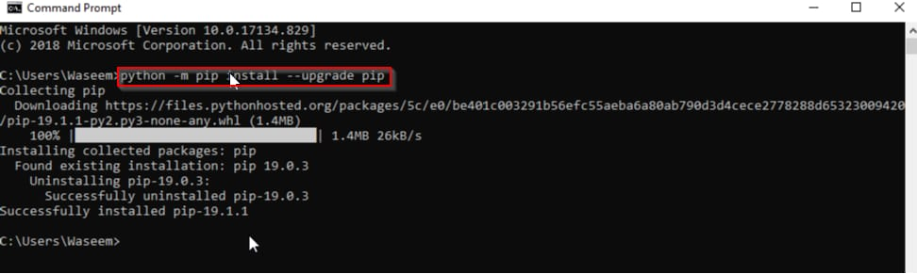

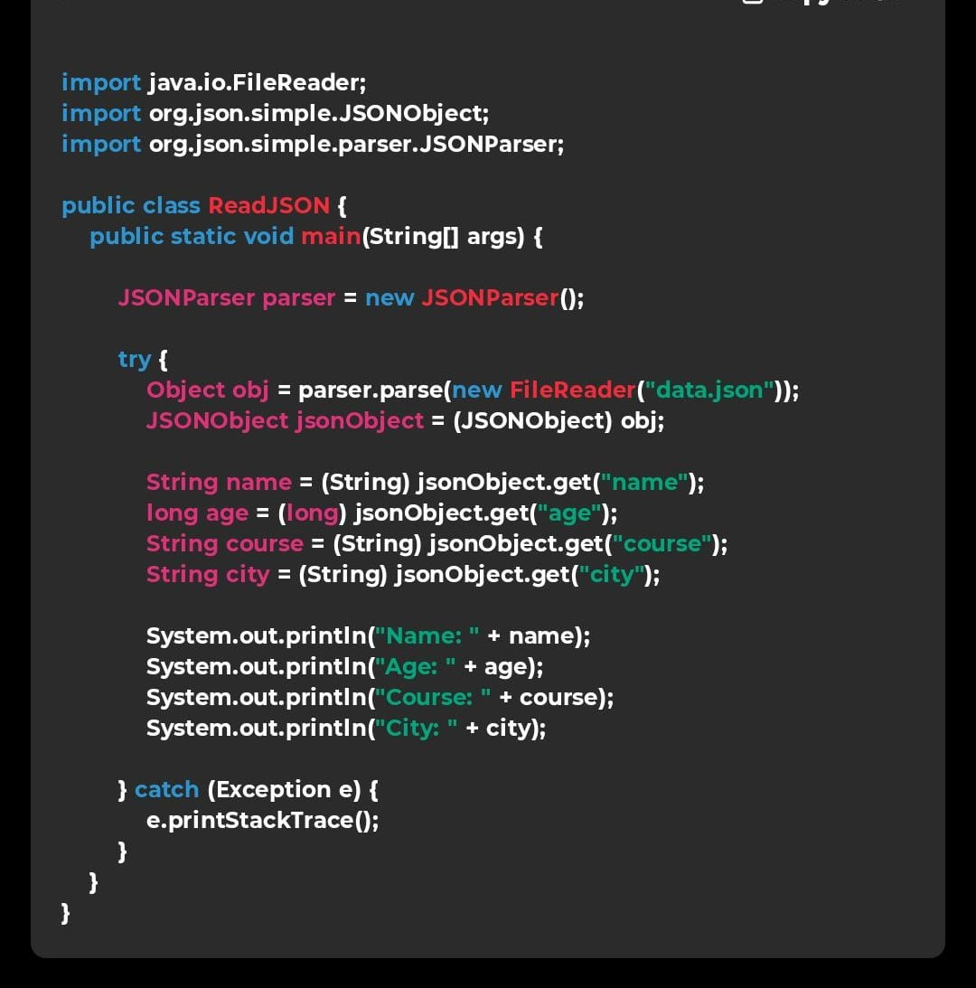

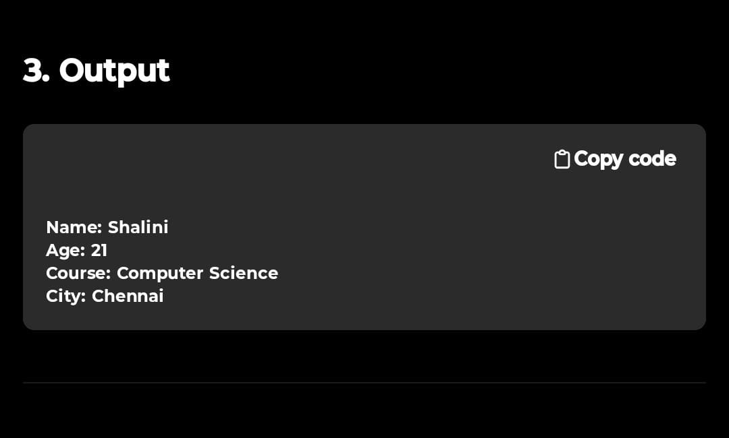

CONCLUSION:
The JSON Refinery – Advanced Edition project was developed to provide an efficient system for processing, cleaning, and transforming JSON data. The project successfully demonstrates how raw or unstructured data can be converted into a well-organized and standardized JSON format.
The system includes important features such as data validation, key normalization, type inference, and JSON transformation. These features help ensure that the data becomes consistent, accurate, and suitable for use in applications, databases, or APIs.
Through this project, users can upload data files, process them using the JSON refining engine, and obtain clean and structured output. The modular architecture makes the system flexible and easy to maintain. Overall, the project shows how modern tools can simplify data management and improve data quality.

FUTURE ENHANCEMENTS

Although the current system performs the core refining tasks effectively, several improvements can be added in the future:
1. Support for More File Formats
The system can be extended to support additional formats such as XML, Excel, and YAML.
2. Advanced Data Visualization
Charts and graphs can be added to visualize processed data.
3. Integration with Databases
The refined JSON data can be directly stored in databases like MongoDB or MySQL.
4. Cloud Deployment
The application can be deployed on cloud platforms for easier access and scalability.
5. Real-Time API Processing
The system can be enhanced to refine data directly from live API responses.
6. User Authentication and Security
Adding login systems and role-based access will improve security.

