SIMATS ENGINEERING
Department of Computer Science & Engineering
ASSESSMENT TOOL 2- PSEUDOCODE WRITING TASK (ALGORITHM DESIGN)

Course Code: | CSA12 | Course Title: | Computer Architecture for Multicore Systems
CO Assessed: | CO5 | Assessment: | ASSESSMENT TOOL2- PSEUDOCODE WRITING TASK (ALGORITHM DESIGN)
Weightage: | 30% | Total Marks: | 25
CO5 Statement: | Construct I/O communication mechanisms by comparing memory-mapped and I/O-mapped techniques, interrupt handling (vectored, hardware, software), DMA controllers, and advanced bus interfaces including PCIe, USB, NVMe, and Thunderbolt.
Student Name: | K Sreelatha | Reg.No.: | 192425248
Department: | AI & ML | Date: | 27/08/2026

ANNEXURE A
Pseudocode Writing Task (Algorithm Design)

- Write pseudocode to design a DMA-based data transfer algorithm that moves data from an I/O device to memory while handling interrupts and minimizing CPU involvement.
- Develop pseudocode for an interrupt handling system that prioritizes vectored interrupts from multiple devices and dispatches appropriate service routines.
- Write pseudocode to select between memory-mapped I/O and I/O-mapped I/O dynamically based on latency and bandwidth requirements.
- Design pseudocode for a bus arbitration algorithm that manages multiple devices communicating over PCIe, USB, and Thunderbolt interfaces.
- Write pseudocode to implement a hybrid I/O communication mechanism that uses polling for low-speed devices and DMA with interrupts for high-speed devices.

Code of Conduct:

I _K Sreelatha(192425248)_ (Name / Reg No) certify that this submission is my original work and that I have adhered to the guidelines specified for this assessment.
I understand that any violation of academic integrity rules will result in disciplinary action.

Signature of the student: Sree K

MARKS ALLOCATION
 | Problem Understanding (20%) | Algorithm Design (30%) | Use of Control Structures (20%) | Pseudocode Structure (10%) | Completeness (20%)
Q1
Q2
Q3
Q4
Q5

RUBRICS FOR CALCULATION:

Criteria | Weightage | Level 4 – Exemplary | Level 3 – Proficient | Level 2 – Developing | Level 1 – Beginning
Problem Understanding | 20% | Identifies all inputs, outputs, constraints accurately | Minor missing elements | Partial understanding | Incorrect interpretation
Algorithm Design | 30% | Complete, correct, and logically sound solution | Minor logical gaps | Partially correct logic | Incorrect approach
Use of Control Structures | 20% | Efficient and appropriate use of loops, conditions, functions/modules | Minor inefficiencies | Limited or basic usage | Incorrect or missing constructs
Pseudocode Structure | 10% | Well-structured, clear, consistent format, easy to follow | Mostly clear with minor issues | Difficult to follow in parts | Poorly structured and unclear
Completeness | 20% | Handles all cases; optimized approach | Handles most cases; reasonable efficiency | Handles basic cases only | Incomplete or inefficient

1)Pseudocode to design a DMA-based data transfer algorithm

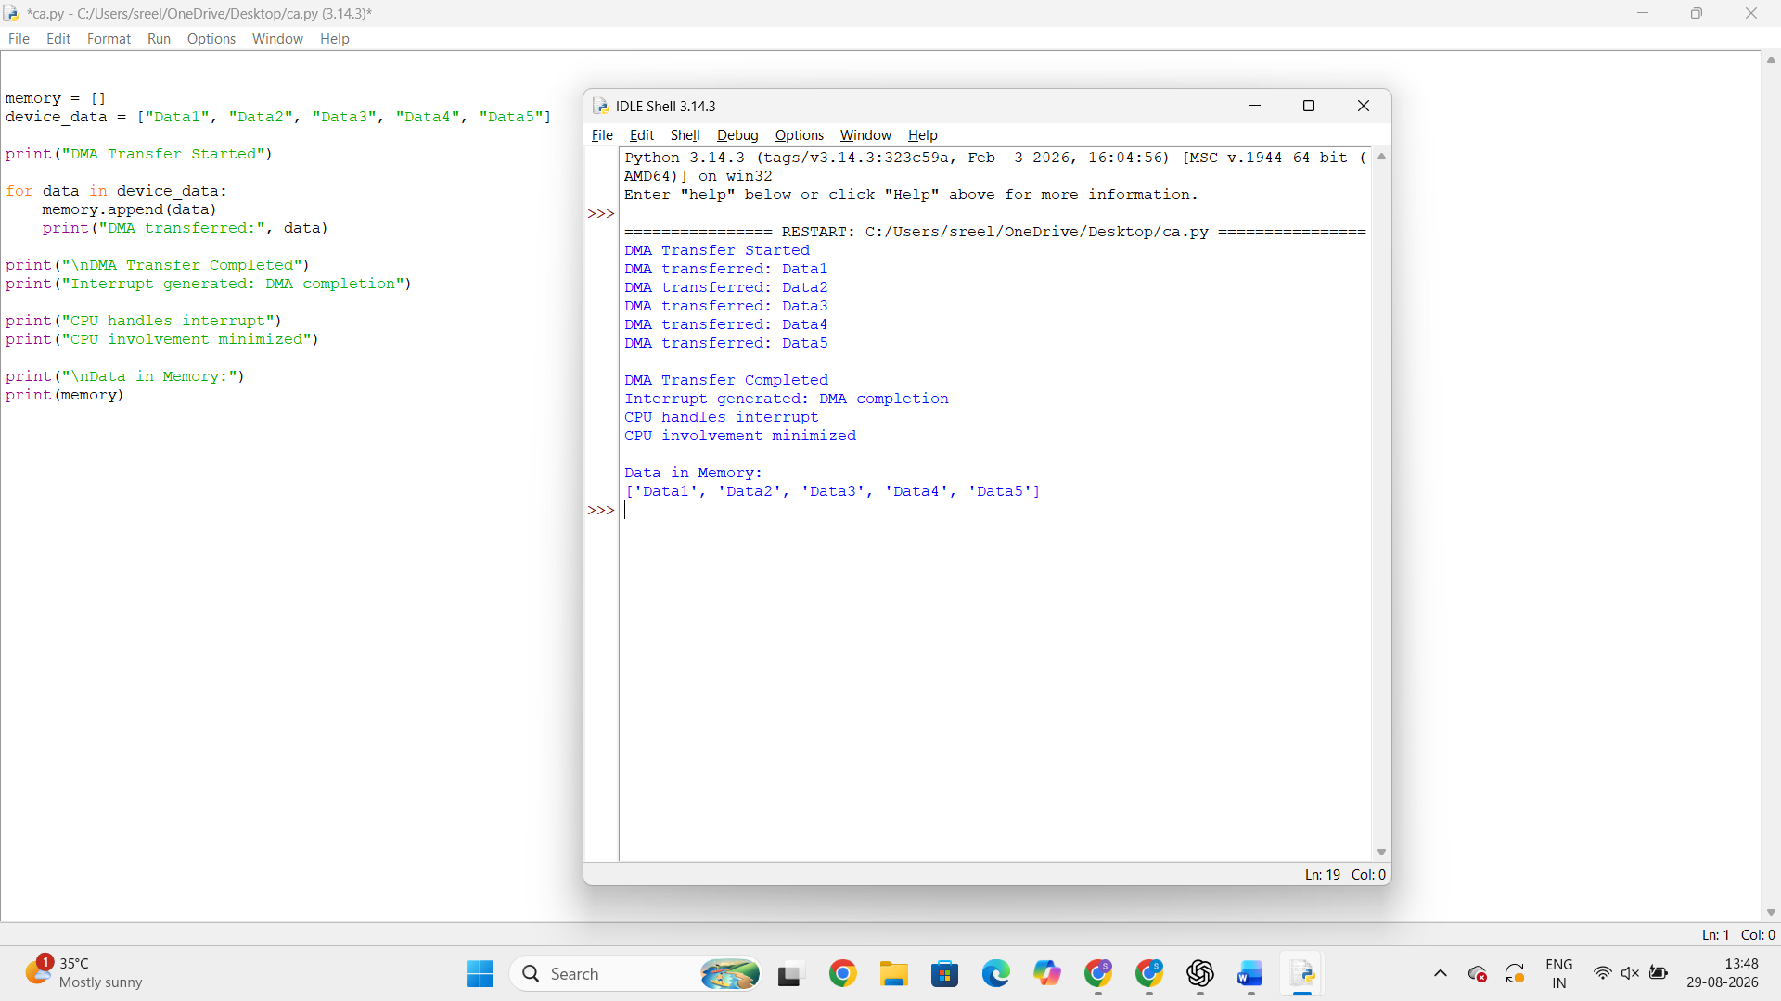

2) Vectored Interrupt Handling System

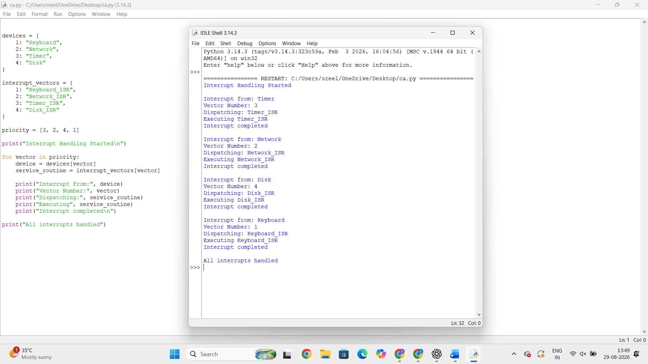

3. Dynamic Selection of Memory-Mapped I/O or I/O-Mapped I/O

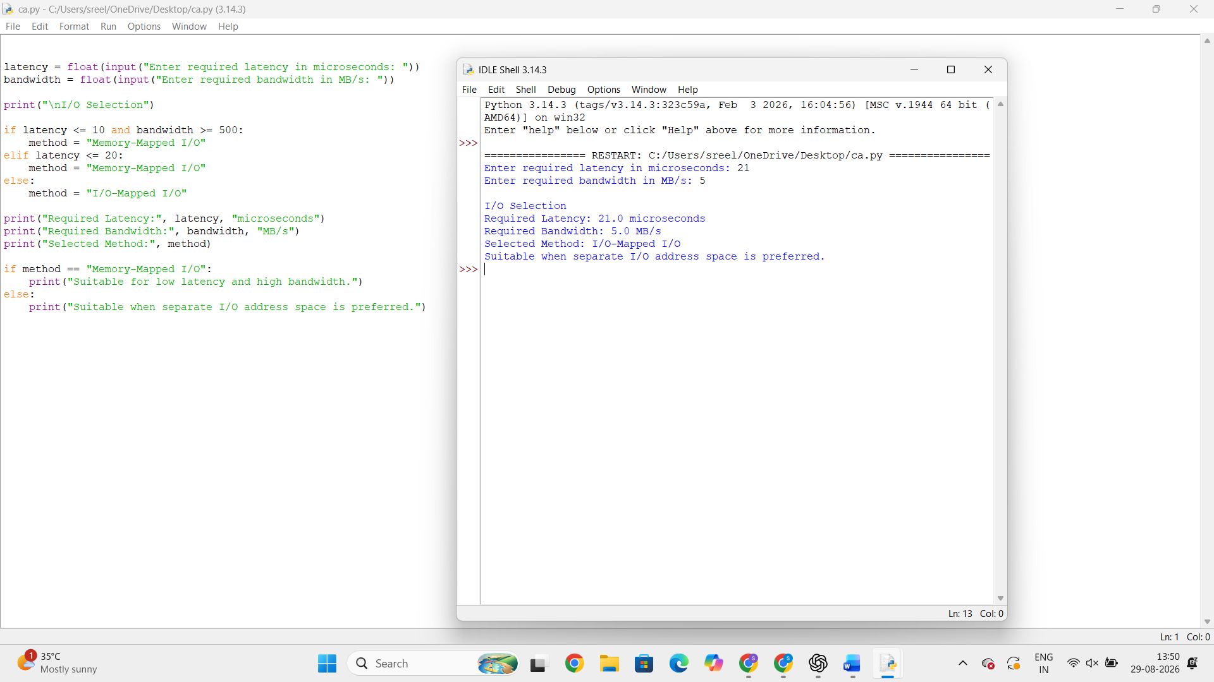

4. Bus Arbitration for PCIe, USB and Thunderbolt

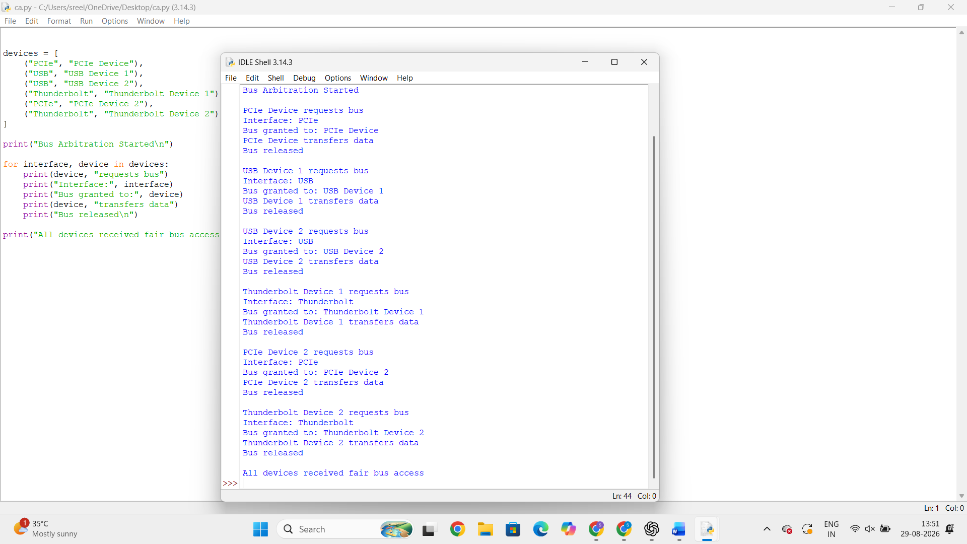

5. Hybrid I/O Communication Mechanism

