SIMATS ENGINEERING
Department of Computer Science & Engineering
ASSESSMENT TOOL 1- INDUSTRY PROBLEM SOLVING TASK

Course Code: | CSA12 | Course Title: | Computer Architecture for Multicore Systems
CO Assessed: | CO4 | Assessment: | ASSESSMENT TOOL1- INDUSTRY PROBLEM SOLVING TASK
Weightage: | 30% | Total Marks: | 25
CO4 Statement: | Implement hierarchical memory systems by differentiating cache levels (L1, L2, L3), virtual memory with paging, and advanced memory technologies (DRAM, SRAM, NAND Flash, MRAM, RRAM) based on latency, bandwidth, and throughput characteristics.
Student Name: | K Sreelatha | Reg.No.: | 192425248
Department: | AI & ML | Date: | 25/08/2026

ANNEXURE A
INDUSTRY PROBLEM SOLVING TASK

- Smartphone Performance Optimization
A mobile manufacturer observes lag while switching between apps. Analyze the role of L1, L2, L3 cache and DRAM and propose a hierarchical memory redesign to reduce latency and improve throughput.
- Cloud Server Memory Bottleneck
A cloud service provider experiences high latency in database queries. Compare cache hierarchy vs virtual memory paging and recommend improvements using appropriate memory technologies.
- Autonomous Vehicle Data Processing
An autonomous vehicle must process sensor data in real time. Evaluate SRAM, DRAM, and MRAM and design a memory hierarchy that maximizes bandwidth and minimizes latency.
- AI Inference Edge Device
An edge AI device needs fast model loading with low power consumption. Compare NAND Flash, DRAM, and RRAM and recommend an optimized hierarchical memory structure.
- High-Performance Gaming Console
A gaming console suffers frame drops during large scene loading. Analyze L3 cache vs DRAM throughput and propose memory hierarchy enhancements.

Code of Conduct:

I _K Sreelatha(192425248)_ (Name / Reg No) certify that this submission is my original work and that I have adhered to the guidelines specified for this assessment.
I understand that any violation of academic integrity rules will result in disciplinary action.

Signature of the student: Sree K

MARKS ALLOCATION
 | Understanding of Industry Problem (20%) | Application of Engineering Concepts (25%) | Solution Design (25%) | Use of Tools (15%) | Analysis (10%)
Q1
Q2
Q3
Q4
Q5

RUBRICS FOR CALCULATION:

Criteria | Weightage | Level 4 – Exemplary | Level 3 – Proficient | Level 2 – Developing | Level 1 – Beginning
Understanding of Industry Problem | 20% | Comprehensive understanding of real-world problem and constraints | Good understanding with minor gaps in requirements | Basic understanding; some requirements unclear | Poor understanding; misinterprets problem context
Application of Engineering Concepts | 25% | Applies advanced and relevant concepts effectively to solve the problem | Applies appropriate concepts with minor errors | Limited application of concepts | Incorrect or no application of concepts
Solution Design | 25% | Innovative, practical, and feasible solution aligned with industry standards | Logical and feasible solution with minor gaps | Basic solution with limited feasibility | Unclear or impractical solution
Use of Tools | 15% | Effective use of modern tools, technologies, and real data | Appropriate use of tools with correct implementation | Limited or inconsistent use of tools | Minimal or incorrect use of tools
Analysis | 10% | Thorough analysis with validated results and performance evaluation | Good analysis with reasonable validation | Basic analysis with limited validation | Poor or no analysis

1) Smartphone Performance Optimization
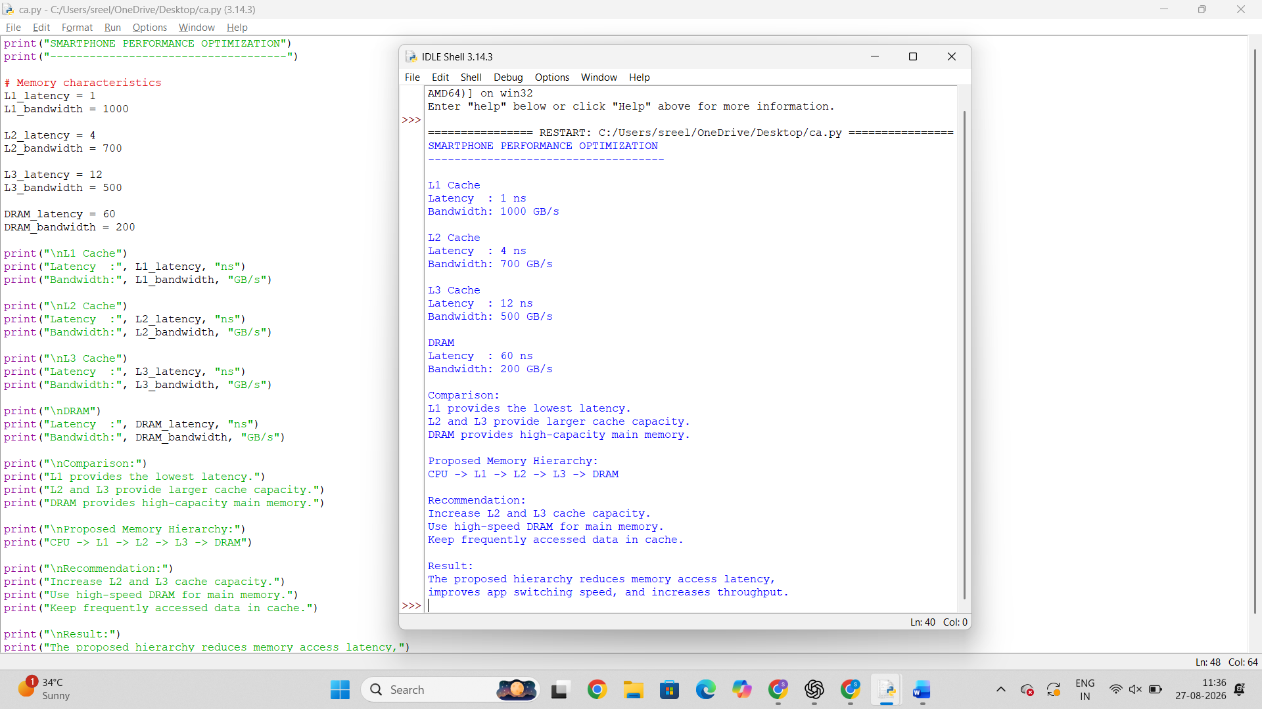

2. Cloud Server Memory Bottleneck

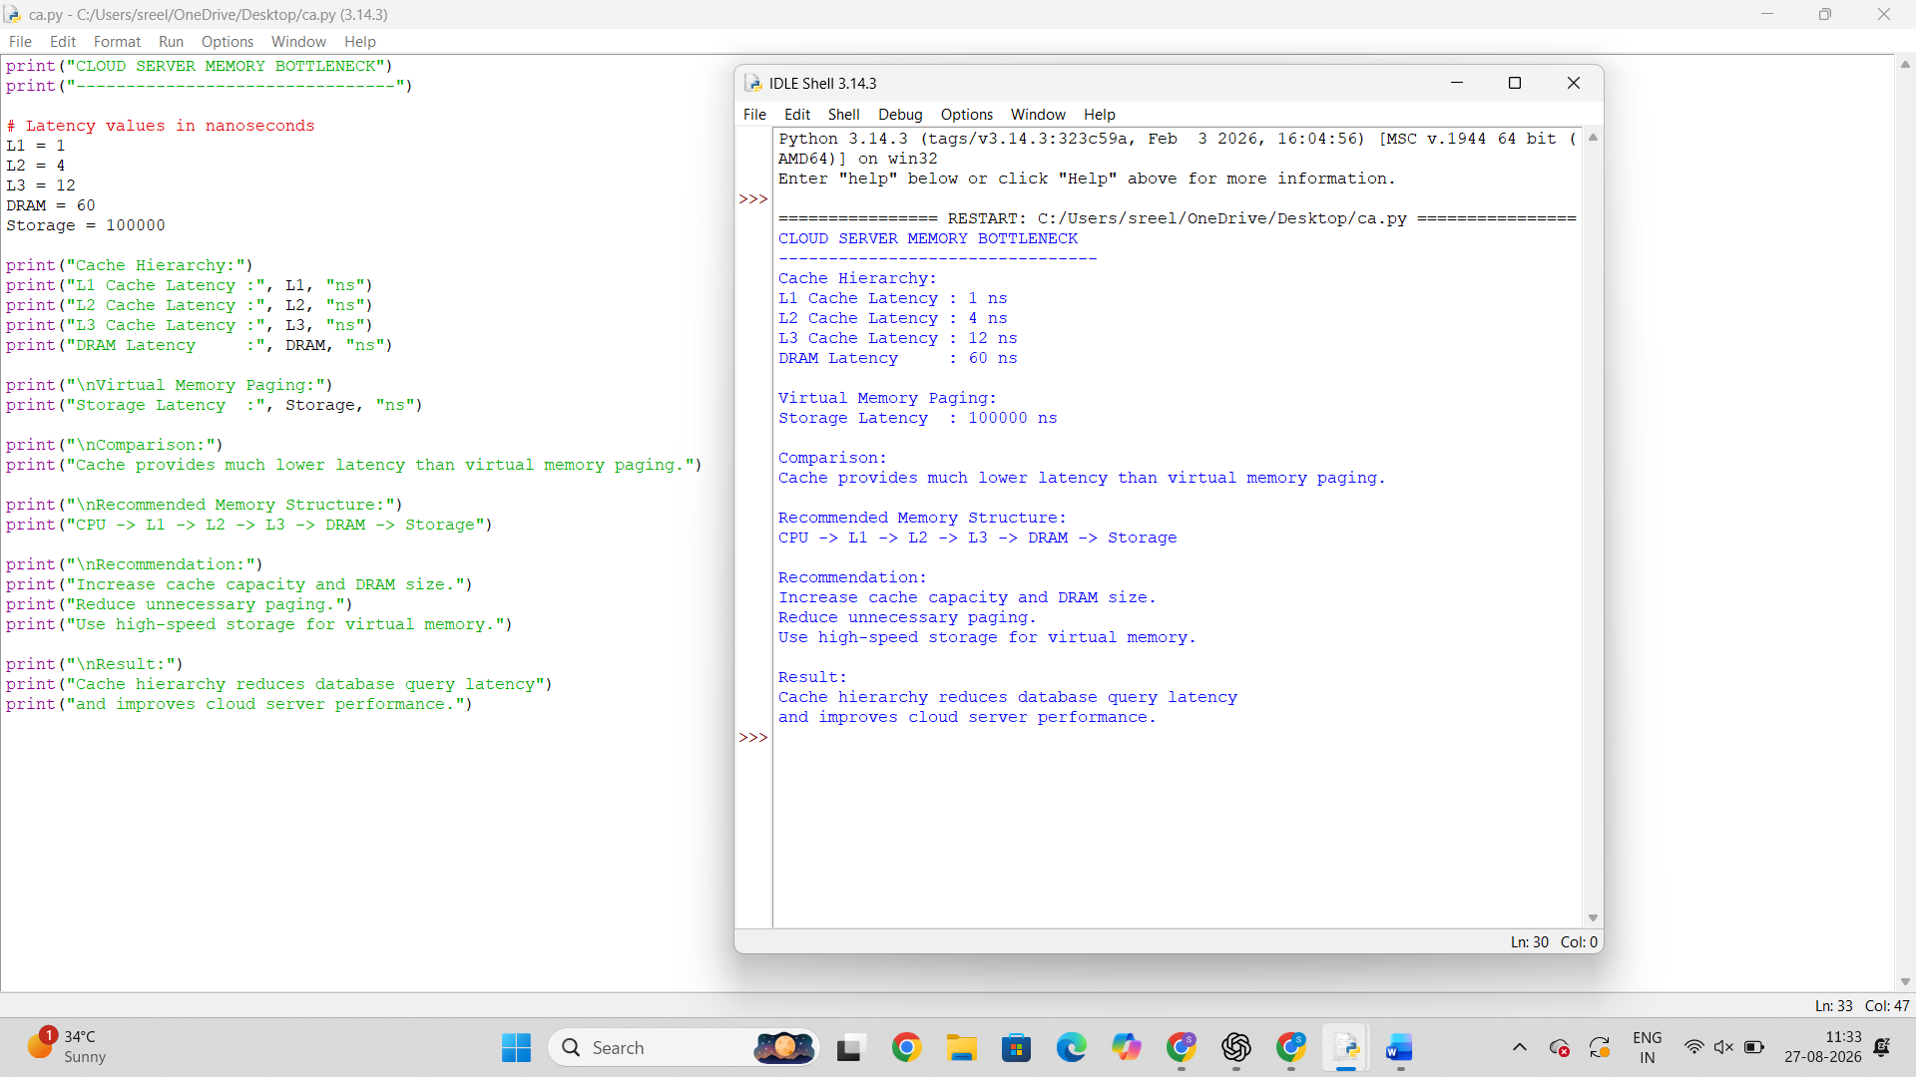

3. Autonomous Vehicle Data Processing

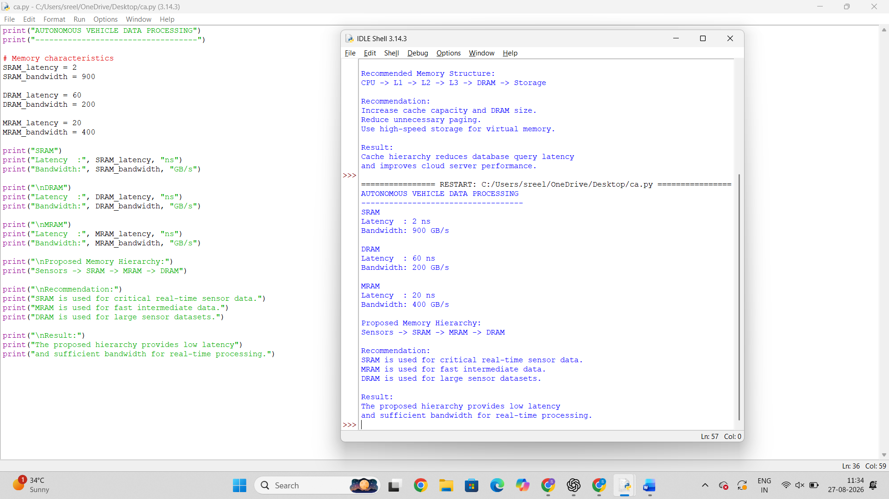

4. AI Inference Edge Device

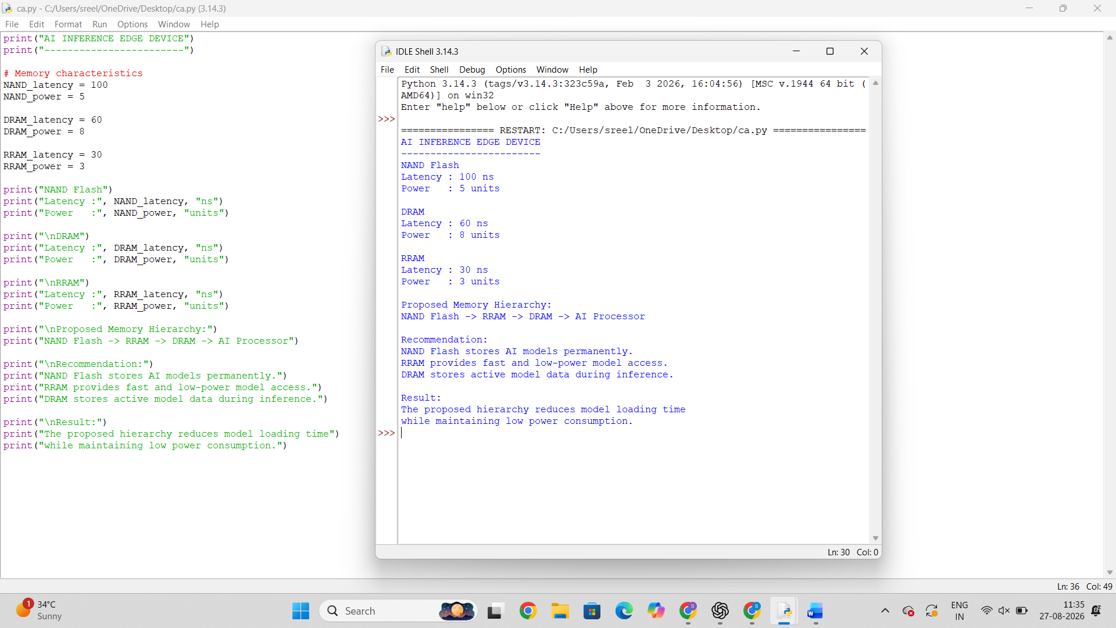

5. High-Performance Gaming Console

