SIMATS ENGINEERING
CO5 - ASSESSMENT TOOL 1
Design Desk
COURSE NAME: Deep Learning COURSE CODE: MLA0408

COURSE OUTCOME COVERED

CO5: Students will be able to analyze and explain advanced generative deep learning models including Autoencoders, Deep Belief Networks, Boltzmann Machines, Deep Boltzmann Machines, and Generative Adversarial Networks. They will be able to compare their architectures, explain their learning mechanisms, and apply suitable generative models to real-world problems. (BTL-3)
Assessment Tool Weightage: 30%

QUESTIONS:

1. Design an Autoencoder-Based Feature Learning System
A manufacturing company wants to detect defective products from high-dimensional sensor data. Design an Undercomplete Autoencoder with suitable encoder, latent representation, decoder, activation functions, and reconstruction loss. Explain how the design performs dimensionality reduction and feature learning.
2. Design a Robust Regularized Autoencoder
A healthcare organization has noisy patient-record features and needs a robust representation for downstream classification. Design a Regularized Autoencoder using an appropriate regularization strategy. Explain the encoder-decoder structure, regularization mechanism, training objective, and how the design reduces overfitting and improves useful feature extraction.
3. Design a Deep Generative Model
A recommendation or content-generation system requires learning complex data distributions. Design a Deep Belief Network or Deep Boltzmann Machine using suitable visible and hidden layers. Illustrate the architecture, explain the learning process, and justify the choice of the model for the proposed application.
4. Design a Stochastic and Contractive Representation Model
A real-world image or signal-processing application requires representations that remain useful under small input variations. Design a model using Stochastic Encoders/Decoders or a Contractive Encoder. Specify the architecture, objective function, and robustness mechanism, and explain how the design improves representation stability.
5. Design a GAN-Based Data Generation System
An organization has limited training images and wants to generate realistic synthetic samples. Design a Generative Adversarial Network with a Generator and Discriminator. Specify the input, network flow, adversarial training process, loss functions, and evaluation approach. Compare the proposed GAN design with an Autoencoder and justify why GAN is suitable for the application.
Design Desk Guidelines
- Identify the real-world problem, requirements, inputs, outputs and constraints.
- Draw a clear architecture or workflow diagram for the proposed model.
- Specify important layers, units, activation functions, latent representation and loss functions.
- Explain the training or learning mechanism and justify major design choices.
- Mention suitable evaluation measures and expected outcomes.
- Use neat labeling and present the design in a logical sequence.
- The solution should be original and written in the student's own words.
Code of Conduct:
I K Sreelatha(192425248)(Name / Reg No) certify that this submission is my original work and that I have adhered to the guidelines specified for this assessment. I understand that any violation of academic integrity rules will result in disciplinary action.
Signature of the student: 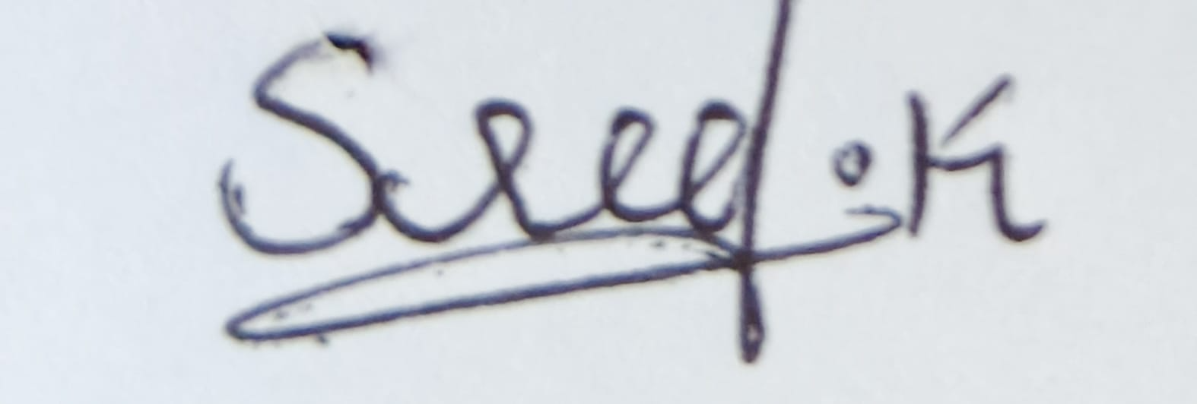

RUBRICS FOR CALCULATION:
Criteria | Weightage | Level 4 Exemplary | Level 3 Proficient | Level 2 Developing | Level 1 Beginning
Understanding of Problem Context | 20 | Clearly understands the problem, requirements, constraints, and expected outcomes. | Good understanding with minor gaps in requirements. | Basic understanding; some requirements are unclear. | Poor understanding or misinterpretation of the problem.
Application of Concepts | 30 | Accurately applies appropriate generative deep learning concepts and architectures. | Applies relevant concepts correctly with minor errors. | Applies basic concepts with limited accuracy. | Fails to apply appropriate concepts.
Design Approach | 20 | Innovative, logical, well-structured, feasible, and technically justified design. | Logical and feasible design with minor gaps. | Basic design with some inconsistencies. | Unclear, illogical, or impractical design.
Accuracy of Solution | 20 | Completely correct architecture, process, objectives, and justification. | Mostly correct with minor technical errors. | Partially correct solution with noticeable gaps. | Incorrect or incomplete solution.
Clarity | 10 | Clear, well-organized diagram and explanation with proper technical labeling. | Understandable with minor clarity issues. | Limited clarity and explanation. | Poorly presented and difficult to understand.

1. Design an Autoencoder-Based Feature Learning System
Aim
To design an Undercomplete Autoencoder for learning compact and useful features from high-dimensional manufacturing sensor data and detecting defective products.
Proposed Architecture
Example: If the sensor data contains 100 input features:
Input (100) → Encoder (64) → Encoder (32) → Latent Space (10) → Decoder (32) → Decoder (64) → Output (100)
The latent representation contains only 10 features, so the system performs dimensionality reduction.
Encoder
The encoder converts the original high-dimensional input into a smaller representation.
Suitable activation:
- ReLU for hidden layers
- Linear or ReLU depending on the sensor-data normalization
Latent Representation
The bottleneck layer contains a small number of neurons, such as 10.
It learns the most important characteristics of the sensor data while removing redundant information.
Decoder
The decoder reconstructs the original input from the latent representation.
The output layer has the same number of neurons as the input, i.e., 100.
Reconstruction Loss
Mean Squared Error can be used:
The network attempts to minimize the difference between the original sensor values and reconstructed values.
How It Performs Feature Learning
- High-dimensional sensor data is given to the encoder.
- The encoder compresses the data.
- The bottleneck stores the most important features.
- The decoder reconstructs the original sensor data.
- Training forces the latent layer to preserve important information.
- The learned latent features can then be given to a classifier such as SVM or Random Forest.
- Products with unusually high reconstruction error can be identified as possible defective products.
Advantages
- Reduces dimensionality.
- Removes redundant features.
- Learns features automatically.
- Reduces computational requirements.
- Useful for anomaly/defect detection.
Result
The undercomplete autoencoder learns a compact representation of manufacturing sensor data. The latent features can be used for classification and high reconstruction error can indicate defective products.

2. Design a Robust Regularized Autoencoder
Aim
To design a Regularized Autoencoder that can learn useful representations from noisy patient-record data while reducing overfitting.
Proposed Architecture
Input → Encoder → Latent Representation → Decoder → Reconstructed Output
Example:
50 Features → 32 → 16 → 8 → 16 → 32 → 50
The 8-dimensional bottleneck provides a compact representation.
Encoder
The encoder transforms input into latent representation :
ReLU can be used in the hidden layers.
Decoder
The decoder reconstructs the original input:
Regularization Strategy
A suitable approach is L2 regularization.
The training objective becomes:
where:
- = reconstruction error
- = regularization strength
- = penalty on large weights
Another suitable approach is Denoising Autoencoder, where noise is intentionally added to the input.
For example:
Noisy patient data → Encoder → Latent representation → Decoder → Clean reconstructed data
Training Process
- Collect patient-record features.
- Normalize the features.
- Introduce noise if using a denoising approach.
- Pass the data through the encoder.
- Generate the latent representation.
- Decode the representation.
- Compare reconstructed data with the original clean data.
- Calculate reconstruction loss and regularization penalty.
- Update network weights.
- Repeat until the loss decreases.
How Regularization Helps
Without regularization, the autoencoder may simply memorize the training data.
Regularization:
- Prevents excessively large weights.
- Reduces overfitting.
- Encourages simpler representations.
- Improves generalization.
- Helps extract robust features from noisy records.
Result
The regularized autoencoder produces a compact and robust representation of patient data. These learned features can be supplied to a downstream classification model for improved prediction.

3. Design a Deep Generative Model
Aim
To design a Deep Belief Network (DBN) for learning complex data distributions and generating useful representations for a recommendation or content-generation system.
Architecture
A DBN can be constructed using multiple Restricted Boltzmann Machines (RBMs).
Example:
Visible Layer (100) → Hidden Layer 1 (64) → Hidden Layer 2 (32) → Hidden Layer 3 (16)
The visible layer represents the input data, while the hidden layers progressively learn higher-level features.
Architecture Diagram
Hidden Layer 3
(16)
↑↓
Hidden Layer 2
(32)
↑↓
Hidden Layer 1
(64)
↑↓
Visible Layer
(100)
Visible Layer
The visible layer receives the original input.
For a recommendation system, the input could contain:
- User preferences
- Item ratings
- Purchase history
- Viewing history
Hidden Layers
Each hidden layer learns increasingly abstract features.
For example:
User ratings → preference patterns → user interests → high-level user profile
Learning Process
DBN training generally occurs in two stages.
1. Unsupervised Pre-training
Each RBM is trained separately.
Visible → Hidden 1
Hidden 1 → Hidden 2
Hidden 2 → Hidden 3
Each layer learns useful features from the previous layer.
2. Fine-tuning
After pre-training, the complete network can be fine-tuned using the desired objective.
Why DBN?
DBN is useful because:
- It can learn complex probability distributions.
- It performs hierarchical feature learning.
- It can work with high-dimensional data.
- It can discover hidden patterns.
- It can be useful for recommendation and content-generation tasks.
Application
For a recommendation system:
User Data
↓
DBN
↓
Hidden User Representation
↓
Learned Preferences
↓
Recommended Items
Result
The DBN learns hierarchical representations from user or content data. These representations can be used to model complex patterns and generate personalized recommendations.

4. Design a Stochastic and Contractive Representation Model
Aim
To design a Contractive Autoencoder that learns representations which remain stable when small changes occur in image or signal inputs.
Architecture
Example:
Input Image → Conv/Encoder Layers → Latent Representation → Decoder → Reconstructed Image
For a simple architecture:
Input
↓
Encoder
↓
ReLU
↓
Latent Representation
↓
Decoder
↓
Reconstructed Output
Main Idea
A normal autoencoder learns to reconstruct the input.
A Contractive Autoencoder (CAE) additionally forces the latent representation to change very little when the input changes slightly.
Objective Function
The CAE objective can be written as:
where:
- = reconstruction loss
- = Jacobian matrix of the encoder
- = contraction coefficient
- = Frobenius norm of the Jacobian
Robustness Mechanism
Suppose an image is slightly changed:
Original Image
↓
Encoder
↓
Feature A
and
Slightly Modified Image
↓
Encoder
↓
Feature A'
The contractive penalty encourages:
Therefore, small variations in the input do not cause large changes in the learned representation.
Example Application
For image processing, small variations may occur because of:
- Lighting changes
- Sensor noise
- Small translations
- Minor distortions
The model learns features that are more stable against these variations.
Advantages
- Robust feature representation.
- Less sensitive to small input changes.
- Useful for image and signal processing.
- Learns locally stable features.
- Improves downstream classification.
Result
The contractive autoencoder learns stable representations that are less affected by small variations in the input, making it suitable for robust image and signal-processing applications.

5. Design a GAN-Based Data Generation System
Aim
To design a Generative Adversarial Network (GAN) for generating realistic synthetic images when only a limited number of training images are available.
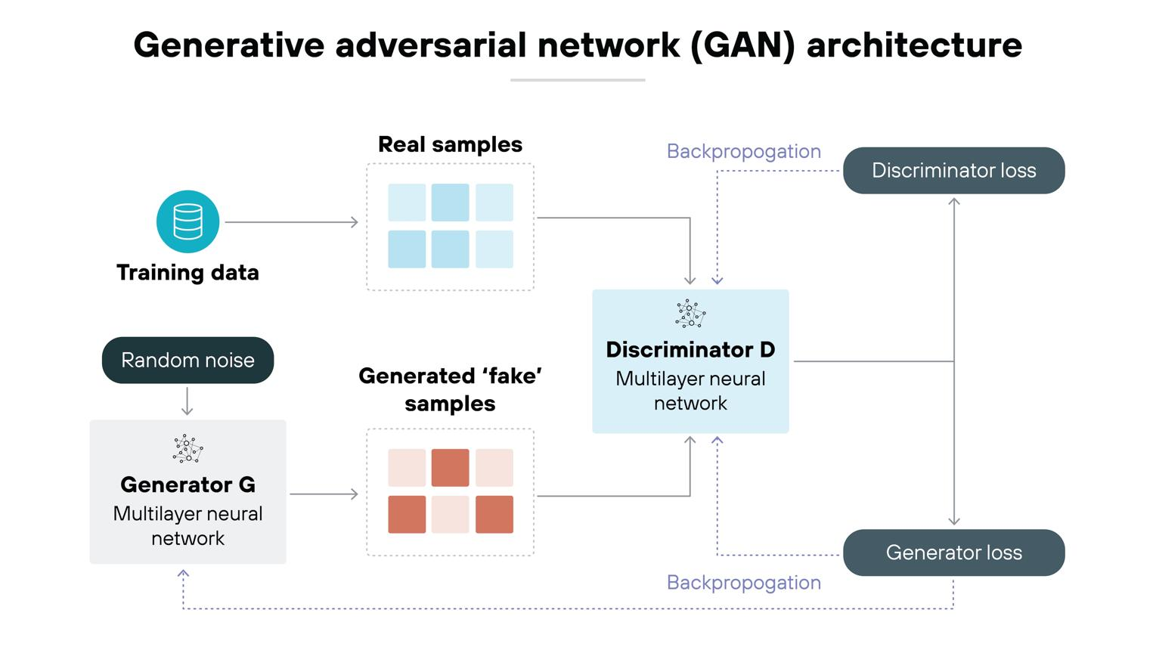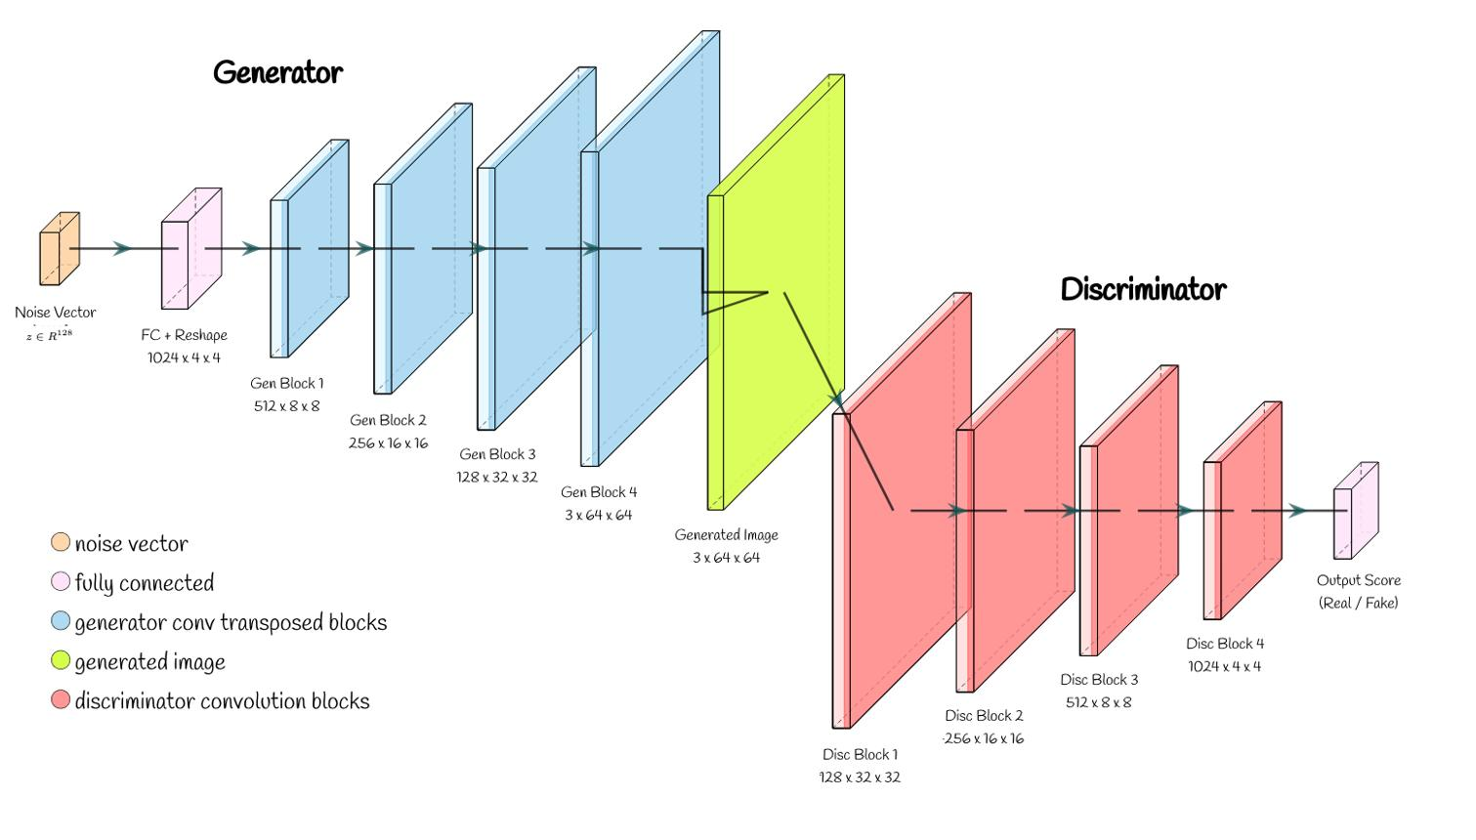

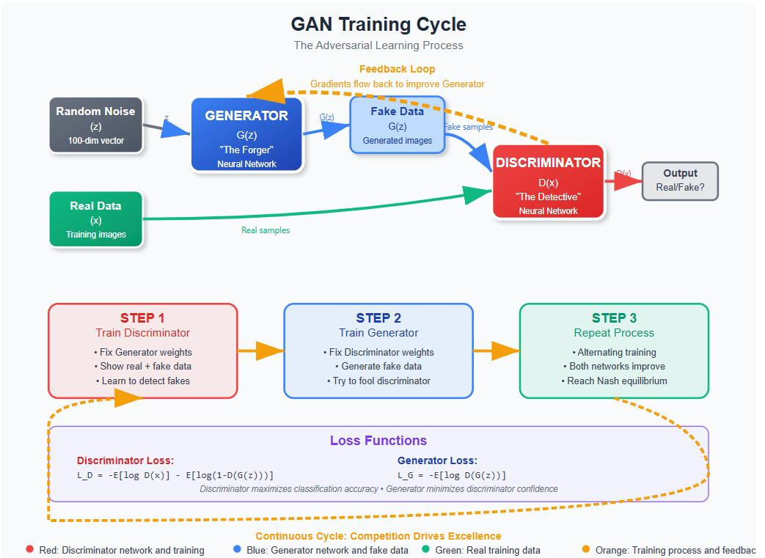

Architecture
A GAN contains two neural networks:
- Generator (G)
- Discriminator (D)
Random Noise z
↓
Generator
↓
Fake Image ─────────┐
↓
Discriminator
↑
Real Image ─────────┘
↓
Real / Fake
Generator
The Generator takes a random noise vector as input.
Example:
The Generator transforms this random vector into an image:
Its objective is to generate images that look like real training images.
Discriminator
The Discriminator receives both real and generated images.
It produces a probability:
where a value close to 1 means real and a value close to 0 means fake.
Adversarial Training
The Generator and Discriminator compete with each other.
Generator:
"I want to fool the Discriminator."
Discriminator:
"I want to distinguish real images from generated images."
Training occurs repeatedly:
Random Noise
↓
Generator
↓
Fake Image
↓
Discriminator ← Real Image
↓
Prediction
↓
Calculate Loss
↓
Update G and D
GAN Loss
The original GAN objective is:
In simple terms:
- Discriminator tries to correctly classify real and fake images.
- Generator tries to make fake images classified as real.
Training Process
- Collect the available real images.
- Normalize and preprocess the images.
- Generate random noise vectors.
- Give noise to the Generator.
- Generate synthetic images.
- Give real and fake images to the Discriminator.
- Calculate discriminator loss.
- Update the Discriminator.
- Calculate Generator loss.
- Update the Generator.
- Repeat for many training iterations.
- Evaluate the generated images.
Evaluation
Generated images can be evaluated using:
- Visual quality
- Diversity of generated samples
- Classification accuracy using synthetic data
- FID (Fréchet Inception Distance)
- Inception Score
A good GAN should produce images that are:
- Realistic
- Diverse
- Similar to the target data distribution

GAN vs Autoencoder
Feature | Autoencoder | GAN
Main purpose | Reconstruction and feature learning | Data generation
Components | Encoder + Decoder | Generator + Discriminator
Input | Original data | Random noise
Output | Reconstructed data | New synthetic data
Training | Reconstruction loss | Adversarial loss
Image quality | Usually smoother/blurry | Can produce sharper images
Feature learning | Excellent | Possible but not the primary goal
Data generation | Limited | Excellent
Main application | Compression, denoising, representation learning | Synthetic image generation
Why GAN is Suitable
The organization has limited training images and needs additional realistic samples.
A GAN is suitable because it learns the distribution of the available real images and generates new synthetic samples.
These samples can potentially be used to:
- Increase training-data size.
- Improve classifier training.
- Reduce dependence on collecting large numbers of real images.
- Generate variations of existing image patterns.
Result
The GAN learns to generate realistic synthetic images through adversarial training between the Generator and Discriminator. Compared with an autoencoder, GANs are particularly suitable when the primary requirement is generating new, realistic samples rather than reconstructing existing inputs.

