**Design Document for CSV Parser C++ Program:**

This document describes brief about the design of the csv parser c++ program.

Below is the high level diagram for the program.

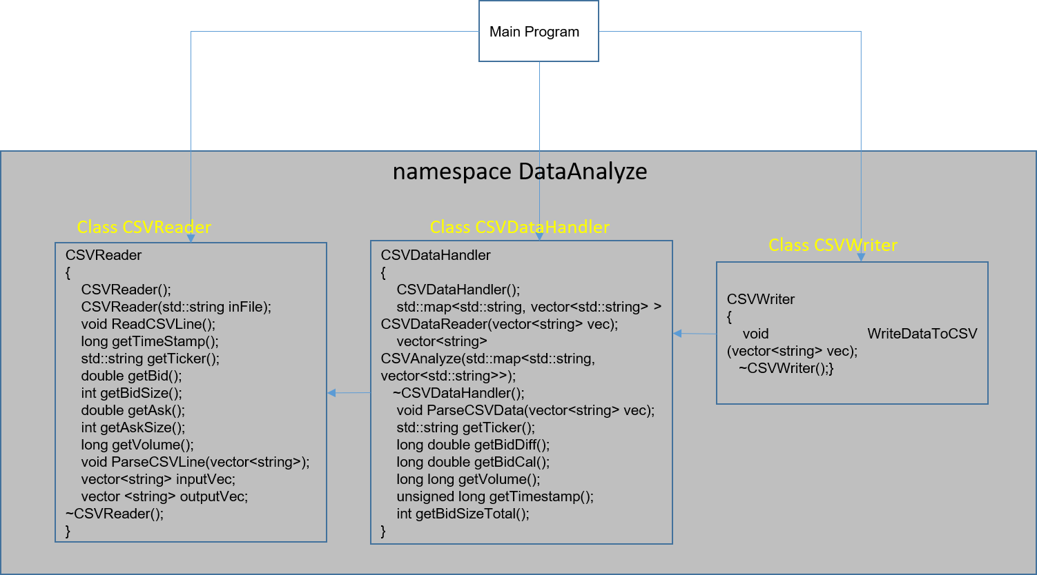

Application will have 3 main classes named CSVReader, CSVDataHandler and CSVWriter and main() Program.

**CSVReader Class:** CSVReader class will handle the reading of data from csv file. It fills the all the input fields as in corresponding methods as well as store the csv data in vector format to use by CSVDataHandler class.

**CSVDataHandler Class:** CSVDataHandler class will get the csv data for each row and do the necessary data processing like calculate bid difference, sum of bid sizes and sum of volumes and store in a vector to use further by CSVWriter class.

**CSVWriter Class:** CSVWriter class will get the processed data from CSVDataHandler class and write the data to output file.

If any input field changes (add/modify or rearrange) then we can create a new class which should extend the CSVDataReader class and do the modifications.

For any output field changes we need modify the CSVDataHandler class by extending this class.