### Day 2- 108415746-Srilekha Bhimavarapu

### GIT HUB:

Git log:

### 

Git show:

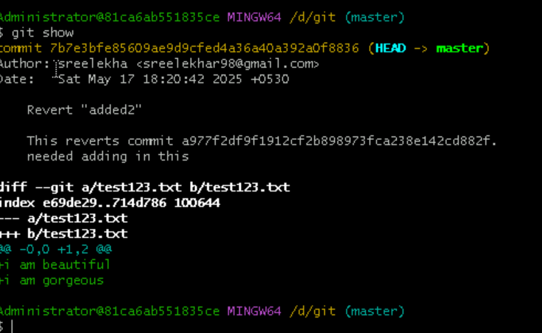

To create new branch:

Git branch <branch name>

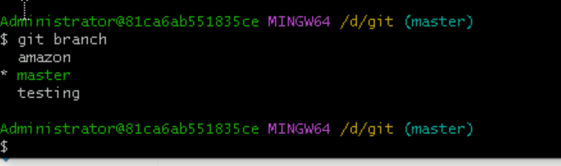

To merge with other-branch

Git merge <branch name of the merging branch>

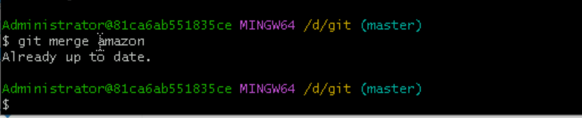

To show all the branches that exists:

Git branch:

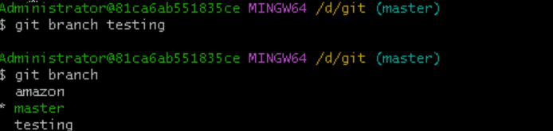

To switch from one branch to other one:

Git checkout <branch name of the other one>

