**HTML**

<!DOCTYPE html>

<html>

<body>

<h2>HTML Buttons</h2>

<p>HTML buttons are defined with the button tag:</p>

<button>Click me</button>

</body>

</html>

**Output:**

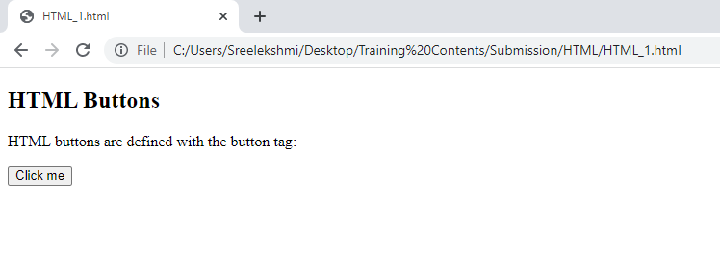

<!DOCTYPE html>

<html>

<body>

<h2>HTML Images</h2>

<p>HTML images are defined with the img tag:</p>

<img src="abc.jpg" alt="abc.com" width="104" height="142">

</body>

</html>

**Output:**

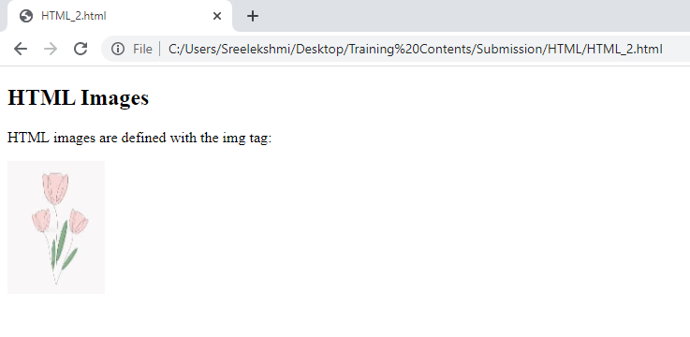

<!DOCTYPE html>

<html>

<body>

<h2>An Unordered HTML List</h2>

<ul>

  <li>Coffee</li>

  <li>Tea</li>

  <li>Milk</li>

</ul>

<h2>An Ordered HTML List</h2>

<ol>

  <li>Coffee</li>

  <li>Tea</li>

  <li>Milk</li>

</ol>

</body>

</html>

**Output:**

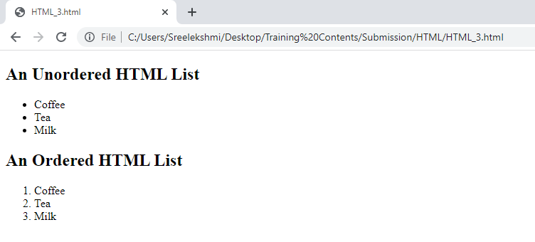

<!DOCTYPE html>

<html>

<body>

<h2>Width and Height Attributes</h2>

<p>The width and height attributes of the img tag, defines the width and height of the image:</p>

<img src="img_girl.jpg" width="500" height="600">

</body>

</html>

**Output:**

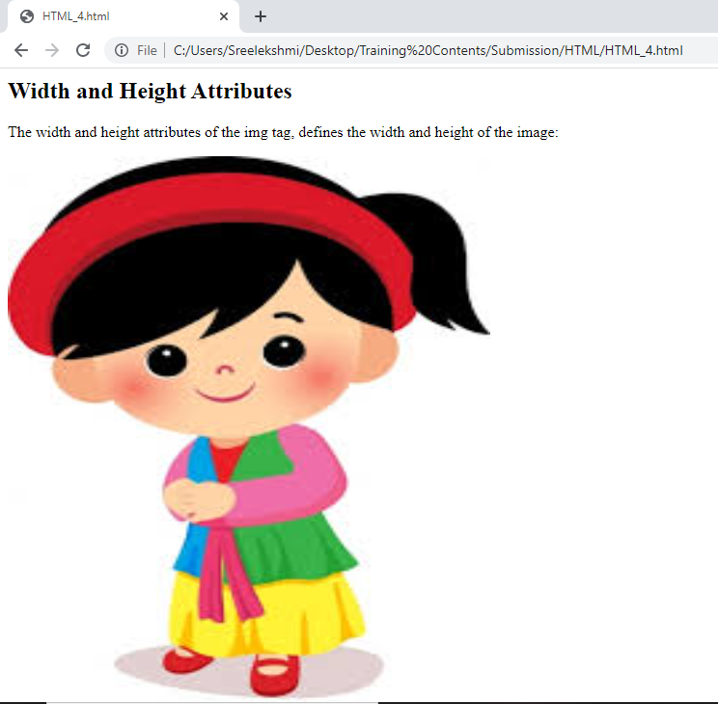

<!DOCTYPE html>

<html>

<body>

<p>This is<br>a paragraph<br>with line breaks.</p>

</body>

</html>

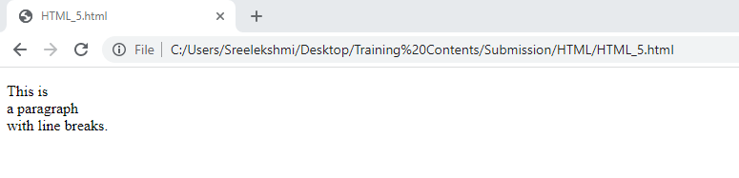**Output:**

<!DOCTYPE html>

<html>

<body>

<h1 style="color:blue;">This is a heading</h1>

<p style="color:red;">This is a paragraph.</p>

</body>

</html>

**Output:**

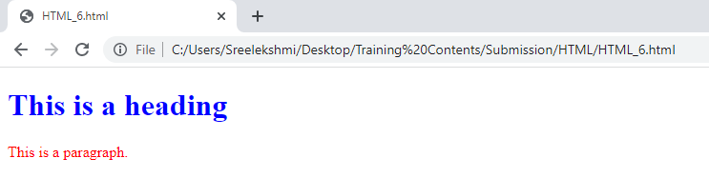

<!DOCTYPE html>

<html>

<body>

<p>My favorite color is <del>blue</del> red.</p>

</body>

</html>

**Output:**

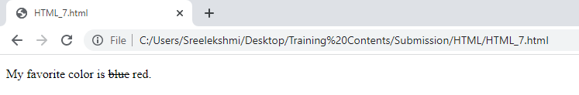

<!DOCTYPE html>

<html>

<body>

<p>My favorite color is <del>blue</del> <ins>red</ins>.</p>

</body>

</html>

**Output:**

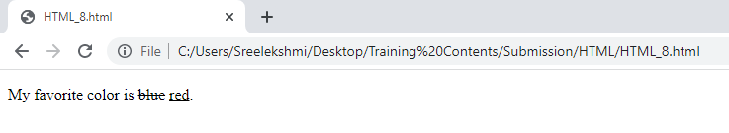

<!DOCTYPE html>

<html>

<head>

<style>

body {background-color: powderblue;}

h1   {color: blue;}

p    {color: red;}

</style>

</head>

<body>

<h1>This is a heading</h1>

<p>This is a paragraph.</p>

</body>

</html>

**Output:**

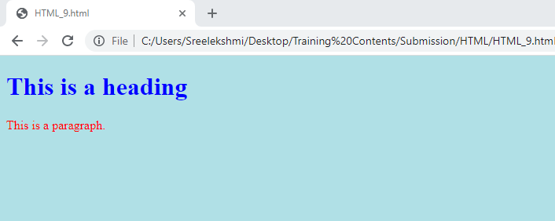

<!DOCTYPE html>

<html>

<head>

  <link rel="stylesheet" href="styles.css">

</head>

<body>

<h1>This is a heading</h1>

<p>This is a paragraph.</p>

</body>

</html>

**Styles.css**

h1

{

    color: blue;

}

p

{

    color: red;

}

**Output:**

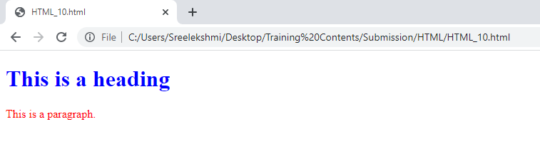

<!DOCTYPE html>

<html>

<head>

<style>

p {

  border: 2px solid powderblue;

}

</style>

</head>

<body>

<h1>This is a heading</h1>

<p>This is a paragraph.</p>

<p>This is a paragraph.</p>

<p>This is a paragraph.</p>

</body>

</html>

**Output:**

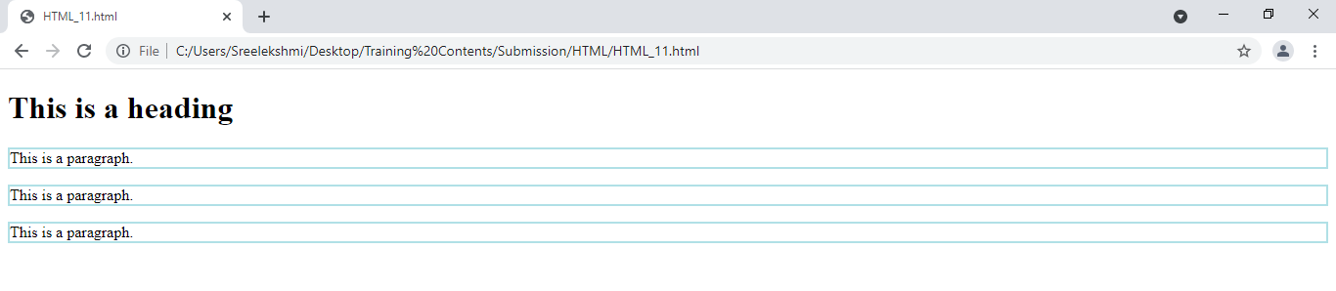

<!DOCTYPE html>

<html>

<head>

<style>

table, th, td {

  border: 1px solid black;

  border-collapse: collapse;

}

th, td {

  padding: 5px;

}

</style>

</head>

<body>

<table>

  <tr>

    <td>

      <p>This is a paragraph</p>

      <p>This is another paragraph</p>

    </td>

    <td>This cell contains a table:

      <table>

        <tr>

          <td>A</td>

          <td>B</td>

        </tr>

        <tr>

          <td>C</td>

          <td>D</td>

        </tr>

      </table>

    </td>

  </tr>

  <tr>

    <td>This cell contains a list

      <ul>

        <li>apples</li>

        <li>bananas</li>

        <li>pineapples</li>

      </ul>

    </td>

    <td>HELLO</td>

  </tr>

</table>

</body>

</html>

**Output:**

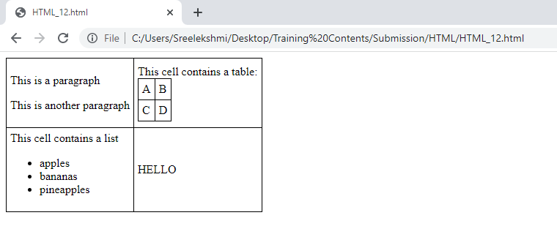

<!DOCTYPE html>

<html>

<body>

<h2>Ordered List with Letters</h2>

<ol type="A">

  <li>Coffee</li>

  <li>Tea</li>

  <li>Milk</li>

</ol>

</body>

</html>

**Output:**

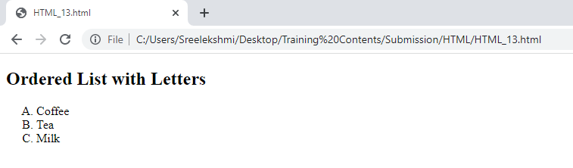

<!DOCTYPE html>

<html>

<body>

<div style="background-color:black;color:white;padding:20px;">

  <h2>London</h2>

  <p>London is the capital city of England. It is the most populous city in the United Kingdom, with a metropolitan area of over 13 million inhabitants.</p>

  <p>Standing on the River Thames, London has been a major settlement for two millennia, its history going back to its founding by the Romans, who named it Londinium.</p>

</div>

</body>

</html>

**Output:**

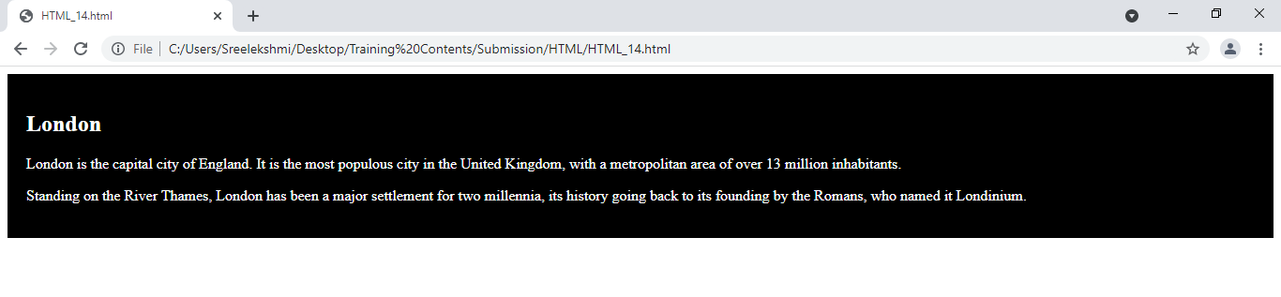

<!DOCTYPE html>

<html>

<body>

<h2>HTML Iframes</h2>

<p>An iframe is used to display a web page within a web page:</p>

<iframe src="demo_iframe.htm"></iframe>

</body>

</html>

**Output:**

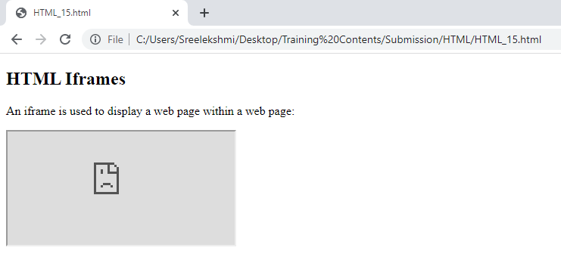

<!DOCTYPE html>

<html>

<body>

<h2>HTML Forms</h2>

<form action="/action_page.php">

  <label for="fname">First name:</label><br>

  <input type="text" id="fname" name="fname" value="John"><br>

  <label for="lname">Last name:</label><br>

  <input type="text" id="lname" name="lname" value="Doe"><br><br>

  <input type="submit" value="Submit">

</form>

<p>If you click the "Submit" button, the form-data will be sent to a page called "/action_page.php".</p>

</body>

</html>

**Output:**

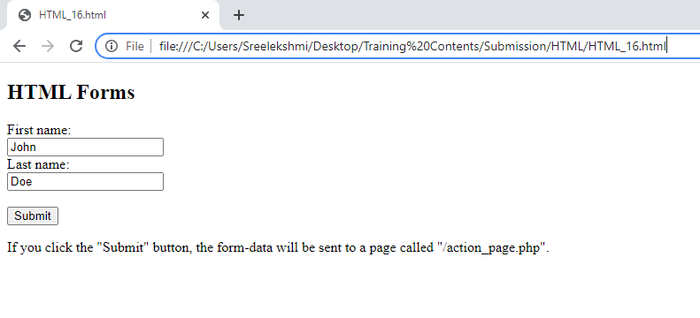

<!DOCTYPE html>

<html>

<body>

<h2>Date Field</h2>

<p>The <strong>input type="date"</strong> is used for input fields that should contain a date.</p>

<form action="/action_page.php">

  <label for="birthday">Birthday:</label>

  <input type="date" id="birthday" name="birthday">

  <input type="submit" value="Submit">

</form>

<p><strong>Note:</strong> type="date" is not supported in Internet Explorer 11 or prior Safari 14.1.</p>

</body>

</html>

**Output:**

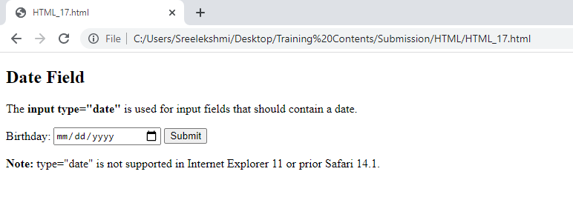

<!DOCTYPE html>

<html>

<body>

<h2>Checkboxes</h2>

<p>The <strong>input type="checkbox"</strong> defines a checkbox:</p>

<form action="/action_page.php">

  <input type="checkbox" id="vehicle1" name="vehicle1" value="Bike">

  <label for="vehicle1"> I have a bike</label><br>

  <input type="checkbox" id="vehicle2" name="vehicle2" value="Car">

  <label for="vehicle2"> I have a car</label><br>

  <input type="checkbox" id="vehicle3" name="vehicle3" value="Boat">

  <label for="vehicle3"> I have a boat</label><br><br>

  <input type="submit" value="Submit">

</form>

</body>

</html>

**Output:**

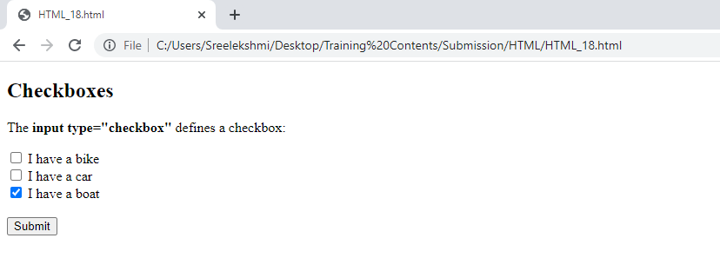

<!DOCTYPE html>

<html>

<body>

<h2>My First Web Page</h2>

<p>My first paragraph.</p>

<p>Never call document.write after the document has finished loading.

It will overwrite the whole document.</p>

<script>

document.write(5 + 6);

</script>

</body>

</html>

**Output:**

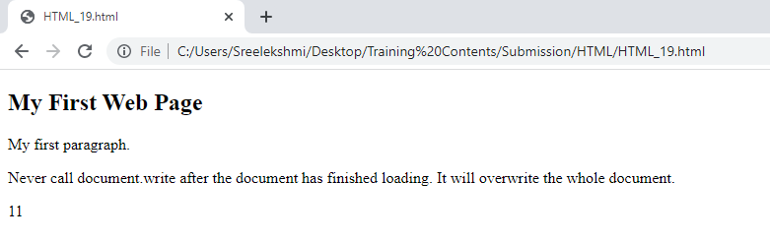

<!DOCTYPE html>

<html>

<body>

<h2>JavaScript Expressions</h2>

<p>Expressions compute to values.</p>

<p id="demo"></p>

<script>

document.getElementById("demo").innerHTML = 5 * 10;

</script>

</body>

</html>

**Output:**

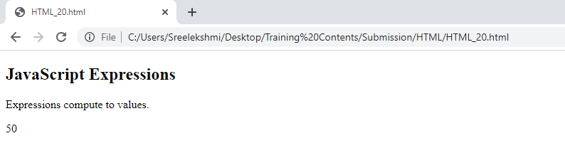

<!DOCTYPE html>

<html>

<body>

<h2>JavaScript Functions</h2>

<p>This example calls a function which performs a calculation and returns the result:</p>

<p id="demo"></p>

<script>

var x = myFunction(4, 3);

document.getElementById("demo").innerHTML = x;

function myFunction(a, b) {

  return a * b;

}

</script>

</body>

</html>

**Output:**



<!DOCTYPE html>

<html>

<body>

<h2>JavaScript String Methods</h2>

<p>Display the first array element, after a string split:</p>

<p id="demo"></p>

<script>

let text = "a,b,c,d,e,f";

const myArray = text.split(",");

document.getElementById("demo").innerHTML = myArray[0];

</script>

</body>

</html>

**Output:**

