**JMeter**

The Apache JMeter application is open-source software, a 100% pure Java application designed to load test functional behavior and measure performance. Apache JMeter may be used to test performance both on static and dynamic resources, Web dynamic applications. It can be used to simulate a heavy load on a server, group of servers, network or object to test its strength or to analyze overall performance under different load types.

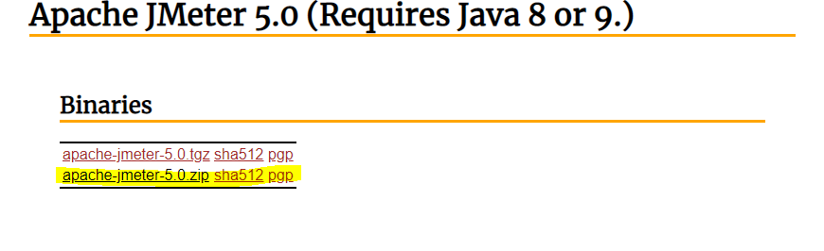**Download JMeter**

**Start JMeter**

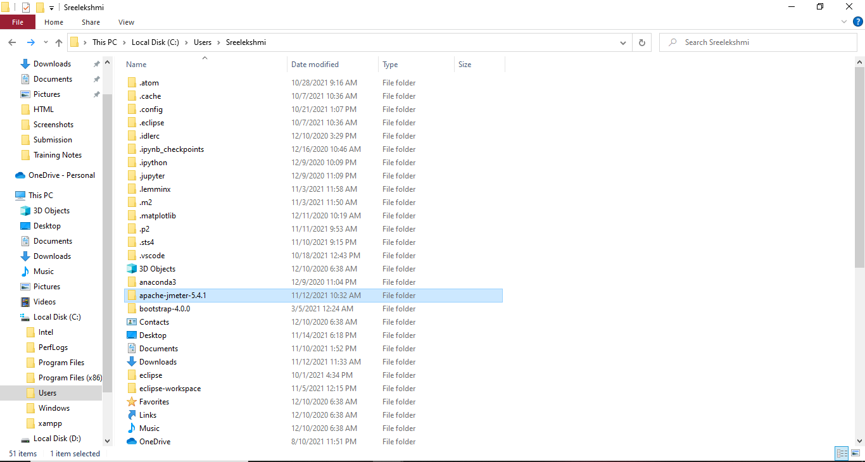To run the JMeter, go to the folder the /jmeter/bin and run jmeter windows batch file.

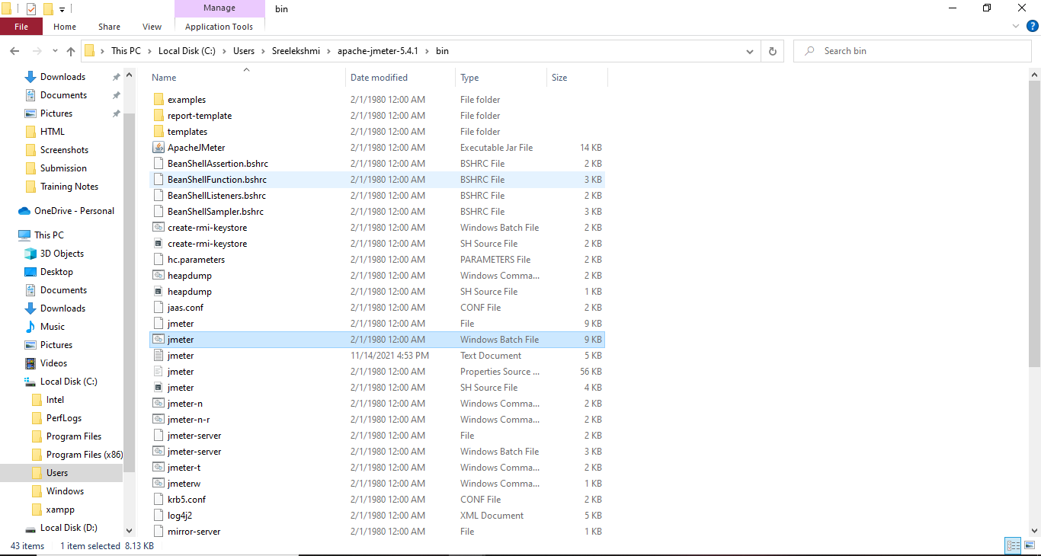

**Create a test plan for our web application’s load testing**

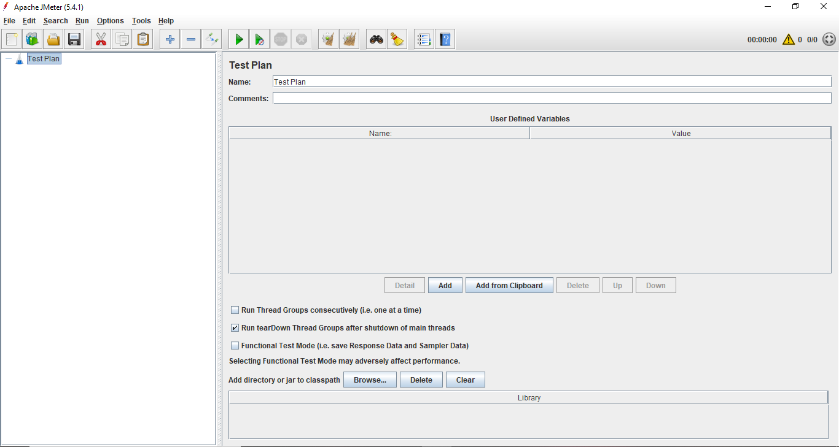

**Create Thread Group**

To create a thread group, navigate to ‘Right click Test Plan -> Add -> Threads -> Thread Group’.

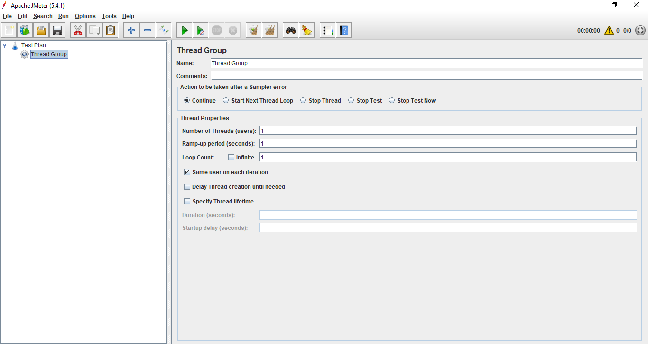

**Create HTTP Request**

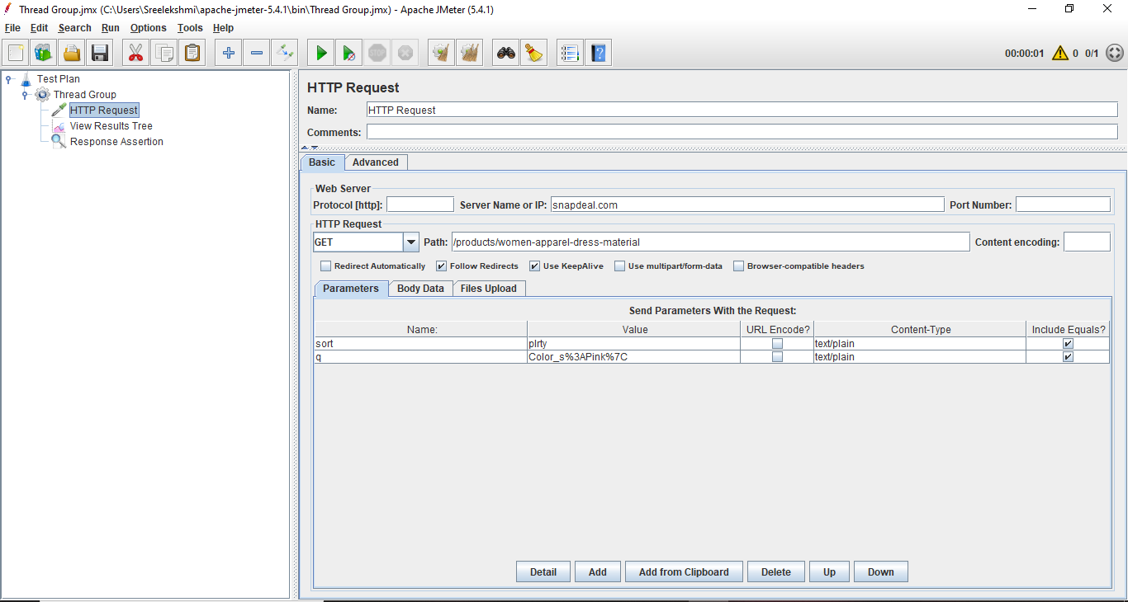To add HTTP request details, navigate to ‘Right click thread group -> Add -> Sampler -> HTTP Request’.

**Add Listener**

To see the results of test plan, add listener named “” by navigating to ‘Right click thread group -> Add -> Listener -> View Results Tree’.

