**How to Download and Install MongoDB**

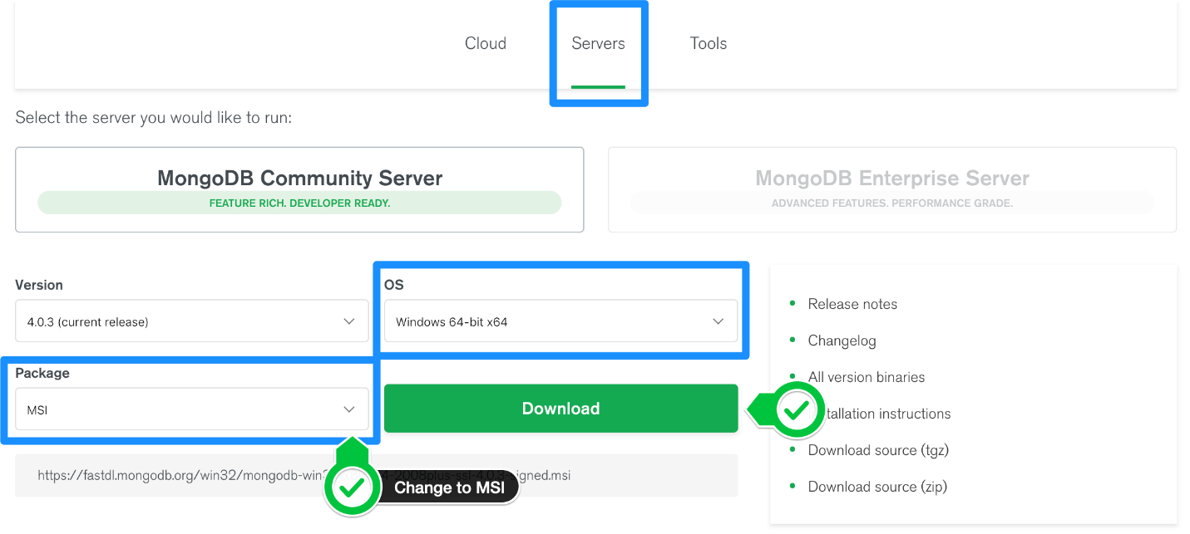Step 1 — Download the MongoDB MSI Installer Package

Step 2 — Install MongoDB with the Installation Wizard

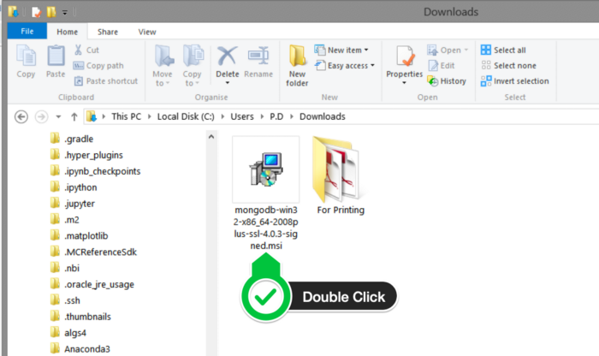

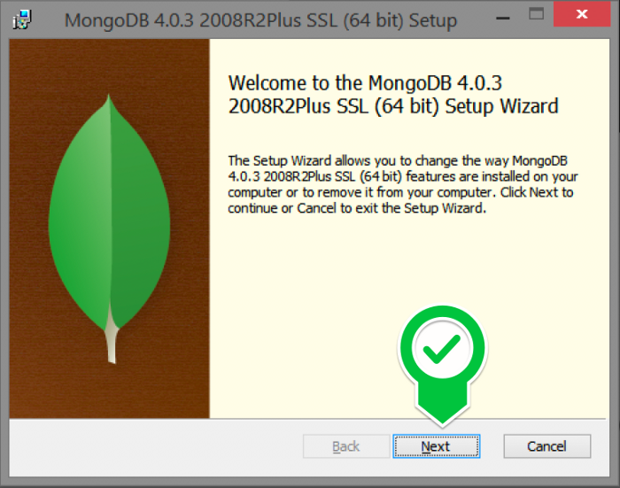Click Next to Start Installation.

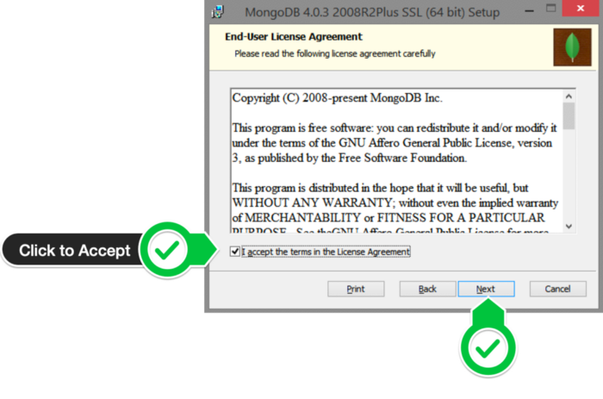Accept the license Agreement then click Next.

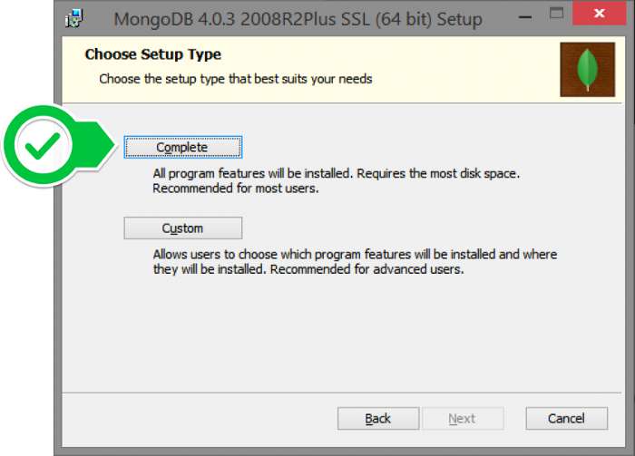Select the Complete Setup.

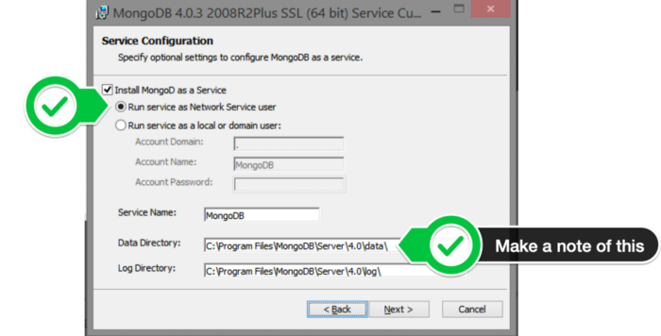Select “Run service as Network Service user” and make a note of the data directory, we’ll need this later.

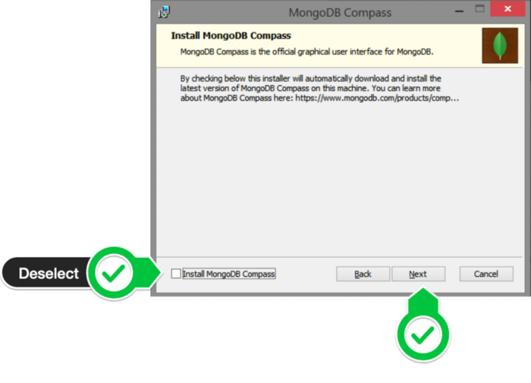Click Next.

Click Install to Begin Installation.

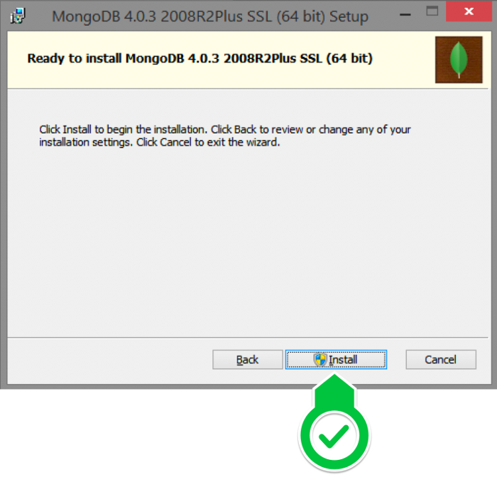

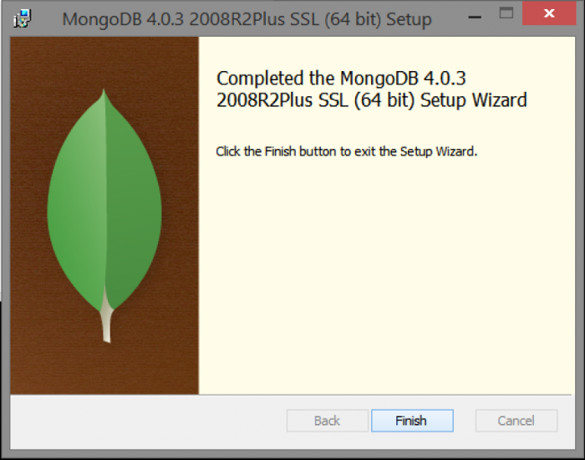Hit Finish to Complete Installation.

1. In your explorer go to C → Program Files → MongoDB → Server → 5.0 → bin.
2. Copy Paste the current folder path into command prompt.
3. Then, Type “mongo.exe” and Click enter.
4. If we need to know the MongoDB version then Type “mongo –version” and click enter.

**How and when to create database**

If there is no existing database, the following command is used to create a new database.

**Syntax:**

use DATABASE_NAME



To **check the currently selected database**, use the command db.



To **check the database list**, use the command show dbs.

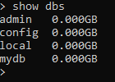

**Insert the Documents**

**Insert at least one document** into it to display database



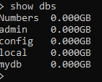

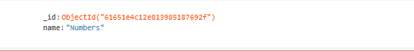

Insert more than one data

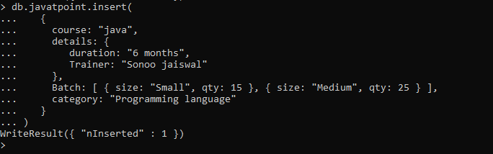

**Check the inserted documents**

find ()

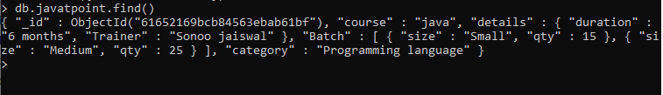

**Create an array of documents**

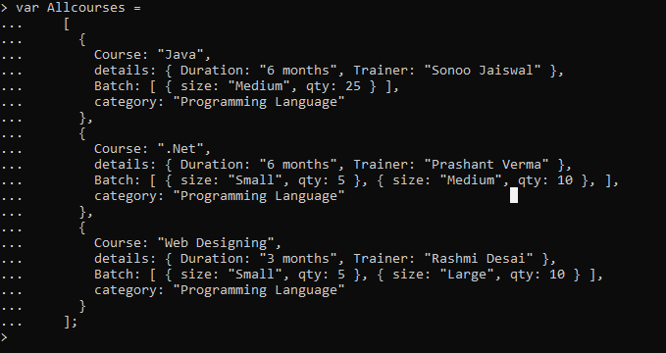To insert multiple documents in a collection, you have to pass an array of documents to the db.collection.insert() method.

Pass this Allcourses array to the db.collection.insert() method to perform a bulk insert.

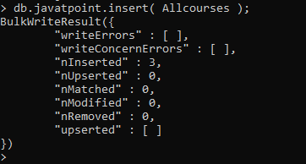

**Update documents**

In MongoDB, update() method is used to update or modify the existing documents of a collection.

**Syntax:**

db.COLLECTION_NAME.update(SELECTIOIN_CRITERIA, UPDATED_DATA)

**Update the existing course "java" into "android":**

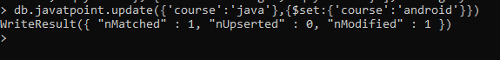



**Delete Documents**

The db.colloction.remove() method is used to delete documents from a collection. The remove() method works on two parameters.

**1. Deletion criteria:** With the use of its syntax you can remove the documents from the collection.

**2. JustOne:** It removes only one document when set to true or 1.

**Syntax:**

db.collection_name.remove (DELETION_CRITERIA)

To remove all documents from the "javatpoint" collection.

db. javatpoint. remove ({})

**Aggregation**

Aggregation’s operations process data records and return computed results. Aggregation operations group values from multiple documents together, and can perform a variety of operations on the grouped data to return a single result.

With the following data –

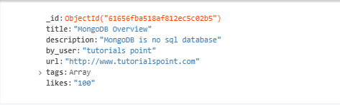

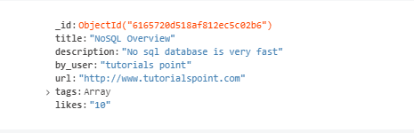

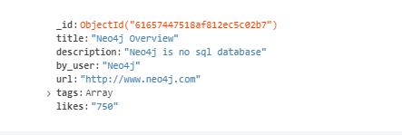

From the above collection, if you want to display a list stating how many tutorials are written by each user, then you will use the following **aggregate ()** method –

**$group**

This does the actual aggregation as discussed above.

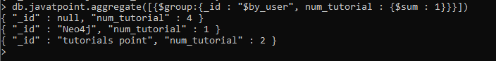

**$match**

This is a filtering operation and thus this can reduce the amount of documents that are given as input to the next stage.

