Experiment No. 1
Generation and Classification of Continuous-Time and Discrete-Time Signals

- To generate and visualize basic continuous-time signals such as unit step, unit impulse, ramp, sinusoidal, and exponential signals.

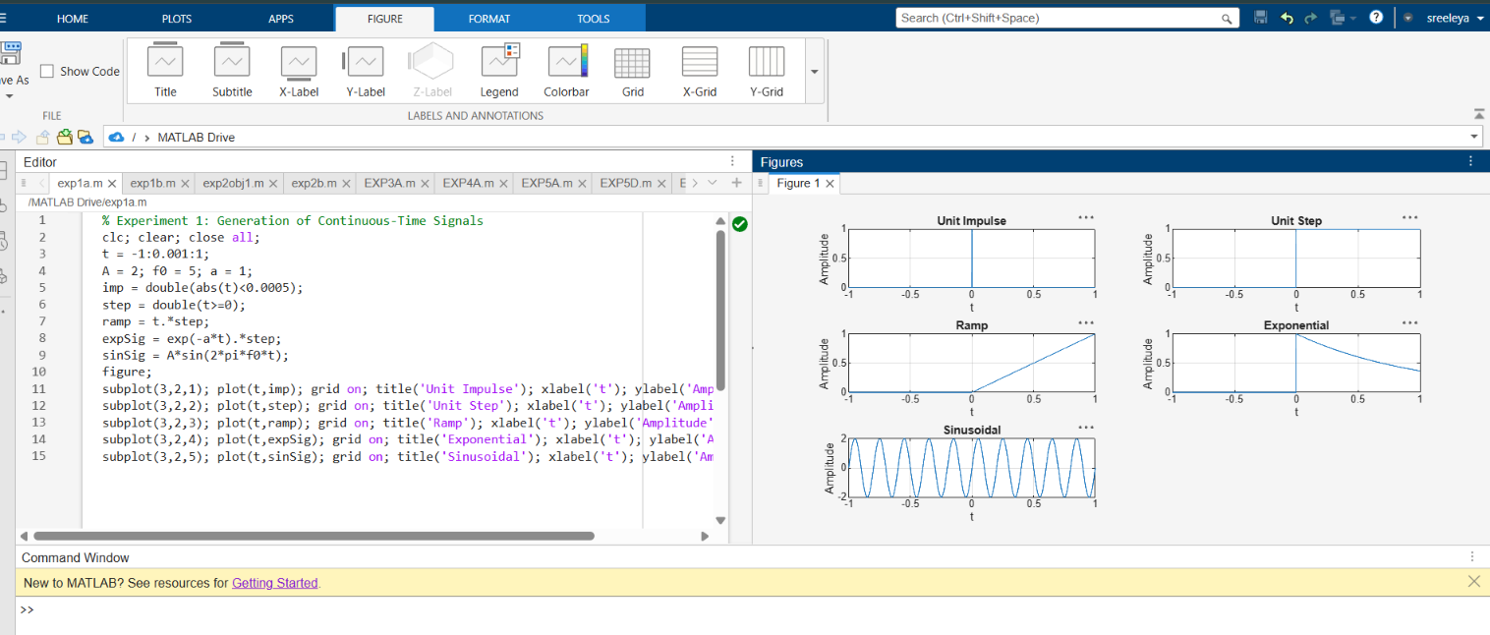

- To generate and visualize basic discrete-time signals and analyze their amplitude and time- index characteristics.

