Experiment – 8: Laplace Transform, Inverse Transform, ROC and Stability
ii) To determine the inverse Laplace transform of a given frequency-domain representation and reconstruct the corresponding time-domain signal.

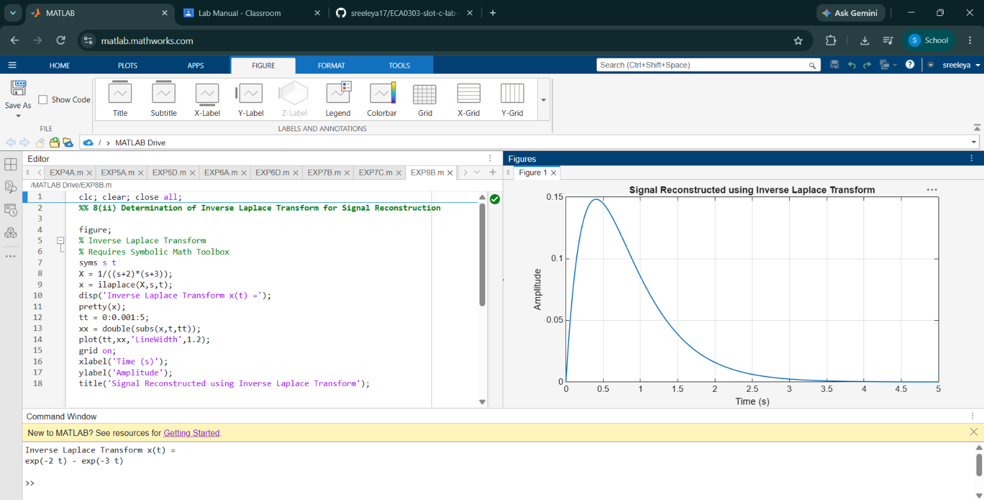

(iii) To determine the Region of Convergence (ROC) of Laplace transforms and analyze its significance in characterizing continuous-time signals and systems.
