Experiment – 7:
Continuous-Time Fourier Transform and Spectrum

(ii) To determine the magnitude and phase spectra of continuous-time signals and analyze their significant spectral components.
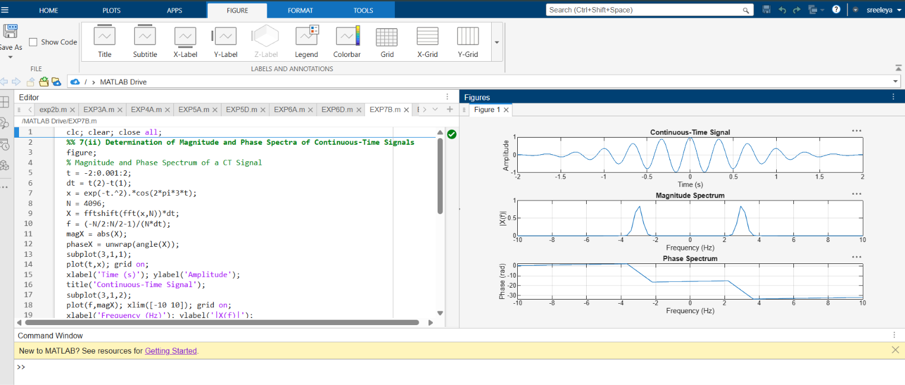

(iii) To verify important Fourier transform properties and examine their effects on the
corresponding time-domain and frequency-domain representations.

