1000BASE-T1:
1000BASE-T1 is defined in IEEE 802.3bp-2016 (now consolidated into 802.3-2018, Clause 96–98 reused, primary clauses 97 and 98). It delivers 1 Gbit/s full-duplex over a single unshielded twisted pair up to 15 metres, simultaneously in both directions, using the same hybrid echo cancellation architecture as 100BASE-T1 but with a dramatically more demanding DSP and a completely different line code. It is the backbone technology of modern zonal automotive architectures and the standard for high-bandwidth sensor links (high-resolution cameras, LIDAR point clouds, radar data fusion).

System overview and how it differs from 100BASE-T1

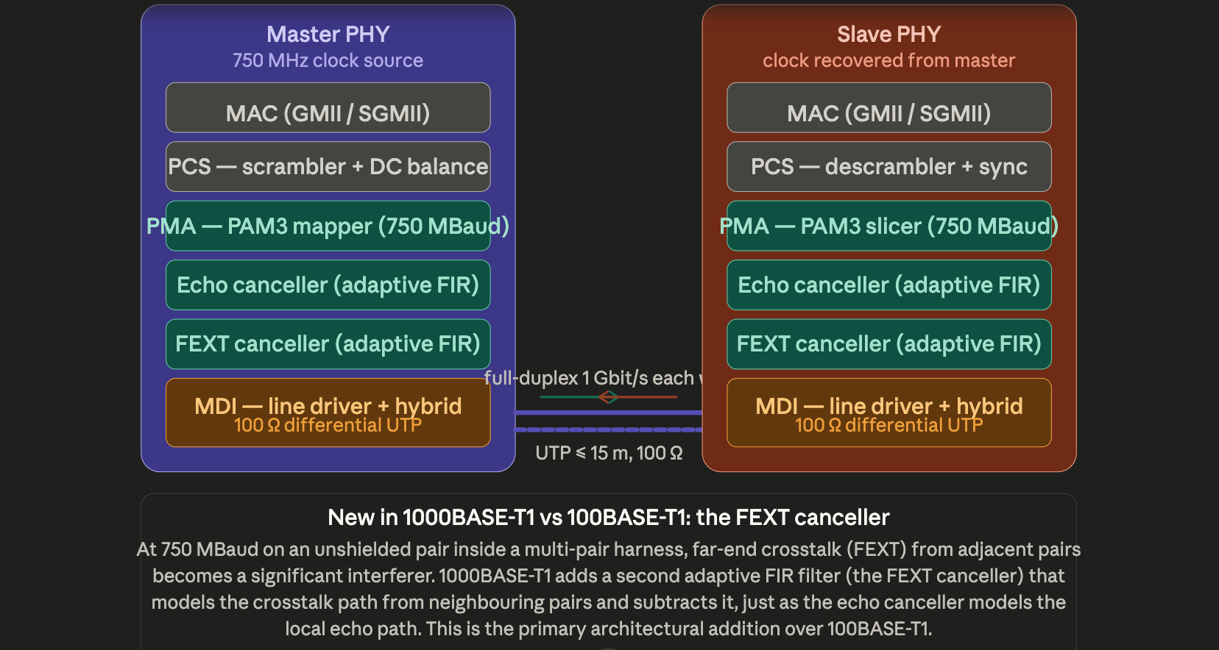

The single most important difference from 100BASE-T1 is not just the tenfold speed increase — it is the addition of the FEXT (Far-End CrossTalk) canceller. At 750 MBaud, the signal's spectral energy extends high enough that a neighbouring pair in the same harness bundle acts as a significant antenna, injecting interference at the far end of the cable. This is a new impairment that simply doesn't matter at 66.67 MBaud. The 1000BASE-T1 DSP must therefore run three concurrent adaptive filters simultaneously: echo canceller, FEXT canceller, and the DFE (Decision Feedback Equaliser) that compensates for intersymbol interference from the cable's frequency-dependent attenuation.

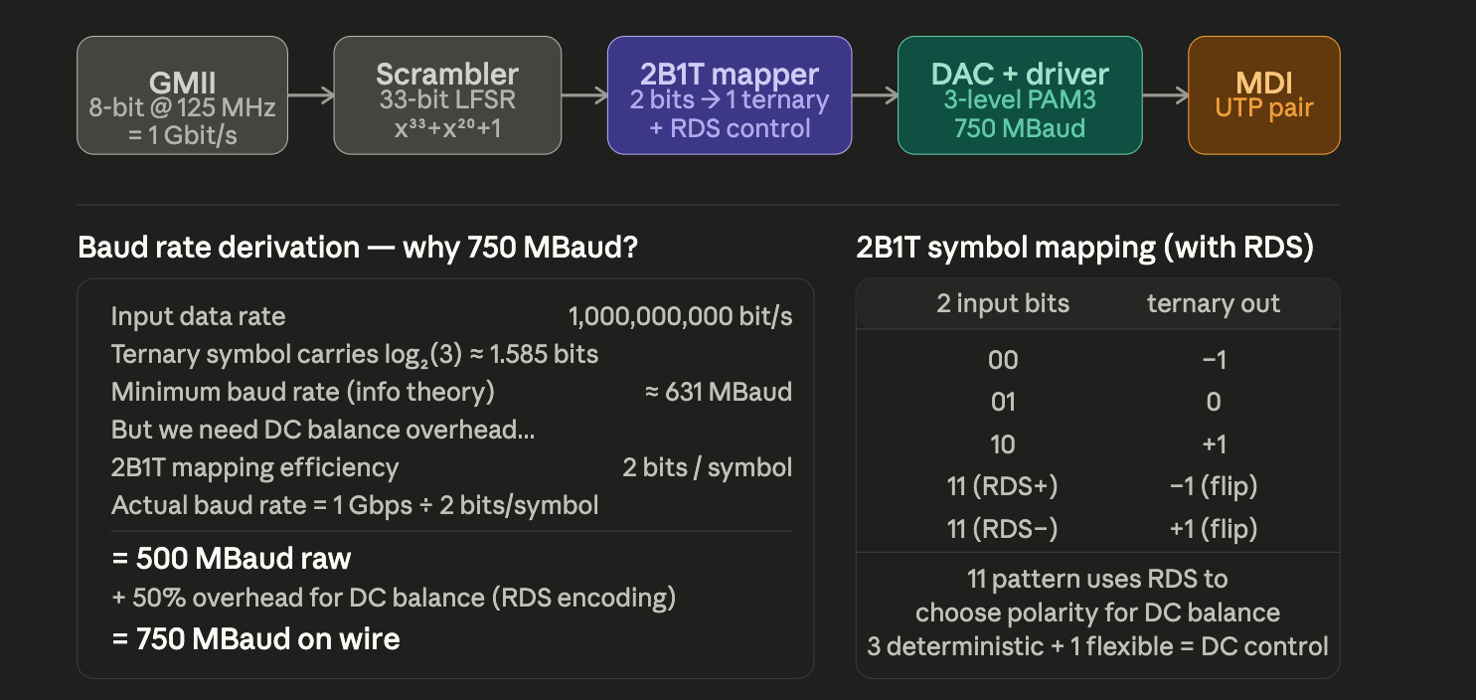
The line code: from bits to PAM3 at 750 MBaud

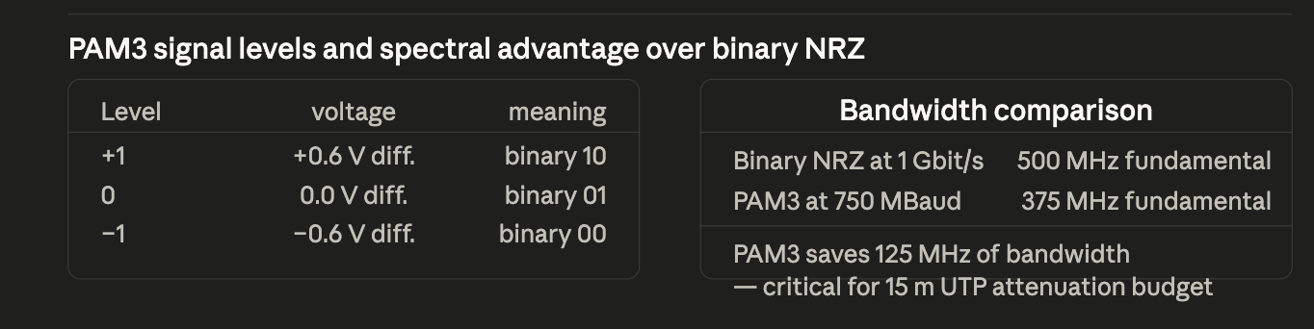
The encoding pipeline is more layered than 100BASE-T1 and deserves careful unpacking.Why 2B1T instead of the 4B3T used in 100BASE-T1? At 750 MBaud, the implementation complexity of the encoder/decoder is dominated by the DSP running at that clock speed, not the code table lookup. 2B1T is the simplest possible ternary mapping — just a straight 2-bit-to-symbol translation with a running digital sum tracker to handle the 11 pattern. This minimises latency through the encoder and keeps the DSP clock at exactly 750 MHz (rather than an awkward fractional multiple). The DC balance overhead takes the raw theoretical 500 MBaud up to 750 MBaud — a 50% overhead that is the direct cost of keeping the running digital sum bounded, which is essential for echo canceller stability.
The scrambler uses the polynomial x³³ + x²⁰ + 1 — a 33-bit LFSR that randomises the bit stream before encoding. Without scrambling, repetitive data patterns (e.g., all-zeros Ethernet idle, or IP packets with long runs of the same byte) would produce periodic ternary sequences that create spectral lines in the transmitted signal. Spectral lines are devastating for the echo canceller because they appear as sinusoidal components at known frequencies in the echo estimate, causing the LMS algorithm to converge to the wrong solution. The scrambler breaks all periodicity.

3. The DSP challenge: three concurrent adaptive filters
This is where 1000BASE-T1 becomes genuinely demanding. The DSP must simultaneously run three adaptive algorithms, all clocked at 750 MHz.
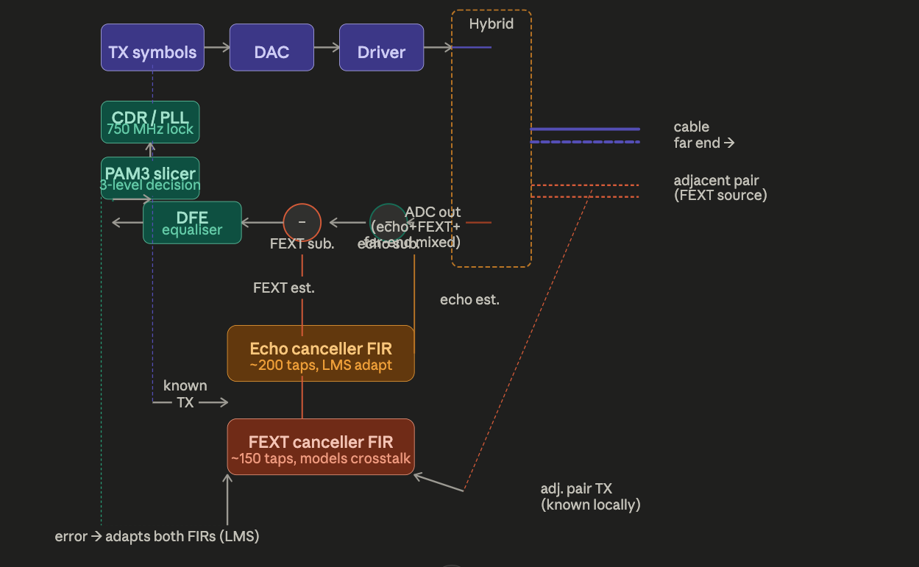

The signal flow is more complex than 100BASE-T1 in three important ways.
The echo canceller now has approximately 200 FIR taps (versus ~100 for 100BASE-T1). More taps are needed because the echo path at 750 MBaud is temporally longer relative to the symbol period — a reflection from a connector mismatch 5 cm away causes an echo delayed by ~0.5 ns, which at 750 MBaud corresponds to ~0.375 symbols. Correctly modelling all such reflections requires more taps to cover the full impulse response of the echo path.
The FEXT canceller models the crosstalk path from adjacent pairs. Critically, the local node knows what the adjacent pair is transmitting (they are co-located in the same ECU or switch chip) so it can build the FEXT estimate directly from that known TX signal, fed through the FEXT FIR model. The LMS algorithm adapts both the echo and FEXT filters simultaneously using the same error signal from the PAM3 slicer.
The DFE (Decision Feedback Equaliser) is a new element absent from 100BASE-T1. At 750 MBaud through a 15 m UTP pair, the cable's high-frequency attenuation causes inter-symbol interference (ISI) — each received symbol is smeared into adjacent symbol periods by the cable's dispersive behaviour. A simple linear equaliser would amplify high-frequency noise along with the signal. The DFE instead uses past decisions (already-decided symbols, fed back through a short FIR filter) to subtract the ISI tail of previous symbols from the current sample. This is more effective because the feedback path uses the noiseless decided values, not the noisy received values.

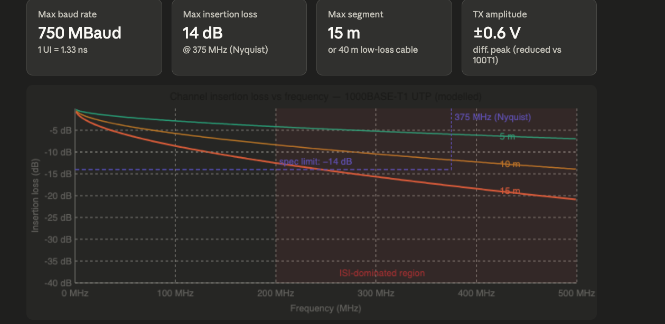
The cable channel at 750 MBaud — why it is so demanding

The insertion loss plot shows the fundamental challenge. At 375 MHz (the Nyquist frequency for 750 MBaud — the frequency above which no useful information can be sent), a 15 m UTP pair has already attenuated the signal by approximately 14 dB. This means the received signal amplitude at the highest frequencies is only about 20% of the transmitted amplitude. The DFE equaliser must restore this lost amplitude by boosting high frequencies — but boosting also amplifies thermal noise, which is why the DFE's decision-feedback architecture (using noiseless past decisions rather than noisy received samples) is essential.
The skin effect dominates at lower frequencies: attenuation grows as √f because current crowds to the outer skin of the conductor at high frequency, increasing effective resistance. The dielectric loss of the insulation grows linearly with f and dominates above ~200 MHz. Both are captured in the cable model IL(f) ≈ −a√f − bf, and both get worse as temperature rises — automotive cables must operate at up to 125°C, where conductor resistivity and dielectric loss tangent both increase, reducing the effective reach. OPEN Alliance TC12 defines specific cable types for 1000BASE-T1 operation up to 125°C.

Training, startup, and link establishment

The total startup time — from power-on to first Ethernet frame — is typically 500–800 ms in production silicon, with the standard mandating no more than 3 seconds. This matters in automotive because control units must be operational within the vehicle's ignition-on timing window. OPEN Alliance TC12 mandates that the link must also re-establish within defined timeouts after a momentary disconnection (e.g., vibration causing a brief connector interruption), without requiring a full cold-start training sequence.

The PAM3 eye diagram at 750 MBaud : why it is harder to close
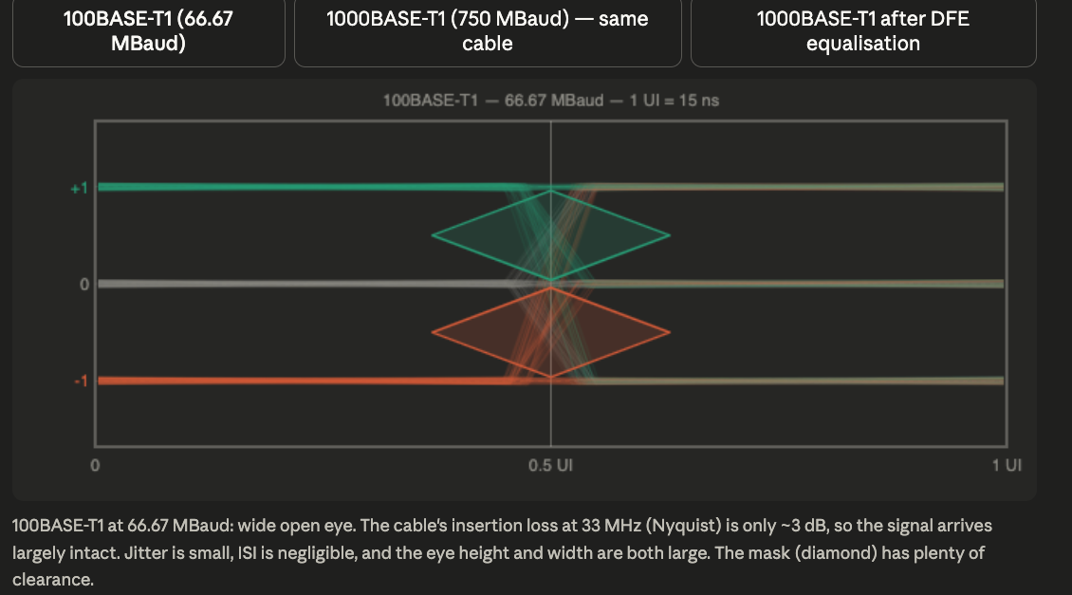

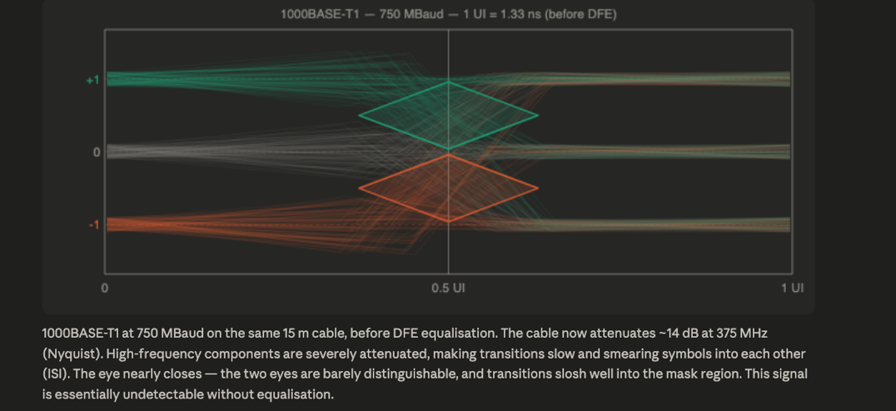

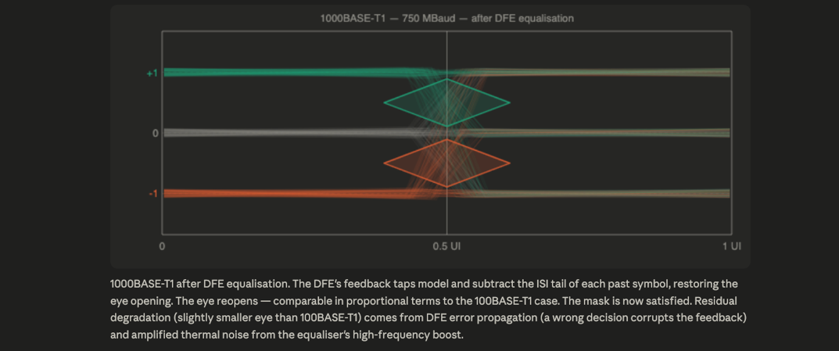

The middle view — 750 MBaud on the raw channel before equalisation — shows viscerally why the DFE is not optional. The cable's dispersive attenuation at high frequencies does not just make the signal smaller; it makes transitions so slow relative to the symbol period (1.33 ns at 750 MBaud) that by the time a transition has settled, the next symbol has already arrived. The symbols smear into each other, virtually eliminating the eye opening.

MDI electrical specification

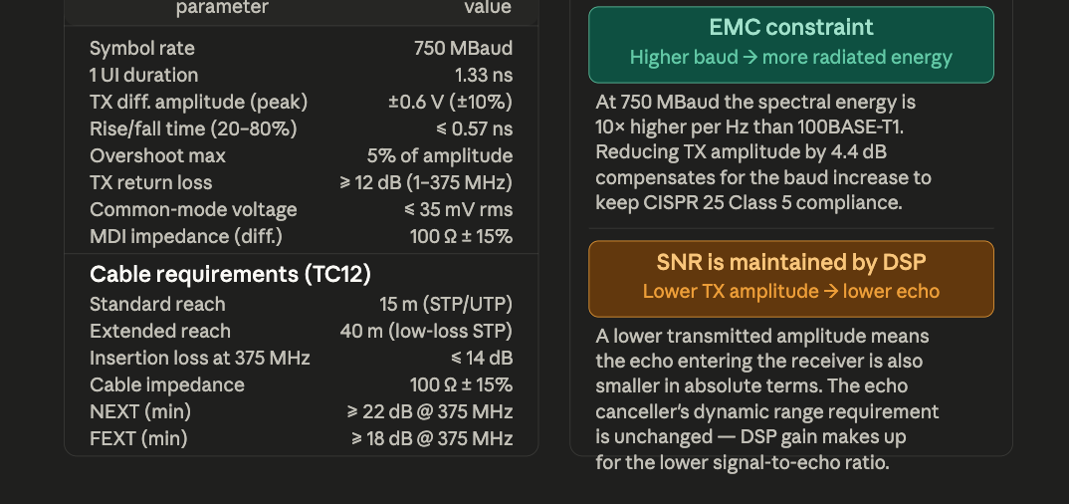

The reduced TX amplitude of ±0.6 V (versus ±1.0 V for 100BASE-T1) is a deliberate EMC trade-off. The 750 MBaud baud rate means the signal's spectral density is spread over a much wider bandwidth than 100BASE-T1, and the peak spectral density near the Nyquist frequency would violate CISPR 25 Class 5 automotive EMC limits if the full ±1.0 V amplitude were used. The solution is to reduce amplitude and rely on the DFE and ADC gain to recover SNR at the receiver — a DSP gain that costs silicon area but not harness weight or shielding.

The extended reach option (40 m with low-loss STP cable) was added to IEEE 802.3bp specifically for backbone runs in larger vehicles — trucks, buses — where a 15 m point-to-point limit would require intermediate switches that add cost, latency, and failure modes. The low-loss cable uses a larger conductor diameter (reducing skin-effect resistance) and a lower-loss-tangent dielectric, bringing the 375 MHz insertion loss below 14 dB at 40 m.

8. OPEN Alliance TC12 and automotive deployment
TC12 (the OPEN Alliance Technical Committee for 1000BASE-T1) defines the component-level compliance specification, including:
Connector requirements. The standard reach (15 m) uses the IEC 63171-6 shielded SPE connector or the HSD2 (High Speed Data, second generation) 2-pin connector. At 750 MHz spectral content, the unshielded IEC 63171-2 connector used for 100BASE-T1 is no longer adequate — shield termination continuity at the connector becomes critical, and TC12 mandates specific shield transfer impedance limits up to 500 MHz.
Functional safety. TC12 v2.x requires PHY vendors to implement ISO 26262 ASIL-B self-diagnostic features including: startup loopback self-test, continuous BER monitoring via the slicer error rate, link-loss detection latency < 5 ms (tighter than 100BASE-T1 because 1G links typically carry safety-critical data streams), and safe-state output signalling to the MAC.
Wake-over-Ethernet (WoE). TC12 v1.1 adds a low-power standby mode where the PHY maintains link detection capability while the main DSP is powered down, consuming < 2 mW. A specific wake pattern in the FLP pulse sequence triggers full power-up. This is essential for automotive sleep/wake power management (ISO 26262 and OEM power-cycle specifications).

Summary: the three single-pair Ethernet standards side by side
Parameter | 10BASE-T1S | 100BASE-T1 | 1000BASE-T1
Standard | 802.3cg | 802.3bw | 802.3bp
Rate | 10 Mbit/s | 100 Mbit/s | 1000 Mbit/s
Line code | 4B5B + MLT-3 | 4B3T (PAM3) | 2B1T (PAM3)
Baud rate | 12.5 MBaud | 66.67 MBaud | 750 MBaud
1 UI | 80 ns | 15 ns | 1.33 ns
Duplex | half (PLCA) | full | full
Topology | multidrop | point-point | point-point
Echo cancel | no | yes (~100 tap FIR) | yes (~200 tap FIR)
FEXT cancel | no | no | yes (~150 tap FIR)
DFE | no | no | yes (8–16 taps)
TX amplitude | ±1.0 V | ±1.0 V | ±0.6 V
Max reach | 25 m | 15 m | 15 m (40 m LL)
OPEN Alliance | TC14 | TC9 | TC12
Training time | ~100 ms (PLCA) | 300–500 ms | 500–800 ms
Typical use | sensor bus | camera / radar | backbone / LIDAR
DSP complexity | none | moderate | very high
The progression from 10BASE-T1S to 1000BASE-T1 is a story of progressively trading DSP silicon complexity for wire. Each step removes one constraint from the physical medium — topology, duplex, reach — by adding adaptive digital signal processing. 1000BASE-T1 represents the current practical limit of what can be extracted from a single unshielded twisted pair in a real automotive environment, and it is why every high-bandwidth sensor and every zonal backbone link in a modern vehicle runs on exactly this standard.

