100BASE-T1 is a fundamentally different beast from 10BASE-T1S — point-to-point, full-duplex, echo-cancelled, and deeply rooted in automotive Ethernet's first serious deployment wave. Let me build this up systematically.

100BASE-T1: Complete Technical Deep-Dive
100BASE-T1 is defined in IEEE 802.3bw-2015 (now consolidated into 802.3-2018, Clause 96–98). It carries 100 Mbit/s full-duplex over a single unshielded twisted pair of up to 15 metres — simultaneously transmitting and receiving on the same wire pair using hybrid echo cancellation. This made it the first Ethernet standard genuinely designed around automotive harness constraints, and it remains the dominant in-vehicle Ethernet PHY for camera, radar, LIDAR, and gateway links in 2024–2026 vehicles.

System overview and protocol stack

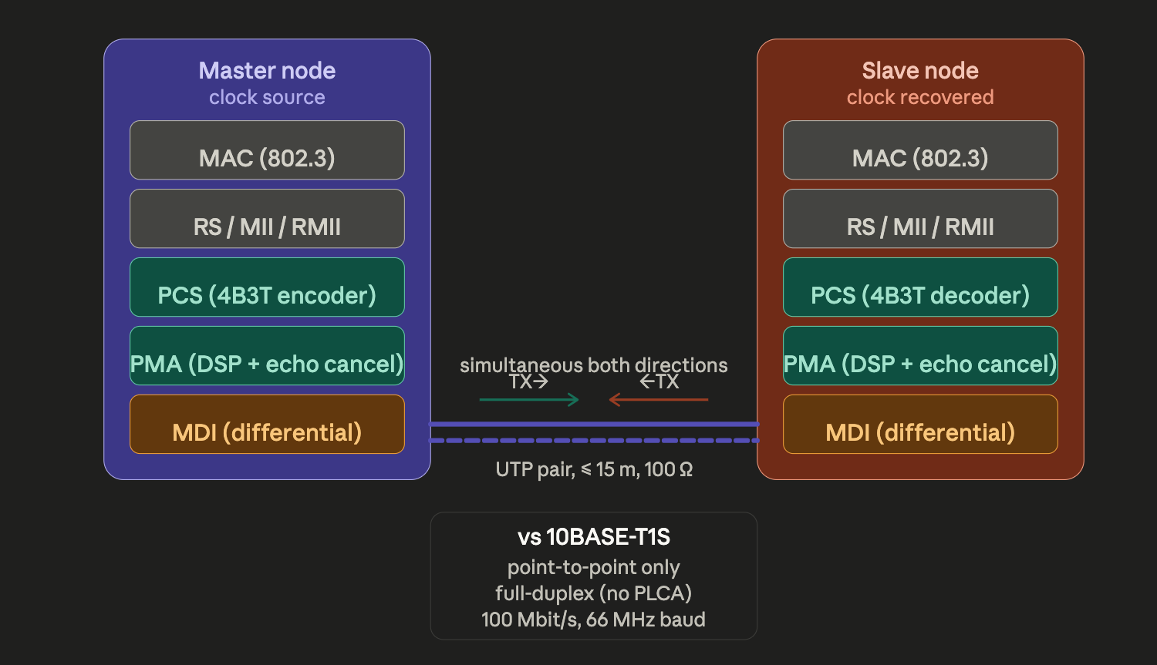

The most important architectural fact about 100BASE-T1 is that it is point-to-point and full-duplex — there is no shared bus, no access arbitration, and no half-duplex collision domain. Both ends transmit simultaneously on the same pair. This is only possible because of the hybrid circuit and digital echo canceller in the PMA, which subtracts the locally transmitted signal from the composite received signal, leaving only the far-end signal. This same principle is used in DSL and V.90/V.92 modems, but implemented here at much higher speed in digital signal processing silicon.

2. The 4B3T line code — the heart of 100BASE-T1
The line code is where 100BASE-T1 diverges most sharply from 10BASE-T1S. Rather than 4B5B + MLT-3, it uses 4B3T (Four Binary, Three Ternary): four input bits are mapped to three ternary symbols drawn from the alphabet {−1, 0, +1}. This achieves a baud rate of 66.67 MBaud for a 100 Mbit/s data rate (100 Mbit/s ÷ (4/3 bits per symbol) = 75 Msymbols needed → actually 66.67 MBaud because 4 bits → 3 symbols gives 4/3 bits/symbol).
4 bits become 3 ternary symbols. The ternary alphabet has 3 values, so 3 ternary symbols can represent 3³ = 27 states. 4 binary bits represent 2⁴ = 16 states, so 16 of the 27 possible ternary words are used as data codewords, leaving 11 unused codewords available for control and DC balance.
The symbol rate is: 100 Mbit/s × (3 symbols / 4 bits) = 75 MBaud for the raw data, but with scrambling overhead the actual line rate is 66.67 MBaud — achieved because the standard's 4B3T encoding is defined within a scrambled NRZ stream that feeds the ternary mapper. The exact baud rate is 66 + 2/3 MHz (i.e., 200/3 MHz).
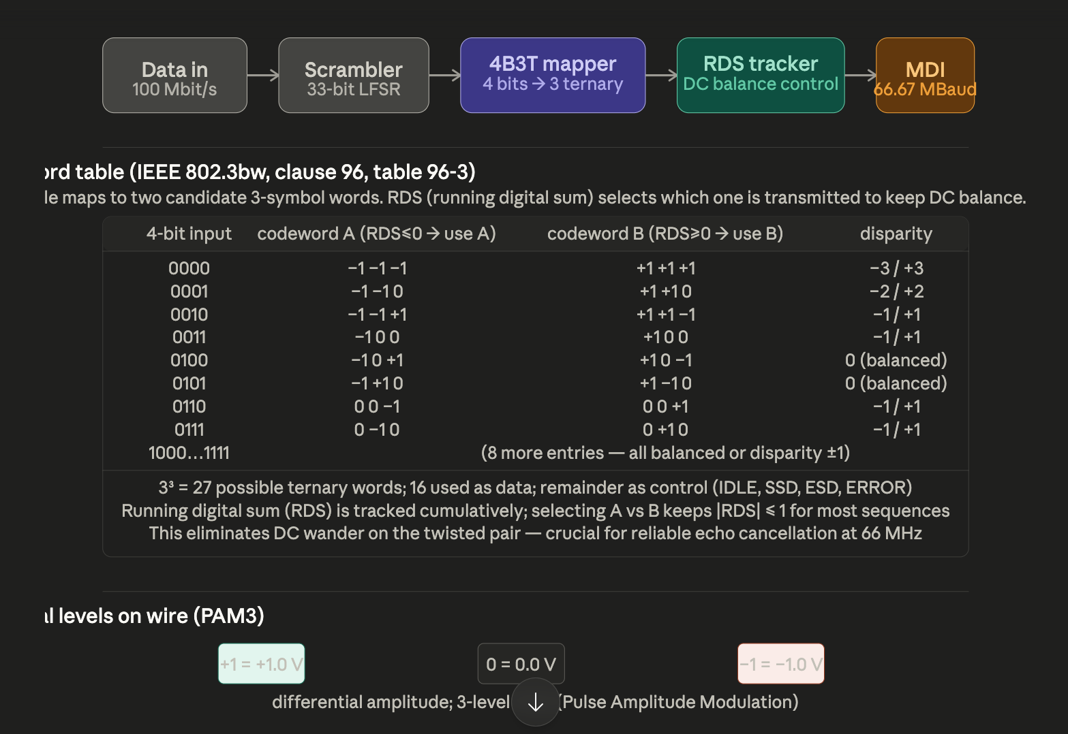

Why 4B3T instead of 4B5B + MLT-3? The key constraint is bandwidth efficiency on a single pair at 100 Mbit/s. 4B5B would require a baud rate of 125 MBaud (100 Mbit/s ÷ 0.8 efficiency), and MLT-3 on top of that gives a fundamental at 62.5 MHz — already challenging for a 15 m UTP pair. 4B3T achieves 66.67 MBaud with a fundamental frequency well below that. More importantly, the ternary alphabet (3 levels vs 2) carries more information per symbol (log₂3 ≈ 1.585 bits/symbol vs 1 bit/symbol for binary), so you need fewer symbols per second for the same data rate.
The running digital sum (RDS) mechanism is the DC balance engine. Since the local transmitter's signal also appears on the shared pair as an echo, the echo canceller must work accurately. Any DC drift makes the echo canceller's baseline wander, degrading cancellation. The paired-codeword scheme keeps RDS bounded to near zero, ensuring no DC component reaches the cable.

3. The echo canceller — how simultaneous bidirectional transmission works
This is the physical miracle of 100BASE-T1. The same pair carries both TX and RX at 100 Mbit/s in each direction, simultaneously. At the receiver, the desired signal is typically 30–40 dB weaker than the locally generated echo (the transmitted signal leaking back through the hybrid circuit). A purely passive hybrid cannot cancel this well enough at 66 MHz — so a digital adaptive echo canceller in the DSP removes it.
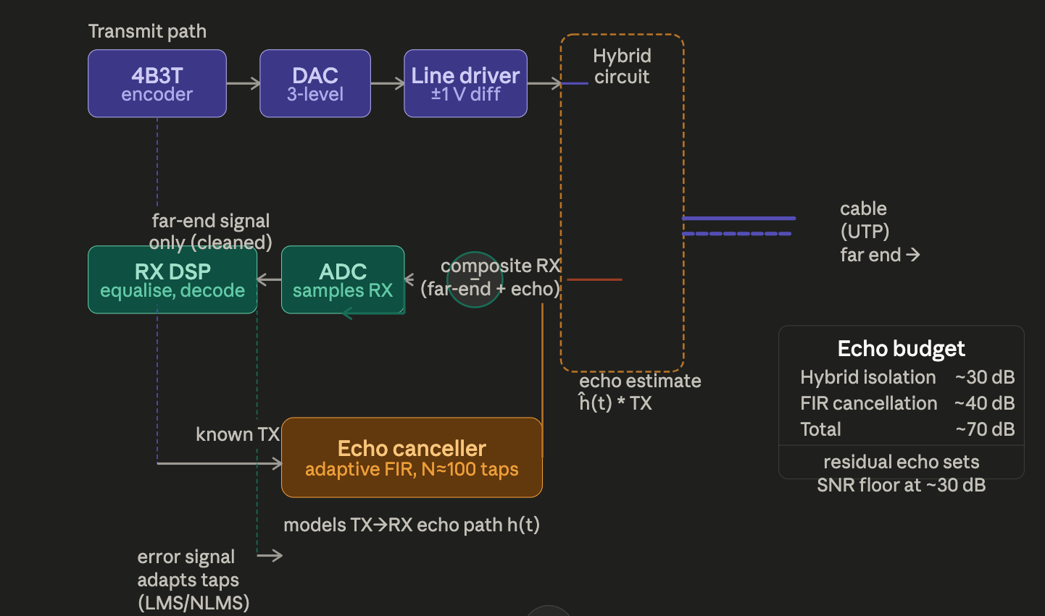

The echo canceller is an adaptive FIR (Finite Impulse Response) filter with approximately 80–120 taps, updated using the LMS (Least Mean Squares) or NLMS (Normalised LMS) algorithm. Since the transmitted signal is known to the local DSP (it generated it), the filter can model the echo path — the impulse response from the line driver output back through the hybrid and cable reflections to the ADC input. The filter output ĥ(t) * TX is the echo estimate; subtracting it from the composite ADC signal leaves the far-end received signal.
The filter must track in real time because the echo path changes slightly with temperature, connector quality, and cable bending over time. The LMS adaptation runs continuously at 66.67 MHz. The hybrid circuit provides an initial ~30 dB of passive isolation (by balancing the cable impedance against a local replica); the digital filter adds a further ~40 dB, giving total echo suppression of ~70 dB — enough to bring the echo well below the far-end signal level.

4. Timing and master/slave architecture
100BASE-T1 requires one end to be the master (clock source) and the other the slave (clock recovered). This is fundamentally different from 1000BASE-T where both ends clock independently.
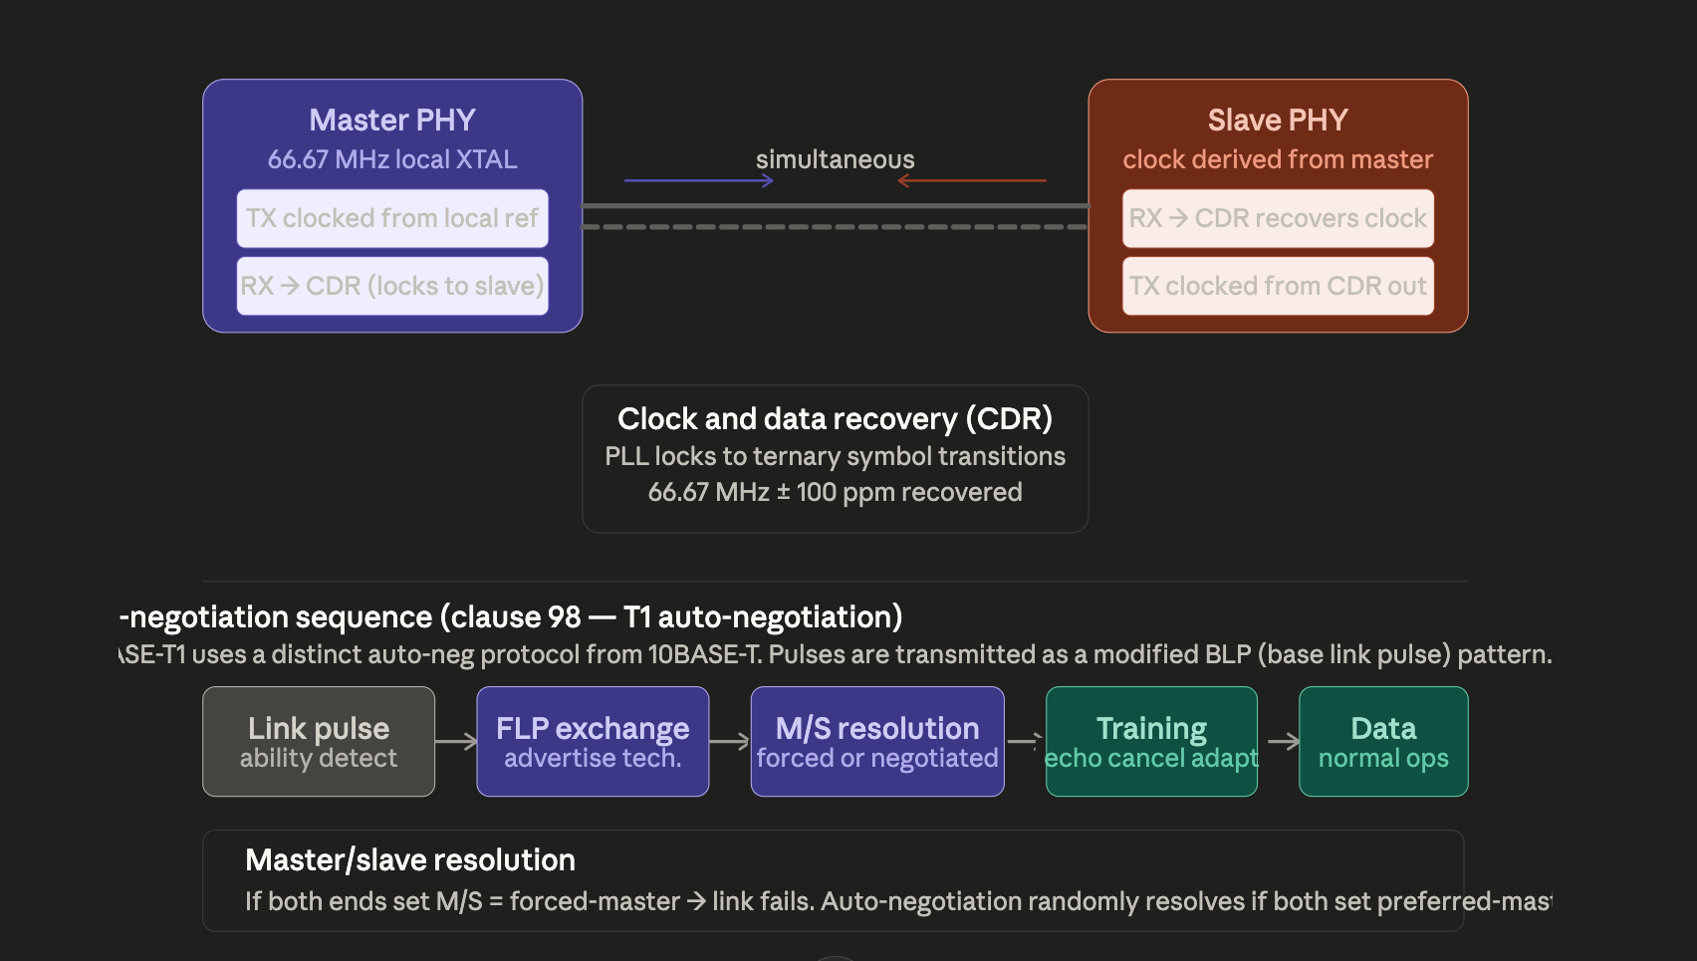
Why master/slave matters. The slave's transmit clock is derived from the master's received symbols via CDR, which means the two ends are frequency-locked. This is critical for the echo canceller: if the TX and RX clocks drifted relative to each other, the echo canceller's FIR filter would need to track a non-stationary echo path, significantly degrading convergence. The master/slave topology eliminates this problem by making the echo path effectively stationary.
Training phase. Before entering data mode, both PHYs send a known training sequence. The echo canceller uses this pseudo-random ternary pattern to compute its initial FIR tap values — analogous to how a DSL modem trains on startup. Training takes approximately 300–500 ms in typical implementations, which is why you observe a link-up delay when connecting a camera or LIDAR sensor. IEEE 802.3bw mandates that training complete within 3 seconds.

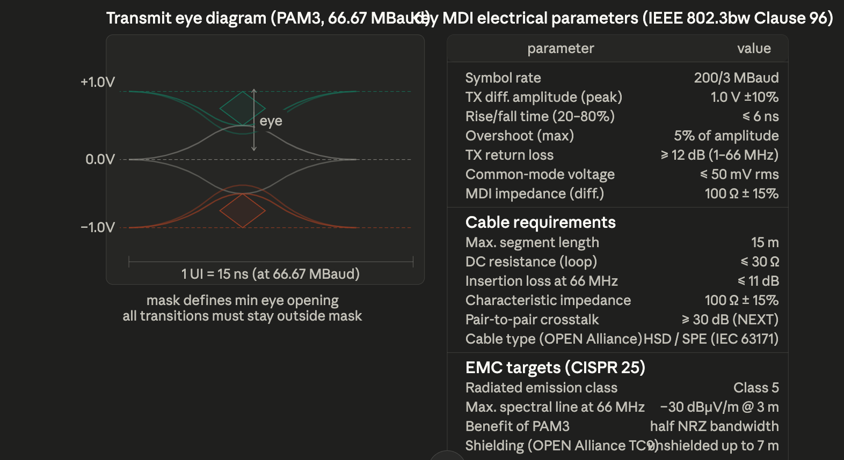
5. MDI electrical specification and cable requirementsThe eye diagram and mask.

At 66.67 MBaud, a PAM3 signal has two superimposed "eyes" — one between the +1 and 0 levels, one between 0 and −1. The IEEE 802.3bw transmit mask defines the minimum opening at the centre of the unit interval that every transmitter must achieve. The mask is diamond-shaped in amplitude–time space; any transition that passes through the diamond causes the eye to be partially closed, which reduces the receiver's noise margin. The 4B3T code with RDS control prevents long runs of the same symbol, keeping the eye open even for repetitive data patterns.
Cable attenuation. The maximum insertion loss of 11 dB at 66 MHz sets the 15 m reach. The cable's characteristic impedance should be 100 Ω to match the MDI — any mismatch causes reflections that the echo canceller must also handle, effectively eating into its dynamic range. OPEN Alliance TC9 defines the specific cable types tested for automotive compliance.

6. OPEN Alliance and automotive deployment context
The OPEN Alliance (One-Pair Ether-Net Alliance) Technical Committee 9 (TC9) defines the component-level compliance specification for 100BASE-T1, including cable, connector, and PCB trace requirements. For 100BASE-T1 specifically:
TC9 in-vehicle specifics. The cable must survive −40 °C to +125 °C (zone-dependent), with insulation rated for the automotive chemical environment (brake fluid, engine oil, fuel vapour). The MDI connector is most commonly the HSD (High Speed Data) connector (4-pin, locking, rated to USCAR-27) or the IEC 63171-6 SPE connector. TC9 mandates that the PHY present a defined impedance even when unpowered, to prevent reflections from a disconnected node degrading other nodes on the same harness segment.
Managed PHY interface. OPEN Alliance TC9 requires the PHY to expose clause 22 or clause 45 MDIO registers including: link status (0.2), master/slave config (0.11), loopback (0.14), training status, and vendor-specific diagnostic counters (symbol error rate, CRC errors, echo canceller convergence status). This is mandatory for automotive onboard diagnostics (OBD) and functional safety (ISO 26262 ASIL) compliance.
Functional safety. Many automotive 100BASE-T1 PHYs implement self-test and watchdog features required under ISO 26262 ASIL-B or ASIL-D, including: continuous CRC monitoring, link-down detection latency < 10 ms, loopback self-test on startup, and safe-state signalling to the MAC on link loss.

7. Where 100BASE-T1 sits in the automotive network hierarchy

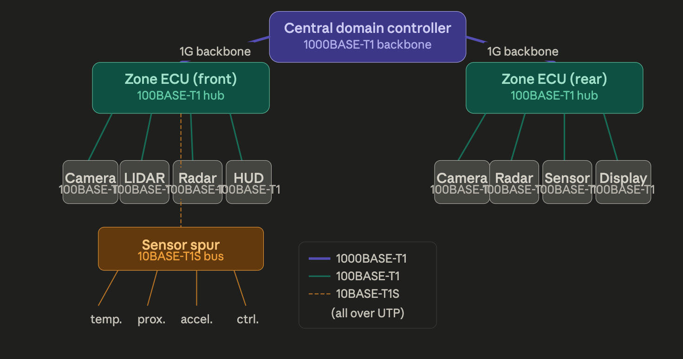

Summary comparison: 10BASE-T1S vs 100BASE-T1 vs 1000BASE-T1
Parameter | 10BASE-T1S | 100BASE-T1 | 1000BASE-T1
Standard | IEEE 802.3cg | IEEE 802.3bw | IEEE 802.3bp
Data rate | 10 Mbit/s | 100 Mbit/s | 1000 Mbit/s
Duplex | half (PLCA) | full | full
Topology | multidrop bus | point-to-point | point-to-point
Nodes | ≤ 8 (TC14) | 2 | 2
Line code | 4B5B + MLT-3 | 4B3T (PAM3) | PAM3
Baud rate | 12.5 MBaud | 66.67 MBaud | 750 MBaud
Max reach | 25 m | 15 m | 15 m
Echo cancel | no | yes (FIR) | yes (FIR)
Training req. | PLCA beacon | ~300–500 ms | ~500 ms
Cable type | UTP 100 Ω | UTP 100 Ω | UTP 100 Ω
OPEN Alliance | TC14 | TC9 | TC14 / TC12
Typical use | sensor bus | camera, LIDAR | backbone
100BASE-T1's fundamental engineering insight — that a high-quality adaptive FIR echo canceller in silicon can resolve 100 Mbit/s simultaneous bidirectional transmission on a single pair at low cost — enabled the modern automotive Ethernet era. Every camera that feeds your rear-view display, every radar sensor talking to an ADAS ECU, and most LIDAR sensors in production vehicles today speak 100BASE-T1 on that single thin wire.

How master/slave is resolved in 100BASE-T1

The process happens before any data flows — both nodes are transmitting only link pulses at this stage, not ternary data. There is no chicken-and-egg problem because link pulses are a distinct, low-level signal that both ends can send simultaneously without needing echo cancellation to be active.
Stage 1 — FLP exchange. Both nodes transmit Fast Link Pulses simultaneously. These are simple baseband pulses at ~125 µs spacing, far below the 66 MHz ternary signal, so the passive hybrid circuit provides enough isolation for both ends to receive each other's pulses without needing the DSP echo canceller. Each node encodes a 16-bit "base page" in its FLP burst.

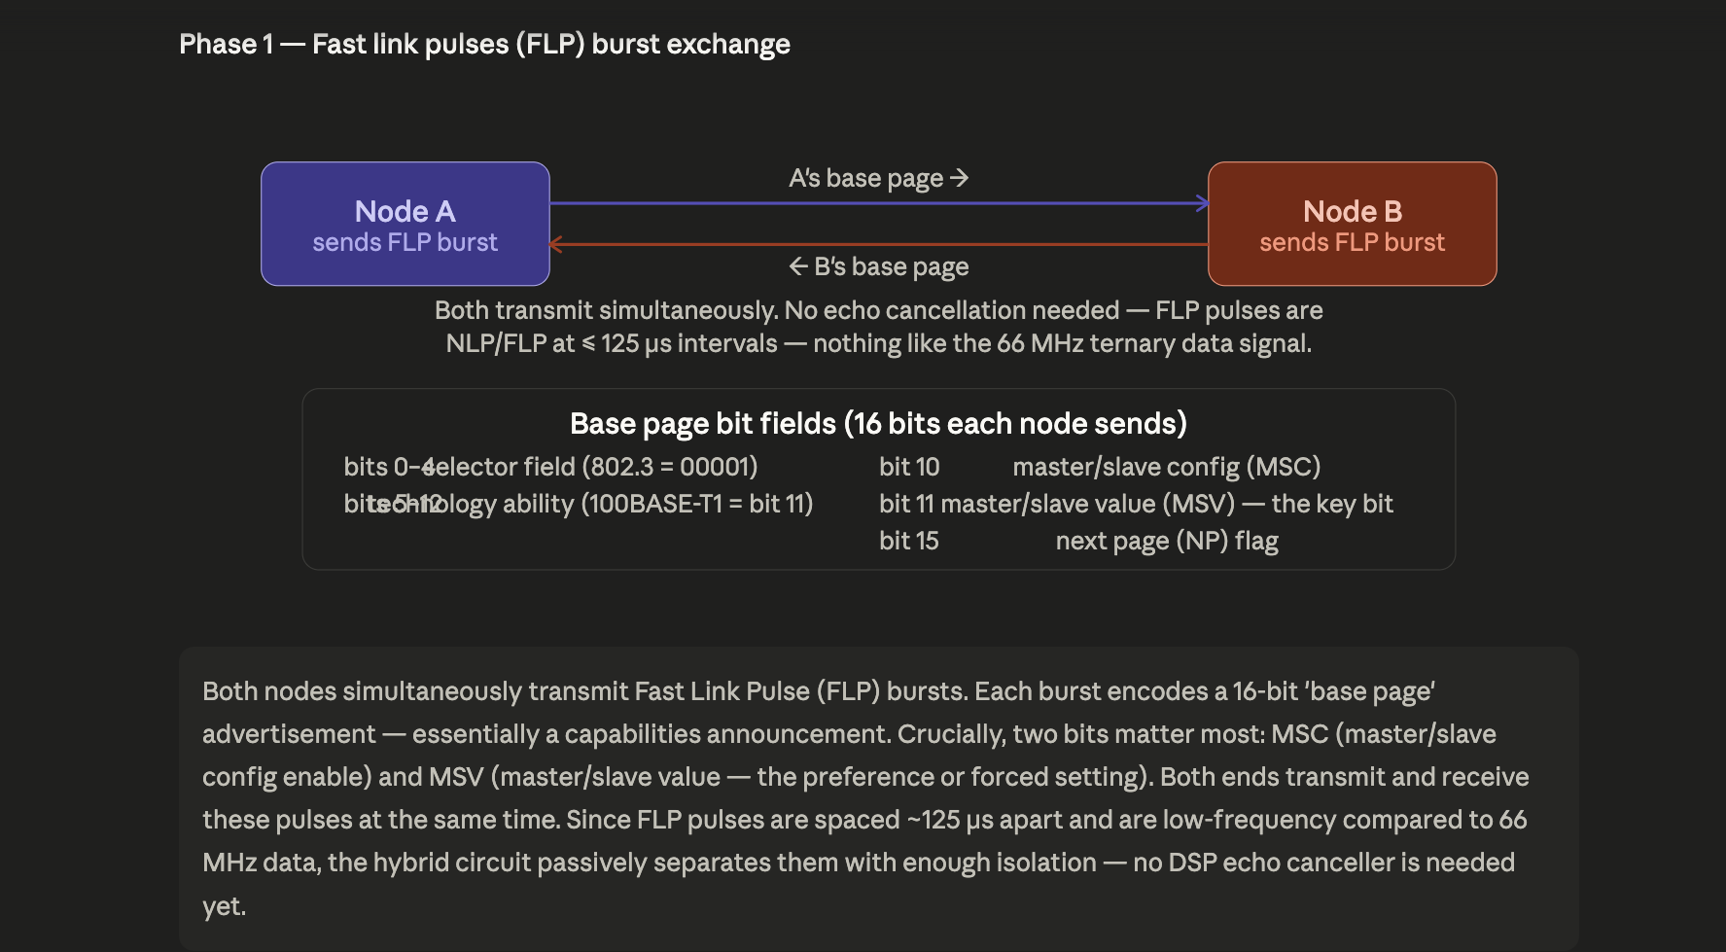

Stage 2 — Resolution from two bits. Two bits inside the base page drive the decision: MSC (config enable, i.e. forced vs preferred) and MSV (the actual master/slave value). The standard defines four meaningful combinations. In automotive systems the most common deployment is one end forced-master (MSC=1, MSV=1) and the other forced-slave (MSC=1, MSV=0) — the result is completely deterministic and instantaneous.
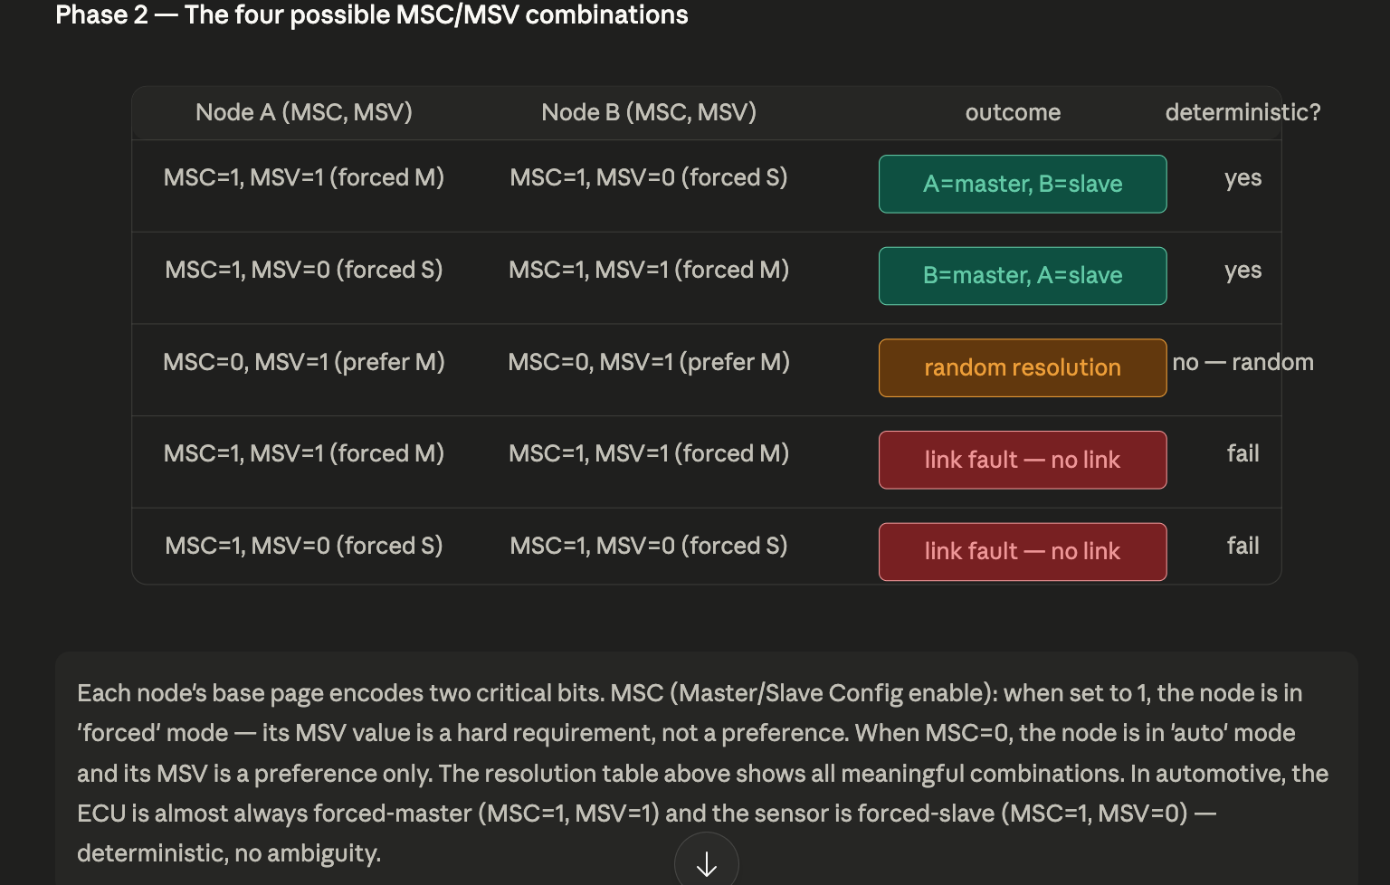

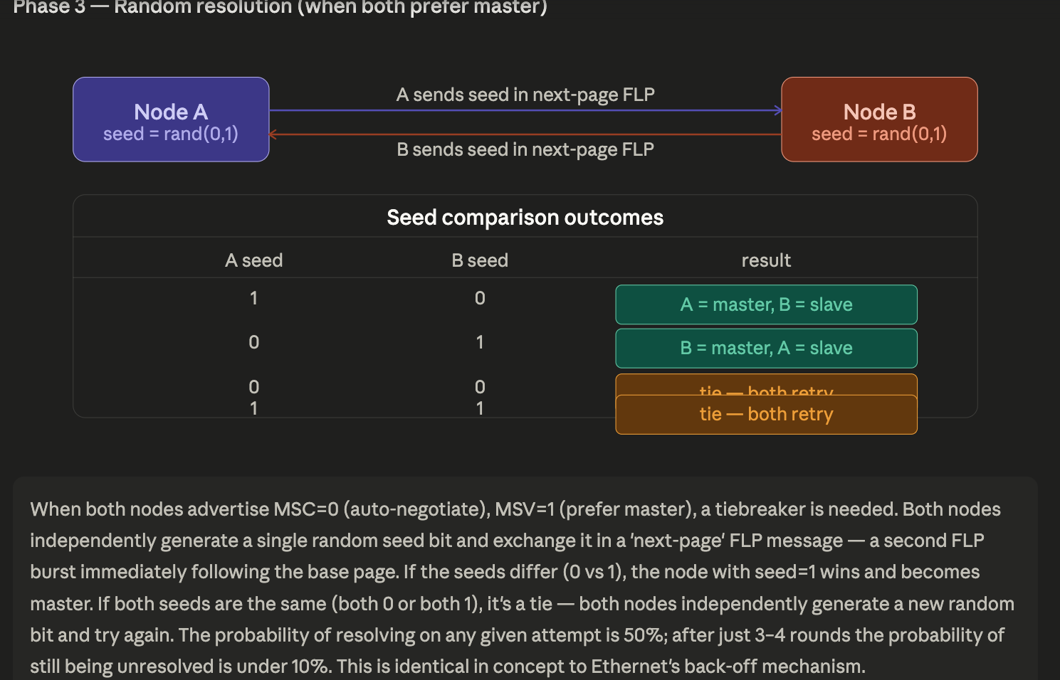
Stage 3 — Random tiebreak (only if both are in auto mode). If both ends advertise MSC=0, MSV=1 (both prefer master but will accept slave), they exchange a second "next-page" FLP containing a single randomly generated seed bit. The node whose seed is 1 while the other's is 0 wins master. If both seeds match (both 0 or both 1), they independently generate new random bits and retry. Statistically this resolves in 2–3 rounds with overwhelming probability. This situation almost never arises in automotive practice — engineers configure M/S explicitly — but it exists for generic infrastructure deployments.

Stage 4 — Training. The moment master/slave is settled, the master starts transmitting the real 66.67 MBaud ternary idle stream. The slave's CDR PLL locks to this clock (takes ~100 µs), then begins transmitting back on its derived clock. Now the echo canceller FIR filters on both sides can do their adaptive convergence — both ends know what they transmitted, so they can subtract their own echo from the composite received signal and extract the far-end signal. After ~300–500 ms, convergence is sufficient, the link-status bit (MDIO register 0.2) asserts, and Ethernet frames begin flowing.
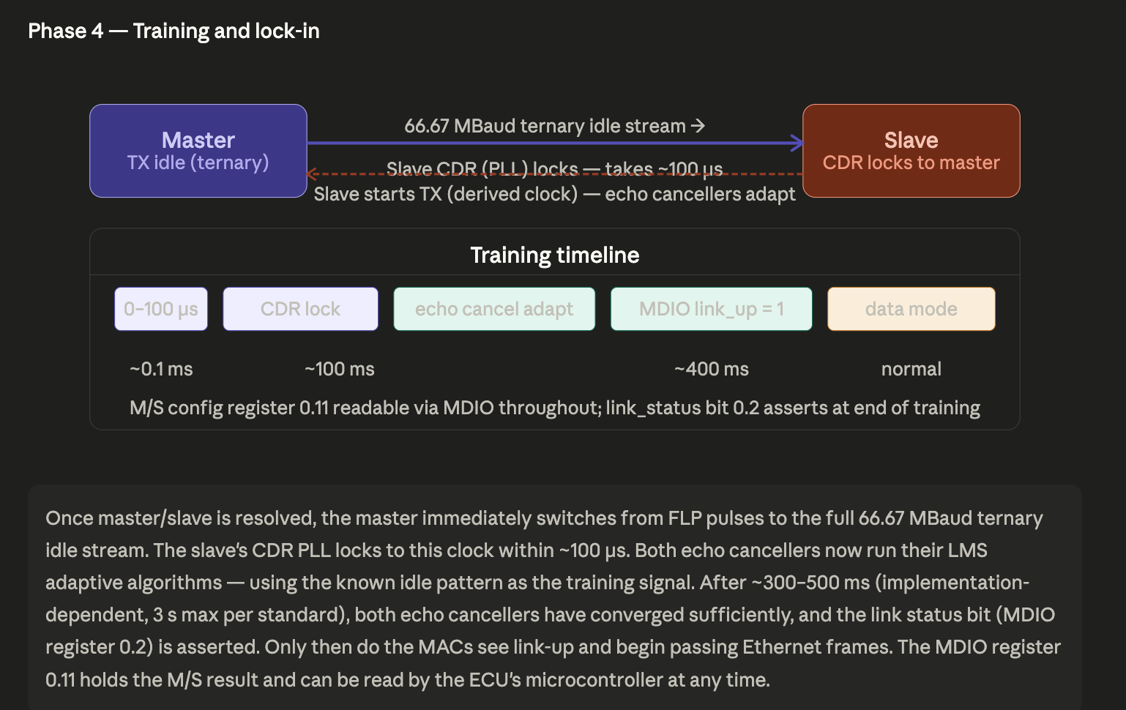
The key insight is that the chicken-and-egg problem — "how do two nodes that are both sending decide who clocks whom before the echo canceller is running?" — is resolved by using a completely different, lower-frequency signalling mechanism (FLP pulses) for auto-negotiation, keeping the DSP entirely out of the loop until after a winner is declared.

FLP pulses are not a differential continuous signal on the pair — they are sparse, low-energy, unipolar voltage pulses separated by long silences, and the hybrid circuit's passive isolation (~30 dB) is more than sufficient to separate them at these frequencies and duty cycles. No DSP is involved at all.

What an FLP burst actually looks like on the wire

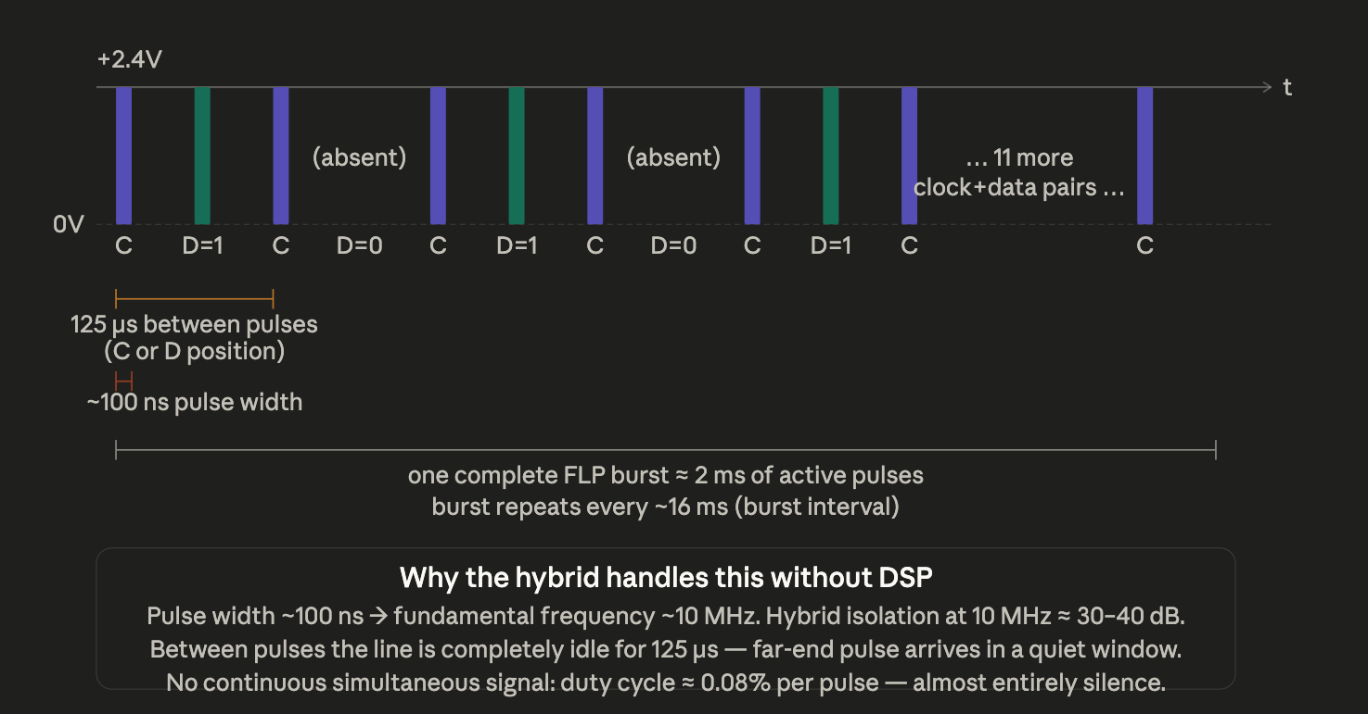

Now the critical comparison — what is the difference between what the hybrid must handle during FLP vs during data mode:

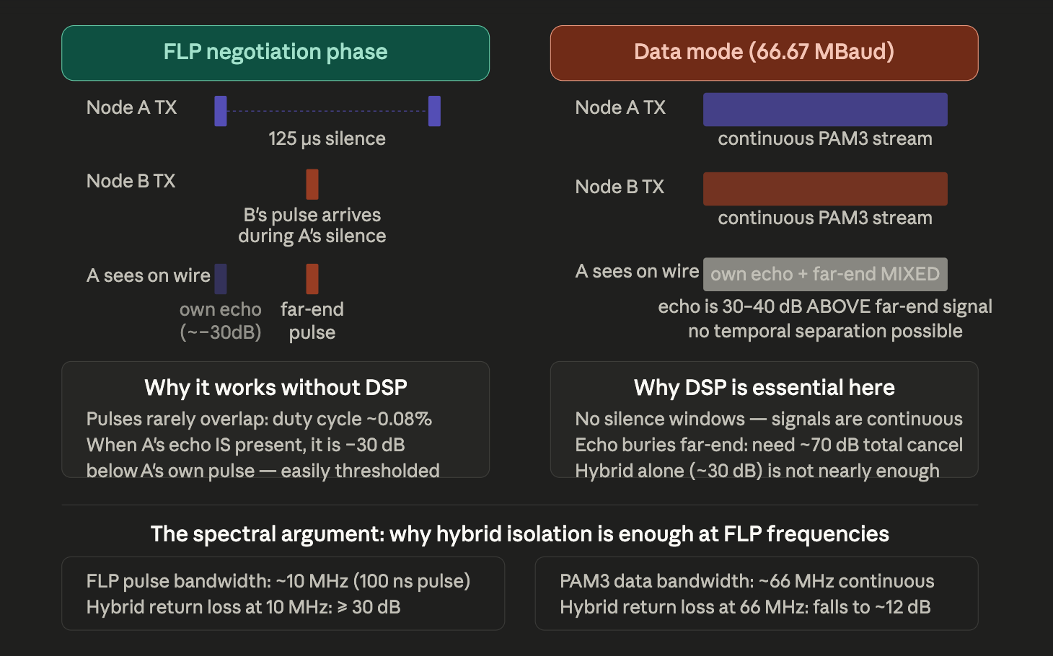

Here is the precise physical reason echo cancellation is not needed during FLP:
The FLP pulses are not simultaneous in the sense that matters. Each pulse is only ~100 ns wide. Between pulses there is 125 µs of complete silence. So the pair looks like this at any instant: one node fires a sharp 100 ns spike, then goes quiet for 125 µs. The far-end node fires its own spike at a slightly different moment, which also arrives during one of those 125 µs silence windows. The two nodes are not co-ordinated — their burst timings are independent — but because the duty cycle of any single pulse is only 100 ns / 125 µs ≈ 0.08%, the probability that the two nodes' pulses land on top of each other at the receiver is essentially zero in practice.
When pulses do overlap, the hybrid's passive ~30 dB isolation means the own-echo contribution is already 30 dB below the locally transmitted pulse. Because the locally transmitted pulse and the far-end received pulse are of similar amplitude (both nominally +2.4 V), the own-echo seen at the receive port during a transmitted pulse is only about +2.4 V / 30 dB ≈ +75 mV. The receiver's FLP threshold comparator can distinguish this easily.
The spectral argument is also clean: the FLP pulse width of ~100 ns gives a dominant spectral component at ~10 MHz. A transformer-coupled hybrid circuit easily achieves ≥ 30 dB of differential rejection at 10 MHz with no active components. It is the continuous 66 MHz PAM3 data stream — where both ends never stop transmitting, so there are zero silence windows and zero opportunity for temporal separation — that exhausts the hybrid's passive capability and demands a 100-tap adaptive FIR filter to do the remaining 40 dB of cancellation.
In short: FLP works because it is a sparse, pulsed, low-duty-cycle signal where temporal separation does most of the work. Data mode fails temporal separation completely because the signal is continuous — that is exactly why the DSP echo canceller was invented for this standard.

