PAM-3: Pulse Amplitude Modulation with 3 Levels
PAM-3 is a line coding scheme that encodes data by using three distinct voltage levels to represent symbols on a transmission line. Let me walk through the fundamentals clearly.

What is PAM-3?
In standard binary signaling (NRZ), each symbol carries one of two voltage levels, encoding exactly 1 bit per symbol. PAM-3 extends this by using three voltage levels — typically +V, 0, and −V — allowing each symbol to carry more information. Specifically, each PAM-3 symbol represents one of three states, encoding log₂(3) ≈ 1.585 bits per symbol.
PAM-3 is most famously used in 100BASE-T2 and 1000BASE-T Ethernet, where it helps achieve higher data rates over copper twisted-pair cabling without increasing the baud rate (symbol rate) proportionally.
Let us start with a diagram showing the three voltage levels and how a bit stream maps to them.
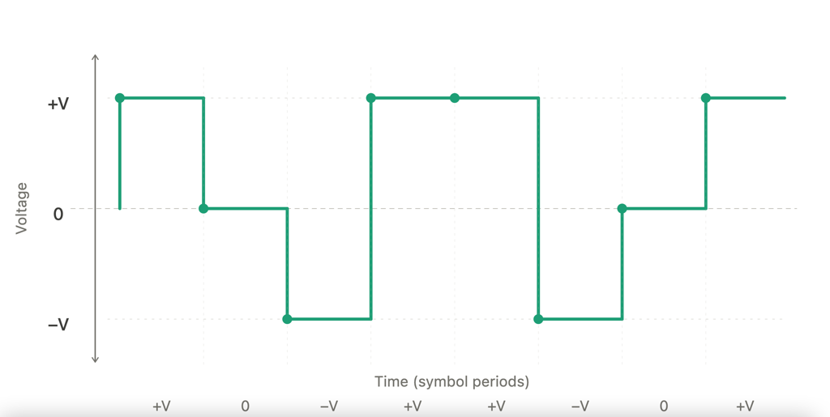

The waveform above shows eight consecutive PAM-3 symbols. At each clock edge, the transmitter drives the line to one of three discrete levels. The receiver samples at each symbol period and decides which of the three levels was sent.

The three levels and their encoding
The mapping from symbols to bits isn't a simple 1:1 correspondence like binary. Since 3 states per symbol gives log₂(3) ≈ 1.585 bits, you can't encode an exact integer number of bits per symbol. There are two common strategies:
Strategy 1 — Ternary digit mapping (used in 100BASE-T2): Groups of bits are mapped onto groups of ternary symbols. For example, 4 bits (16 values) can be encoded into 3 PAM-3 symbols (3³ = 27 possible values, 16 of which are used). The remaining 11 unused codewords can be reserved for control signaling or chosen for favorable spectral properties (DC balance).
Strategy 2 — Direct ternary coding (simpler conceptual model): Each symbol is assigned a meaning: +V → "+1", 0V → "0", −V → "−1". This is useful for understanding the signal on the wire, even if the actual bit-to-symbol mapping uses a lookup table.
Now let us see how PAM-3 compares to binary NRZ in terms of bandwidth efficiency.

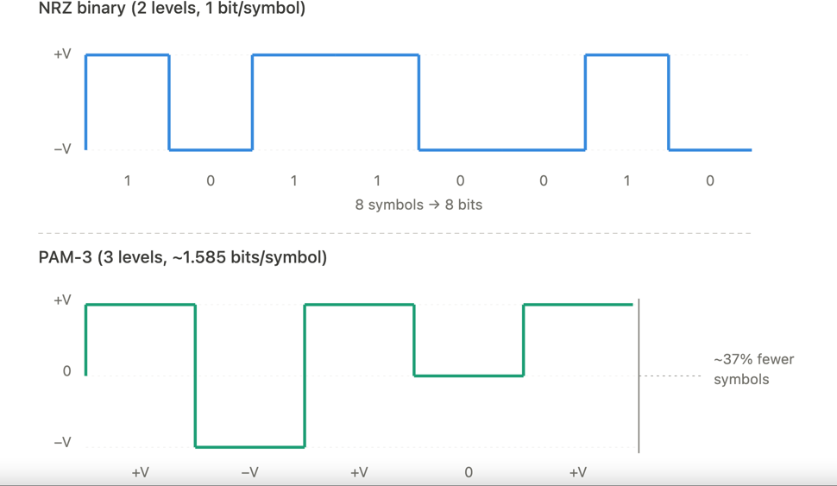

The key insight here: because each PAM-3 symbol carries ~1.585 bits instead of 1 bit, you need roughly 37% fewer symbol periods to transmit the same data. This means you can either run the symbol clock slower (saving bandwidth) or push more data at the same clock rate.

Eye diagram and noise margins
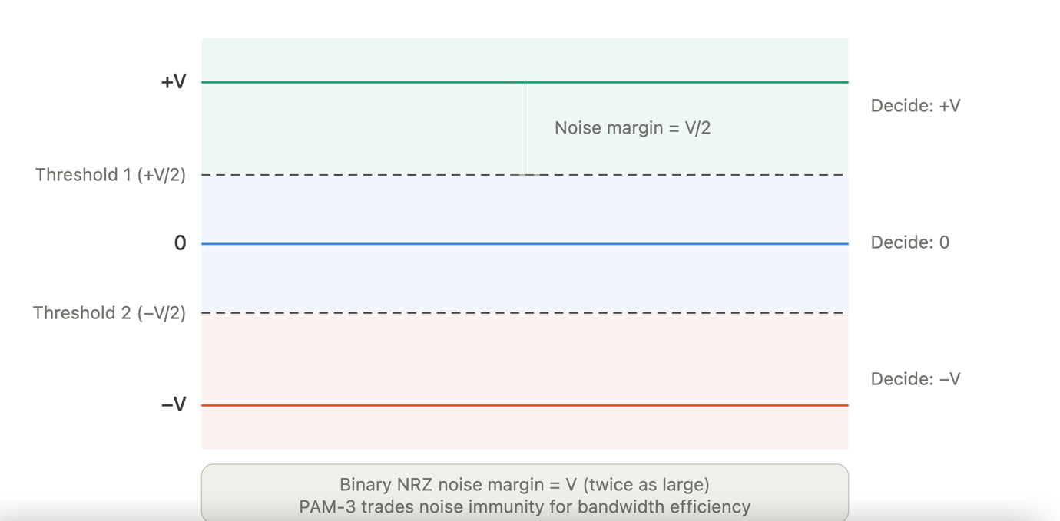
The trade-off with PAM-3 is that the voltage spacing between levels is smaller than in binary. If the total voltage swing is the same (say ±1V), then binary has a distance of 2V between its two levels, while PAM-3 has only 1V between adjacent levels. This makes PAM-3 more susceptible to noise — the receiver has tighter decision thresholds.
The receiver uses two decision thresholds at +V/2 and −V/2. Any received signal above the upper threshold is decoded as +V, between the thresholds as 0, and below the lower threshold as −V. The noise margin — the amount of noise a signal can tolerate before being misinterpreted — is V/2 per level, compared to V for binary NRZ. This is the fundamental PAM-3 trade-off.

Summary of key properties
Information density: Each PAM-3 symbol carries log₂(3) ≈ 1.585 bits, compared to 1 bit for binary. This means ~58.5% more data per symbol period.
Bandwidth efficiency: For a given data rate, PAM-3 requires a lower symbol rate than binary, which means the signal occupies less bandwidth on the wire. This is critical in Ethernet standards where cable bandwidth is constrained.
Noise sensitivity: The reduced spacing between levels (V instead of 2V for the same swing) means PAM-3 requires better signal-to-noise ratio (SNR) at the receiver. Roughly 3–4 dB more SNR is needed compared to binary for the same bit error rate.
DC balance: The three levels (including zero) make it easier to achieve DC balance on the line, which is important for transformer-coupled interfaces. Encoding schemes can choose codewords that keep the running digital sum near zero.
Practical usage: PAM-3 is used in 100BASE-T2 Ethernet (100 Mbps over two pairs of Cat 3 cable) and as a building block concept in 1000BASE-T (which uses PAM-5 but with related principles). It sits in the family between simple binary NRZ and higher-order schemes like PAM-4 (used in 400G Ethernet) and PAM-5.
Interactive Encoder PAM-3

