PTP and gPTP
Precision Time Protocol (IEEE 1588) and
Generalised PTP for Time-Sensitive Networks (IEEE 802.1AS)
A Complete Technical Reference

Covering: synchronisation fundamentals · four-timestamp mathematics · hardware timestamping · BMCA · clock types · gPTP peer delay · correctionField propagation · servo control · automotive deployment

1. Why Synchronisation Is Hard — and Why NTP Is Not Enough
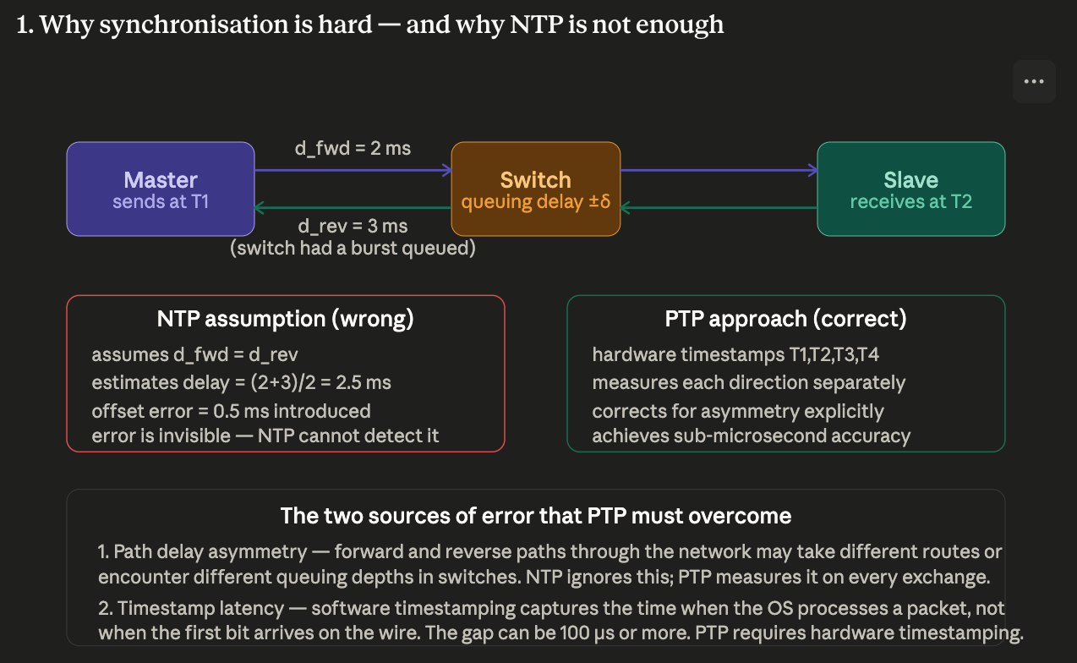
Network Time Protocol (NTP) achieves millisecond-level accuracy over the internet by averaging many round-trip measurements and assuming that the forward and reverse path delays are equal (symmetric). These two assumptions break down when microsecond accuracy is needed.

The asymmetric delay problem
Consider two nodes exchanging timing messages through a switch. The forward path may take 2 ms and the reverse path 3 ms — because the switch had a burst of queued traffic in one direction but not the other. NTP calculates the one-way delay as (2 + 3) / 2 = 2.5 ms and applies a 2.5 ms correction. The true delay in the forward direction was only 2 ms, so the NTP-corrected slave clock is 0.5 ms wrong. Critically, NTP cannot detect this error — it has no way to measure each direction independently.

NTP error: assumes forward delay = reverse delay. If the switch queuing is asymmetric, the error is silent and uncorrectable from the slave's perspective.

The software timestamp problem
NTP and naive PTP implementations record the time when the operating system (OS) processes a received packet — not when the first bit arrived at the network interface. The gap between actual packet arrival and OS processing can be 50 to 500 microseconds, and it varies unpredictably with CPU load, interrupt latency, and cache state. This alone limits any software-timestamped protocol to millisecond accuracy at best.

PTP (Precision Time Protocol, IEEE 1588) solves both problems: it measures each direction of the path delay separately using four hardware timestamps, and it captures those timestamps at the physical layer boundary (the MDI — Media Dependent Interface) the instant the Start Frame Delimiter (SFD) byte crosses the wire.

2. The Four Timestamps — The Mathematical Foundation of PTP
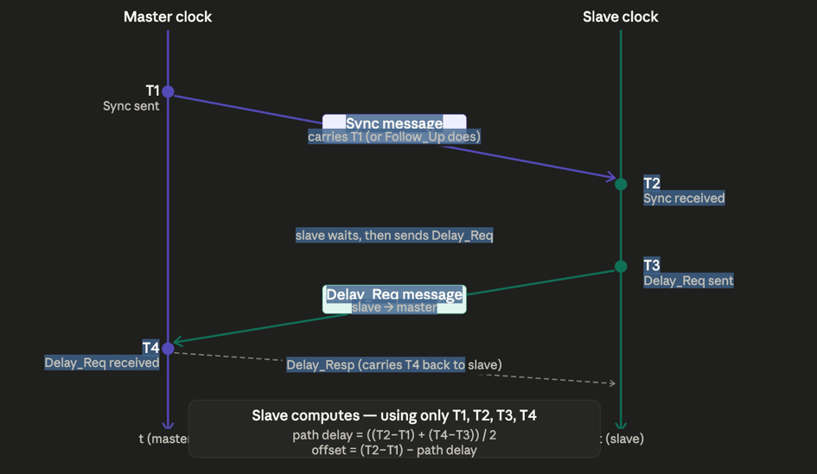
Every PTP synchronisation exchange produces exactly four hardware timestamps. These four numbers are sufficient to simultaneously solve for both the clock offset and the one-way path delay — two unknowns from four equations.

The timestamp exchange sequence

Timestamp | Who captures it | What it records
T1 | Master PHY hardware | Exact moment the master transmits the Sync message (SFD crosses the master MDI outbound)
T2 | Slave PHY hardware | Exact moment the slave receives the Sync message (SFD crosses the slave MDI inbound)
T3 | Slave PHY hardware | Exact moment the slave transmits the Delay_Req message (SFD crosses the slave MDI outbound)
T4 | Master PHY hardware | Exact moment the master receives the Delay_Req message (SFD crosses the master MDI inbound)

The mathematics
From these four timestamps, the slave computes two quantities:

path_delay = ((T2 - T1) + (T4 - T3)) / 2
clock_offset = (T2 - T1) - path_delay

The elegance of this formulation is that the path delay cancels out of the offset calculation, and the clock offset cancels out of the path delay calculation. The two unknowns are fully determined by the four measurements regardless of the magnitude of either.

Worked example with real numbers
Suppose the master clock is the ground truth. The slave clock is running 10 microseconds (µs) ahead of the master (offset = +10 µs), and the one-way propagation delay is exactly 5 µs in each direction.

Timestamp | Value (µs) | Derivation
T1 | 1000.000 | Master sends Sync at this master-clock time
T2 | 1015.000 | Slave receives it: 1000 + 5 (delay) + 10 (offset) = 1015 on slave clock
T3 | 2000.000 | Slave sends Delay_Req at this slave-clock time
T4 | 1995.000 | Master receives it: 2000 - 10 (offset) + 5 (delay) = 1995 on master clock

Applying the formulae:
path_delay = ((1015 - 1000) + (1995 - 2000)) / 2 = (15 + (-5)) / 2 = 5 µs ✓
clock_offset = (1015 - 1000) - 5 = 15 - 5 = +10 µs ✓
The slave now knows it is 10 µs ahead and corrects its clock accordingly. Both results are exact — the arithmetic is not an approximation.

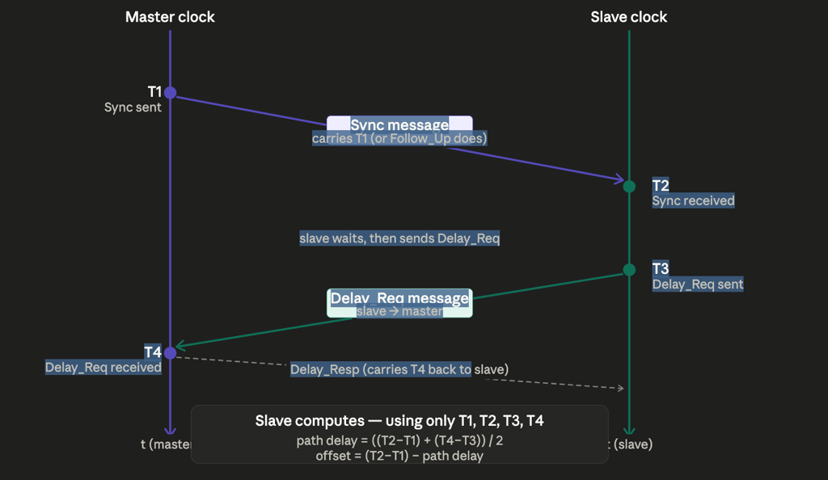
3. Hardware Timestamping ---Why Software Timestamps Fail

The hardware timestamp unit is a small register in the PHY or MAC silicon that latches the current value of a free-running nanosecond counter the instant the SFD is detected at the MDI. This happens entirely independently of the CPU, OS scheduler, interrupt handler, and application software.

Approach | Where timestamp is captured | Typical accuracy
Software timestamping | Inside the OS network stack, after interrupt processing, driver execution, and kernel scheduling | 50–500 µs — variable and unpredictable
NIC-level timestamping | In the NIC driver at the point of DMA completion — better than pure software but still above the MAC | 1–10 µs — improved but insufficient for PTP
Hardware (PHY/MAC) timestamping | At the MDI boundary, the instant the SFD crosses the wire interface — in silicon, no software involvement | < 8 ns — sufficient for sub-microsecond PTP accuracy

IEEE 802.1AS (gPTP) makes hardware timestamping mandatory at every port. Without it, gPTP compliance cannot be achieved. This is also why gPTP-capable switch ASICs contain a dedicated PTP timestamp unit — separate from the normal forwarding pipeline — that captures SFD arrival times to nanosecond resolution.

How the hardware timestamp unit works
The PHY runs a free-running 64-bit counter clocked from its recovered line clock (for receive) or its local crystal reference (for transmit). When the SFD pattern (0xAB in an Ethernet frame) is detected, the counter value is latched into a dedicated register. The PTP software reads this register via the MDIO (Management Data Input/Output) interface after transmission or reception. The counter frequency is typically 125 MHz (8 ns resolution) or higher.

4. PTP Message Types — The Complete Protocol Vocabulary
PTP defines two categories of message: event messages (which are hardware-timestamped on both transmit and receive) and general messages (which carry information but do not require timestamping).

Event messages — hardware timestamped
Message | Direction | Purpose
Sync | Master → Slave | Primary timing message. Carries T1 (the master's send timestamp) either embedded in the message (one-step mode) or via a subsequent Follow_Up message (two-step mode). The slave captures T2 on receipt.
Delay_Req | Slave → Master | Initiates the reverse path delay measurement. The slave captures T3 on transmission. Sent at a lower rate than Sync — typically once per second.
Pdelay_Req | Port → Neighbour | Used in the peer-to-peer delay mechanism (mandatory in gPTP). Initiates a link delay measurement between directly connected ports. Captures T1 on transmission.
Pdelay_Resp | Neighbour → Port | Response to Pdelay_Req. The responding port captures T2 (receive time of Pdelay_Req) and T3 (send time of Pdelay_Resp). Both are hardware timestamped.

General messages — not timestamped
Message | Direction | Purpose
Follow_Up | Master → Slave | Carries the precise T1 hardware timestamp for the preceding Sync when two-step clock mode is used. The master reads the hardware timestamp register after transmission and sends it in this message.
Delay_Resp | Master → Slave | Carries T4 (master's receive timestamp of the Delay_Req) back to the slave. After receiving this, the slave has all four timestamps.
Pdelay_Resp_Follow_Up | Neighbour → Port | Carries the precise T3 hardware timestamp for the Pdelay_Resp in two-step mode. Completes the peer delay exchange.
Announce | Master → All | Carries the grandmaster's clock quality attributes used by the Best Master Clock Algorithm (BMCA) to elect the grandmaster. Every potential master sends Announce periodically.
Management | Bidirectional | Read and write PTP configuration and state variables on remote clocks. Optional in IEEE 1588-2019.
Signaling | Bidirectional | Negotiate unicast transmission contracts — a slave requests that a master send Sync at a specific rate. Used in large-scale unicast PTP deployments.

5. The Best Master Clock Algorithm (BMCA) — Electing the Grandmaster
The BMCA (Best Master Clock Algorithm) is the election protocol that determines which clock becomes the grandmaster. It runs locally and independently on every PTP-capable device — there is no centralised election server. Every device that receives Announce messages applies the same deterministic comparison and converges to the same answer.

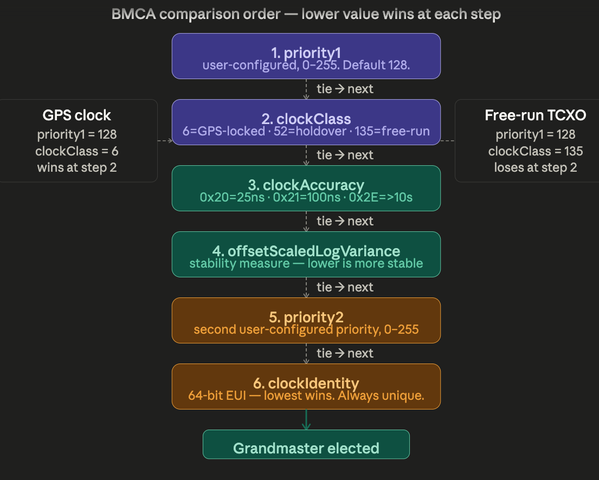

Comparison order — lower value wins at each step
Two candidate clocks are compared in strict priority order. The first attribute that differs determines the winner. If all attributes are equal, the comparison continues to the next level.

Step | Attribute | Range / typical values | Notes
1 | priority1 | 0–255, default 128 | User-configured. The single most powerful override — set priority1=1 to force a clock to always win regardless of quality.
2 | clockClass | 6 = GPS-locked; 52 = holdover; 135 = free-running oscillator | The most important attribute in practice. A GPS-disciplined clock (class 6) always beats a free-running oscillator (class 135) regardless of priority2.
3 | clockAccuracy | 0x20 = 25 ns; 0x21 = 100 ns; 0x2E = > 10 s | Encoded enumeration. Reports the clock's accuracy relative to UTC.
4 | offsetScaledLogVariance | Lower = more stable | A measure of the clock's frequency stability (Allan deviation). More stable clocks win.
5 | priority2 | 0–255, default 128 | Second user-configured priority. Used to break ties between clocks of the same quality class.
6 | clockIdentity | 64-bit EUI (Extended Unique Identifier) | Derived from the device MAC address. Always unique — guarantees a deterministic result even if all other attributes are identical.

Practical rule: any clock with clockClass 6 (GPS-locked) will automatically become grandmaster on any network it joins, provided its priority1 is not set higher than 127. No manual configuration is needed — the BMCA handles it.

What happens when the grandmaster fails
If the grandmaster stops sending Announce messages, all devices start an Announce receipt timeout timer (typically 3 × announce interval). When the timer expires, every device runs the BMCA again using the remaining Announce messages. The next-best clock becomes the new grandmaster within seconds. No manual failover is required.

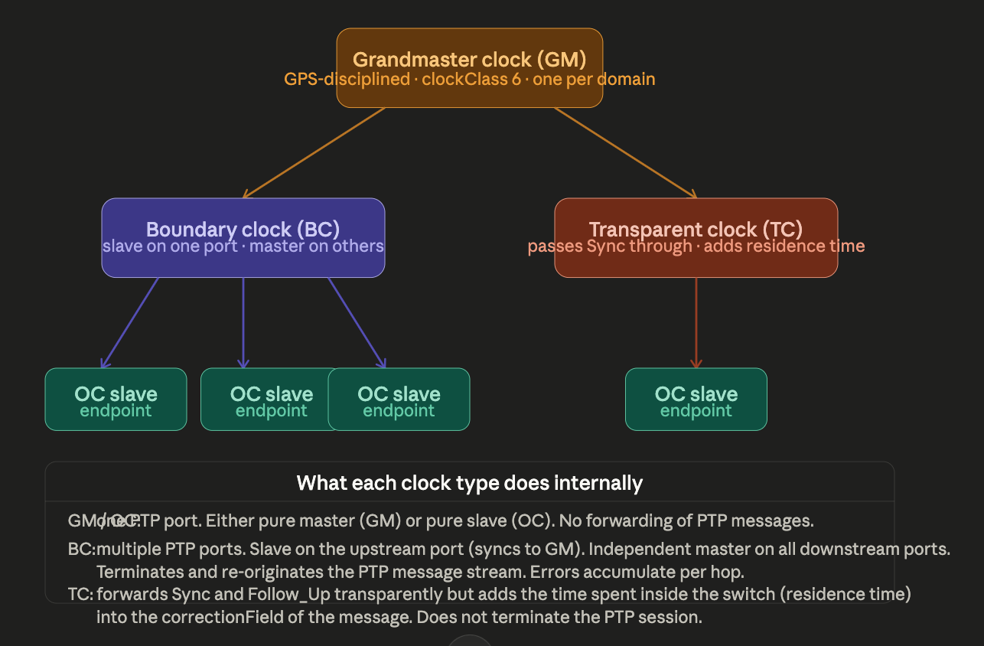
6. PTP Clock Types — Grandmaster, Ordinary, Boundary, and Transparent
PTP defines four clock types, each with a distinct role in distributing time through a network. Understanding them is essential for designing a PTP deployment correctly.
Clock type | Acronym | Ports | Role
Grandmaster clock | GM | One (master only) | The network's single authoritative time source. Typically disciplined by a GPS/GNSS receiver, which gives it clockClass 6 and traceable accuracy to UTC. Sends Sync messages to all slaves. There is exactly one active grandmaster per PTP domain.
Ordinary clock | OC | One (master or slave) | The simplest clock type — one PTP port, either pure master or pure slave. Does not forward or relay PTP messages. Every endpoint ECU in a vehicle (camera, radar, brake controller) is an OC operating in slave mode. Receives Sync messages and runs the servo to align its local clock.
Boundary clock | BC | Multiple | Slave on its upstream port (synchronises to the grandmaster), independent master on all downstream ports. Terminates and re-originates the PTP session at each hop. Downstream slaves see the boundary clock as their master, not the grandmaster. Errors accumulate per hop but the topology scales to large networks.
Transparent clock | TC | Multiple (switch) | Passes Sync messages through without terminating the PTP session. Measures its own frame residence time (how long the frame spent inside the switch) and adds it to the correctionField of the Sync message. The downstream slave can then subtract the accumulated correctionField and effectively see the grandmaster directly. More accurate than a boundary clock — errors do not accumulate.

The correctionField — how transparent clocks account for themselves
When a Sync message enters a transparent clock switch, the hardware records its ingress timestamp. When the Sync leaves on the egress port, the hardware records the egress timestamp. The difference — the residence time — is added to the correctionField in the frame before it is forwarded. The downstream slave subtracts correctionField from its receive timestamp and recovers the grandmaster's original send time, as if the switch had zero latency.

Example: Sync enters switch at 1000.000 µs, exits at 1000.800 µs. Residence time = 800 ns. Switch adds 800 ns to correctionField. Slave receives frame, subtracts 800 ns from its calculation. From the slave's perspective, the switch is transparent.

7. gPTP (IEEE 802.1AS) — The TSN Profile of PTP
gPTP (Generalised Precision Time Protocol) is not a separate protocol — it is a precisely constrained profile of IEEE 1588, specifically designed for bridged IEEE 802 LAN environments including automotive networks, industrial automation, and professional audio/video. It makes mandatory several choices that IEEE 1588 leaves optional, and adds the concept of per-port link delay measurement.

Key differences: gPTP versus IEEE 1588
Aspect | IEEE 1588-2019 | IEEE 802.1AS-2025 (gPTP)
Network scope | Any IP or Ethernet network, including WAN | Bridged IEEE 802 LANs only — single network segment
Transport | UDP/IPv4, UDP/IPv6, or Ethernet Layer 2 | Ethernet Layer 2 only (EtherType 0x88F7) — no IP overhead
Delay mechanism | Either end-to-end (E2E) or peer-to-peer (P2P) — operator chooses | Peer-to-peer (P2P) only — mandatory. Each port measures its direct neighbour independently.
Hardware timestamps | Recommended but not mandatory | Mandatory at every port. Non-negotiable for compliance.
One-step vs two-step | Both permitted | Both permitted; one-step strongly preferred to reduce message count
Clock model | GM + BC + TC + OC | Every bridge port is a time-aware system. All bridges act as TC with per-port link delay correction.
Accuracy target | Sub-microsecond to tens of nanoseconds (hardware dependent) | ± 1 µs required across the full vehicle network (up to 8 hops)
Typical domain | Up to 128 independent clock domains | Domain 0 only in automotive — all nodes share one domain

Why peer-to-peer delay is mandatory in gPTP
In the end-to-end delay mechanism (used by IEEE 1588), the slave sends a Delay_Req all the way to the grandmaster and waits for a response. In a large network with many hops, this creates significant traffic and the path delay measurement reflects the entire network path, not individual links.

In the peer-to-peer mechanism, every port measures the delay to its direct neighbour independently and continuously. This has three advantages for TSN networks: it is faster to converge (only one link hop per measurement), it is more accurate (no accumulated error from intermediate switches), and it gives each switch precise knowledge of its own link delays — essential for computing correctionField values accurately when forwarding Sync messages.

8. gPTP Peer Delay Measurement — The Per-Link Engine
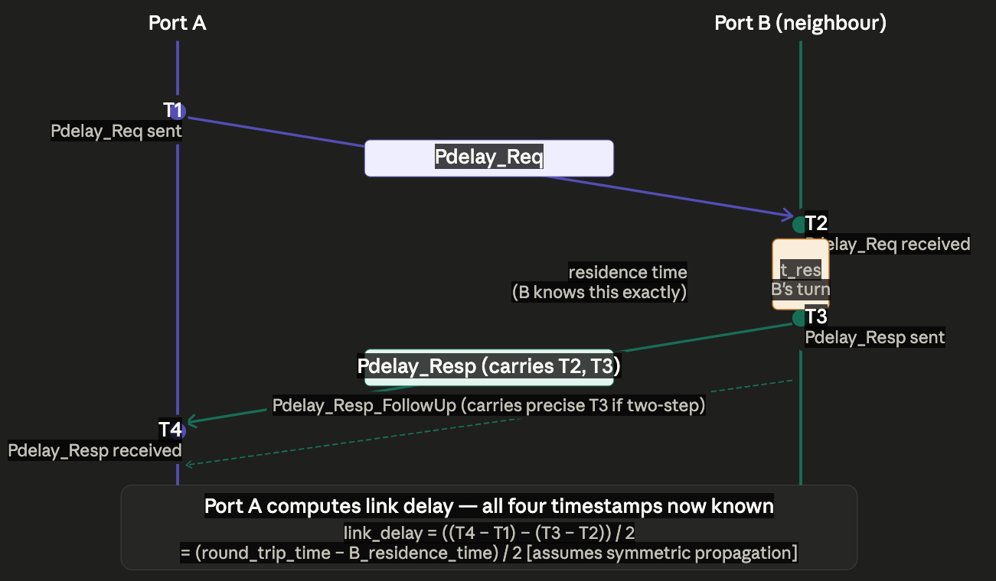
The peer delay mechanism is the continuous, per-port measurement engine that underlies all of gPTP's accuracy. Every gPTP port measures the propagation delay to its direct neighbour using a four-timestamp exchange analogous to the main Sync/Delay_Req cycle, but running independently on each link.

Timestamp | Who captures | What it records
T1 | Port A hardware | Port A sends Pdelay_Req — SFD crosses Port A's MDI outbound
T2 | Port B hardware | Port B receives Pdelay_Req — SFD crosses Port B's MDI inbound
T3 | Port B hardware | Port B sends Pdelay_Resp — SFD crosses Port B's MDI outbound
T4 | Port A hardware | Port A receives Pdelay_Resp — SFD crosses Port A's MDI inbound

The link delay formula
link_delay = ((T4 - T1) - (T3 - T2)) / 2
This is: (total round-trip time minus Port B's residence time) divided by 2. Port B's residence time (T3 - T2) is known exactly because Port B measured both T2 and T3 with its own hardware. The division by 2 assumes symmetric propagation — that the signal takes the same time in each direction. This assumption is valid for point-to-point links but can introduce small errors on links with asymmetric media (e.g. fibre with different transmit and receive wavelengths).

Worked example
Suppose: T1 = 0 ns, T2 = 520 ns (520 ns forward propagation), T3 = 620 ns (Port B spent 100 ns processing), T4 = 1140 ns (620 ns + 520 ns back).
link_delay = ((1140 - 0) - (620 - 520)) / 2 = (1140 - 100) / 2 = 520 ns
Port A now knows the one-way delay to its neighbour is 520 ns. It stores this value and uses it when forwarding Sync messages — adding 520 ns to the correctionField so the downstream slave can correct for it. This measurement runs at a configurable interval (typically every 1 second) on every port in the network, simultaneously and independently.

9. correctionField Propagation Through a Multi-Hop Network
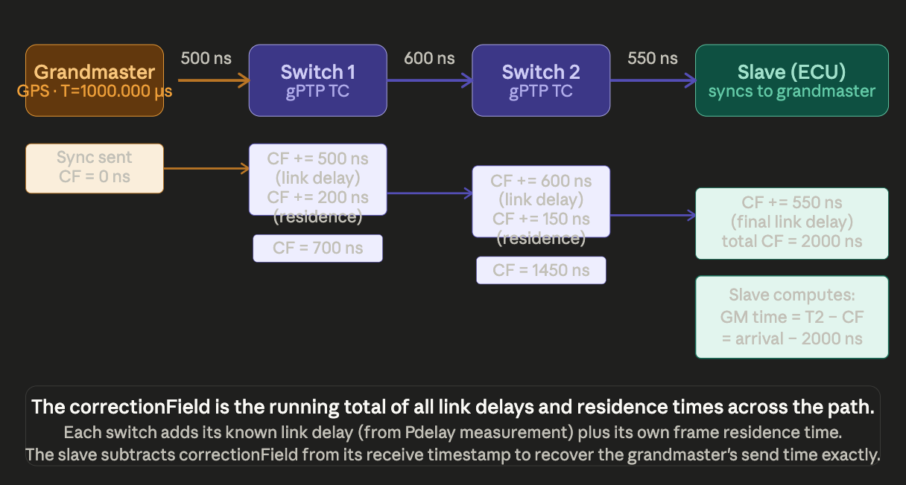
The correctionField is a 64-bit field in every PTP Sync and Follow_Up message that accumulates the total of all link delays and switch residence times along the path from grandmaster to slave. By the time the Sync reaches the final slave, its correctionField contains the complete accounting of all latency introduced between the grandmaster and the slave.

Step-by-step example: three hops
Network element | Action on correctionField | correctionField value after action
Grandmaster | Sends Sync with correctionField = 0 | 0 ns
Link GM → Switch 1 | Switch 1 adds link_delay = 500 ns (measured by Pdelay) | 500 ns
Switch 1 (residence) | Switch 1 adds its own frame residence time = 200 ns | 700 ns
Link SW1 → Switch 2 | Switch 2 adds link_delay = 600 ns | 1300 ns
Switch 2 (residence) | Switch 2 adds its own frame residence time = 150 ns | 1450 ns
Link SW2 → Slave | Slave does not modify correctionField; it just subtracts it | 1450 ns (final)
Slave | Computes: GM send time = T2 (receive time) - correctionField = T2 - 1450 ns | Used, not stored

The slave's clock offset is then: offset = (GM send time) - (local time at T2). The slave drives this offset to zero using its servo. From the slave's perspective, it is directly connected to the grandmaster — all intermediate switch latency has been accounted for.

10. The Servo — How a Slave Adjusts Its Clock
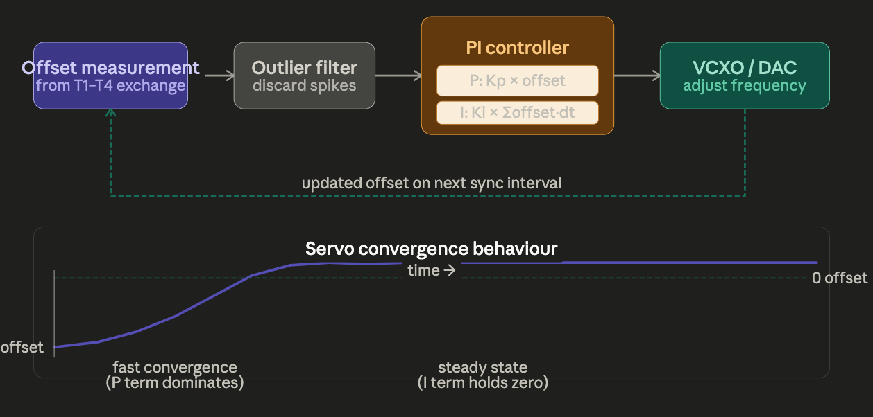
Knowing the offset is not sufficient. The slave must steer its clock to eliminate the offset without causing a discontinuous jump in time. A sudden time jump would corrupt any application using the clock — scheduled transmissions, sensor fusion timestamps, and TSN gate schedules would all become invalid.

The PI controller
PTP clock servos almost universally use a PI (Proportional-Integral) controller. The servo receives a new offset measurement after each Sync/Delay_Req exchange and computes a frequency adjustment for the local oscillator.

Controller term | Formula | Effect
Proportional (P) | output_P = Kp × current_offset | Responds immediately to the current offset. Large offset → large frequency correction. Provides fast initial convergence but leaves a residual steady-state error if used alone.
Integral (I) | output_I = Ki × sum(offset × dt) | Integrates the history of offset measurements. Eliminates steady-state error caused by fixed asymmetries (e.g. a cable that is physically longer in one direction). Converges slowly but completely.
Combined output | freq_adjust = output_P + output_I | Applied to the VCXO (Voltage-Controlled Crystal Oscillator) via a DAC (Digital-to-Analogue Converter). The oscillator frequency is nudged up or down — the clock is steered, never jumped.

Convergence behaviour
On startup, the offset may be hundreds of microseconds or more. The proportional term drives rapid convergence — within a few sync intervals the offset typically drops to single-digit microseconds. The integral term then takes over to eliminate the remaining bias, reaching steady state in tens to hundreds of seconds depending on the sync interval and PI gains.

In steady state on a well-configured automotive network with hardware timestamping, the residual offset between any two nodes is typically 50–300 nanoseconds. The IEEE 802.1AS-2025 requirement of ± 1 µs across the full vehicle network (up to 8 hops) is comfortably achievable.

The servo never jumps the clock forward or backward. It only adjusts oscillator frequency (adjFreq, defined in IEEE 1588). If the initial offset is so large that frequency steering alone would take too long, many implementations do a single one-time step adjustment on startup before switching to frequency-only steering.

11. gPTP in Automotive Networks — The Complete Deployment Picture
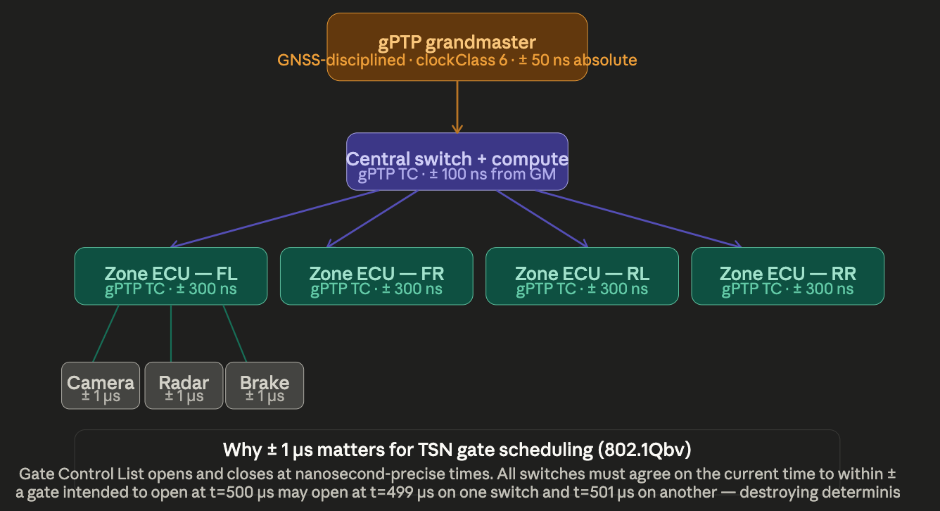
In a modern zonal vehicle architecture, gPTP provides the common timebase that makes TSN determinism possible. All switches, zone ECUs (Electronic Control Units), and sensor nodes must agree on the current time to within ± 1 µs for the 802.1Qbv Time-Aware Shaper (TAS) gate schedules to function correctly.

Why ± 1 µs matters for TSN gate scheduling
The 802.1Qbv Gate Control List (GCL) opens and closes egress queue gates at precisely scheduled times. Consider a safety-critical stream (PCP = 7, brake-by-wire command) with a gate window that opens at t = 500 µs in every 1 ms cycle. If two switches in the path disagree on the current time by 2 µs, one switch may open its gate at t = 498 µs and the other at t = 502 µs. The frame arrives at the first switch's open gate but the second switch's gate has already closed — the frame is delayed by a full cycle (1 ms). For brake-by-wire, this is a functional safety violation under ISO 26262.

Typical accuracy budget — four-hop vehicle network
Network level | Accuracy relative to GPS grandmaster | Clock type
GPS grandmaster (GNSS receiver) | ± 50 ns (traceable to UTC) | Grandmaster (OC master)
Central compute switch — hop 1 | ± 100 ns | gPTP Transparent Clock
Zone ECU switch — hop 2 | ± 300 ns | gPTP Transparent Clock
ECU sensor/actuator — hop 3 | ± 600 ns | OC slave
Worst case across 8 hops | < ± 1 µs | IEEE 802.1AS requirement

Acronym reference — all terms used in this document
Acronym | Full name | Brief definition
PTP | Precision Time Protocol | IEEE 1588 — sub-microsecond clock synchronisation for packet networks
gPTP | Generalised Precision Time Protocol | IEEE 802.1AS — PTP profile for bridged LANs and TSN
GM | Grandmaster clock | Single authoritative time source per PTP domain; typically GPS-disciplined
OC | Ordinary Clock | Single-port PTP device; either pure master or pure slave endpoint
BC | Boundary Clock | Multi-port device: slave upstream, master downstream; terminates PTP per hop
TC | Transparent Clock | Switch that passes Sync through and adds residence time to correctionField
BMCA | Best Master Clock Algorithm | Distributed election protocol for grandmaster selection
SFD | Start Frame Delimiter | Byte 0xAB marking start of Ethernet frame; hardware timestamp is captured at SFD
MDI | Media Dependent Interface | The physical wire boundary of a network port; where hardware timestamps are taken
VCXO | Voltage-Controlled Crystal Oscillator | Oscillator whose frequency the servo adjusts via DAC voltage
DAC | Digital-to-Analogue Converter | Converts servo PI controller output to analogue voltage driving the VCXO
CDR | Clock and Data Recovery | PHY PLL that extracts a clock from incoming data transitions
MDIO | Management Data Input/Output | Two-wire serial interface for reading/writing PHY and PTP registers
CF | correctionField | 64-bit PTP message field accumulating all link delays and residence times on the path
TAS | Time-Aware Shaper | IEEE 802.1Qbv gate scheduling mechanism; requires gPTP for timing
GCL | Gate Control List | The schedule table that controls when each TSN queue gate opens and closes
NTP | Network Time Protocol | RFC 5905 — millisecond-accuracy time sync; insufficient for TSN applications
PI | Proportional-Integral (controller) | Servo algorithm: P term gives fast response, I term eliminates steady-state error
TSN | Time-Sensitive Networking | IEEE 802.1 suite of standards for deterministic Ethernet, built on gPTP
GNSS | Global Navigation Satellite System | GPS, Galileo, GLONASS etc. — source of traceable UTC time for PTP grandmasters
ECU | Electronic Control Unit | Automotive embedded computer; typically an OC slave in a gPTP network
UTC | Coordinated Universal Time | The international civil time standard; PTP grandmasters are traceable to UTC

End of document

