1. Start with the actual reliability problem
A normal Ethernet path is usually a single active path from sender to receiver. If a link or bridge on that path fails at the wrong moment, frames are lost until some other recovery mechanism reacts. IEEE 802.1CB Frame Replication and Elimination for Reliability (FRER) attacks that problem in a very direct way: instead of waiting for failure detection and switchover, it sends duplicates of the same frame over multiple paths and removes the extras at the far end. The IEEE 802.1CB base standard says it specifies procedures, managed objects, and protocols for bridges and end systems that provide identification and replication of packets for redundant transmission, identification of duplicate packets, and elimination of duplicate packets, and it also states that it is not concerned with the creation of the multiple paths over which the duplicates are transmitted.
That last sentence is one of the most important foundations in the whole topic. FRER is a redundancy handling mechanism, not a routing protocol. It assumes there are multiple usable paths and then defines how to identify a stream, replicate frames, number them, recognize duplicates, and recover the original stream. Path construction belongs to something else, typically IEEE 802.1Qca Path Control and Reservation, which the IEEE standards page says provides explicit path control, bandwidth reservation, and redundancy for data flows.
So the cleanest first-principles summary is:
FRER does not decide where the copies go. It decides how to make multiple copies behave like one reliable stream.

2. What FRER is really trying to achieve
The usual intuition is “send duplicates so at least one arrives.” That is true, but incomplete. FRER is not only about increasing delivery probability. It is also about making recovery effectively seamless from the receiver’s point of view. An IEEE 802.1 overview slide describes 802.1CB as sending frames on multiple maximally disjoint paths, then combining and deleting extras, and emphasizes per-frame 1+n redundancy with no failure detection or switchover.
That means FRER is fundamentally different from classic redundancy approaches that wait for a failure, declare a switchover, and then start using a backup path. FRER uses all protected paths immediately, so the first valid arriving copy can be accepted without waiting for control-plane reaction. That is why FRER is attractive where recovery time must be essentially zero.

3. The FRER processing chain
The FRER base standard and associated IEEE material imply a processing chain with four logical steps:
- identify which incoming packets belong to a stream
- generate or encode a sequence number for that stream
- replicate the numbered packet onto multiple member paths
- at merge points or the final receiver, eliminate duplicates and recover one clean stream.
The IEEE 802.1CB standard text visible in the public PDF says the expanded input port identifies packets belonging to a stream, serializes the packets with a Sequence Generation function, encodes the sequence number with an R-TAG, and then gives the packets belonging to this stream a {vlan_identifier, destination_mac_address} pair that is unique at least inside the bridge.
That is a very useful standards-grounded description because it shows that FRER is not a single monolithic block. It is a classification + sequencing + replication + recovery chain.

4. Disjoint path selection from first principles
Now to the part many people explain too casually.
FRER works best when replicas travel over disjoint or at least largely independent paths. If two copies traverse the same failing link, they will fail together and the redundancy is much weaker. IEEE overview material uses the phrase maximally disjoint paths, and the IEEE 802.1Qca standards page says Path Control and Reservation provides explicit path control and redundancy for data flows.
So the correct engineering statement is:
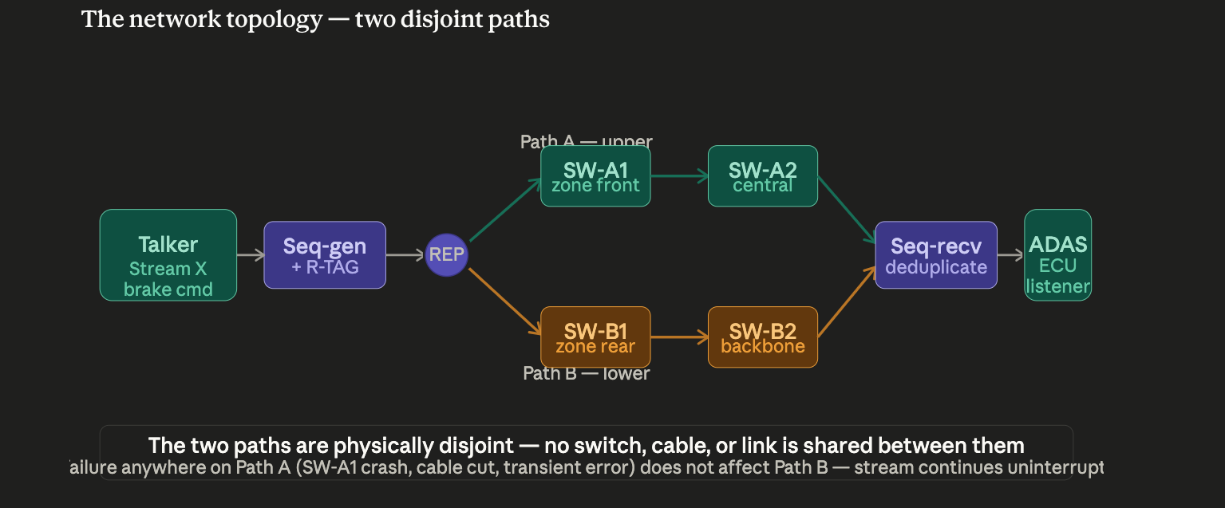
FRER benefits from disjoint path selection, but FRER itself does not define the path-selection mechanism.
That path engineering is usually provided by:
- the network topology design itself
- explicit path control such as IEEE 802.1Qca
- centralized or hybrid configuration in the surrounding Time-Sensitive Networking system.
This distinction matters because it is often mistakenly asumed that “802.1CB creates disjoint paths.” It does not. It uses them. The standard explicitly says path creation is out of scope for 802.1CB.

5. What “replication” actually means
Replication is not merely copying packets in software in some vague way. In FRER terms, one original stream is split into multiple member streams that carry equivalent frame content plus the information needed for recovery. Public FRER descriptions and implementation papers summarize this by saying a frame stream is replicated into one or more linked member streams, and that the copies carry the same sequence number.
The important conceptual point is that the duplicates must remain identifiable as copies of the same original frame. That is why FRER needs stream identification and sequence numbering. If the receiving side cannot tell that two arriving frames are replicas of the same original frame, it cannot safely eliminate duplicates.
So replication is not “blind duplication.” It is structured duplication with stream context and sequence context.

6. What “elimination” actually means
Elimination is the reverse side of replication. The receiver-side FRER logic, or an intermediate merge point, sees multiple copies of what should be the same stream and decides which copies are valid new arrivals and which are duplicates that must be discarded. The IEEE 802.1CB base standard describes identification of duplicate packets and elimination of duplicate packets as core functions.
This is deeper than simple duplicate suppression by byte comparison. The receiver uses stream identity and sequence history to decide whether an arriving frame is the first valid copy of a new frame or a later duplicate of something already accepted. That is why the standard has a sequence recovery function, and why later maintenance and amendment work spends so much effort on sequence recovery algorithms and parameters. The active-ballots page even shows a current 802.1CB revision and a related project on sequence recovery function refinements and parameter configuration, which underlines how central this function is.
So elimination is not “drop whichever copy comes second” in a trivial sense. It is a sequence-aware recovery algorithm.

7. Sequence numbers: why they are unavoidable
FRER without sequence numbers would be nearly useless, because the receiver would have no robust way to distinguish:
- a new frame arriving slightly out of order
- a duplicate of a frame already accepted
- a replay after a path delay anomaly.
The 802.1CB text visible in the public PDF says the stream is serialized with a Sequence generation function and that the sequence number is encoded with an R-TAG. The FRER R-TAG improvement slides further say that the R-TAG is used by the sequence encode/decode function and that its purpose is to add information to frames required by FRER functions, specifically the low-order 16 bits from the sequence_number subparameter.
So the sequence number is the receiver’s main clue that two copies correspond to the same original source frame. Without that numbering, the receiving side would need much weaker heuristics and could not do robust elimination.

8. R-TAG from first principles
The R-TAG, or Redundancy Tag, is the mechanism IEEE 802.1CB uses to carry FRER-specific information in the frame. The FRER R-TAG slides say:
- 802.1CB-2017 defines the Redundancy Tag
- it is used by the sequence encode/decode function
- its EtherType is F1-C1
- an Ethernet frame may contain multiple R-TAGs
- its purpose is to add the information required by FRER functions, including the low-order 16 bits of the sequence number.
That gives the right intuition: the R-TAG is not a random extra header. It is the FRER bookkeeping header that lets downstream functions know how to recover the stream correctly. In most introductory explanations, the essential takeaway is simply that the R-TAG carries the FRER sequence information needed for encoding, decoding, and recovery.

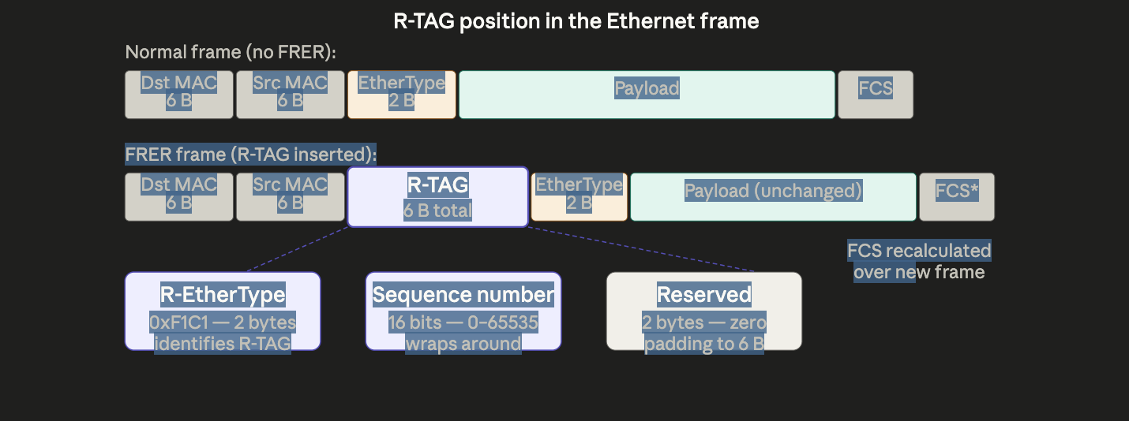

9. Why FRER needs stream identification before sequence numbering
A sequence number has meaning only within a stream. If you do not know which stream a packet belongs to, the sequence field by itself is not enough.
IEEE stream-identification material says 802.1CB specifies how an end station or relay system can use the stream_handle for FRER and for quality-of-service functions in IEEE 802.1Q. It also lists the kinds of fields that may be used for stream identification: input port number, source and destination Media Access Control (MAC) addresses, Virtual Local Area Network (VLAN) identifier, Layer 2 priority, Internet Protocol (IP) source and destination addresses, next protocol, transport-layer ports, and Differentiated Services Code Point (DSCP).
So the sequence number is meaningful only after the packet has been classified into a stream. That is why stream identification is logically first, and why IEEE 802.1CBdb later became important.

10. IEEE 802.1CBdb: what it actually adds
IEEE 802.1CBdb-2021 is titled Extended Stream Identification Functions. The IEEE 802.1 Time-Sensitive Networking page says exactly that, and the project page says this amendment specifies procedures and managed objects that add new stream identification functions, while also addressing errors and clarifications.
So the best way to explain 802.1CBdb is:
the base FRER standard already needed stream identification, but real deployments wanted more ways to identify streams cleanly and consistently, so 802.1CBdb extends that identification toolbox.
This matters because FRER’s usefulness depends heavily on correct stream classification. If the device cannot robustly identify which packets belong to which FRER-protected stream, then all the downstream sequence generation, replication, and elimination logic becomes fragile.

11. IEEE 802.1CBcv: one important correction first
IEEE 802.1CBcv-2021 is not a runtime “conformance verification protocol” on the wire.
It is the amendment titled Information Model, YANG Data Model, and Management Information Base Module. The IEEE sitemap and the publicly accessible amendment abstract both say that 802.1CBcv specifies YANG data models and Management Information Base (MIB) modules that allow configuration and status reporting for bridges and end systems with FRER and stream-identification capabilities.
So if “802.1CBcv conformance verification” means “the management and conformance machinery that lets vendors expose and verify what FRER capabilities are implemented,” that is a fair practical interpretation. But the amendment itself is about:
- the information model
- YANG management
- MIB support
- conformance clauses and Protocol Implementation Conformance Statements (PICS)-style declaration support, as seen in public draft status material.
That means 802.1CBcv is best taught as the management and conformance-support amendment for FRER, not as a packet-level verification function.

12. Why 802.1CBcv matters even though it is “only management”
In deterministic networking, management is not secondary. We need to know:
- which stream-identification types are supported
- which sequence-recovery algorithms are implemented
- how recovery parameters are configured
- what status and counters the device exposes
- whether two vendors’ devices can be configured and monitored consistently
The 802.1CBcv draft update says the draft included complete MIB and YANG modules plus a conformance clause and a PICS clause, and the final amendment abstract says it enables configuration and status reporting for FRER and stream identification.
So 802.1CBcv matters because FRER is not useful at scale unless you can configure it, observe it, and declare support for it consistently.

13. A clean end-to-end FRER example
An example:
A talker sends a critical stream.
A stream-identification function classifies each packet as belonging to Stream X.
A sequence-generation function assigns a sequence number.
An R-TAG is inserted carrying FRER sequence information.
The packet is replicated onto two or more disjoint member paths.
At the far end, sequence-recovery logic sees copies arriving, accepts the first valid copy of each new sequence value, and discards later duplicates.
This is precisely the kind of ladder-style behavior shown in public NXP automotive Ethernet FRER material, and it matches the 802.1CB standard’s description of identification, sequence generation, R-TAG encoding, replication, and recovery.

Automotive perspective and context

14. Why FRER is especially attractive in vehicles
Vehicles increasingly use switched Ethernet for traffic that can be safety-relevant, perception-relevant, or otherwise intolerant of recovery gaps. The IEEE 802.1DG automotive profile is now published and defines a Time-Sensitive Networking Profile for Automotive In-Vehicle Ethernet Communications. Earlier automotive use-case material also explicitly says redundancy is a major approach to achieving high reliability in in-vehicle networks and that multiple levels of redundancy and switchover times, including seamless instantaneous behavior, are required.
That is exactly the niche FRER serves well. Unlike “detect failure, then reroute,” FRER can provide instantaneous seamless protection because the copies are already in flight. That is why FRER is one of the most obviously automotive-relevant pieces of the Time-Sensitive Networking toolbox.

15. Disjoint paths in automotive networks
In a vehicle, disjoint paths are not just a mathematical nicety. They are part of the safety and fault-containment story.
If two FRER copies share the same switch, power domain, or cable segment for too much of their journey, then a single fault can still kill both copies. That is why automotive profile material explicitly includes 802.1Qca Path Control and Reservation in the toolbox and even calls out FRER and Qca together in profile outlines. The 802.1Qca standard page says it provides explicit path control, bandwidth reservation, and redundancy for flows.
So the automotive engineering lesson is:
FRER without careful path engineering can give a false sense of security.
In a vehicle, path diversity should ideally be evaluated not only in graph-theory terms, but also in terms of shared switch silicon, shared power, shared zone controller dependency, and shared harness segments. That latter point is an engineering inference, but it is exactly the spirit of the automotive profile’s interest in redundancy and common-cause fault analysis.

16. Replication and elimination in zonal architectures
Zonal architectures make FRER especially interesting. A zonal controller or central switch can replicate a critical stream into multiple backbone paths, and the receiving side can merge them back into one clean stream. Public NXP material explicitly shows this kind of talker–bridge–bridge–listener ladder with replication points and elimination points.
That means FRER is not only for end-to-end duplication between two smart endpoints. It can also be used inside the switched infrastructure itself, provided the switches support the relevant stream identification, sequencing, and recovery functions.

17. Stream identification is even more important in vehicles
Automotive traffic is often mixed: control, sensor, diagnostics, infotainment, service, logging. If FRER is to be used selectively for only certain high-value streams, stream identification must be very precise. That is why 802.1CBdb’s extended stream identification functions are especially relevant in automotive networks. You may need to classify streams not only by VLAN and MAC address, but also by ingress port, IP header information, or other layered attributes, depending on the architecture. The project page says 802.1CBdb adds new stream identification functions and clarifications.
So in an automotive context, 802.1CBdb should be explained as “the amendment that makes real-world stream identification more practical,” especially when the vehicle network is no longer a simple one-service-per-VLAN design.

18. Why 802.1CBcv matters in automotive programs
Automotive programs are rarely single-vendor forever. They involve integration, validation, production tooling, service diagnostics, and long lifecycle maintenance. So 802.1CBcv’s management role becomes very important. The amendment abstract says it provides YANG and MIB support for configuration and status reporting of FRER and stream identification, and the draft-history material shows explicit conformance and PICS support.
In practical automotive terms, that matters because an engineer needs to answer questions like:
- which FRER capabilities does this switch implement?
- which stream-identification types are supported?
- what are the sequence-recovery parameters?
- what counters or history does the device expose?
- how do we prove in validation that the configured FRER behavior matches the intended profile?
That is why one would frame 802.1CBcv in automotive not as “boring management,” but as the amendment that makes FRER deployable and auditable at fleet scale.

19. Summary
In pure data communications, IEEE 802.1CB FRER provides identification, replication, duplicate detection, and elimination for redundant frame transmission, but it does not create the redundant paths itself. Disjoint-path selection typically comes from topology design or from tools such as IEEE 802.1Qca. Replication works by classifying a stream, assigning sequence numbers, and carrying the FRER information in the R-TAG; elimination works by sequence-aware duplicate removal at merge points or receivers. IEEE 802.1CBdb extends stream-identification functions. IEEE 802.1CBcv adds the information model, YANG, MIB, and conformance-management support for FRER and stream identification.
In automotive networks, FRER is attractive because it gives seamless, no-switchover redundancy for critical streams, which aligns strongly with in-vehicle reliability and safety goals. But its real value depends on careful disjoint-path engineering, precise stream identification, and manageable, verifiable implementations — which is exactly why Qca, CBdb, and CBcv matter around the base FRER mechanism.

