Motor Fault Detection Using Vibration Analysis and Machine Learning
A B Sreeman, Dhinesh kumar H, Vikram M
Department of Electronics and Communication Engineering
Prathyusha Engineering College, Tiruvallur, India
sreemanarumugam@gmail.com
Dr.N.Sujitha*, Assistant Professor
Department of Electronics and Communication Engineering
Prathyusha Engineering College
sujielanthirai@gmail.com
Abstract— Unexpected failures in rotating machinery can lead to increased maintenance costs, production downtime, and reduced operational efficiency in industrial environments. To address this problem, a motor fault detection system based on vibration analysis and machine learning techniques is proposed. The developed system continuously monitors vibration signals generated by a motor to detect abnormal operating conditions at an early stage.In the proposed system, vibration signals are captured using an ADXL345 accelerometer sensor connected to an ESP32 microcontroller. The accelerometer converts mechanical vibrations into electrical signals, which are collected through the microcontroller using an I²C communication interface. The obtained vibration data is analyzed using statistical feature extraction techniques to determine important vibration parameters such as Root Mean Square (RMS), peak value, mean, and standard deviation.These extracted features are used as input parameters for machine learning algorithms including Random Forest and Support Vector Machine (SVM) to classify motor operating conditions. The system can identify different motor states such as normal operation, inner race fault, and outer race fault. A graphical user interface (UI) is developed to visualize vibration parameters and display the diagnostic results in real time.The proposed system provides an intelligent and automated solution for monitoring motor health. It enables early fault detection, reduces unexpected machine failures, and supports predictive maintenance in industrial environments.  Keywords— Motor Fault Detection, Machine Learning, Vibration Analysis, Predictive Maintenance  I. INTRODUCTION  Industrial motors are very important in factories and automated systems. Many machines depend on motors to run continuously and efficiently. When a motor develops a fault, it can cause sudden breakdown, production delay, and increased maintenance cost. These problems become more serious in industries where machines operate for long hours without interruption. Traditional motor monitoring methods do not always work well. These systems often depend on manual inspection or simple vibration level checking. This  motor performance, which limited their usefulness in modern automated industrial environments.  As signal processing techniques and computational capabilities improved, vibration-based condition monitoring systems were introduced to overcome the limitations of conventional monitoring. These systems analyze vibration signals to estimate motor health condition and detect abnormal behavior during operation. Recent approaches use machine learning and pattern recognition algorithms to classify different motor fault conditions such as bearing defects, rotor imbalance and shaft misalignment. Compared to traditional monitoring, data-driven systems can learn complex relationships in vibration data and provide more reliable fault detection without requiring constant manual intervention.  Further improvements were made by using intelligent predictive maintenance strategies. Machine learning models can analyze historical vibration data and predict possible failure conditions before they become critical. Some researchers have also developed real-time monitoring frameworks where sensor data is continuously processed to improve maintenance planning and system reliability. These systems aim to reduce unexpected downtime and improve industrial productivity by enabling timely fault detection and decision making.  However most existing solutions focus either on signal analysis accuracy or machine learning model performance separately rather than integrating a complete end-to-end fault monitoring framework. This separation limits their practical deployment in industrial applications where both reliable signal feature extraction and robust classification are required together. Therefore there is a need for an intelligent motor fault detection system that combines vibration signal feature analysis with machine learning based classification to provide efficient and scalable predictive maintenance support  III. PROPOSED SYSTEM  A. System Overview  The proposed motor fault detection system is designed to monitor the health condition of industrial motors during operation. It analyzes vibration signals generated by the motor to understand its performance and detect possible faults at an early stage. The system uses computational techniques to process vibration data and identify abnormal behavior in real time. It continuously observes the motor operating condition by collecting vibration signal patterns that indicate different mechanical states such as healthy operation or developing faults.  The system then uses machine learning models to classify the motor condition based on extracted signal features. By analyzing these features, it determines whether the motor is operating normally or experiencing issues such as bearing wear, shaft misalignment or rotor patterns, it analyzes them using trained classification models to determine the type and severity of the fault. This process helps distinguish between normal motor behavior and developing mechanical issues such as bearing wear or rotor imbalance.  The classification model processes the extracted vibration features and predicts the motor health condition within a short time. If the predicted condition indicates a possible fault, the system can alert maintenance personnel or schedule inspection activities. This ensures that corrective actions are taken before the motor performance degrades further. By enabling intelligent fault classification, the system supports smooth industrial operation and reduces the risk of sudden equipment failure in environments where motors operate continuously.  D. Machine Learning Based Fault Classification  The machine learning based fault classification system is designed to improve motor safety and reliability by identifying abnormal operating conditions. When the system detects unusual vibration feature  continuous workflow helps maintain reliable motor performance and enables timely fault detection in real industrial environments.  E. Fault Decision Priority Logic  The fault decision process follows a hierarchical set of steps to ensure reliable motor operation. Critical fault conditions such as severe bearing damage or excessive vibration levels are handled first because they can lead to immediate motor failure. After addressing critical faults, the system evaluates moderate fault indicators such as early-stage misalignment or imbalance that may require scheduled maintenance. Finally, normal operating conditions are monitored to maintain optimal performance and prevent unnecessary interventions.  This structured way of making decisions helps prioritize important reliability and safety concerns while allowing the motor to continue functioning smoothly under normal conditions. The fault decision priority logic ensures that serious issues are detected and acted upon quickly, while minor variations in vibration are observed and managed appropriately. By organizing fault responses based on severity, the system supports efficient maintenance planning and improves overall industrial system stability.  V.EXPERIMENTAL RESULTS  A. Experimental Setup  The proposed machine learning based motor fault detection system has been experimentally evaluated using a vibration signal monitoring framework developed for simulation-based analysis. The setup consists of a vibration signal generation module representing motor operating conditions, a feature extraction unit for processing signal characteristics, and a machine learning classification module for identifying fault conditions. The experiment evaluated three monitoring strategies: (1) Conventional threshold-based vibration monitoring, (2) Statistical feature-based monitoring without machine learning, and (3) Proposed machine learning based fault detection system.  Different motor operating scenarios were simulated including normal operation, early-stage fault conditions, and severe mechanical fault conditions such as imbalance or bearing degradation. For each scenario, performance measures such as fault detection accuracy, response time for fault identification, and classification reliability were analyzed. These evaluations helped assess how effectively the proposed system can detect abnormal motor behavior and support predictive maintenance decision making under varying operating conditions.  B. Fault Detection Performance Analysis  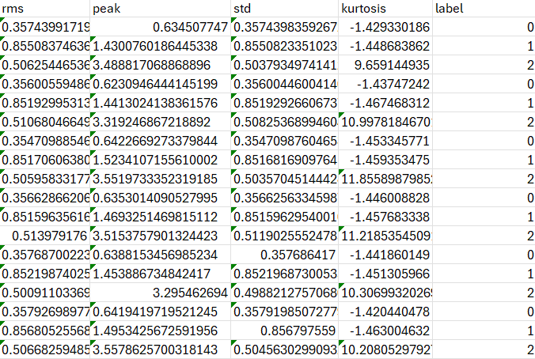  The key performance indicator in this study was the accuracy and reliability of motor fault detection under different operating conditions. The conventional threshold-based monitoring system, which relied on fixed vibration limits, showed reduced performance because it could not adapt to variations in motor operating behavior. This often resulted in delayed fault identification or false alarms when vibration levels fluctuated due to normal load changes. A feature-based monitoring approach without machine learning provided improved performance as it analyzed multiple signal characteristics, but it was still limited in distinguishing complex fault patterns.  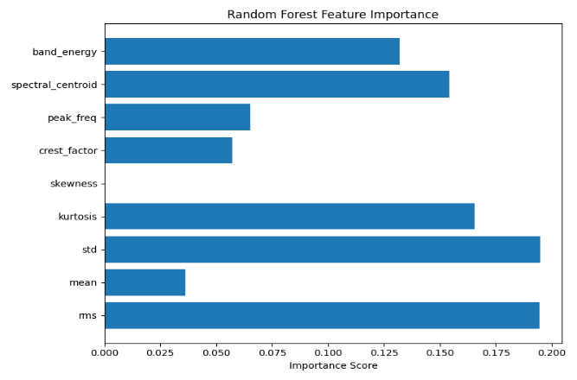  The proposed machine learning based system was able to utilize learned vibration patterns to identify motor faults more effectively. By analyzing combinations of extracted statistical features, the system achieved more stable and consistent classification results. The machine learning model demonstrated improved detection capability across different simulated fault scenarios and maintained reliable performance even when signal variations were present. As a result, the proposed approach consistently achieved higher fault detection accuracy and reduced misclassification compared to conventional monitoring methods.  as long as abnormal feature combinations were detected and returned the motor status to normal monitoring mode once stable signal behavior was observed. This adaptive decision capability allowed faults to be recognized more consistently and reduced unnecessary maintenance interventions. Consequently, the proposed approach improved the efficiency of fault identification and helped maintain stable motor operation across different simulated working conditions.  D. Operational Robustness  The conventional vibration monitoring system was sensitive to variations in operating conditions such as load changes, speed fluctuations, and external mechanical disturbances. Under these conditions, fixed threshold methods often produced inaccurate fault indications because they could not distinguish between normal operational variations and actual fault development. The feature-based monitoring approach improved performance by analyzing multiple signal characteristics, but it was still affected by noise and signal disturbances that could influence fault interpretation.  The proposed machine learning based system demonstrated improved robustness by learning fault patterns from diverse vibration signal conditions. By combining feature extraction with trained classification models, the system was able to reduce the impact of environmental noise and operational variability on fault detection decisions. This integrated analysis helped avoid incorrect fault predictions and allowed the monitoring framework to maintain consistent performance across different simulated motor operating scenarios. As a result, the proposed approach provided more reliable motor condition assessment and | means that small faults are not detected early, which can lead to major failures and equipment damage.  To make motor monitoring better, researchers have been working on intelligent condition monitoring systems. These systems use vibration signals to understand the health condition of motors. At first, monitoring systems only checked whether vibration levels crossed a certain limit. These approaches were simple to implement but they could not identify the exact type of fault or predict future failure. They also required frequent human supervision and were not suitable for modern automated industries.  Now machine learning techniques are being used to analyze vibration signals more effectively. These techniques can study patterns in vibration data and help detect faults at an early stage. They can also classify different fault conditions such as bearing wear, shaft misalignment, and rotor imbalance. By using data-driven models, motor health can be monitored continuously without depending only on fixed threshold values.  This paper presents a machine learning based motor fault detection system that uses vibration signal feature analysis. The system extracts important statistical features from vibration signals and uses classification models to identify motor health conditions. It helps detect faults early and supports predictive maintenance planning. This approach is useful because it improves system reliability, reduces unexpected downtime, and supports intelligent industrial automation.  II. LITERATURE SURVEY  Traditional motor fault detection systems mainly used manual inspection or simple vibration threshold monitoring methods. These approaches allowed basic fault identification by measuring vibration amplitude or temperature levels during motor operation. While they helped in detecting severe faults, they were not effective for early fault diagnosis because they required human supervision and periodic maintenance checks. Also imbalance. The goal of the proposed system is to reduce unexpected motor failures, improve maintenance planning and enhance system reliability. This approach enables intelligent condition monitoring without requiring complex manual inspection procedures or major changes to existing industrial setups.  B. Hardware Architecture  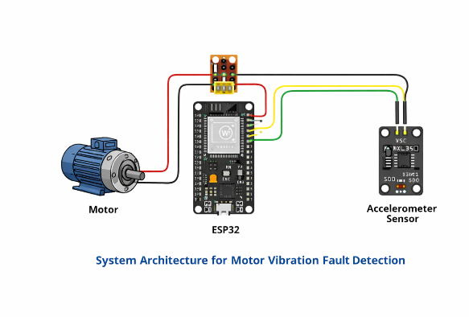  The proposed motor fault detection system consists of two main parts: a vibration sensing unit that captures motor condition data and a processing unit that analyzes the collected signals. The vibration sensing unit can be implemented using an accelerometer sensor mounted on the motor surface to measure vibration patterns during operation. These signals are continuously transmitted to a processing platform where signal analysis and fault classification are performed. The processing unit may be developed using a microcontroller or a computing device capable of handling feature extraction and machine learning tasks.  The sensing and processing units communicate through wired or wireless data transfer depending on the monitoring setup. Additional hardware components include signal conditioning circuits to improve sensor accuracy and a stable power supply to ensure reliable operation. By adopting a distributed architecture, the system separates data acquisition and computational processing tasks. This improves monitoring efficiency, enhances real-time fault detection capability, and allows easy integration with existing industrial motor systems without requiring major structural modifications.  C. Vibration Signal Acquisition and Feature Extraction  The vibration sensor continuously captures signals from the motor during operation. These signals represent the mechanical behavior of the motor and contain useful information about its health condition. The system uses signal processing techniques to analyze these vibration signals and identify important patterns. It measures different statistical characteristics such as signal amplitude, variation and peak values to understand the operating condition of the motor.  The extracted signal features are then used to determine whether the motor is running normally or showing signs of developing faults. By analyzing these feature values, the system can recognize abnormal vibration conditions that may indicate problems such as bearing defects or imbalance. Motors with higher vibration irregularities are given more attention for fault detection while stable vibration conditions indicate healthy operation. This process helps reduce unexpected failures and improves overall monitoring efficiency by enabling timely maintenance actions.  F. Operational Workflow  The proposed motor fault detection system operates in a continuous monitoring loop during motor operation. It begins by capturing vibration signals from the motor in real time using the sensing unit. These signals are then processed to extract important statistical features that represent the current mechanical condition of the motor. The system analyzes these feature values to understand whether the motor is functioning normally or showing signs of abnormal behavior.  After feature analysis, the machine learning model evaluates the motor condition and classifies the operating state based on fault severity. If a potential fault is detected, the system can generate alerts or recommend maintenance actions depending on the priority level. The processed information can also be stored for future analysis and predictive maintenance planning. Once the decision process is completed, the system continues monitoring the motor by repeating the same steps. 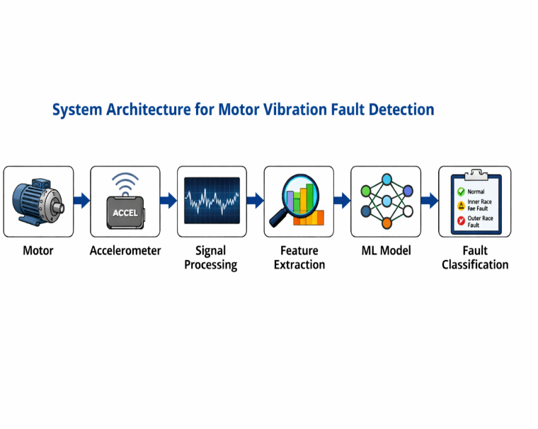  IV. SYSTEM ARCHITECTURE  The proposed motor fault detection system consists of multiple functional layers including a vibration sensing layer, a signal processing layer, a feature extraction layer, a decision-making layer, a communication layer and a monitoring execution layer. The main goal of using vibration sensing is to make the system more reliable in identifying mechanical abnormalities during real-time motor operation under different industrial conditions.  The vibration sensor continuously observes the mechanical behavior of the motor such as oscillations, imbalance effects and structural disturbances. These sensors can detect even small variations in vibration patterns that may indicate developing faults. By using vibration sensing, the system can obtain detailed information about the motor condition without interrupting normal operation.  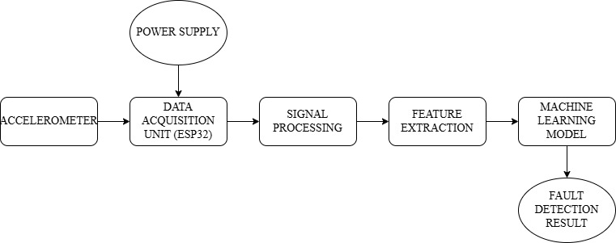In the signal processing layer, the captured vibration signals are transmitted to a computing platform where they are filtered and analyzed. The processing unit examines the signal characteristics and removes noise components that may affect fault identification accuracy. Sometimes raw vibration signals may contain disturbances due to environmental factors or electrical interference, which makes preprocessing necessary for reliable monitoring.  That is why feature extraction techniques are applied. The system calculates statistical indicators such as root mean square value, peak amplitude, kurtosis and standard deviation from the processed vibration signals. These features provide a more meaningful representation of motor health compared to raw signal observations and help improve classification performance.  The decision-making layer evaluates the extracted features using trained machine learning algorithms to determine the motor operating condition. The classification model analyzes feature variations and assigns a health status such as normal operation, early fault indication or critical fault condition. Higher importance is given to abnormal feature patterns that indicate severe mechanical issues requiring immediate attention.  The communication layer enables interaction between sensing devices, processing units and monitoring interfaces. Processed fault information can be transmitted to maintenance systems or industrial monitoring dashboards for further action. This allows the system to respond quickly to changes in motor condition and support predictive maintenance planning.  The monitoring execution layer represents how maintenance decisions are implemented based on the  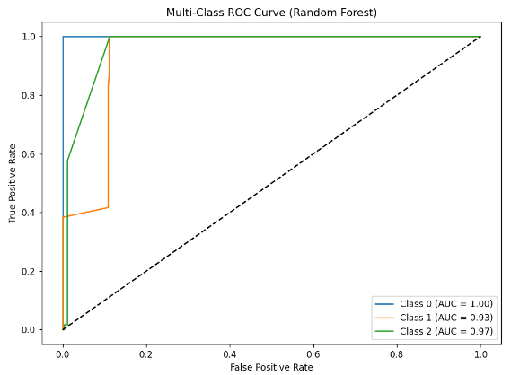  C. C.Fault Identification Consistency  In the conventional threshold-based monitoring system, prolonged abnormal motor operation often went unnoticed because the vibration limits were fixed and did not adapt to varying load conditions. This resulted in delayed fault recognition and accumulation of mechanical stress within the motor. The feature-based monitoring approach was able to improve fault identification to some extent by analyzing statistical variations in vibration signals. However, it sometimes produced incorrect interpretations when normal operational fluctuations were mistaken for fault indicators.  The machine learning based system addressed these limitations by continuously evaluating learned vibration patterns and identifying the actual presence of fault conditions. The classification model maintained fault alerts  or disturbances are present. This integrated approach supports continuous motor condition assessment and enables more confident predictive maintenance planning in industrial environments. supported stable predictive maintenance under varying industrial conditions.  E.Discussion  The experimental investigation shows that the integration of vibration signal feature extraction with machine learning classification significantly improves the reliability of motor fault detection systems. The proposed machine learning based approach, when compared with conventional threshold monitoring, achieved noticeable improvement in fault identification accuracy and reduced false alarm occurrences. The feature-based monitoring method without machine learning was less effective in distinguishing complex fault patterns, especially under varying motor operating conditions.  In addition to improving detection accuracy, the proposed system enhanced consistency of fault recognition, response speed for maintenance decision support, and overall monitoring stability. The combination of statistical signal analysis and data-driven classification provides a dependable monitoring framework that continues to perform effectively even when signal variations o  VI. CONCLUSION AND FUTURE WORK  The proposed machine learning based motor fault detection system combines vibration signal analysis with intelligent classification techniques to monitor motor health under different operating conditions. Motor performance is continuously observed by capturing vibration signals that reflect mechanical behavior such as imbalance, misalignment, and bearing degradation. Statistical feature extraction helps represent the motor condition more accurately, while machine learning models enable reliable identification of fault patterns at an early stage.  A hierarchical fault evaluation strategy was implemented where critical fault conditions are given the highest priority, followed by moderate degradation indicators, and finally normal operational variations. Instead of relying on fixed vibration thresholds, the system adapts its fault detection decisions based on learned signal patterns and feature relationships. This enables more flexible and responsive monitoring suitable for dynamic industrial environments.  Experimental analysis demonstrated that integrating feature extraction with machine learning improved fault detection performance compared to conventional threshold-based monitoring and basic feature evaluation methods. The proposed approach enhanced classification consistency, reduced false alarm occurrences, and maintained stable monitoring performance under varying simulated operating scenarios. The system provides a practical predictive maintenance solution that can support industrial automation

systems where operating conditions and mechanical stresses change frequently.
Future work will focus on implementing real-time hardware validation using vibration sensors mounted on industrial motors and exploring advanced deep learning models for improved fault classification accuracy. Integration with Industrial Internet of Things platforms can also enable remote monitoring and large-scale deployment of intelligent motor health management systems.

ACKNOWLEDGMENT
The authors would like to express their sincere gratitude to the project guide for their valuable guidance, encouragement, and continuous support throughout the development of this work. The authors also thank the Department of Electronics and Communication Engineering for providing the necessary academic environment and facilities required to complete this research as part of the final year project
. REFERENCES

REFERENCES

[1] A. Widodo and B. S. Yang, “Support vector machine in machine condition monitoring and fault diagnosis,” Mechanical Systems and Signal Processing, vol. 21, no. 6, pp. 2560–2574, Aug. 2007.

[2] J. Lee, F. Wu, W. Zhao, M. Ghaffari, L. Liao, and D. Siegel, “Prognostics and health management design for rotary machinery systems—Reviews, methodology and applications,” Mechanical Systems and Signal Processing, vol. 42, no. 1–2, pp. 314–334, Jan. 2014.

[3] S. Yin, H. Gao, and O. Kaynak, “Data-driven fault detection and diagnosis for industrial systems,” IEEE Transactions on Industrial Electronics, vol. 62, no. 1, pp. 657–667, Jan. 2015.

[4] R. Yan, R. X. Gao, and X. Chen, “Wavelets for fault diagnosis of rotary machines: A review with applications,” Signal Processing, vol. 96, pp. 1–15, Mar. 2014.

[5] W. Wang, “Early detection of gear tooth cracking using vibration analysis techniques,” Mechanical Systems and Signal Processing, vol. 15, no. 5, pp. 887–903, Sep. 2001.

[6] J. Antoni and R. B. Randall, “Unsupervised noise cancellation for vibration signals: Part I—Evaluation of adaptive algorithms,” Mechanical Systems and Signal Processing, vol. 18, no. 1, pp. 89–101, Jan. 2004.

[7] Z. Gao, C. Cecati, and S. X. Ding, “A survey of fault diagnosis and fault-tolerant techniques—Part I: Fault diagnosis with model-based and signal-based approaches,” IEEE Transactions on Industrial Electronics, vol. 62, no. 6, pp. 3757–3767, Jun. 2015.

[8] A. K. S. Jardine, D. Lin, and D. Banjevic, “A review on machinery diagnostics and prognostics implementing condition-based maintenance,” Mechanical Systems and Signal Processing, vol. 20, no. 7, pp. 1483–1510, Oct. 2006.

[9] G. Niu, B. S. Yang, and M. Pecht, “Development of an optimized condition-based maintenance system by data fusion and reliability-centered maintenance,” Reliability Engineering & System Safety, vol. 95, no. 7, pp. 786–796, Jul. 2010.

[10] H. Qiu, J. Lee, J. Lin, and G. Yu, “Robust performance degradation assessment methods for enhanced rolling element bearing prognostics,” Advanced Engineering Informatics, vol. 17, no. 3–4, pp. 127–140, Oct. 2003.2002.Signal Control Using Machine Learning," IEEE Access, vol. 8, pp. 205360–205372, 2020.

