GIS-BASED ACCESSIBILITY ANALYSIS OF
NAMMA METRO STATIONS
Population accessibility within 5-, 10- and 15-minute walking catchments

Project Report
Bengaluru, Karnataka
Prepared using QGIS and spatial accessibility analysis
Sreeman Bondada
Manipal Institute of Technology
Bengaluru, Karnataka

Abstract
This project evaluates the population accessibility of Namma Metro stations in Bengaluru using a GIS-based walking-catchment methodology. Metro station locations were combined with a population raster and a pedestrian/walking network in a common projected coordinate system (WGS 84 / UTM zone 43N, EPSG:32643). Network-based service areas were developed for 5-, 10- and 15-minute walking thresholds, and population falling within the resulting catchments was estimated for each station. Population gains between successive accessibility thresholds were then calculated and used with the final accessibility classification to identify stations with relatively high, moderate and low accessibility. The final master dataset contains 81 metro station features. The final classification consists of 18 High, 13 Moderate and 50 Low accessibility stations. The results provide a spatial basis for understanding where expanding the practical walking catchment of metro stations reaches substantially larger populations.

1. Introduction
Urban rail accessibility is not determined solely by the presence of a metro station. A station is useful to surrounding residents only when it can be reached conveniently, and walking distance is one of the most direct measures of this first/last-mile connection. A GIS-based accessibility analysis therefore provides a more meaningful representation than a simple circular buffer because it can account for the structure of the pedestrian network.
The objective of this project is to quantify how much population can reach Namma Metro stations within 5, 10 and 15 minutes of walking and to classify stations according to the resulting accessibility pattern. The analysis also examines the additional population reached when the walking threshold is expanded from 5 to 10 minutes and from 10 to 15 minutes.

1.1 Objectives
- Prepare a consistent GIS database of Namma Metro station locations and supporting spatial data.
- Generate walking-based accessibility areas for 5-, 10- and 15-minute thresholds.
- Estimate the population contained within each station's accessibility area.
- Calculate population gain between the 5-, 10- and 15-minute thresholds.
- Classify the 81 final station features into High, Moderate and Low accessibility classes.
- Produce maps and statistical visualizations suitable for interpretation and reporting.

2. Study Area and Data
The study focuses on the Bengaluru metropolitan area and the Namma Metro network represented in the project GIS database. All principal spatial datasets used in the final analysis were handled in EPSG:32643 (WGS 84 / UTM zone 43N), a projected CRS with metre units.
Dataset | Type | Key information | Role in analysis
metro_stations_utm43 | Vector | 81 features; EPSG:32643 | Metro station locations
walking_network_utm43 | Line vector | 238,269 features; EPSG:32643 | Pedestrian/network accessibility
bengaluru_population_2020_utm43 | Raster | Float32; 891 × 681; ~91.10 m pixels | Population surface
NammaMetro_Accessibility_Master | Vector | 81 final station records | Integrated final results

2.1 Population raster
The population dataset used in the project is the GeoTIFF `bengaluru_population_2020_utm43.tif`. Its metadata reports EPSG:32643, Float32 data, an 891 × 681 raster dimension, and an approximate pixel size of 91.098 m by 91.098 m. The raster provides the spatial population surface from which zonal population totals were derived.

2.2 Walking network
The walking network layer `walking_network_utm43` contains 238,269 line features and is stored as a GeoPackage layer. It is used to represent the paths available for walking-based accessibility rather than assuming that residents can move in straight lines through the urban fabric.

3. Methodology
The workflow consists of data preparation, coordinate-system harmonization, walking-network accessibility analysis, zonal population estimation, population-gain calculation, classification, and visualization.

3.1 Coordinate reference system
The final spatial workflow uses EPSG:32643 (WGS 84 / UTM zone 43N). The projected metre-based coordinate system is appropriate for distance and network operations because walking thresholds are expressed in physical distance/time units.

3.2 Accessibility thresholds
For each metro station, accessibility was evaluated at three walking thresholds: 5 minutes, 10 minutes and 15 minutes. The resulting station-specific catchments were used to summarize the population reachable within each threshold.

3.3 Population aggregation
Zonal statistics were used to extract population information from the 2020 population raster for the station accessibility areas. The resulting fields include population totals associated with the 5-, 10- and 15-minute thresholds.

3.4 Population gain
Population gain was calculated between successive walking thresholds. The principal measures used in the final dataset are:
Population gain (5–10) = Population(10 min) − Population(5 min)
Population gain (10–15) = Population(15 min) − Population(10 min)
Population gain (5–15) = Population(15 min) − Population(5 min)

3.5 Final accessibility classification
A final categorical field, `access_class`, was created in the integrated station dataset. The project classification contains three categories: High, Moderate and Low. These categories were visualized using green, yellow and red symbology respectively.

4. Results
The final integrated dataset contains 81 station features. The distribution of the final accessibility classes is shown below.
Accessibility class | Number of stations | Share
Low | 50 | 61.7%
Moderate | 13 | 16.0%
High | 18 | 22.2%
Total | 81 | 100.0%

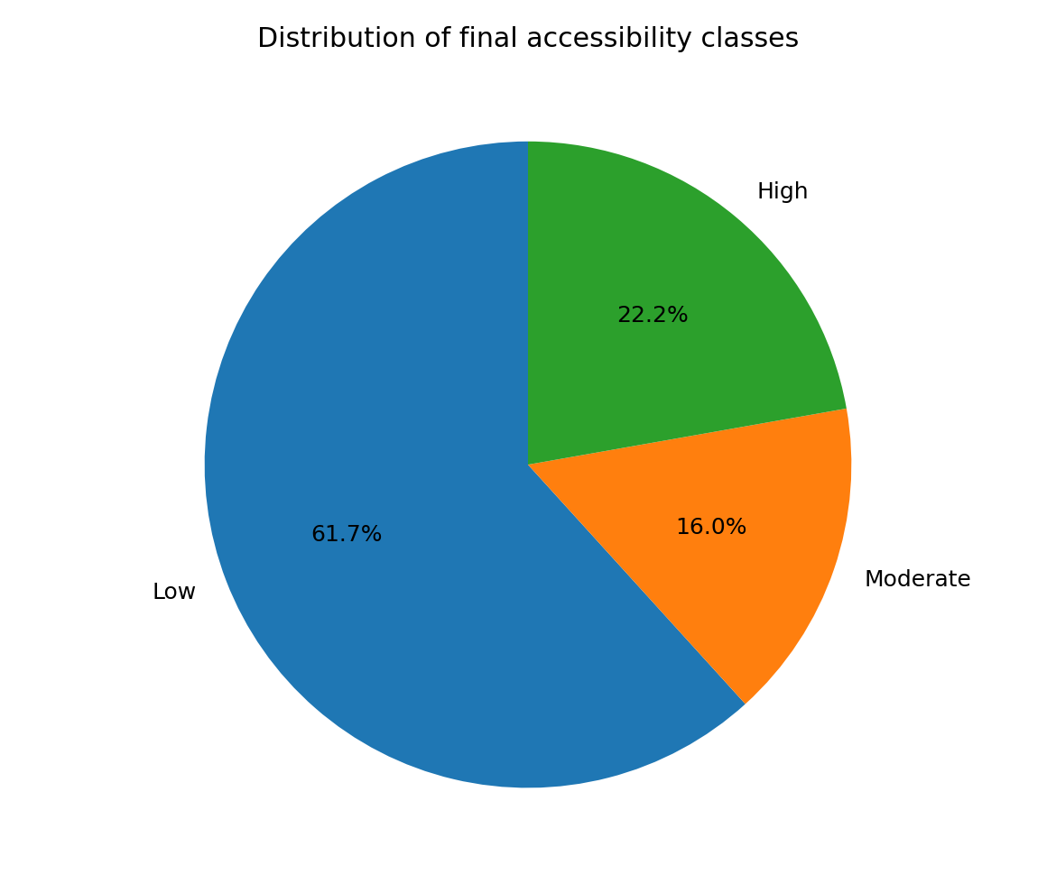
Figure 1. Final accessibility class distribution across the 81 metro station features.

4.1 Population gain from 5 to 15 minutes
The largest 5–15 minute population gains occur at stations where expanding the practical walking catchment reaches substantial additional residential population. The highest values in the final dataset include Vijayanagar, Srirampura, Rajajinagar, Mahakavi Kuvempu Road and Sri Balagangadharanatha Swamiji Station.
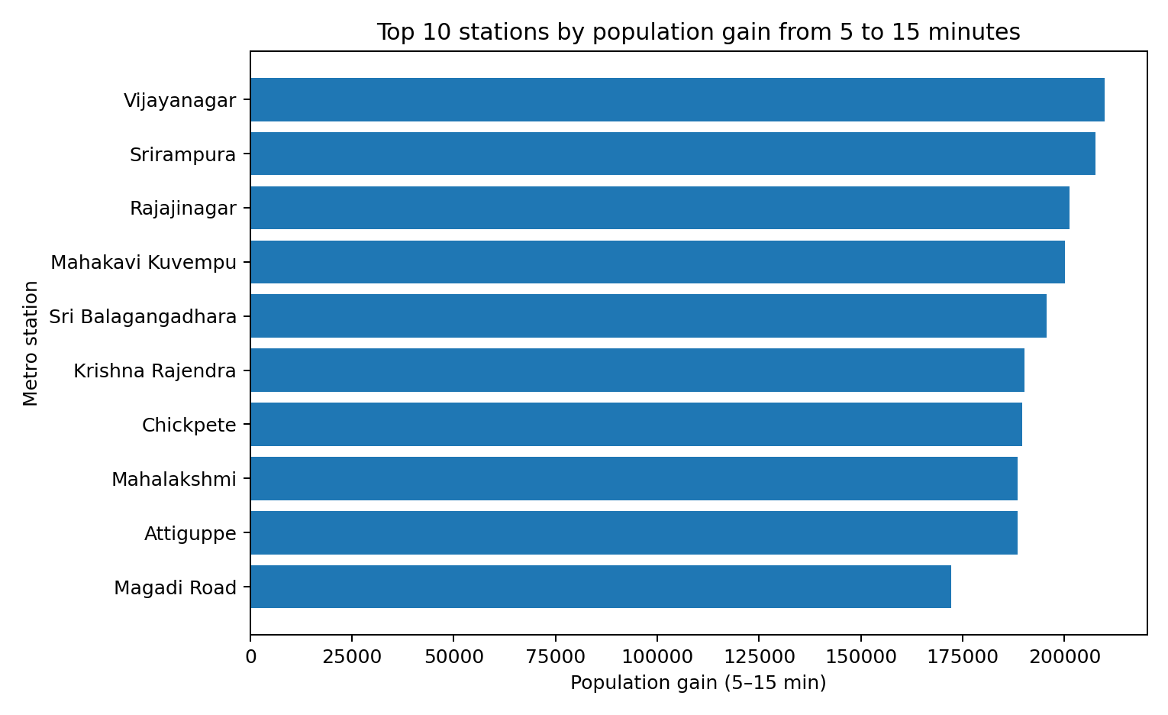
Figure 2. Top 10 stations by population gain between the 5- and 15-minute thresholds.

4.2 High-gain stations
Rank | Station | Population gain (5–15 min)
1 | Vijayanagar | 209,887
2 | Srirampura | 207,569
3 | Rajajinagar | 201,244
4 | Mahakavi Kuvempu | 200,043
5 | Sri Balagangadhara | 195,679
6 | Krishna Rajendra | 190,155
7 | Chickpete | 189,533
8 | Mahalakshmi | 188,557
9 | Attiguppe | 188,428
10 | Magadi Road | 172,162

4.3 15-minute population accessibility
A separate visualization was produced for stations with comparatively high population totals within the 15-minute accessibility threshold. This view is useful because absolute accessible population and incremental population gain answer different questions: the former identifies stations serving large populations within 15 minutes, while the latter identifies where expanding the catchment produces the greatest additional reach.
Insert the final QGIS/Data Plotly 15-minute population chart here.
Figure 3. Population accessible within the 15-minute threshold for selected high-value stations.

5. Spatial Interpretation
The final QGIS map classifies station accessibility using the `access_class` field. High accessibility is displayed in green, Moderate in yellow, and Low in red. The map provides the spatial counterpart to the statistical results and allows clusters of accessibility performance to be identified along the metro network.
Insert the final QGIS accessibility map here.
Recommended caption: Final Namma Metro station accessibility classification.
Figure 4. Final GIS map of Namma Metro station accessibility classes.

6. Discussion
The analysis demonstrates that metro accessibility changes substantially as the walking threshold increases. A 5-minute catchment represents a relatively immediate station service area, whereas a 15-minute catchment incorporates a much larger portion of the surrounding pedestrian network. Consequently, stations located near dense or spatially extensive residential areas can show very large incremental population gains when the threshold is expanded.
The final classification also reveals that accessibility is not uniform across the network. The presence of 50 Low-class features compared with 18 High and 13 Moderate features indicates that a large share of the analyzed stations do not achieve the same population-accessibility levels under the project's classification scheme.
Several southern and eastern stations illustrate why the distinction between absolute population and incremental gain matters. A station can have a comparatively small immediate 5-minute catchment but gain a substantial population by 15 minutes if the surrounding network connects to denser residential areas. Conversely, a station with a high immediate population can show a different gain profile if much of its surrounding population is already captured within the shorter threshold.

7. Limitations
- The population surface represents 2020 conditions and may not reflect the current population distribution.
- Raster resolution is approximately 91 m, so very fine-scale population variation is generalized.
- Walking accessibility depends on the completeness and positional accuracy of the walking network.
- A walking-time threshold requires assumptions about walking speed and network traversal; these assumptions should be stated explicitly in a final academic submission if required by the project specification.
- The accessibility classification is a project-specific analytical classification and should not be interpreted as an official Namma Metro rating.
- The analysis estimates population within spatial catchments; it does not directly measure actual metro ridership, travel demand, or individual route choices.

8. Future Work
- Update the population surface with the most recent available population estimates.
- Incorporate road crossings, barriers, footpaths, pedestrian entrances and station access points where data are available.
- Compare accessibility results with actual station ridership and interchange demand.
- Add land-use, employment and points-of-interest data to create a broader multimodal accessibility index.
- Evaluate accessibility separately by neighborhood or demographic group where appropriate data are available.
- Repeat the analysis for proposed/future metro extensions to identify potential accessibility gains before construction.

9. Conclusion
This project developed a GIS-based framework for evaluating population accessibility to Namma Metro stations using walking-based 5-, 10- and 15-minute catchments. By integrating station locations, a pedestrian network and a population raster in a common projected coordinate system, the analysis moves beyond simple distance buffers and provides a network-oriented view of practical station access.
The final master dataset contains 81 station features and classifies them into 18 High, 13 Moderate and 50 Low accessibility stations. Population-gain analysis identifies Vijayanagar, Srirampura, Rajajinagar and other central/northern stations among the strongest 5–15 minute incremental-accessibility cases. Together, the final map, statistical summaries and charts provide a coherent evidence base for interpreting spatial differences in metro accessibility across Bengaluru.

Appendix A. Key final fields
Field | Meaning
name | Metro station name
pop5_sum | Population associated with the 5-minute catchment
pop10_sum / join10_sum | Population associated with the 10-minute catchment
pop15_sum / pop15_correct | Population associated with the 15-minute catchment
pop_gain_5_10 | Additional population reached from 5 to 10 minutes
pop_gain_10_15 | Additional population reached from 10 to 15 minutes
pop_gain_5_15 | Additional population reached from 5 to 15 minutes
access15_pct_final | Final 15-minute population-accessibility percentage
access_class | Final High / Moderate / Low accessibility category

Appendix B. Project data inventory
- metro_stations_utm43.gpkg — final station point layer; 81 features.
- walking_network_utm43.gpkg — walking network; 238,269 line features.
- bengaluru_population_2020_utm43.tif — 2020 population raster; Float32; 891 × 681; approximately 91.10 m pixel size.
- station_population_final.gpkg — intermediate/final station-population dataset referenced during the workflow.
- NammaMetro_Accessibility_Master.csv — exported integrated tabular master dataset containing the final station attributes.

10. Detailed GIS Workflow and Implementation
The project was implemented as a sequence of GIS preprocessing, network analysis, raster summarization, attribute integration and visualization operations in QGIS. The workflow was designed so that each major intermediate result could be inspected through the layer panel, attribute tables and statistical tools before being incorporated into the final master layer.

10.1 Data preparation
- Metro station data were converted/prepared in the common UTM coordinate system and represented as station features.
- The Bengaluru population raster was prepared in the same projected CRS so that the raster and vector analyses shared a consistent spatial reference.
- The walking network was stored as a line-based GeoPackage layer and used as the network representation for accessibility analysis.
- Intermediate station-population and zonal-statistics layers were retained during processing to allow validation of individual stages.
- The final integrated station layer was checked in the attribute table to confirm that the expected station records and derived fields were present.

10.2 Network-based service areas
Instead of using only Euclidean buffers around stations, the project uses walking-network accessibility. This is important in an urban environment because buildings, roads, crossings, and network connectivity can make the actual walking path considerably different from a straight line. The three thresholds represent progressively larger practical walking catchments.
The 5-minute threshold represents the immediate station catchment. The 10-minute threshold extends this catchment to nearby neighborhoods, while the 15-minute threshold captures a broader first/last-mile service area. Comparing these thresholds provides more information than reporting only a single accessibility value.

10.3 Raster-to-zone population estimation
The population raster was summarized against station accessibility zones using zonal statistics. The resulting population totals were associated with individual station records. This process creates a direct analytical link between the physical accessibility geometry and the population potentially served by each station.

10.4 Attribute-field engineering
The final station table contains both source attributes and derived analytical fields. The most important derived variables are population totals for each time threshold, accessibility shares, and population-gain fields. These variables make it possible to perform station-level ranking, classification and statistical visualization without repeating the spatial analysis.

10.5 Quality-control checks
- The final master table was verified to contain 81 station records.
- The 5–15 minute population-gain field was sorted in ascending and descending order to inspect the lowest and highest values.
- The final accessibility field was filtered to verify the High category and its selected-feature statistics.
- The final map was visually inspected to confirm that High, Moderate and Low symbology was being rendered.
- The exported NammaMetro_Accessibility_Master.csv was reopened in QGIS and verified to contain the station attributes and derived fields.

11. Statistical Interpretation of the Results
The statistical results should be interpreted at two levels: absolute accessibility and incremental accessibility. Absolute accessibility asks how much population is reachable within a specified time threshold. Incremental accessibility asks how much additional population becomes reachable when the threshold is increased.

11.1 Final accessibility-class distribution
The final classification contains 81 station features: 18 High, 13 Moderate and 50 Low. Expressed as percentages, these correspond to approximately 22.2%, 16.0% and 61.7%, respectively. Therefore, Low is the largest class in the final classification, while High represents slightly more than one-fifth of the stations.

11.2 Interpretation of the 5–15 minute gain
The 5–15 minute gain field is particularly useful for identifying stations where extending the walking catchment substantially increases the population reached. The highest observed values in the inspected final table include Vijayanagar (~209,887), Srirampura (~207,569), Rajajinagar (~201,244), Mahakavi Kuvempu (~200,043), Sri Balagangadharanatha Swamiji Station (~195,679), Krishna Rajendra Market (~190,155), Chickpete (~189,533), Mahalakshmi (~188,557), Attiguppe (~188,428), and Magadi Road (~172,162).
These results indicate that the additional 10 minutes of walking reach can represent a very large incremental population in some dense urban station environments. Such stations are especially interesting from a first/last-mile planning perspective because improvements that make a longer walking catchment more practical could potentially expose the metro system to a substantially larger surrounding population.

11.3 Low-gain cases
The lower end of the 5–15 minute gain ranking contains stations where extending the catchment produces little additional population under the project's population surface and network. Examples inspected in the final table include Challaghatta, Kengeri Bus Terminal, Nadaprabhu Kempegowda Station and Rajarajeshwari Nagar. The very small or near-zero incremental values suggest that much of the population represented by the raster in those local station areas is already captured by the shorter accessibility threshold, or that the network/catchment geometry does not reach a large additional population area.

11.4 Why rankings should not be treated as ridership rankings
A key distinction is that this project measures spatial population accessibility rather than actual metro usage. A station with high accessible population is not necessarily the station with the highest passenger count. Ridership is influenced by employment, schools, commercial activity, interchange behavior, fare structure, trip purpose, feeder services and many other factors. The present analysis should therefore be described as a population-accessibility study.

12. Cartographic Design and Visualization
The final QGIS visualization uses categorical symbology for the accessibility classes. Green represents High accessibility, yellow represents Moderate accessibility, and red represents Low accessibility. This classification allows a reader to interpret station-level differences directly on the Bengaluru basemap.
The project also uses DataPlotly to produce statistical graphics. A bar chart was used to inspect population-gain values, while a pie chart was used to visualize the distribution of the final accessibility classes. A separate 15-minute population chart was used to inspect high-value station cases. Together, the map and charts provide both spatial and statistical views of the same dataset.

12.1 Recommended final map composition
- Use the final accessibility layer as the primary thematic layer.
- Keep the Bengaluru basemap visible at a subdued visual weight.
- Retain the High/Moderate/Low legend clearly.
- Include a title, north arrow, scale bar and CRS information in the final map layout.
- Avoid displaying every intermediate processing layer in the final presentation map.
- Use station labels selectively so that the map remains readable.

12.2 Recommended figures for final submission
- Final accessibility classification map.
- Accessibility-class distribution pie chart.
- Top-10 5–15 minute population-gain bar chart.
- 15-minute accessible-population bar chart.
- Optional workflow diagram showing station → network catchment → zonal population → classification.

13. Reproducibility and Project Organization
For a strong academic and portfolio submission, the project should be organized so that another student can understand the source data, processing sequence, outputs and final conclusions. The QGIS project file should be kept together with a clear directory structure.
Suggested folder | Contents
project/ | QGIS project file (.qgz) and project-level documentation
data/raw/ | Original station, network and population inputs
data/processed/ | Processed GeoPackages, zonal statistics and joined layers
outputs/maps/ | Final map exports such as PNG/PDF
outputs/charts/ | DataPlotly/statistical figures
reports/ | Detailed project report and presentation
README.md | Project overview, methodology, setup and results

13.1 Recommended README contents
- Project title and one-paragraph summary.
- Author: Sreeman Bondada.
- Institution: Manipal Institute of Technology, Bengaluru.
- Problem statement and objectives.
- Data sources and CRS.
- Software/tools used: QGIS and DataPlotly.
- Methodology summary.
- Final results: 81 stations and 18/13/50 accessibility classes.
- How to reproduce the workflow.
- Limitations and future work.

14. Academic Presentation of the Project
The project can be presented as an applied GIS and urban-transport accessibility study. Its technical contribution is the integration of network-based walking accessibility with raster population analysis at multiple time thresholds. The multi-threshold design is important because it allows the analysis to distinguish immediate accessibility from the additional population reachable through a longer but still practical walking journey.
From an academic perspective, the strongest aspect of the work is the linkage between spatial network analysis and quantitative population statistics. From a practical perspective, the final classification can be used to identify areas where station accessibility is comparatively strong or weak, while the population-gain field highlights locations where expanding the walking catchment has the greatest potential effect.

14.1 Suggested project contribution statement
This project presents a reproducible GIS workflow for evaluating population accessibility to Namma Metro stations through walking-network service areas. It combines 5-, 10- and 15-minute accessibility thresholds with a 2020 population raster, derives incremental population gains, and summarizes station-level accessibility using a final categorical classification. The workflow can be adapted to other metro systems, updated with newer population data, or extended with ridership and land-use variables.

14.2 Suggested viva questions
- Why was EPSG:32643 used instead of a geographic CRS?
- Why is a network service area preferable to a circular buffer for walking accessibility?
- What is the difference between population accessible within 15 minutes and population gain from 5 to 15 minutes?
- Why does high population accessibility not necessarily mean high metro ridership?
- What are the limitations of using a 2020 population raster?
- Why is raster resolution relevant to the accuracy of zonal population estimates?
- How does the walking network influence the final accessibility result?
- What additional datasets would improve the model?

15. Final Project Status
Component | Status
Metro station layer prepared | Completed
Common CRS / UTM 43N workflow | Completed
Walking network prepared | Completed
5-minute accessibility analysis | Completed
10-minute accessibility analysis | Completed
15-minute accessibility analysis | Completed
Population zonal statistics | Completed
Population gain fields | Completed
Final High/Moderate/Low classification | Completed
Final 81-feature master dataset | Completed
CSV export / master table | Completed
DataPlotly visualizations | Completed
Detailed written report | Completed
Final QGIS print-layout map | Pending insertion into report
Final report polishing/references | Pending
GitHub repository organization | Pending

16. Final Conclusion
The completed GIS workflow establishes a station-level accessibility database for the Namma Metro network using walking-network catchments and population data. The analysis successfully integrates 81 metro station records with 5-, 10- and 15-minute accessibility measures, population totals, population gains and a final categorical accessibility field.
The results show a clear spatial and statistical variation in accessibility. With 18 High, 13 Moderate and 50 Low classifications, the final map highlights substantial differences across the network. The 5–15 minute gain analysis further demonstrates that certain stations can reach very large additional populations when the practical walking threshold is expanded.
The project is therefore suitable for presentation as a GIS-based urban transportation accessibility study. With the final map inserted, the report polished and the project directory organized, it can also serve as a strong portfolio project demonstrating QGIS, spatial analysis, network analysis, raster processing, attribute engineering and data visualization.

