**Project Report 3**

**Objective:**

Added the below described features:

1. Accomplished with AR implementation part.

3D Display of the ingredients for a recipe named Smoothie are displayed using Unity Tool.

1. As a part of interaction through social networking, we have used twitter search API. This was achieved by following the below pattern

a. Interaction with twitter

b. Using of Twitter search API to fetch the popular tweets for the hashtag (Recipe name like #smoothie)

**Unity tool for AR implementation:**

Unity tool is used for the displaying of the 3D objects for the ingredients present in any of the recipe.

**Twitter Search API:**

[https://developer.twitter.com/en/docs/tweets/search/api-reference/get-search-tweets](https://www.google.com/url?q=https://developer.twitter.com/en/docs/tweets/search/api-reference/get-search-tweets&sa=D&source=hangouts&ust=1524631026284000&usg=AFQjCNEq73RChLaLlhKREvTHOV6RqFL-Lw)

**Implementation:**

We have installed unity and appened 3D images in AR Camera and ImageTarget folder. Appened apple, yogurt, banana images in to a bowl.

The bowl images is downloaded from vuforia. Vuforia Developers portal is the site where we stored the database and a target. In the project the target is bowl.

**Please find the screen shots below:**

Target image



Licenece manager

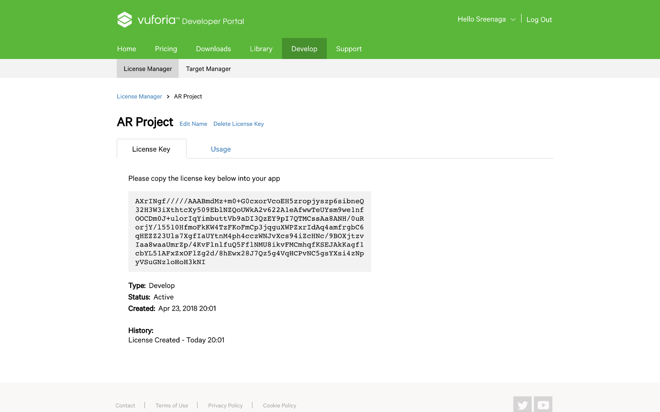

Target manager

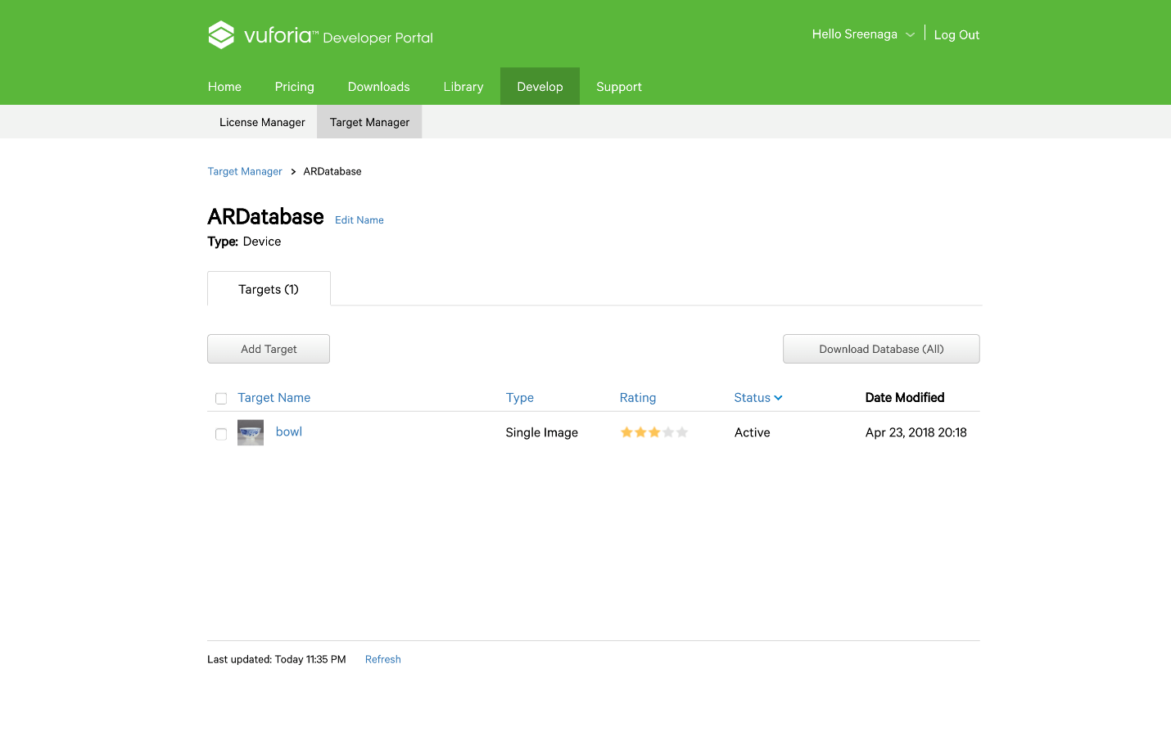

Task manager

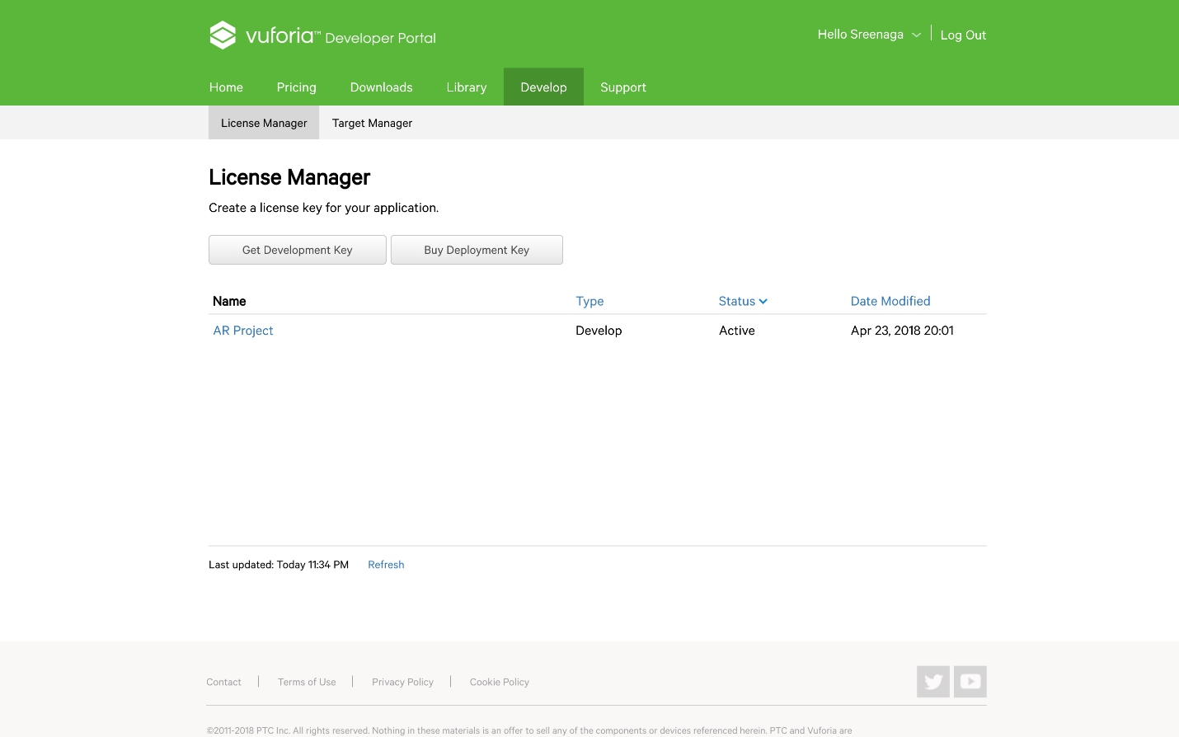

Bowl object points

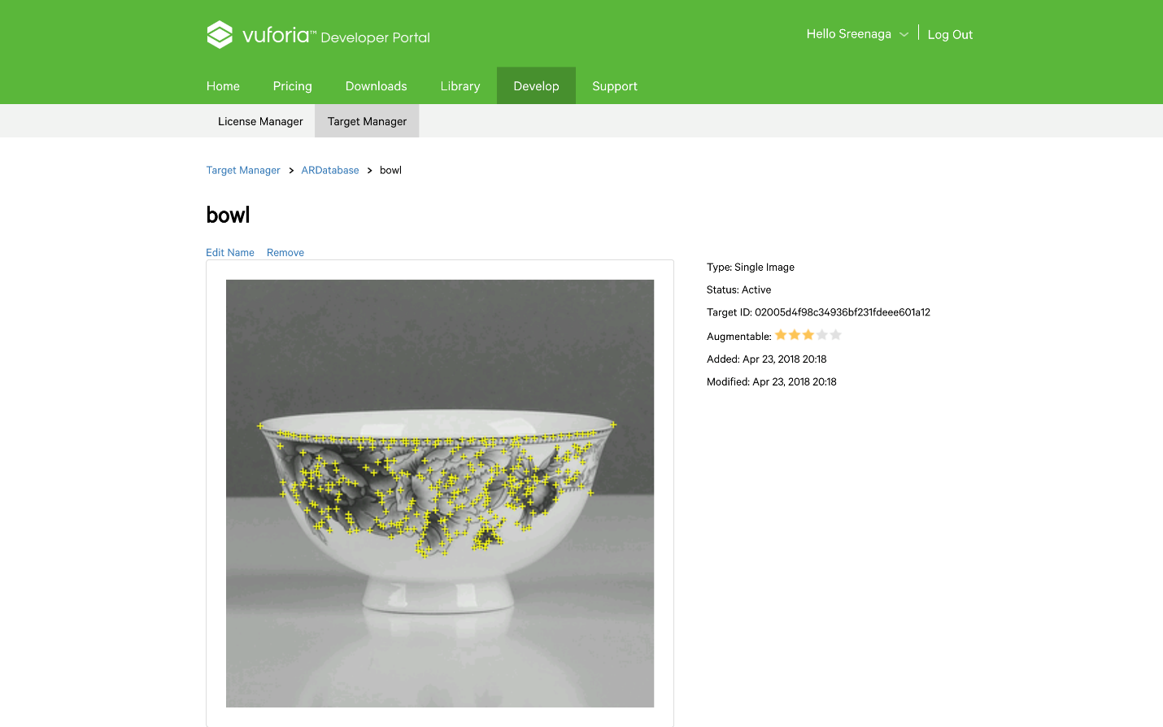

Unity screenshots:

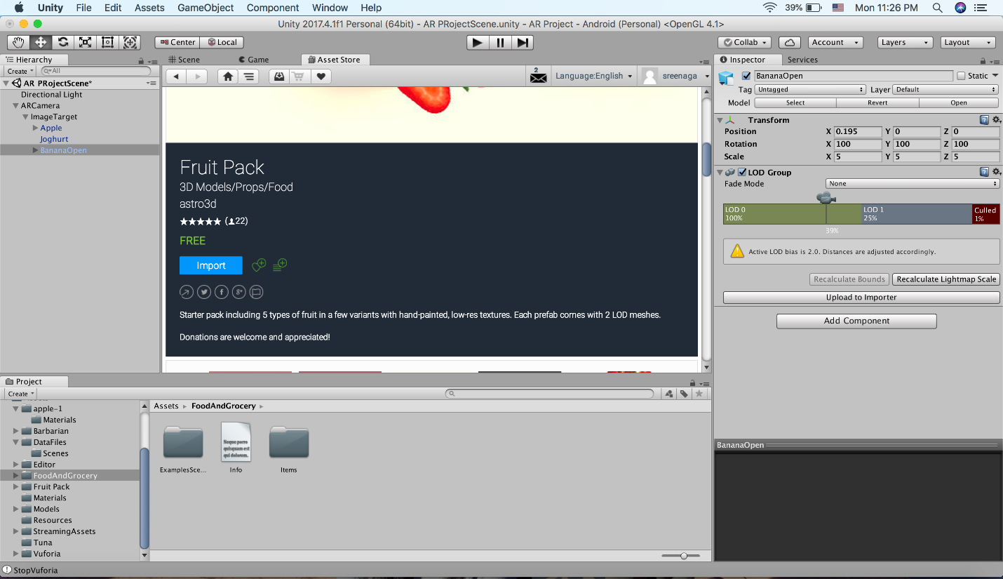

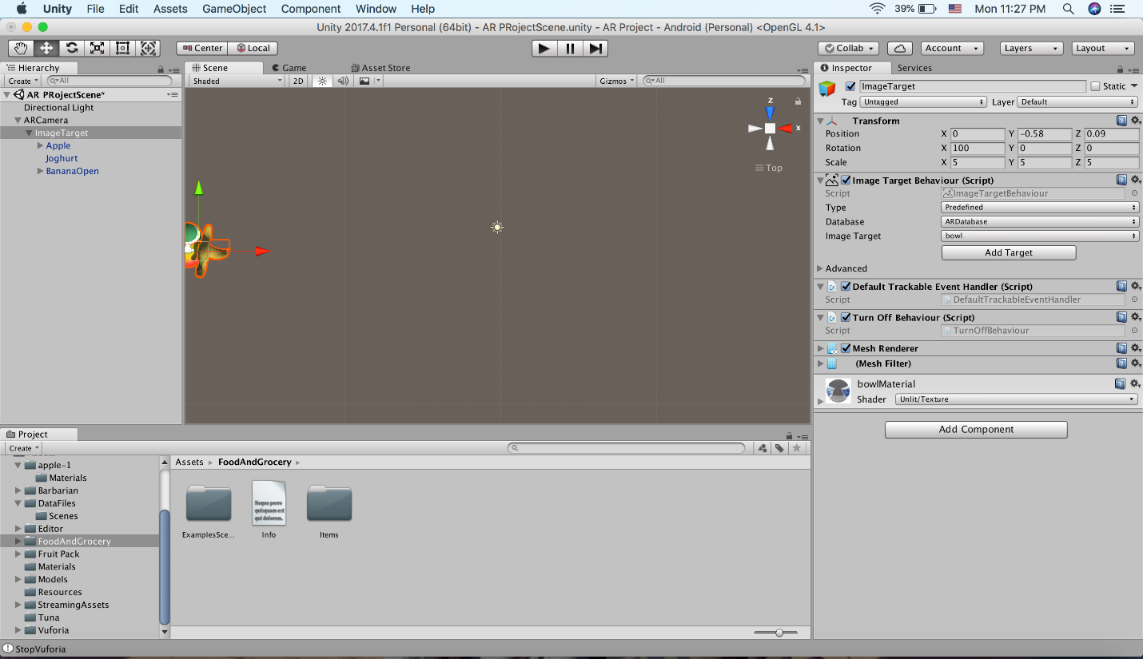

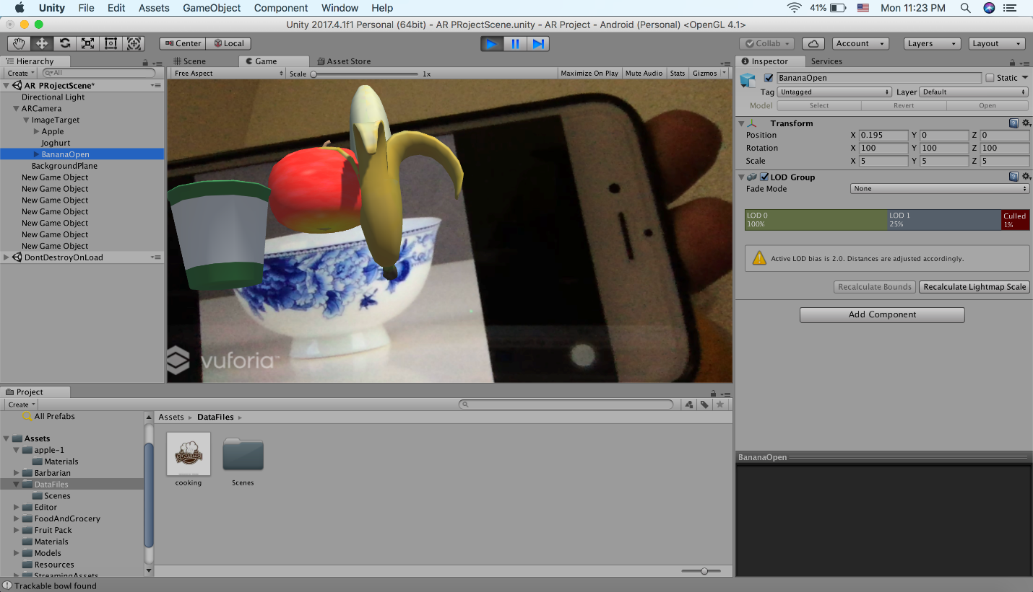

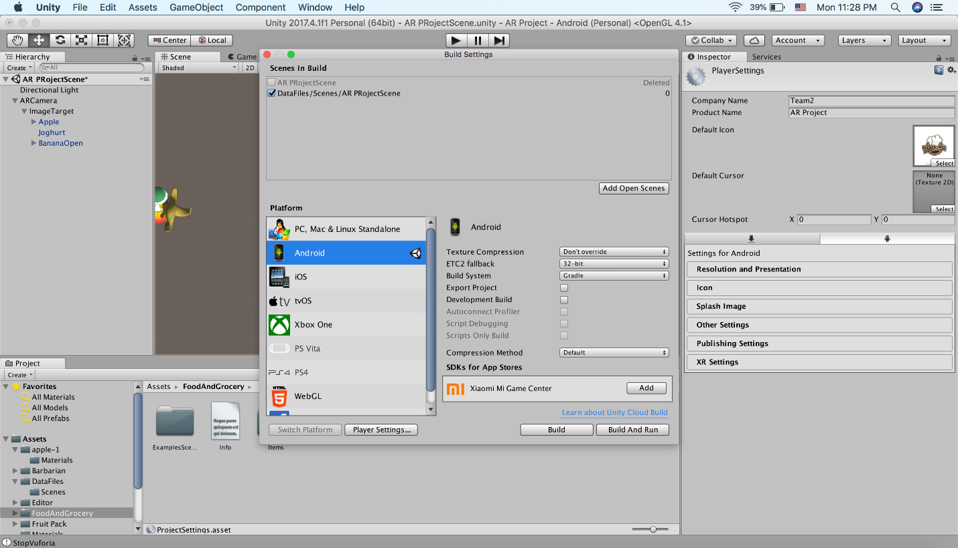

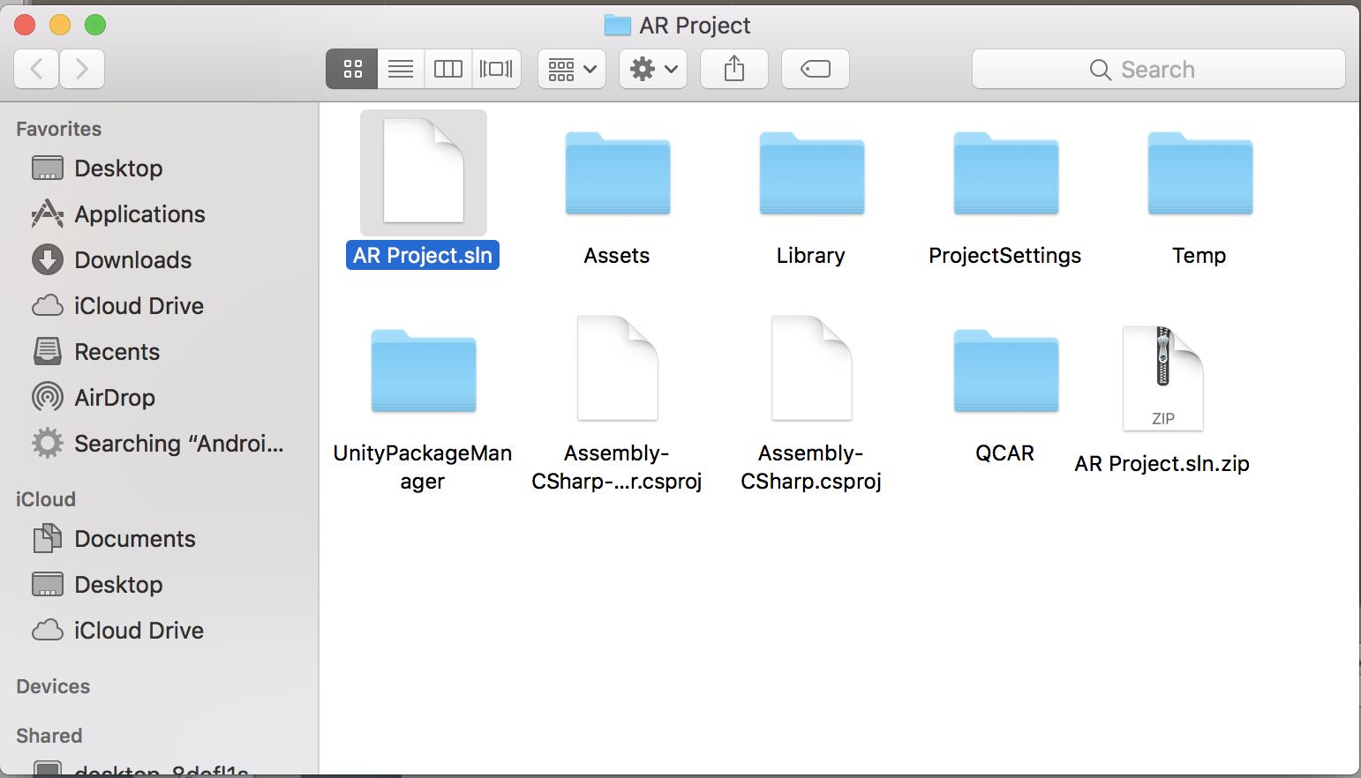

Once the execution is played sucessfully in unity. We need to download and an apk file. But in mac PC the file is getting downloaded in sln format and we are working on it.

Twitter Trends Screen shots:

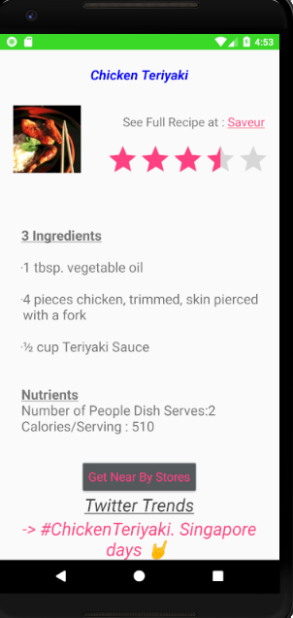

**Github Wiki Link:**

https://github.com/KranthiKumarGangineni/ASE-Project1/wiki/ASE-Project-3-Wiki

**Responsibilities:**

**Kranthi Kumar Gangineni:** Worked on Unity Tool for Augment Reality Implementation, Twitter Social networking Interaction

**Yuvesh Linga Sai Kotiala:**

Worked on Unity Tool for Augment Reality Implementation, Twitter Social networking Interaction

**Sree Naga Sayana:**

Worked on Unity Tool for Augment Reality Implementation, Twitter Social networking Interaction

**Hari Manasa Ganganagunta :**

Worked on Unity Tool for Augment Reality Implementation, Twitter Social networking Interaction

**Bibliography :**

<https://www.youtube.com/watch?v=WdfStRynCLw>

[https://developer.twitter.com/en/docs/tweets/search/api-reference/get-search-tweets](https://www.google.com/url?q=https://developer.twitter.com/en/docs/tweets/search/api-reference/get-search-tweets&sa=D&source=hangouts&ust=1524631026284000&usg=AFQjCNEq73RChLaLlhKREvTHOV6RqFL-Lw)