**In Class Programming 4 Program 1**

**Team 10 Class ID 6 and 29**

**Simple_ae**

Learning_rate = 0.01

Optimizer = AdagradOptimizer

Range = 10001

No of steps = 1000

**Loss:**

|  |
| --- |
| step, loss = 0: 0.754 |
| step, loss = 1000: 0.260 |
| step, loss = 2000: 0.249 |
| step, loss = 3000: 0.237 |
| step, loss = 4000: 0.229 |
| step, loss = 5000: 0.219 |
| step, loss = 6000: 0.210 |
| step, loss = 7000: 0.200 |
| step, loss = 8000: 0.188 |
| step, loss = 9000: 0.183 |
| step, loss = 10000:0.175 |
| loss (test) = 0.17955483 |

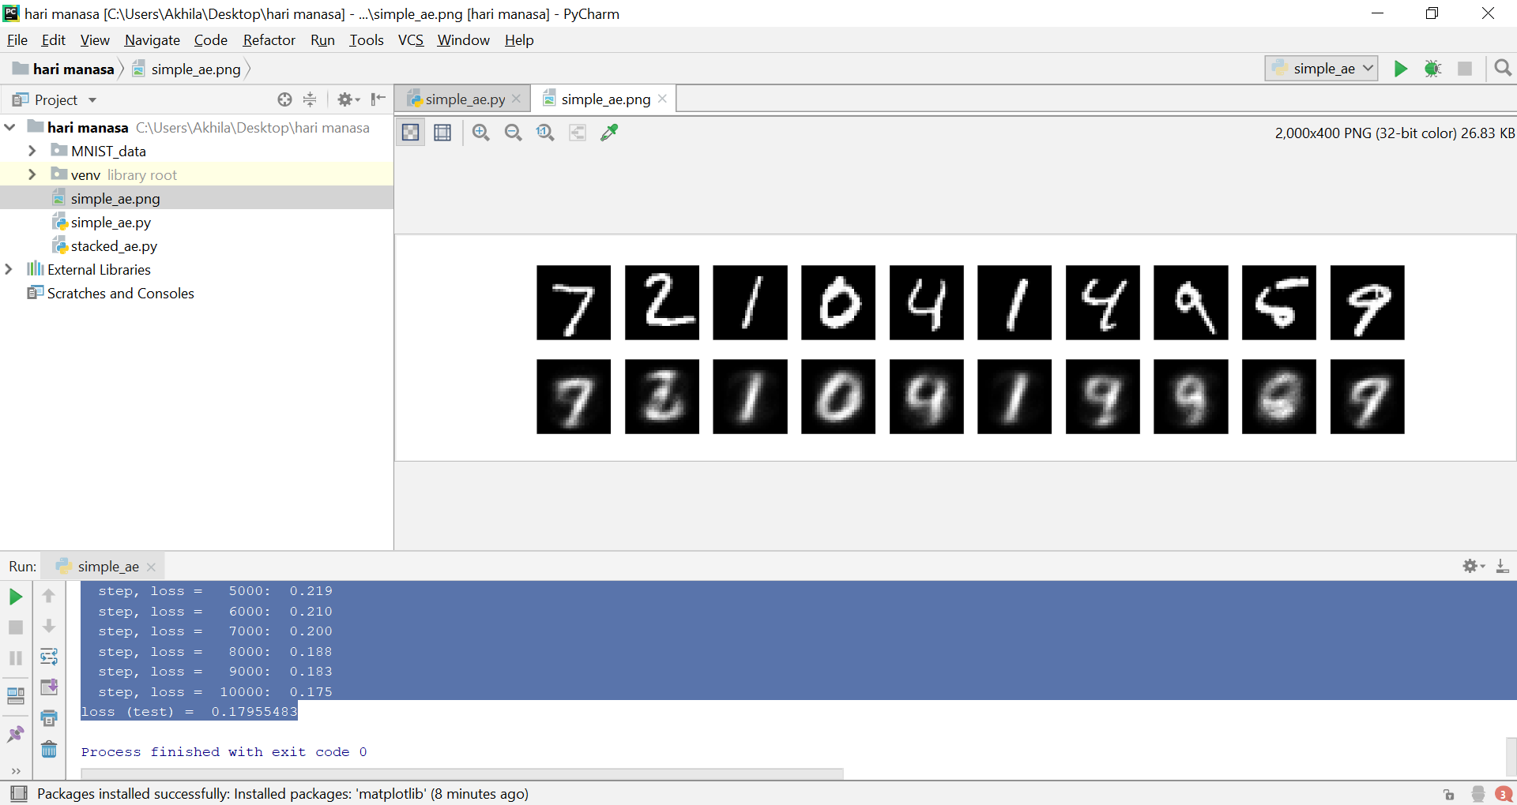

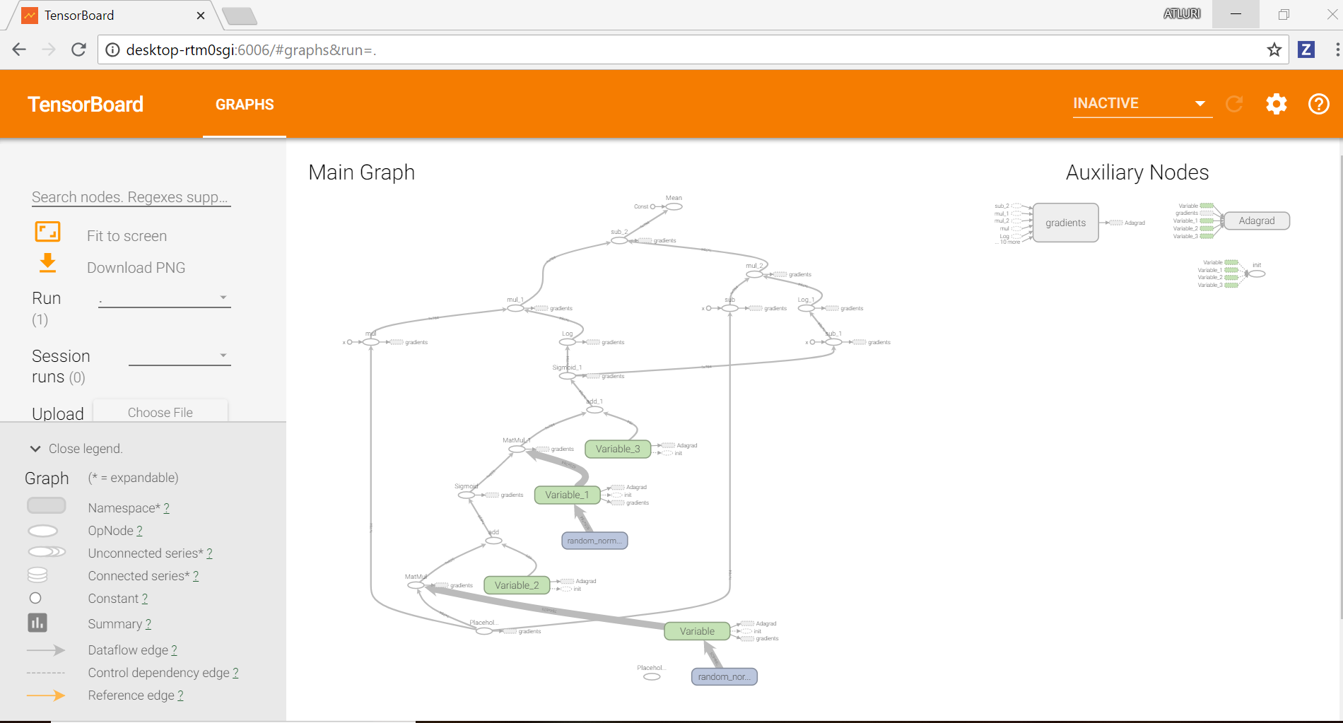

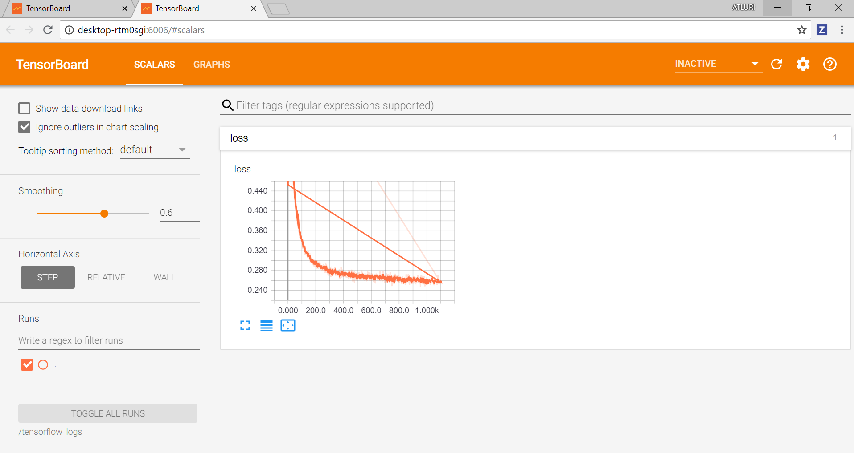

Learning_rate = 0.1

Optimizer = AdagradOptimizer

Range = 3000

No of steps = 300

**Loss:**

step, loss = 0: 0.704

step, loss = 300: 0.266

step, loss = 600: 0.264

step, loss = 900: 0.252

step, loss = 1200: 0.249

step, loss = 1500: 0.240

step, loss = 1800: 0.225

step, loss = 2100: 0.226

step, loss = 2400: 0.220

step, loss = 2700: 0.209

loss (test) = 0.2051148

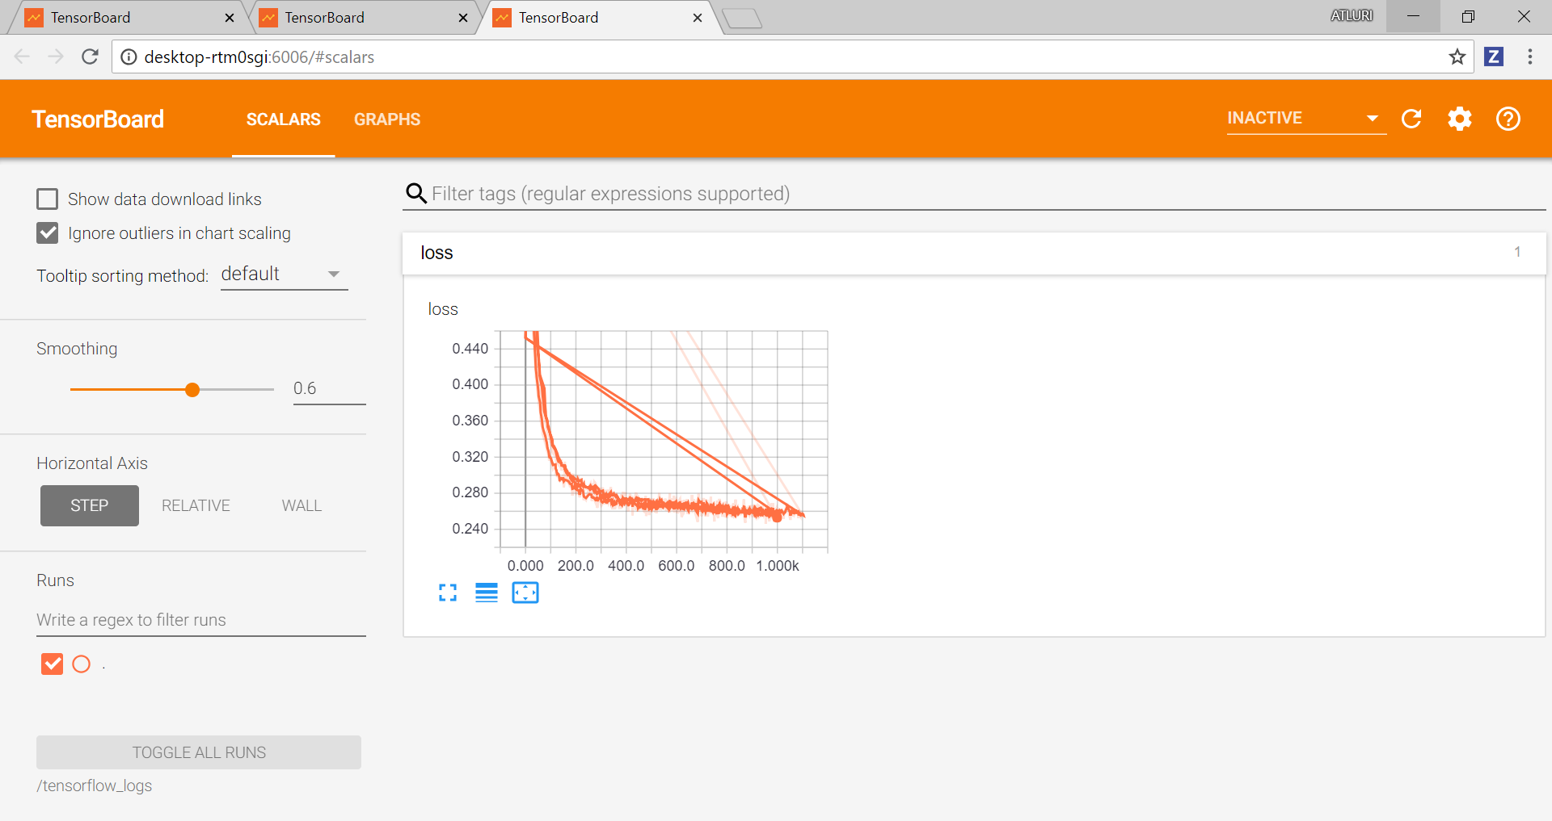

Learning_rate = 0.01

Optimizer: GradientDescentOptimizer

Range = 3000

No.of steps: 500

Training...

step, loss = 0: 0.742

step, loss = 500: 0.491

step, loss = 1000: 0.391

step, loss = 1500: 0.342

step, loss = 2000: 0.318

step, loss = 2500: 0.303

loss (test) = 0.295759

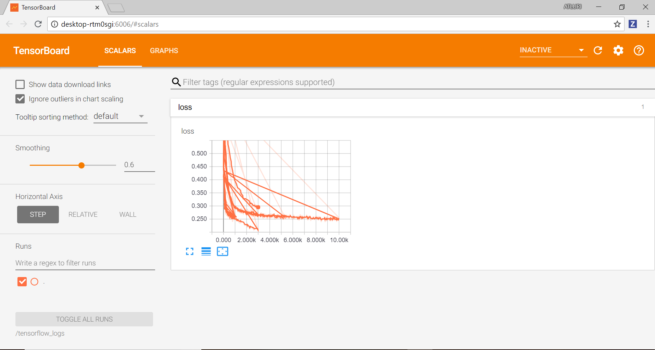

Learning_rate = 0.02

Optimizer: GradientDescentOptimizer

Range = 2000

No.of steps: 200

Training...

step, loss = 0: 0.740

step, loss = 200: 0.524

step, loss = 400: 0.421

step, loss = 600: 0.366

step, loss = 800: 0.336

step, loss = 1000: 0.320

step, loss = 1200: 0.303

step, loss = 1400: 0.300

step, loss = 1600: 0.298

step, loss = 1800: 0.288

loss (test) = 0.2848166

