**In class programming ICP4 : Program 2**

**Team 10 Class ID: 6,29**

**Stacked_ae**

learning_rate = 0.01  
num_steps = 30000  
batch_size = 256  
  
display_step = 1000

Optimizer: RMSPropOptimizer

**Loss:**

|  |
| --- |
| Step 1: Minibatch Loss: 0.438291 |
| Step 1000: Minibatch Loss: 0.148076 |
| Step 2000: Minibatch Loss: 0.122552 |
| Step 3000: Minibatch Loss: 0.111660 |
| Step 4000: Minibatch Loss: 0.104348 |
| Step 5000: Minibatch Loss: 0.097379 |
| Step 6000: Minibatch Loss: 0.095225 |
| Step 7000: Minibatch Loss: 0.091457 |
| Step 8000: Minibatch Loss: 0.089962 |
| Step 9000: Minibatch Loss: 0.087239 |
| Step 10000: Minibatch Loss: 0.083245 |
| Step 11000: Minibatch Loss: 0.079431 |
| Step 12000: Minibatch Loss: 0.080987 |
| Step 13000: Minibatch Loss: 0.075759 |
| Step 14000: Minibatch Loss: 0.074525 |
| Step 15000: Minibatch Loss: 0.074886 |
| Step 16000: Minibatch Loss: 0.074411 |
| Step 17000: Minibatch Loss: 0.072780 |
| Step 18000: Minibatch Loss: 0.070930 |
| Step 19000: Minibatch Loss: 0.068987 |
| Step 20000: Minibatch Loss: 0.066750 |
| Step 21000: Minibatch Loss: 0.064278 |
| Step 22000: Minibatch Loss: 0.063570 |
| Step 23000: Minibatch Loss: 0.060386 |
| Step 24000: Minibatch Loss: 0.060173 |
| Step 25000: Minibatch Loss: 0.057175 |
| Step 26000: Minibatch Loss: 0.054556 |
| Step 27000: Minibatch Loss: 0.055261 |
| Step 28000: Minibatch Loss: 0.053202 |
| Step 29000: Minibatch Loss: 0.055817 |
| Step 30000: Minibatch Loss: 0.053295 |
| Original Images |
| Reconstructed Images |

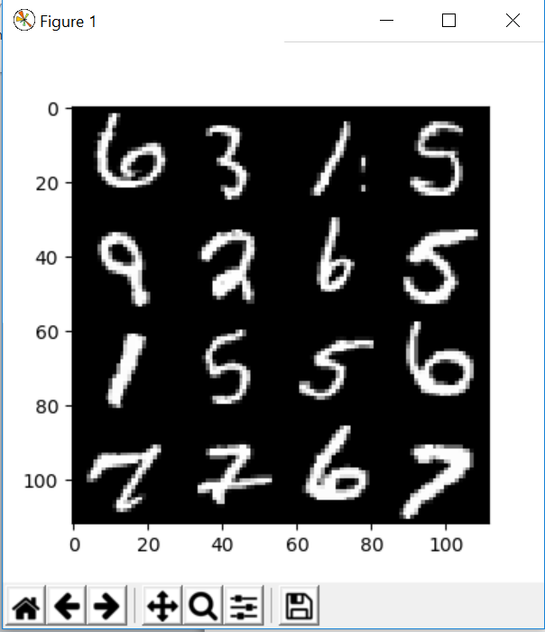

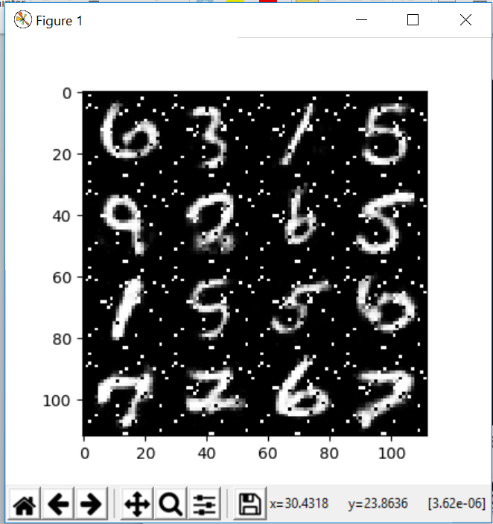

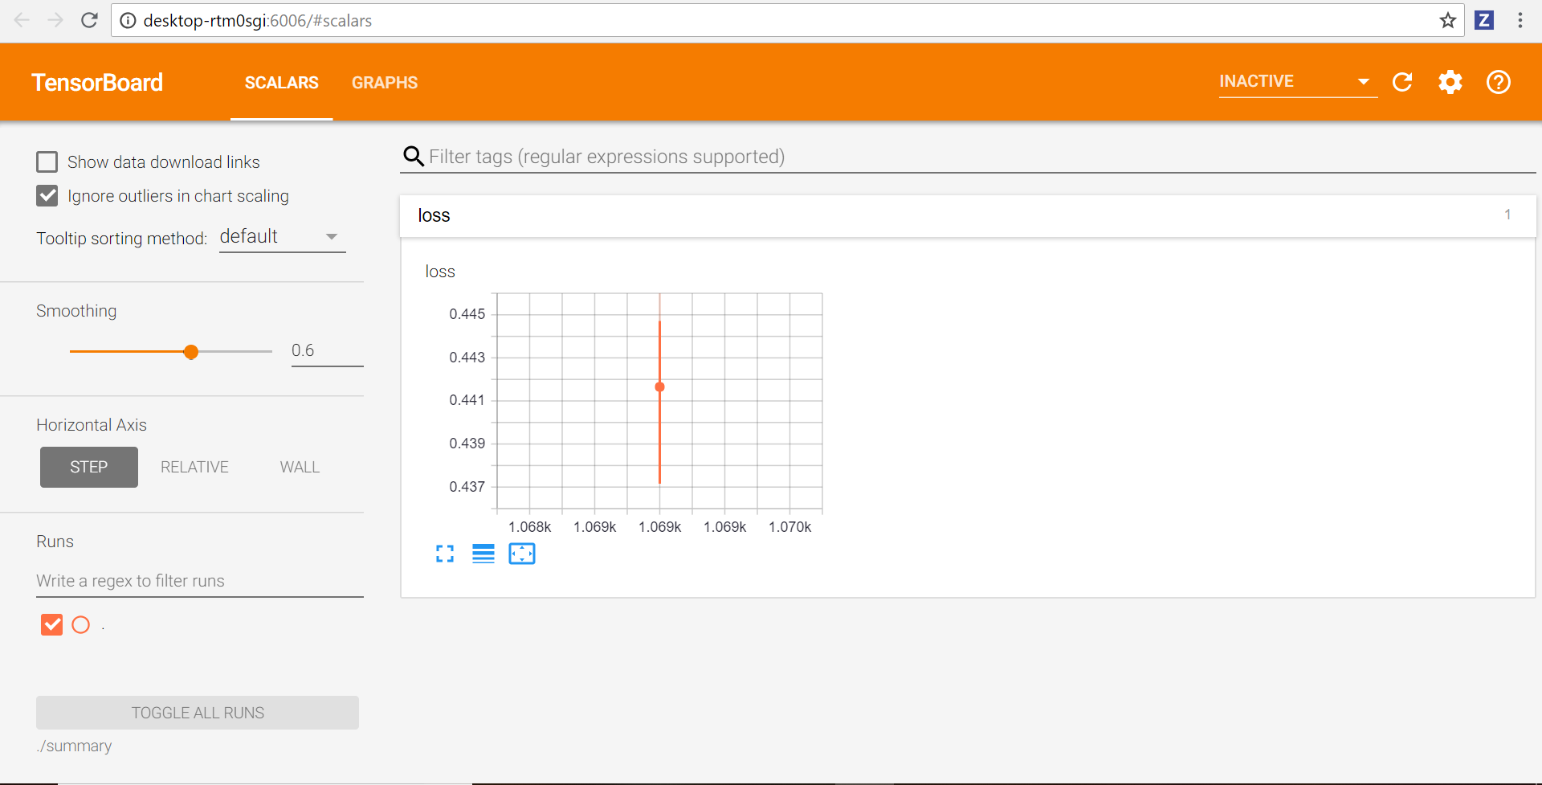

**After adding Layer 3**

learning_rate = 0.1  
num_steps = 3000  
batch_size = 256  
  
display_step = 100

Optimizer: RMSPropOptimizer

**Loss:**

Step 3000: Minibatch Loss: 0.431185

Original Images

Reconstructed Images

Epoch: 0005 cost= 0.002088927

Optimization Finished!

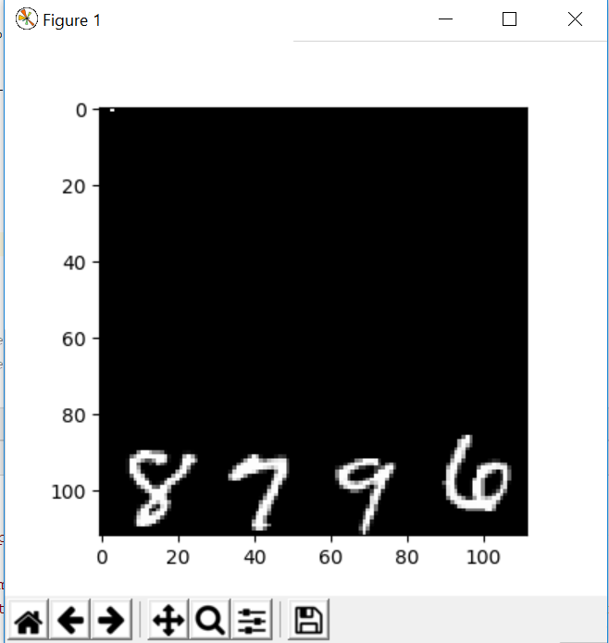

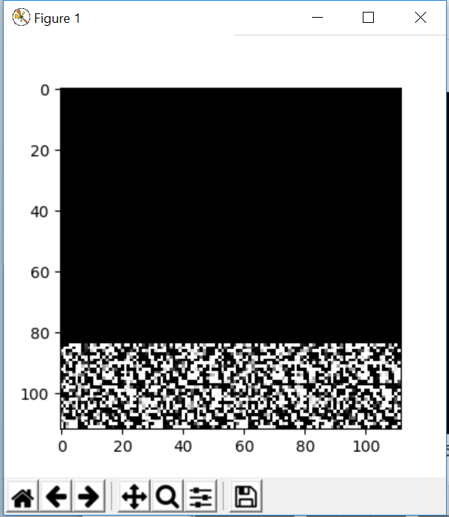

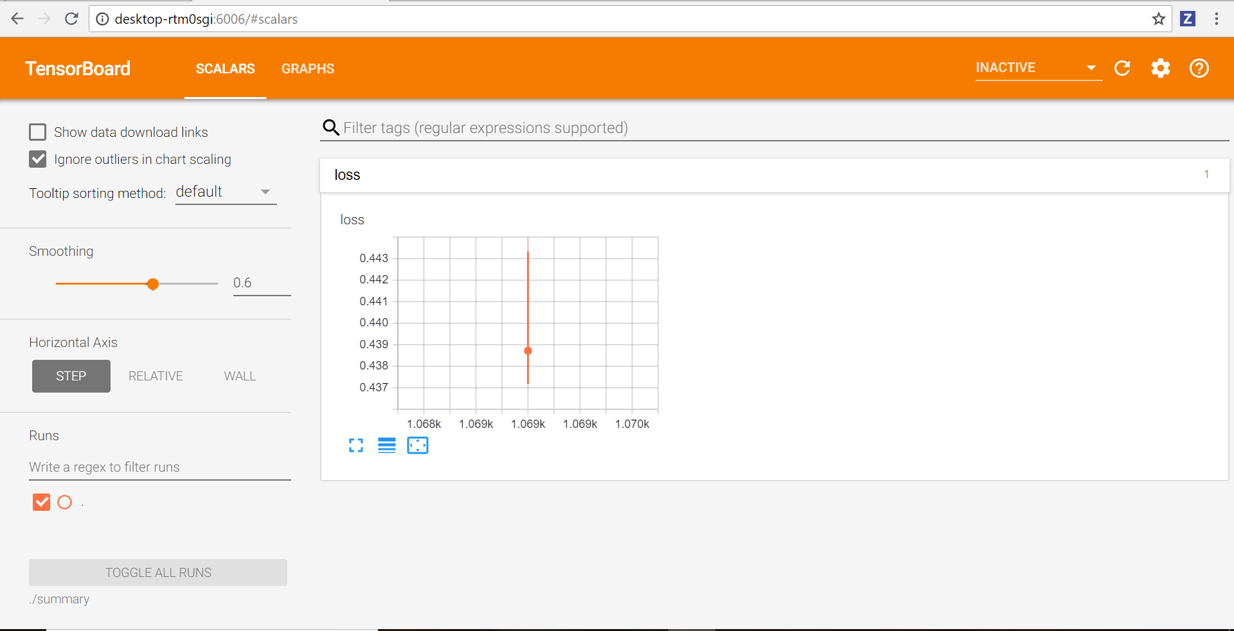

learning_rate = 0.1  
num_steps = 3000  
batch_size = 256  
  
display_step = 100

Optimizer: GradientDescentOptimizer

**Loss:**

Step 3000: Minibatch Loss: 0.451465

Original Images

Reconstructed Images

Epoch: 0005 cost= 0.002110910

Optimization Finished!

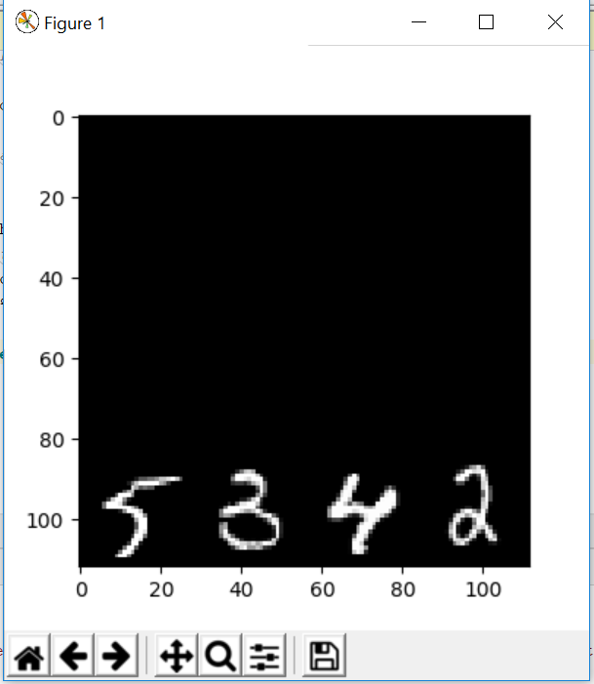

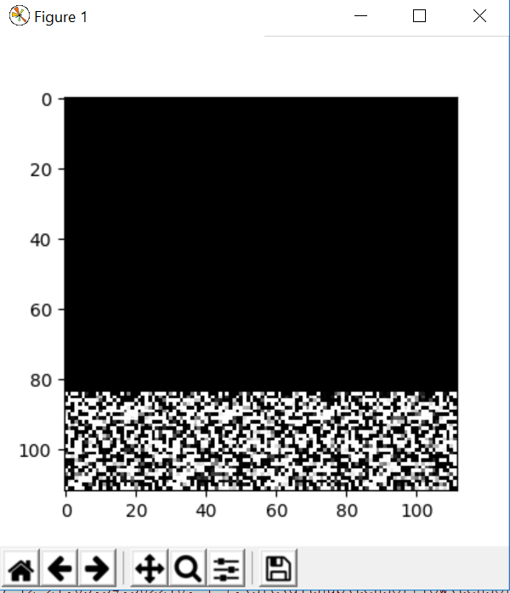

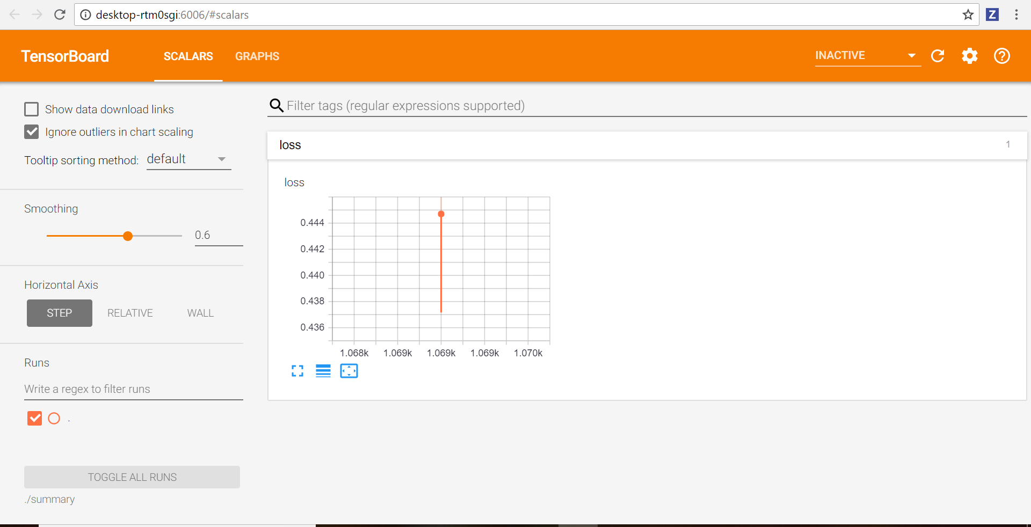

learning_rate = 0.02  
num_steps = 5000  
batch_size = 256  
  
display_step = 150

Optimizer: GradientDescentOptimizer

