Default Values

Filter size: 3,4,5

Number of filters: 128

Dropout probability: 0.5

Batch size: 64

Number of epochs:200

Adam Optimizer:

Loss : 0.288

Accuracy: 0.75

Number of steps: 200

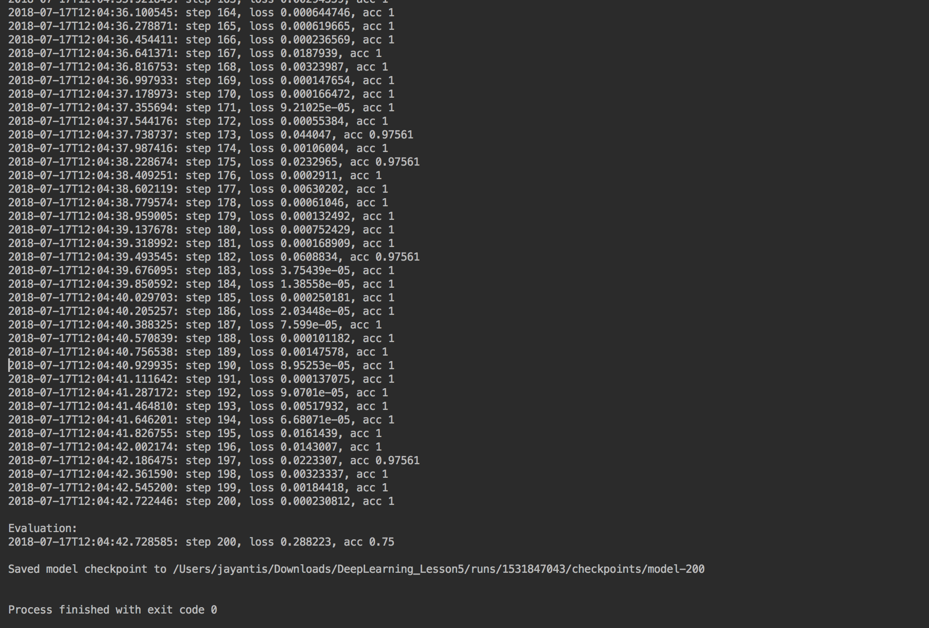

RMSProp Optimizer:

Loss:0.092

Accuracy:1

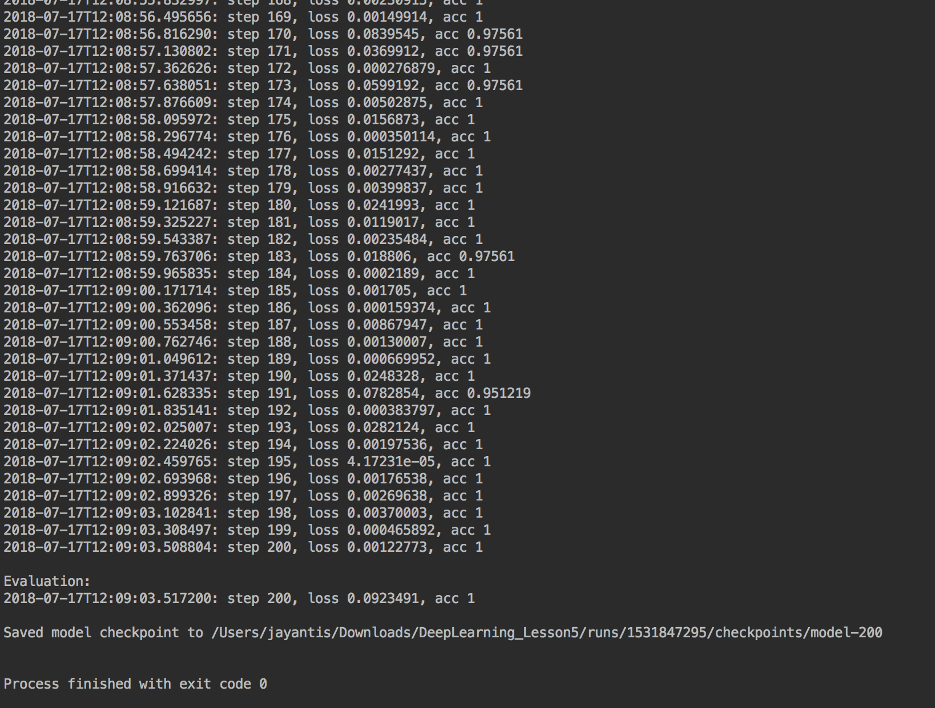

Adagrad Optimizer:

Loss:0.684819

Accuracy: 0.75

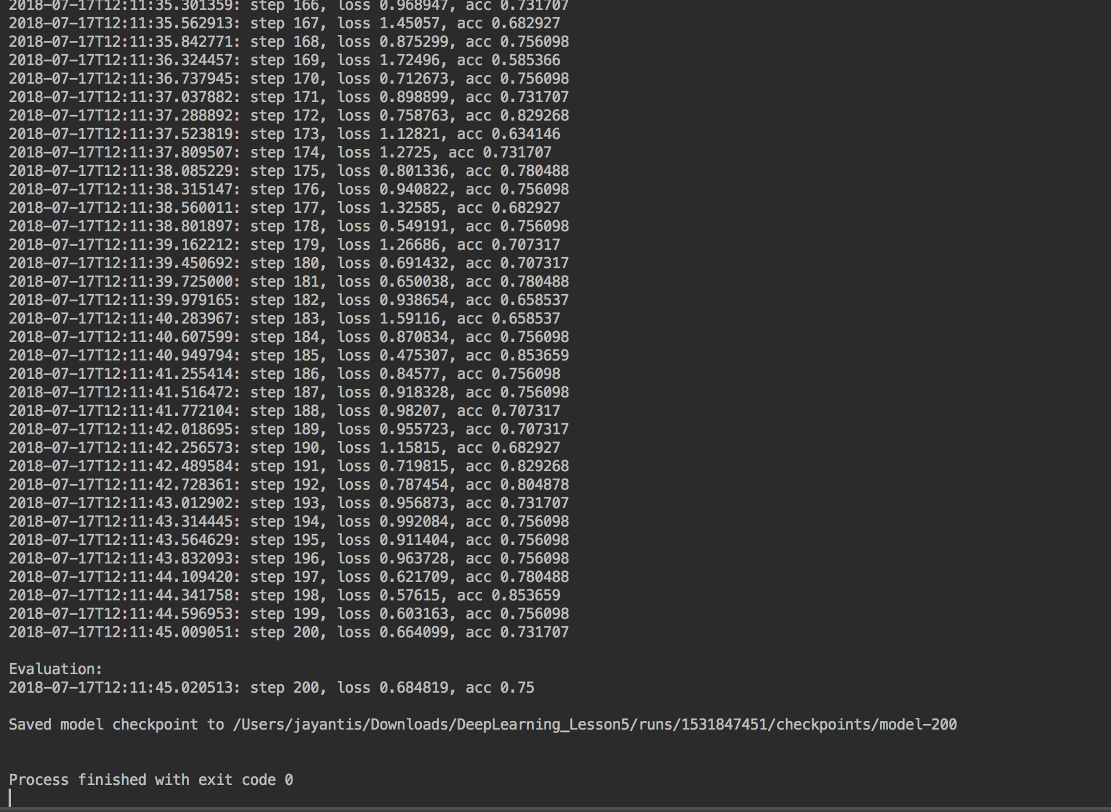

Gradientdescent Optimizer

Loss: 0.971553

Accuracy: 0.5

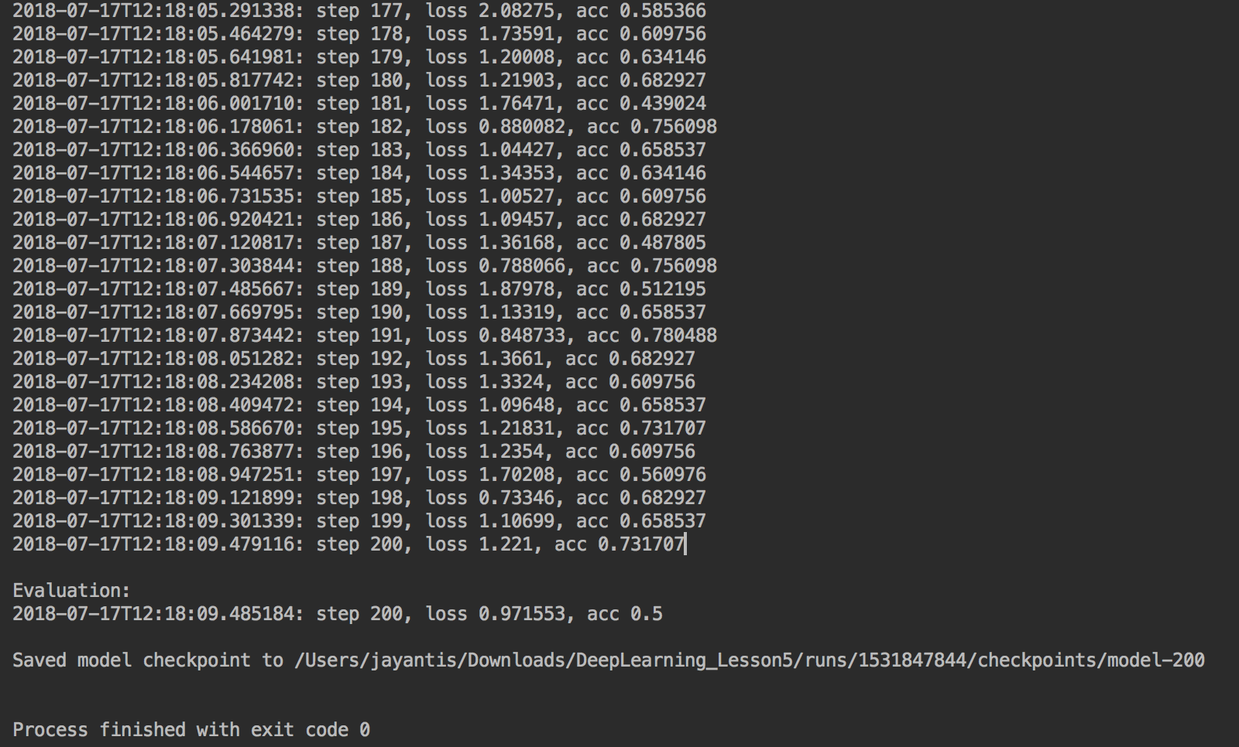

Optimizer: AdamOptimizer

Filter size: 1,2,3

Number of filters: 64

Dropout probability: 0.7

Batch size: 128

Number of epochs:300

Evaluated values:

Loss: 0.16; Accuracy:1

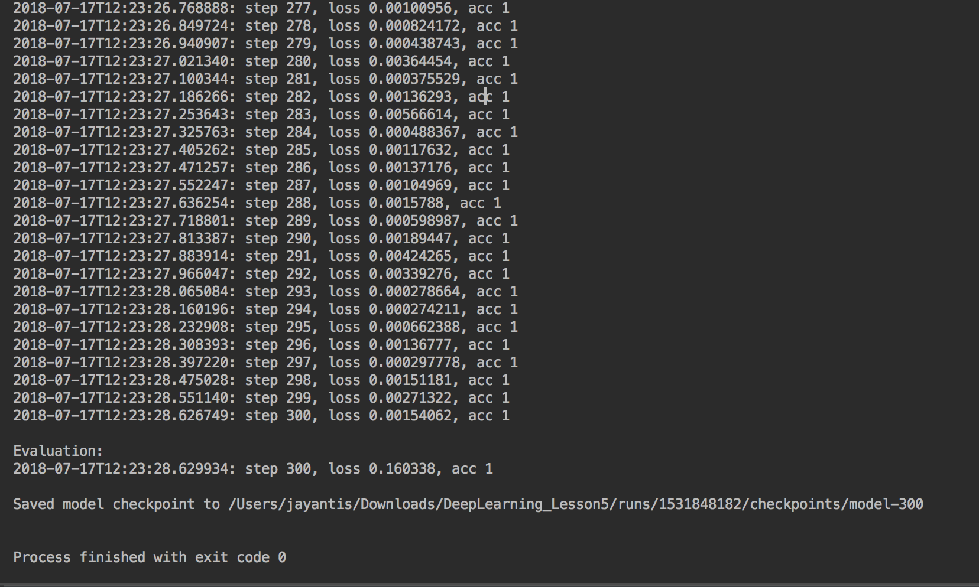

Optimizer: AdamOptimizer

Filter size: 4,5,6

Number of filters: 64

Dropout probability: 0.7

Batch size: 128

Number of epochs:300

Loss: 0.55; accuracy: 0.75

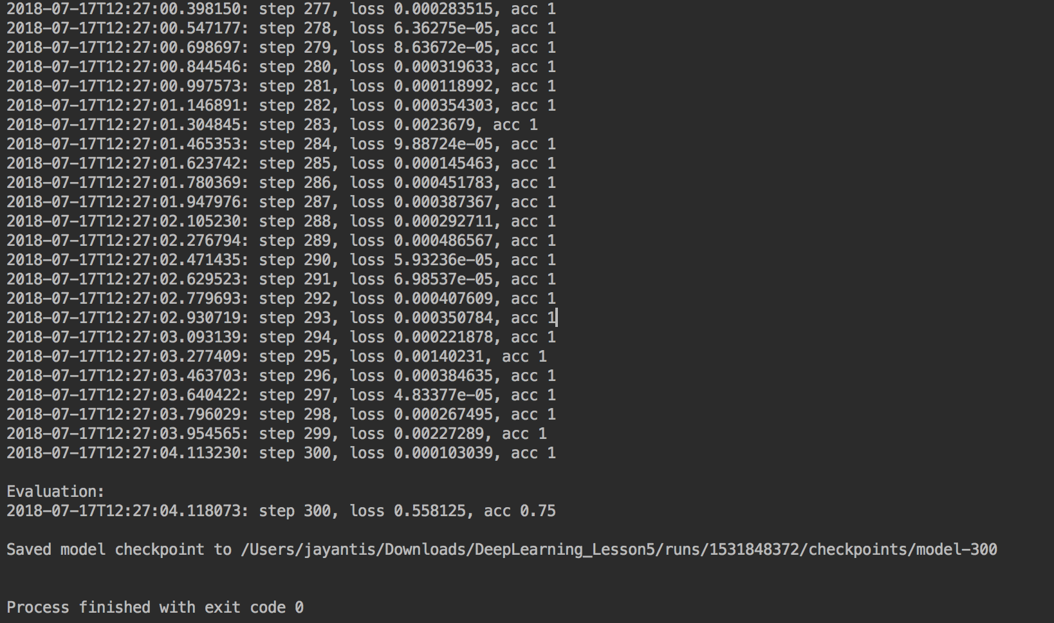

Optimizer: AdamOptimizer

Filter size: 4,5,6

Number of filters: 256

Dropout probability: 0.8

Batch size: 256

Number of epochs:100

Loss: 0.11; Accuray: 1

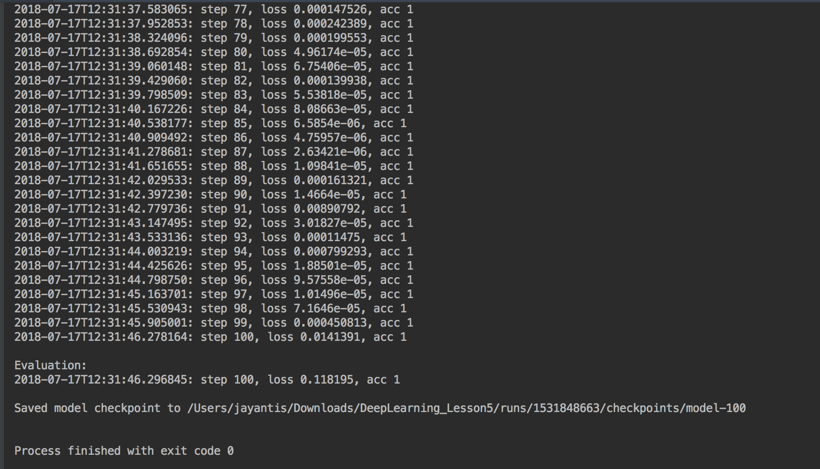

Optimizer: AdamOptimizer

Filter size: 4,5,6

Number of filters: 256

Dropout probability: 0.8

Batch size:64

Number of epochs:100

Loss: 0.55; accuracy: 0.5

